

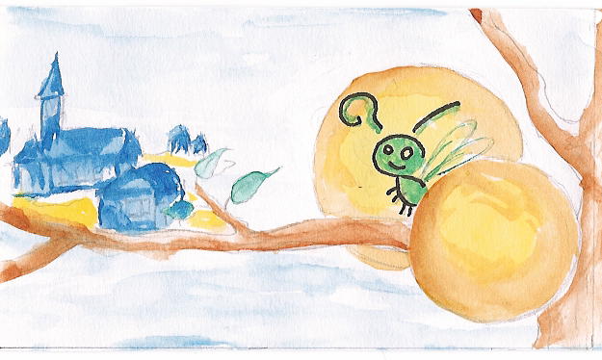

Denis MOREL
Animateur-Formateur
 : 0033(0)2 97 43 41 32
Mobile : 0033(0)6 72 43 16 18
ASSOCIATION LUCIOLE
ASSOCIATION
LUCIOLE
Réseau
Manifeste
E-mail : luciole.ara@mageos.com
To give to every individual the possibility
to act in her/his own life and social environment…
ARA
Le Bois Grignon/56220 Malansac/France

Curriculum Vitae
Nationality | French  Age : 35 years old
Education/Training | - 1992: Master degree « Social and economical administration », speciality in psycho-sociology and human resources.  - 1996 : State diploma « Technical youth worker in popular education »  - 1997 - 2000 : State diploma of youth worker – Project coordinator  - 1999/2000 : LTTC International Youth Worker (Council of Europe)  - 2000/2003 : Advanced Training for Trainers, Pilots training on European Citizenship Education done by Council of Europe and European Union
Professional Experiences | - 1989 to 1995 : Children and youth worker during holidays  - 1995 to 2000 : Manager of summer camps (children and young)  - 1999/2000 : Project coordinator in Manifeste ARA (NGO)  . Manager of local projects towards young  . Manager of international projects towards young  - 2000/2005 : Youth worker /Trainer / Adviser in Luciole (NGO) :  . Leader of local and international projects towards youth  . Adviser in local and international projects  . Manager of training of youth workers and training for trainers on  Active participation of young people  From local to European citizenship  Intercultural education  Human right education  Project’s methodology  - Since 2001 : external trainer for the Youth Directorate of the Council of Europe (training and study sessions of the European youth foundation, assistance program)  - 2004 : External trainer for Salto  - Since 2002 : Trainer in University of Social work on “Youth Work, Intercultural learning, and Europe”
Other experiences | Since 2000 : Creation of ENOA (European Network of Animation : www.enoa.de ) promoting and acting for youth empowerment – President of the network
Main last projects as coordinator or trainer : | Project coordinator  - September 2001 : Organization of an action training in refugees camps in Bosnia-Herzegovina, to motivate them to act – ENOA  - Starting in April 2002 : « Crossroad Project » : to develop concrete partnerships between small local youth organizations of 6 different countries (Italy, Spain, France, Lebanon, Malta, Turkey) – Training / Accompaniment of European Projects  - June 2002 : Rural Areas – Portugal : Action Training on promote youth initiatives  - May 2004 : Beginning of a European Long term training for trainers on ‘promoting intercultural youth action”  - April and June 2005: Networking between formal and non formal training structures that deliver youth work degrees in Poland, Belgium, Portugal and France in order to promote Intercultural and European dimension in vocational youth work / social work trainings and studies.  Trainer at international level  - September 2001 : Organization of a workshop about ‘street animation and youth participation” in a youth work training organized by YEN (Youth Express Network)  - October 2001 : Trainer in a pilot training course (Council of Europe/European Union) « European Citizenship Education in Youth Work”  - December 2002 – Moldova: Training on free time activity with children and young people : how to promote their active participation?  - June 2003 : Evaluation meeting on “European Citizenship” training course in European youth center of Budapest  - November 2003, external education adviser for a study session on globalization  - October 2004 : Trainer in a TC in Azerbaijan on youth participation, organized by the assistance program of Council of Europe  - November 2004: Trainer in a regional training course on Human right education supported by the youth directorate of Council of Europe.  - December 2004 : Trainer in Salto Course on Action 3 – Networking projects  - April 2005 : Action 3 Training course in Poland with youth leaders  - June 2005 : Training for Trainers in Russia with the assistance program  - November 2005 : Training of the partnership agreement “European citizenship and intercultural learning”  Trainer at national level  - Since 2002, intervention in a Social institute of Social work in France about intercultural and international dimension in youth work  - Since 2002, intervention in a University of social work to promote intercultural and human rights education  - 2004 : Training of youth workers and responsible on youth active participation – City Hall of Brest  - 2004/2005 : Creation of a module in University of Social work “Youth work, intercultural learning and Europe” (for the 2 years studies of youth workers)  - 2005 : Trainer for the French National agency of youth program “preparation and evaluation of action1”  Support / Accompaniment of projects  - Since 2000 Support of youth groups in developing local and international projects  - Supporting of youth organisations and structures.
Spoken languages | - English, French, French Sign Language

