كم أنّي الشّخص ذاته، كم أنّي شخصٌ آخر

I am the same, Yet so different

NI TOUT À FAIT LE MÊME, NI TOUT À FAIT UN AUTRE

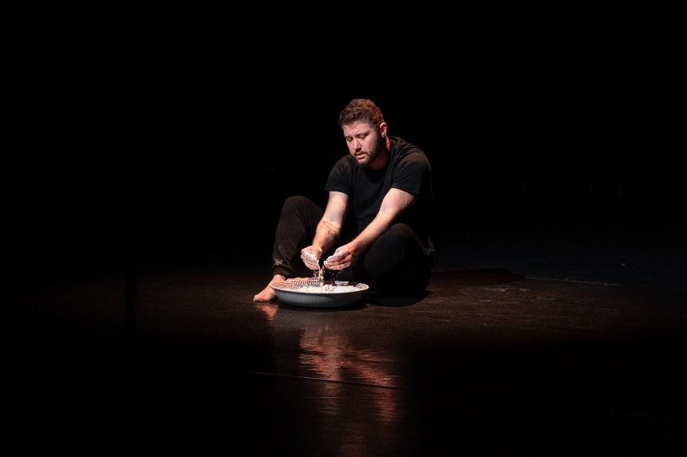

About the performance
Who are we when the body we were born in, and our features change along with the heart of our city? What is left of us? And what does it mean to be oneself, at home with oneself? What new refuges can we give ourselves?

A transman and a poet, Hashem Hashem emerges as a Lebanese version of Virginia Woolf's Orlando. He explores the ever-changing ‘essence’ of individual and collective identity in an intimate performance-text. Like his body in motion, the city of Beirut appears as a restless physical space marked by profound transitions.

Written and performed by Hashem Hashem, dramaturged and directed by Patricia Nammour, this solo performance was developed in the context of the ArtEvolution programme of the Goethe-Institut Libanon. It was performed at Mansion (2021) and Hammana Artist House (Nehna wel Amar wel Jiran Festival, August 2023) in Lebanon; at the Théâtre National de la Fédération Wallonie-Bruxelles (MAD Festival, March 2023) and Muntpunt (Passa Porta Literary Festival, March 2023) in Belgium; and most recently at Les Amis musiquethéâtre in Geneva ( La Bâtie-Festival de Genève, September 2023).
On 25 November 2023, the performance will be hosted by Le Relais du Pantin in Paris. Then, on 19 and 20 January 2024, it will feature at Le Centquatre-Paris as part of their Singulier·es Festival.

Written & performed by: Hashem Hashem
Directed by: Patricia Nammour
Dramaturgy by: Patricia Nammour

Language: Arabic with French & English subtitles
Duration: 55 minutes

Tour Dates
MAD² Festival  Link | Theatre National Wallonie-Bruxelles;  Brussels, Belgium | 18.03.2023
Passa Porta Festival  Link | MuntPunt Library  Brussels, Belgium | 25.03.2023
Zoukak Theatre | Beirut, Lebanon | 9-10 June 2023
Nehna wel Amar wel Jiran Festival | Hammana Artist House  Lebanon | 11-12 August 2023
La Bâtie-Festival de Genève  Link | Geneva, Switzerland | 4-7 Sep 2023
Le Relais Pantin | Paris, France | 25 Nov 2023
Singulier·es Festival  Link | Le CENTQUATRE-PARIS  Paris, France | 19 & 20 Jan 2024

Trailer
Watch French trailer.
Watch English trailer.

About the artists
Hashem Hashem (b. 1988) is a poet, writer and theatre maker based in Beirut. He holds an MA in Gender and Sexuality Studies from SOAS University of London and is involved in local and regional queer and trans groups. He performs regularly at poetry nights and has been invited to participate in various art festivals abroad, including Mexico City, Kathmandu, Brussels, Belfast, Geneva and Paris. In 2018 he collaborated with Baladi dancer Alexandre Paulikevich in the performance The Last Distance. His poetry is included in "And We Chose Everything", a poetry anthology published by Turning Point Books. In 2019, Hashem received the AFAC Performing Arts Grant to develop a collaborative project entitled Night Prayer with Alexandre Paulikevitch. Following the Beirut port explosion in August 2020, Hashem received the 'Fund the Arts in Beirut' grant by Mophradat in 2021. That same year, Hashem was also selected to join the ArtEvolution programme of the Goethe-Institut Lebanon where he developed his first solo performance, "I am the same, yet so different", which he presented in Beirut in November 2021. In March 2023, Hashem presented his performance at MAD2 Festival at the Theatre National Wallonie-Bruxelles, and at Passa Porta international Literary Festival at MuntPunt library in Brussels.

Patricia Nammour is a Lebanese performer and director with a strong passion for using theater as a means for social change. She built a reputation for herself by showcasing her talent in TV series, movies, and theater productions. Nammour is also the co-founder of “L’atelier du Je” established in 2009, with the aim of empowering people to express themselves through theater. As a director, Patricia has always been interested in themes that are close to her heart: individuality, interdependence, collective identity, women’s rights, gender justice, personal freedoms and breaking free from societal stigma. Through her work, she has been able to touch the hearts of many and spark meaningful conversations about these important topics. In 2022, Nammour moved to Croatia where she founded “Udruga Play”, an art association that uses various forms of art, connecting people from different parts of the world. Patricia’s vision for the organization is to help people find a common ground through the transformative power of art and theater.

In the Media

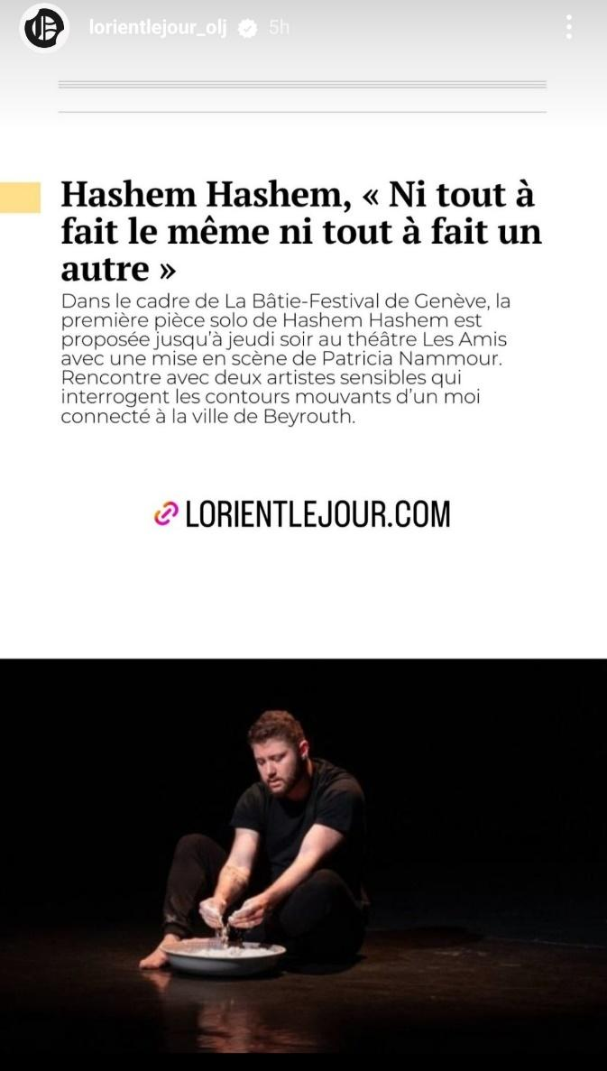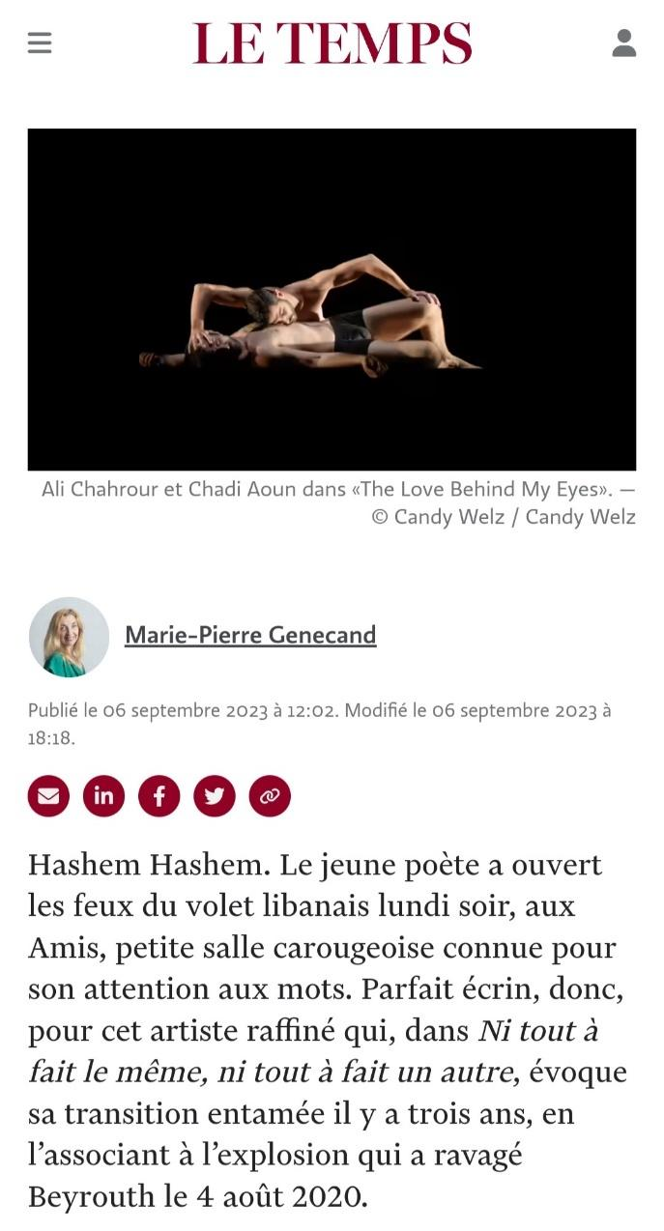
L’Orient Le Jour, Lebanon (5 September 2023) Le Temps, Switzerland (7 September 2023)

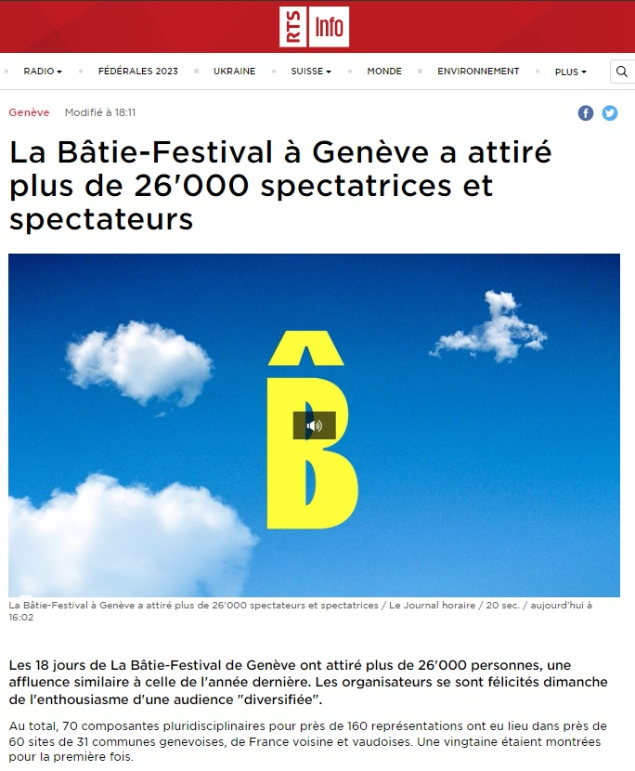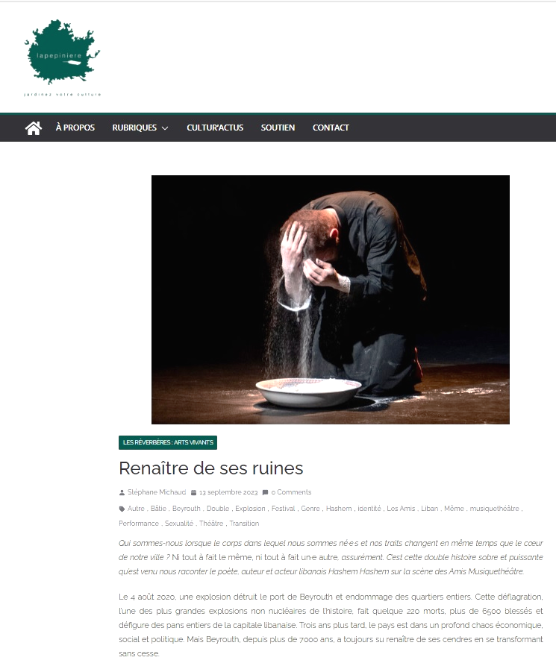
RTS, Switzerland (17 September 2023) La Pepiniere Geneve (13 September 2023)

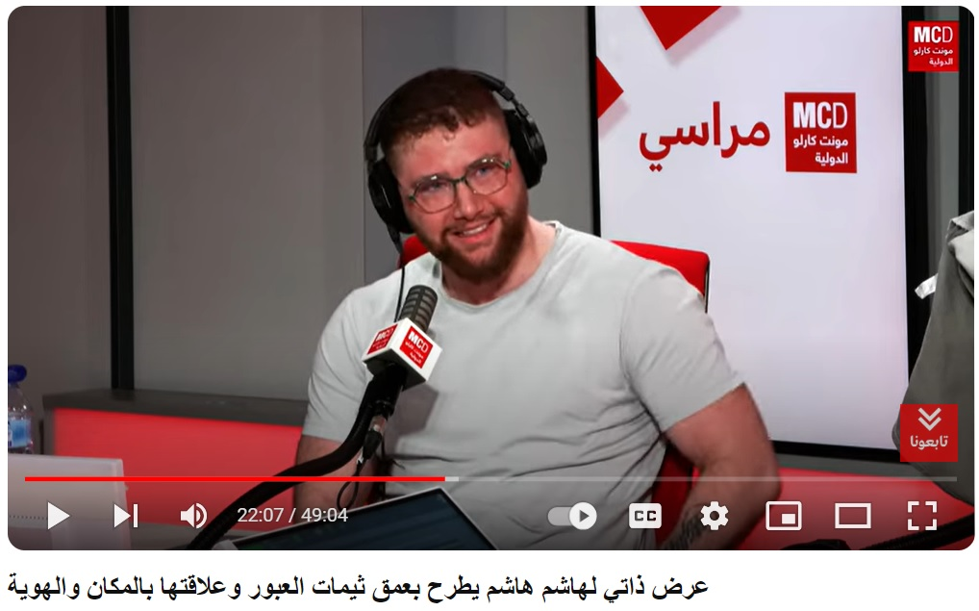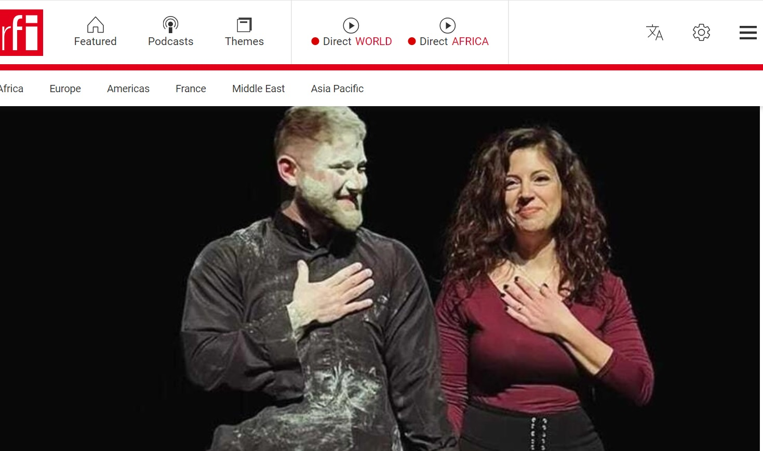
Radio Monte Carlo, Paris (22 January 2024) RFI, Paris (23 January 2024)

Contact Info
Hashem Hashem | Ha.hashem2020@gmail.com  +961-3-874147 (calls, whatsapp)
Patricia Nammour | patricianammour.hr@gmail.com  +385976337821 (calls)  +961-3-789394 (whatsapp)

