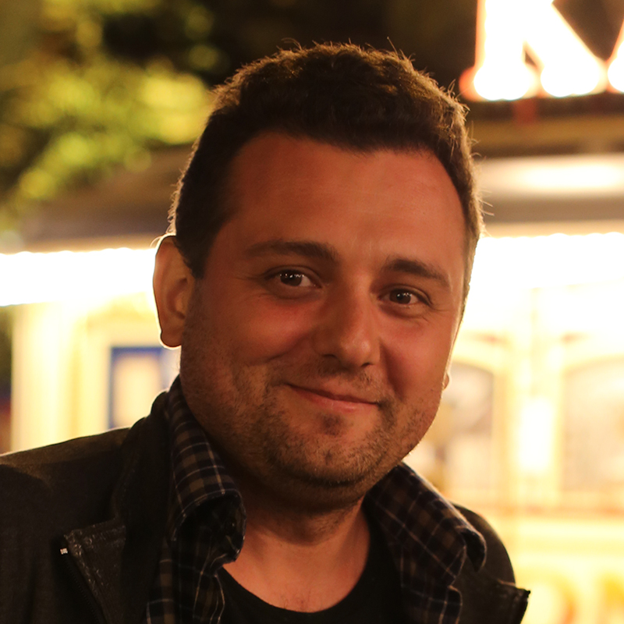 | EDUARD R. OGANYAN  I believe in Experiential Learning, I think the best way to learn is through personal experience, discovering, curiosity and learning by doing. Theoretical knowledge without experience, practical use and applicability fading and wasted in the end. So the best experience is life, the best study is a challenge and the greatest teacher is you yourself. And I think one of the main and general professional and life competences is Creativity. Especially if you open and discover totally unknown or want to do something in a new way, creativity is your key. Discover, challenge, learn, be creative and have fun.

Address: Szasz Korly ut.1, 1027, Budapest. Hungary
Tel: +36 70 8824882
e-mail: eduardoganyan@gmail.com

LANGUAGES:
Russian (native), English (fluent)
FORMAL EDUCATION:
2001 - 2005 Specialist (5 years) in finances and management, Moscow University of Business and Politics

WORK EXPERIENCE
2018 – onwards | Tegyünk Együtt az Ifjúságért Alapítvány (TE IS)
2014 – onwards | Founder director and trainer of Social organisation «Academy of innovation»
2011 – 2017 | Member of SALTO EECA Pool of accreditors of EVS progamme in Eastern Partnership Countries and in Russia region
2010 – onwards | Founder and director of business travel agency
2010 – 2013 | Administrative support of SALTO EECA in organization of EVS training cycle in Russia
2007 – 2013 | Founder administrator and finance manager at SFERA Movement
2003 – 2007 | International voluntary projects coordinator at Nizhny Novgorod Voluntary Service

VOLUNTEERING
2014 | Volunteer of the XXII Olympic Winter Games of 2014 in the City of Sochi
2003 – 2008 | Volunteer and campleader in international work camps and short-term projects in Finland, UK, Czech Republic and Russia. As a volunteer I was working with young people from disadvantage and marginalized groups of people, was working at natural parks, promoting health issues and lifestyles
2003 | EVS volunteer in KVT Finland
1999 – 2013 | Volunteer at Nizhny Novgorod Voluntary Service

NON-FORMAL EDUCATION

31 May – 08 Jun 2009 | “FLY – Facilitating Learning for Youth” international training for trainers, level I, run under YiA Programme, Dilijan, Armenia
08-16 July 2010 | “FLY - lab phase”, international training for trainers, level II, run under YiA Programme, Austria
19-24 May 2015 | TC “COMETS – ICC” - Trainer competence development training for advanced trainers at European level, by SALTO-YOUTH training and cooperation resource centre, Nessebar, Bulgaria
29 Jan - 06 Feb 2016 | Training course “Coaching for Change”, - development of coaching skill implemented in educational field, run under YiA Programme, Yerevan, Armenia
18-25 February 2016 | Training course “Open Space on Visual Thinking”, - learning and development graphic facilitation skills, run under YiA Programme, Dilijan, Armenia
01-06 October 2018 | Training course “Training for Facilitators”, training on developing the competences of participants to act as facilitators or course directors on basis of the quality standards for intercultural non-formal learning activities, by Council of Europe (DDCP-YD), European Youth Centre Budapest, Hungary

TRAINING EXPERIENCE:

Since 2010 work as trainer and expert in different educational and youth activities. Since then implemented over 50 national and international trainings. For local, intercultural and international groups. During this time, cooperate in different international teams, with co-trainers from different cultures and backgrounds. Main topics: youth participation, youth empowerment, cultural dialogue, social inclusion, non-formal education, facilitation, human rights, conflict transformation, peace building, communication, digital competences, graphic facilitation, gamification, volunteering, Outdoor education, leadership, personal development and project management.

Some examples of training activities:

2019 | 20– 28 July | LTTC “Labyrinth” part 2 – “Out Door in Action”. - Training course on outdoor education for youth workers aims to train youth workers on how to use outdoor education and building so called soft competences and skills, such as respect, efficient communication, tolerance, non-judgment approach, ability to work in teams and critical thinking, Baikal, Russia.
2019 | 07– 15 June | CMS "Eduactor for Change" - CMS will bring NGOs working on capacity building for educators and educators themselves coming from different backgrounds in order to meet together and reflect &review how to strengthen our capacities in human rights education and intercultural learning in order to address current challenges of nowadays, Mariapfarr, Austria.
2019 | 18– 23 April | LTTC “Labyrinth” part 1 – “Out Door in Action”. - Training course on outdoor education for youth workers aims to train youth workers on how to use outdoor education and building so called soft competences and skills, such as respect, efficient communication, tolerance, non-judgment approach, ability to work in teams and critical thinking, Sondershausen, Germany
2019 | 07– 14 April | Training course “Go Visual part 2” part 2. - Training course and capacity-building activity on gamification and educational game designing for youth workers and educators, Tsaghkadzor, Armenia.
2019 | 16– 21 March | Training course “Memory Diaries” - training course on historical memory, remembrance, critical thinking, mass media, conflict analyses and what influence history have on conflicts today, specially on conflict between Russia and Ukraine. TC for young people, Krasnodar, Russia.
2018 | 11– 19 December | Training course “Go Visual part 2” part 1. - training course and capacity-building activity on on-line graphical and video making tools, digital instruments and it skills development for youth workers and educators, Luxembourg, Luxembourg.
2018 | 27 October – 04 November | Training course “inFormal Basic” part 2. - training activity on Integration of non-formal education approach to the formal education system for youth empowerment at local level, Tsaghkadzor, Armenia.
2018 | 06 -14 October | Training course “Go Visual” – training course and capacity-building activity on graphic facilitation and visual thinking tools for youth workers dealing with integration of migrants and refugees. Vienna, Austria.
2018 | 25 -30 September | Training course “inFormal Russia”. - training activity on Integration of non-formal education approach to the formal education system for youth empowerment at local level, Moscow, Russia
2018 | 18 -26 August | Study Visit “Another Peace” part 2. - Study Visit activity on peace building, conflict resolution, intercultural learning and human rights education. Yerevan, Armenia.
2018 | 09 -18 July | Training course “Another Peace” part 1. – training activity on peace building, conflict resolution, intercultural learning and human rights education. Luxembourg, Luxembourg.
2018 | 29 June - 07 July | Training course “inFormal Basic” part 1. – training activity on Integration of non-formal education approach to the formal education system for youth empowerment at local level. Luxembourg, Luxembourg.
2018 | 02 - 10 June | Training course “Make yourself visible” part 2. – training activity on improving skills in information technology of youth workers all around Europe. Focused on development of IT skills of youth workers and young people active in social field. Ivancice, Czech Republic.
2018 | 14 - 22 April | Training course “Communication With No Words” part 2. – training activity on fostering non-violent communication in educational process addressing current challenges such as intercultural dialogue in the work with refugees or preventing radicalization of young people through different forms of Art including drawings, sketching, comics, different forms of theatre, dance. Ivancice, Czech Republic.
2018 | 31 March - 09 April | Training course “inFormal ReVision” part 2. – training activity on Integration of non-formal education approach to the formal education system for youth empowerment at local level. Weimar, Germany.
2017 | 27 October – 04 November | Training course “inFormal ReVision” part 1. – training activity on Integration of non-formal education approach to the formal education system for youth empowerment at local level. Tsaghkadzor, Armenia.
2017 | 07 - 15 October | Training course “Communication With No Words” part 1. – training activity on fostering non-violent communication in educational process addressing current challenges such as intercultural dialogue in the work with refugees or preventing radicalization of young people through different forms of Art including drawings, sketching, comics, different forms of theatre, dance. Ivancice, Czech Republic.
2017 | 24 July - 01 August | Training course “inFormal Coaching”, part 2, - how to use coaching in formal and non-formal environments, Weimar, Germany.
2017 | 01 - 09 July | Training course “Go Visual”, part 2 Go Digital, - training course and capacity-building activity on digital graphic tools, visual thinking, It instruments, presentations, whiteboard scribing, stop motion and video making for youth workers and educators, Yerevan, Armenia.
2017 | 09 - 15 June | Study Visit “Open Doors”, - Study Visit with partnership-building elements, is an opportunity to learn from the local youth initiatives and street work, as well as to share other experience of successful youth engagement practices in Europe. And possibility to reconsider and develop further youth activities of better quality and more sustainable youth work. Amarant, Portugal.
2017 | 22 - 30 May | Training course “Go Visual”, part 1 Go Graphic, - training course and capacity-building activity on graphic facilitation and visual thinking tools for youth workers and educators, Rostov the Great, Russia
2017 | 26 April – 04 May | Training course “MovieDoc”, - training course on Documentary film-making and promotion of Human Rights education, participants youth with disabilities, Dilijan, Armenia
2017 | 08 -15 April | Study Visit “Home” - training element on strategic planning, sharing tools, best and worst practices of work towards refugees. Luxembourg, Luxembourg.
2017 | 18 - 26 March | Training course “inFormal Coaching”, part 1, - how to use coaching in formal and non-formal environments, Rostov the Great, Russia
2017 | 27-29 January | EVS coordinators meeting - external expert on behalf of SALTO EECA pool of accreditors.
2017 | 02 – 11 September | Editorial Meeting “Q Stand” - quality standards in intercultural projects focusing on active participation – connecting theory and practice. Meeting meant to serve the finalisation of the publication. The Editorial team will take the ideas and content developed during the “Q Stand” seminar and the Editorial meeting and will further develop them through online co-operation with those participants of the seminar that will express their interest to continue to contribute to the project, Saint-Sever-Calvados, France
2017 | 02 January -09 February | Training course “Home” - training course on understanding the phenomena of refugees and human rights of refugees. Yerevan, Armenia.
2017 | 27-29 January | EVS coordinators meeting - external expert on behalf of SALTO EECA pool of accreditors.
2016 | 04-12 December | Long-term training course “inFormal” part 2, Quality Assessment, training course, Integration of non-formal education approach to the formal education system for youth empowerment at local level. Hradec Kralove, Czech Republic
2016 | 20-24 October | School of personal growth for youth “Perspectivi 2016” (Mirniy) Yakutia, Russia
2016 | 09-22 August | Youth forum “Agidel” for tatar–speaking young people, project management. Tatarstan republic, Russia
2016 | 24 July - 01 August |       Long-term training course “inFormal” part 1 - Integration of non-formal education approach to the formal education system for youth empowerment at local level, for youth workers, youth leaders and educators Rostov the Great, Russia
2016 | 15-22 May | ITC “Strategic Mentoring”: Training of EVS Mentors, Dilijan, Armenia
2016 | 05-13 January | ITC “Experientiality” – experience and reflexivity contributing to youth participation”, Brno, Czech Republic
2015 | 03-09 August | Youth forum “Agidel” for tatar–speaking young people, project management. Tatarstan republic, Russia
2015 | 07-14 July | International Youth Forum “Selet” on youth participation and project management. Organised by Selet foundation in Tatarstan Republic, Russia and Ministry of Education and Ministry of youth and sport.
2015 | 07-09 April | EVS coordinators meeting - external expert on behalf of SALTO EECA pool of accreditors.
2015 | 20-30 May | EVS training cycle - on-arrival training and mid-term meeting for EVS volunteers, trainer and expert on behalf of SALTO EECA. Russia
2013 | January - March | “YES, YOU CAN” informational/educational campaign on social rights in 26 regions of Russia
2010 | February - March | Training of trainers in the frame of “KOMANDA 2020” regional project, on rural youth participation run in cooperation with Ministry on Youth and Sport. Nizhny Novgorod regions, rural areas

COMPETENCES:
Graphic facilitation skills: visual thinking, graphic facilitation, illustration, sketch noting, visual meeting, presentations, poster making, animation, graphic recording, storytelling, whiteboard scribing.
Organisational / managerial skills: Leadership, ability to manage groups of different size (from 10 till 250), good HR management skills and project management skills.
Communication skills: As I work as a coach and trainer I have good communication skill, both – verbal and non-verbal expression. I think I can adopt myself easily to the different personalities and to find “common language”. I can make myself clear and understood, as well as I have developed active listening skills.

Flexibility, ability to work under pressure and meet strict deadlines and prioritize multiple tasks;
Willingness to work as part of a team in a multicultural environment with people coming from different cultural ethnic and social background
Facilitation skills – ability to support group discussions, debates and sharing the experience, tracking and balancing skills, as well as good analysing skills, skills in finalising ,making logical and fare conclusions out of the group discussion
Knowledge and experience of youth work and volunteering; practical experience of work in local, national and international NGOs and their young volunteers on different topics such as youth participation, employability, youth empowerment, leadership, volunteering, Human Right and intercultural dialogue, personal and professional growth etc.
Understanding of complexity of volunteering and identity of youth work, practical experience of being a volunteer and youth work
Job-related skills: Ability to assess needs of participants, ability to develop training programme based on those needs, ability to implement and to evaluate the educational activity, conflict transformation skills, equal-to-equal approach, good communication skills, facilitation skills, debriefing skills, ability to give and receive feedback, learning-to-learn skill, methodological skills, creativity;.
Responsibility: respect for deadlines, good time-management, reporting in time;
Computer skills: good command of Microsoft Office™ tools, mind mapping tools, word press, web programming, web design (HTML, PHP), (Photoshop, illustrator, Dreamweaver) ... Net work administrator experience

