PERSONAL INFORMATION | Marius ULOZAS
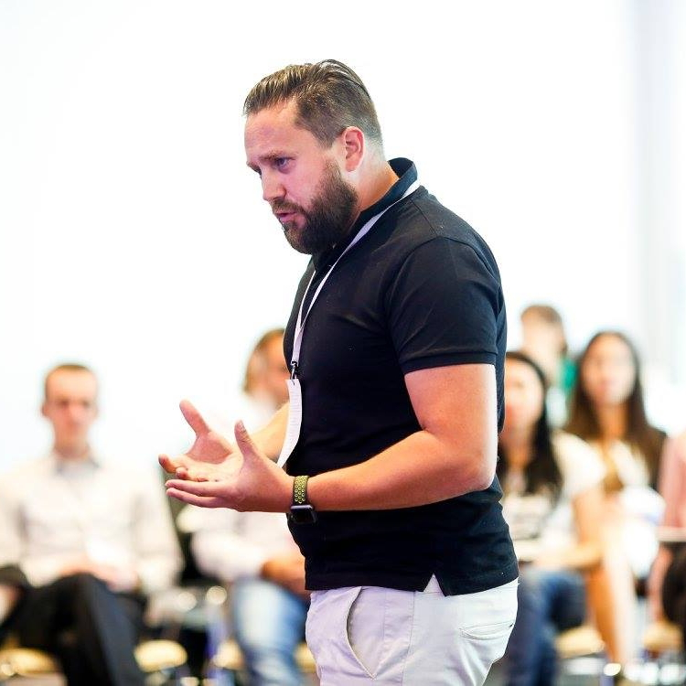 |   V.Žalakevičiaus 4A-34, LT-10111 Vilnius, Lithuania
 |  +370 686 26260

Marius.ulozas@gmail.com
 | skype marius.ulozas@gmail.com
 | Sex male | Date of birth 30/07/1978 | Nationality Lithuanian

Work experience

2005 – till now | Freelance trainer and Membership in professional bodies
2005 – till now | - Member of Council of Europe Pool of trainers and youth policy experts (since 2007),  - Expert for European Knowledge Centre for Youth Policy (since 2009);  - Member of Association of Non-formal Education in Lithuania (since 2006);  - Member of European Youth Forum Pool of trainers and facilitators;  - Member of European Structured Dialogue Support Structure of facilitators (2009 – 2013);  - Member of Council of Lithuanian Youth organizations pool of trainers (since 2005)  - Expert, member of pool of experts on youth NGO's performance quality of the Lithuanian national youth council (LiJOT), from 2007;  - Trainer for Department of Youth affairs under Ministry of Social security and Labour, Republic of Lithuania from 2007.
Aug 2011 – till now | Managing director, Senior expert
Aug 2011 – till now | Politikos tyrimų ir analizės institutas / Institute for Policy Research and Analysis
Aug 2011 – till now | - Mission: to contribute to development of public policies and it's actors (stakeholders). Fields of activities: facilitation, research, policy analysis, and operational performance improvement.
Aug 2011 – till now | Research and Education
June 2016 – till now | Senior expert
June 2016 – till now | MedvirkningsAgentene (Norway) / Participation Agency
June 2016 – till now | - Mission: to contribute to promote youth participation in different policy areas, facilitation of participatory processes; capacity building of public sector to run participatory processes. Fields of activities: Facilitation, strategy development, capacity building, policy analysis.  Research and Education
2002 – 2007 | PR project manager
2002 – 2007 | In that time span worked for three Lithuanian PR agencies: JSC “Consensus PR”, JSC “Contact Market” and JSC “NeoMedia”.
2002 – 2007 | - My responsibilities included public affairs, public campaigns, development of strategic communication plans, PR project implementation and supervision (organization of conferences, press conferences, seminars). Also, I was in charge of all IT related activities: website optimisation for search engines, publishing etc
2002 – 2007 | PR and communication

EDUCATION AND TRAINING

2000 - 2004 | Masters Degree in Law
2000 - 2004 | Lithuanian Law University (Currently renamed to Mykolas Romeris University), Lithuania
2000 - 2004 | - Law and Management, EU law
1996 - 2000 | Bachelors Degree in Philosophy
1996 - 2000 | Vilnius university, Lithuania
1996 - 2000 | - Philosophy and Social sciences
PERSONAL SKILLS

Mother tongue(s) | Lithuanian
Other language(s) | UNDERSTANDING |  | SPEAKING |  | WRITING
Other language(s) | Listening | Reading | Spoken interaction | Spoken production
English | C1 | C1 | C1 | C1 | C1
 | Replace with name of language certificate. Enter level if known.
Russian | C1 | C1 | C1 | C1 | B2
 | Replace with name of language certificate. Enter level if known.
Levels: A1/A2: Basic user - B1/B2: Independent user - C1/C2 Proficient user
Common European Framework of Reference for Languages

Communication skills | - Strong communication and 7-year experience in PR and political communication – campaigns, public speaking, preparing media strategies and talking points, trainings

Organisational / managerial skills | - Working in the role of manager for more than 10 years (small and medium size organizations);  - Managing international trainer and expert teams for more than 10 years;  - Experience cooperating using online and phone communication;  - Capable to meet deadlines

Digital competence | SELF-ASSESSMENT
Digital competence | Information processing | Communication | Content creation | Safety | Problem solving
 | Proficient user | Proficient user | Proficient user | Proficient user | Proficient user
- Would call myself IT-native, working with most major office program packages,
- Vast experience combining online and offline learning, Online Learning badges, creating video and photo materials for dissemination of training results and visibility.

Key qualifications related to assignment | - Strategic planning and facilitation of various policy processes;  - Good knowledge of history and contemporary development of youth policy and youth work in Europe;  - In-depth knowledge of Erasmus+ programme;  - Training and capacity building;  - Good communication skills, experience with mass media, social media;  - Open for innovations and technology;  - Policy development;  - Experience in politics, party-politics, policy development;  - Lobbing and advocacy;  - Facilitation of large scale events;  - Ability to deal with complex political contexts;  - Stakeholder interest analysis;  - Cross-sectorial cooperation;  - Research and analysis;  - Project management;  - Policy review writing;  - Preparation of legal documents;  - Social and personal competencies;  - Great interpersonal skills;  - Intercultural competencies and culture-sensitiveness;  - Teamwork.

Driving licence | B, since 1999

ADDITIONAL INFORMATION

Publications  Honours and awards | - Publication / report on youth situation and proposals for youth policy development in Gyumri, Armenia, 2015-2014 (co-author);  - Manual on Integrated youth policy implementation, 2014, p.176 (co-author);  - N.Miginis, M.Ulozas, Role of young people and civil society in promoting democratic changes in Eastern Partnership countries, 2012  - Analysis of Integrated youth policy on the national level in Lithuania, 2011, p.108, http://www.google.lt/url?sa=t&rct=j&q=&esrc=s&source=web&cd=1&ved=0CFAQFjAA&url=http%3A%2F%2Fijpp.lt%2Ffile%2FTB_ANALIZE.pdf&ei=zKnZT8erBIjbtAbzjc3sBw&usg=AFQjCNEVenxt2_llav1vhpMFJHKBJN108Q&sig2=G2Ta6nUyqcWnAZrLTcY44Q  - CoE & EC Youth Partnership: Article in the youth policy - Youth worker certification methodology in Lithuania, 2010-2011, (team leader, co-author).  - Accreditation mechanism of youth work system in Lithuania, 2010-2011, (team leader, co-author).  - Youth worker professional standard in Lithuania, 2009-2012, (member of national working group, co-author).  - Rapporteur of Council of Europe “European Citizenship training modules 2005-2006 (author)  - CoE & EC Youth Partnership: Article in the youth policy expert publication “Coyote” #11 on Non-formal education;  - European Youth forum: Article in the expert publication “Youth Opinion” - Ensuring Sustainability of Youth Organisations, 2005  - Youth policy expert publication “Po skėčiu” (Lithuania): member of editorial board, have published numerous articles related to youth policy issues (2005-2013).  - Awarded status of “Youth ambassador 2005” and “Youth ambassador 2011” by Lithuanian national Youth Council

ANNEXES

Specific experience in various regions:

Ukraine, 2016 February 9-11, international trainer at Regional training seminar for young local leaders on local and regional democracy.
Latvia, 2014 May – 2015 February, Preparation and Implementation of the Eastern Partnership Youth Forum, focusing on policy recommendations and good practice sharing in the fields of youth work and youth employment in EU and Eastern Partnership region
Moldova , 2014, December. Contracted by UNFPA as Senior expert to support “Youth Index” development.
Armenia 2014 - 2015. Developing evidence-based and participatory youth policy in Gyumri, Armenia. Conducting youth research, creating proposals for youth policy improvement on the local and regional levels.
Georgia, Moldova, Azerbaijan, Ukraine, Belarus, Turkey. Direct work with National youth councils and supporting capacity building of Youth councils and their member organizations, supporting cooperation between NGO representatives and State institutions; supporting establishment of Youth Council in Turkey initiative.
Turkey. Cooperation with educational institutions in Turkey (Abdullah Gul University, Euromed Youth center) and building closer ties with European networks.
EU and Lithuania 2009 – 2013. Structured dialogue support structure of Facilitators. Implementing Structured dialogue conferences with decision makers and youth representatives.
Coordinator of EU youth conference in the framework of Lithuanian EU Presidency, 2013. Head-facilitator in several other EU level conferences.
Member of national working group of structured dialogue in Lithuania from 2010.
Turkmenistan, 2013, June. Senior expert to consult members of Turkmenistan Parliament and youth expert group on Youth strategy development in Turkmenistan.
Palestine 2011 – 2014. Founder of Lithuanian – Palestinian youth NGO network, aiming to support youth sector in Palestine and establish international cooperation.
Ukraine, Belarus Run several capacity-building trainings for youth-wings of political parties in Ukraine and Belarus, also, non-political grass-root youth organizations working with environment, culture, and leisure time topics.
Georgia, 2011 June – November, Consulting Georgian national government on youth policy development.
Georgia 2012 January – February, Consulting 18 Georgian municipalities on local youth policy, youth work development.
MEDA, EU, EaP countries, 2004-2015, Hands-on experience as trainer at local and international level on the topics youth policy, youth work, non-formal education, youth participation.
Turkey, 2007, In the framework of Year of Intercultural dialogue run several large scale international events in Turkey, on the topic of Inter-religious and inter-cultural dialogue
Lithuania 2009-2016, Youth work system creation in Lithuania.
Lithuania 2005-2015, Local youth policy development at municipal level, creating youth participation, youth support systems, consulting youth center establishment.

