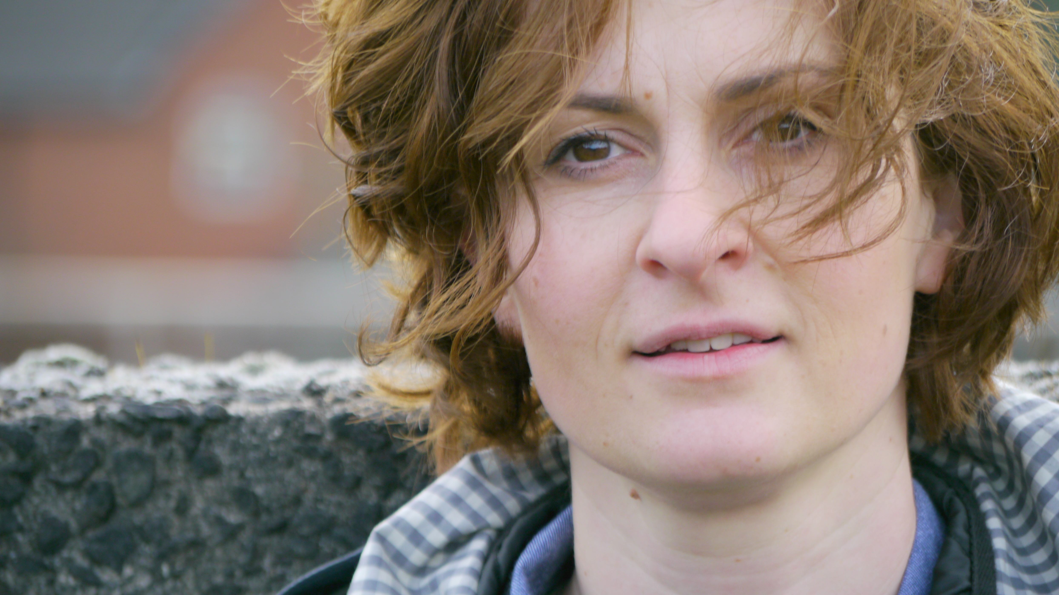

Aleksandra Nikolajev-Jones www.aleksandrajones.com
tel: +447531 581808
sandrabalans@gmail.com

PERSONAL INFORMATION
place of birth: Belgrade, Serbia/Yugoslavia
date of birth: March 26, 1973.
live: Cardiff, Wales, United Kingdom

EDUCATION
NATIONAL BALLET SCHOOL LUJO DAVICO 1979-1989
PHILOSOPHY FACULTY BELGRADE www.f.bg.ac.rs 1991-
DRAMA/THEATRE AND EDUCATION www.ukparobrod.rs 1996-2006
CEDEUM-Centre for Drama and Education and Arts www.cedeum.org.rs1999-2011
FORUM Theatre http://www.arttrain.dk and www.theatrfforwmcymru.org.uk 2005-2008

PROFESIONAL EXPERIENCE

Freelance TV and Film Actress

YEAR | TYPE | ROLE | PRODUCTION | COMPANY | DIRECTOR
2010 | Film | Alex | The Last Class | Republic of the Imagination | Iwan Brioc
2009 | Film | Diva | Don’t Go Back to Sleep | Republic of the Imagination | Iwan Brioc
2002 | TV | Mod | Twins | Radio Television Serbia (RTS) | Rade MMarkovic
1985 - 1986 | TV | Girl | Program for Children | Radio Television Serbia (RTS) | Jovan Ristic

PRODUCER

2009/2010 Film “Nemoj ponovo zaspati” by Director Iwan Brioc
2011 Film “Poslednji Cas” by Director Iwan Brioc
2012 Theatre Production “Women In Pregnancy”
2013 Theatre production “Conference of the Birds” in La Marmita, Portugal
2014 Film and Theater Production “GRAVIDA” in Chapter Theatre, Wales, UK
2014 Theatre Production on International Festival Cardiff in Sherman Theatre,UK
2015 Gravida short film nominated for Welsh Dance Platform/ Cinema program, UK

HEAD for DEVELOPMENT and FUNDRAIZING for Wales International Documentary Festival –WIDF www.widf.info 2016

PRODUCER for Shoot from the Hip Films www.shootfromthehipfils.com 2015

DIRECTOR and PRODUCER of the Republic of the Imagination Film&Theatre Company 2008-
Projects: Art of Living, Women in Pregnancy supported by Art Council Wales

DIRECTOR and PRODUCER of the Republic of the Imagination Network www.troti.org

PRODUCER for Theatr Cynefin, (www.cynefin.org) 2006-2013
Developing projects for International Applied Theatre Company in Balkan Region

CHOREOGRAPHER AND DIRECTOR 1991-2016
DIVE stage one National Dance Company and Wales Dance Platform 2015
GRAVIDA short film nominated for Wales Dance platform 2014
LARVAE by Theatr Ffynnon, Wales, UK www.theatrffynnon.co.uk
EMRYO by Theatr Ffynnon, Wales, UK
HOUSE FOR SALE by Theatr Ffynnon, Wales, UK
GRAVIDA duet, Bolero Chapter Art Centre, Cardiff, Wales, UK
STONES AND DREAMS by Odil Duboc, France
DUET, Marko Milic, 2nd prize on The Festival of Choreographic miniatures 2015
PLAY solo Marko Milic special prize on The Festival of Choreographic miniatures 2002
REPERTOIRE: Out of the Box, Big bang, With Moon I am walking, Gradiva, Behind the door, Seed- Serbia
WEDDING DUET, Ireland

TRAINER/EDUCATOR/Forum Theater facilitator 2001 – 2011
CEDEUM, Serbia (www.cedeum.org.rs) 1999-2011
Duties included curator of International Festival BITEF Polyphony special drama/theatre program; Trainer for UNICEF Drama in Education project AIDS awareness program “Right to Know”;
Trainer of teachers for over 200 schools for UNICEF Schools without Violence Program;
Trainer for both CARE International European Initiative for Democracy and Human Rights and Tolerance and Peace Building Program;
Trainer for World Bank Education Improvement Program;
Trainer and national coordinator for 3 year Theatre for Interethnic Dialog project;
CAA Center against war and COOPI Internazionale as a trainer and team coordinator;
CARE International Yugoslavia, a tolerance and peace-building program in six towns of Sandzak region.
DICE-Drama Improves Lisbon Key Competences in Education http://www.dramanetwork.eu/
Nova Vizija (or New Vision) supports the development of local communities in Sandzak through the implementation of projects that incorporate all social groups, regardless of nationality, religion, gender or social status. www.insightonconflict.org/conflicts/western-balkans/peacebuilding-organisations/nova-vizija/
TRAINER/EKSPERT/Theatre of the Oppressed
UGRAFT www.ugraft.org NGO for Community Training and Development through Creative Movement and Theatre.
People with Disabilities - Ticket for Visibility project and Share-See for Handicap International;
Young People in Youth for Youth and Youth Forum for National Youth Strategy of Serbia.
POD Theatre podteatar.blogspot.co.uk and www.podteatar.org.rs “Rehearsal for Reality” supported by USA Embassy in Belgrade
People with Disabilities - Ticket for Visibility project and Share-See for Handicap International;
Young People in Youth for Youth and Youth Forum for National Youth Strategy of Serbia.
RED CROSS and Municipality Palilula, Refugees and Roma people, Forum theatre training.

PERFORMER/DANCER 1990 –
FRUIT with Marko Milic, Ministry for Culture and STATION service for contemporary dance www.dancestation.org
SERIES by Choreographer Marko Milic for GNARL Festival, Lincoln, England
CONFERENCE OF THE BIRDS, Peter Brook, by director Iwan Brioc, UK and Portugal
AUDIENCE by Jo Fong, UK
NOT THE THING OUT OF THE PLACE Radio drama by actor and director John Norton, UK
METAMORPHOSIS performance by director Iwan Brioc, Serbia
Sensory Labyrinth Performances by director Iwan Brioc in UK, Denmark, Portugal, Bulgaria.
STONES AND DREAMS by Odil Duboc, France
BODY FRAME by Gesel Mason USA
FUNNY SIDE OF HISTORY with The Cougars Theatre Company touring comedy plays and political satire.
CABARET by actor and director Milan Gutovic, Yugoslav Drama Theatre

DIRECTOR OF MOVEMENT 2002-2013
Conference of the Birds research and development production by Director Iwan Brioc
Piece 2005, production in Ireland
TV show TWEENS, Funny side of History by Theatre Cougars, Flintstone’s performance, Serbia

CREATIVE MOVEMENT FACILITATOR 1996-2013
Family Dance Classes, Chapter Art Centre
Studio Balans http://aleksandrajones.com/index.php/balans
SPIN-CIGRA Summer schools and camps, Numerous Team Building for HR Agency SPIN; Creative Movement and Dance Workshop. Trained 15,000 volunteers for Universiada in non- verbal communication and perception in 2009

BALANS & WELLBEING 1996-2016
Working with professional dancers, actors, musicians and community. Body, Mind and Voice program based on movement.

LANGUAGES

All Balkan Languages, English (B2 ILTS)

h

