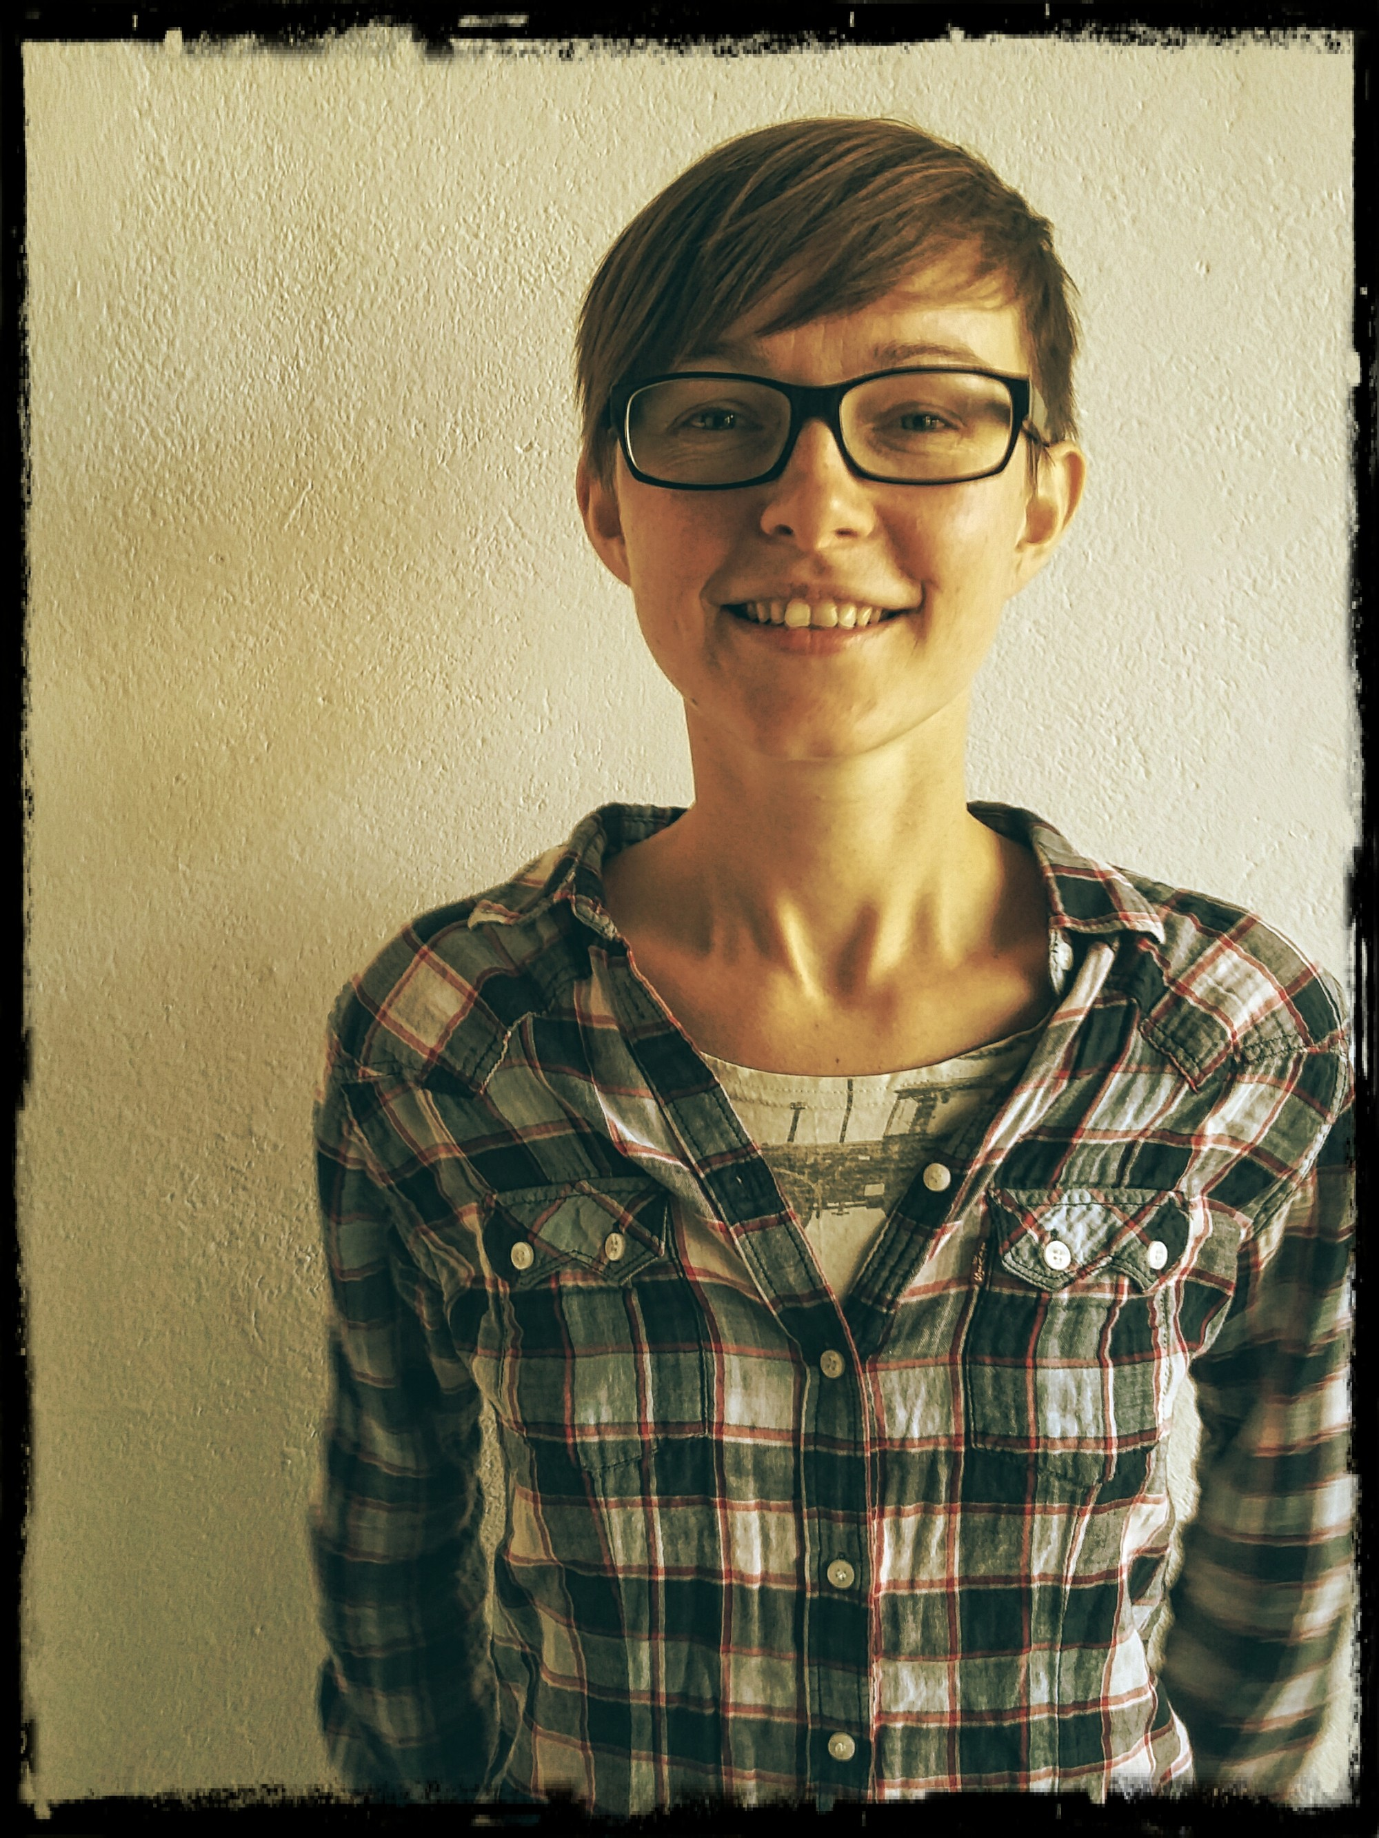  PERSONAL INFORMATION | KINGA KARP

ul. Kwietniowa 17b, 93-361 Lodz, Poland
 |  +48 796820101

k.karp@tea.org.pl
 | Sex Female | Date of birth 01/01/1982 | Nationality Polish

WORK EXPERIENCE

06/2016 - now  06/2015 – 06/2019  10/2013 - now  08/2016 – 11/2016 | Self-employed trainer
 | Kinga Karp OTWARTE Szkolenia I Rozwój
- Preparing programmes for trainings and workshops (anti-discrimination, gender eqauality, empowerment etc.)
- Conducting trainings for women (incl. trans/queer people) and girls (WenDo- assertiveness and self-defence)
- Facilitating meetings and conferences
- Contact with clients, promotion, logistics

The Board Member and Coordinator
The Anti-discrimination Education Society (TEA)
- Running the association office work
- Planning strategies and implementing ideas and projects
- Organising and running workshops for educators
Business or sector NGO

International trainings facilitator

ULEX Project (4 trainings x 7-10 days, 2022) Erasmus+
- Active Solidarity and Empowerment / Regenerative Activism: sustainable organising / Self-defence, empowerment and anti-discrimination: for women and trans activists
- for activists from parter organisations in Europe
- preparing the programme and running the trainings with co-facilitators from other countries

TKALNIA Association (2x36h, two trainings, 5 days each, 04&10/2018) Erasmus +
- SAFE project (Sexual Education, Assertiveness, Feminism and Equality)
- for youth workers (Erasmus +)
- preparing the programme and running the training with co-facilitator in English

FERSO Foundation (40h, one training, 5 days, 02/2017) Erasmus +
- Cours des methodes non-formelles pour enseignanats et travailleurs de jeunesse in Madrid (Non-formal education methods)
- for teachers from public schools in Europe
- preparing the programme and running the workshops with translator (English-French)

European Network for the Work with Perpetrators of Domestic Violence e.V (20h, annual meeting, 3 days, 10/2016)
- moderation of 3-day annual conference in English (Annual Meeting) in Kraków
- for members of WWP network (Working with Perpetrators)
- preparing the programme and facilitating the group of 70 people

Instituto de Juventud de Caceres, Spain (30h, one study visit + training, 6 days, 06-07/2016) Erasmus +
- „Colors beyond the rainbow” Erasmus + project
- For LGBT+ activists and NGO representatives
- preparing the programme and running the training and study visit part with co-trainer in English

Instytyt Działań Twórczych (The Creative Action Institute) (20h, one seminar, 4 days, 06/2016) Erasmus +
- „The others is us” Erasmus + project
- for LGBT+ activists from European NGOs
- preparation of the programme and running the seminar on good practice exchange in prevention of discrimination based on sexual orientation and sexual identity

Instytyt Działań Twórczych (The Creative Action Institute) (70h, one training, 10 days, 08/2014) Erasmus +
- „The colors behind the rainbow” Erasmus + project
- for LGBT+ activists from European NGOs
- preparation of the programme and running the training on prevention of LGBT+ discrimination together with preparing direct action in Lodz on the topic

Project Action Coordinator
Fundacja Autonomia
▪ Coordination of the whole project on gender based violence prevention
▪ Preparing financial documents and contact with beneficiaries
▪ Reporting to the fund operators
▪ Coordination of 16 Days of Activism against Gender-Based Violence Campaign in Poland
09/2009 - now | Anti-discrimination trainer and sex educator
09/2009 - now | SPUNK Foundation of Modern Education (Lodz), FERSO (Lodz), Campaign Against Homofobia (Lodz), The Association of Anti-discrimination Education (Warsaw) and other NGOs
09/2009 - now | - Preparing programmes for antidiscrimination and gender trainings  - Conducting sexual education classes for youths and teachers  - Conducting trainings on anti-discrimination (mainly gender and LGBTQI issues)
09/2009 - now | Business or sector NGO
09/2009 – 02/2016 | School psychologist and Project action coordinator
09/2009 – 02/2016 | Publiczne Gimnazjum im. Roberta Schumana in Lodz  - Individual diagnosis and counselling  - Prevention workshops for youth  - Coordination of the whole project called ‘Handicrafts in Europe’ funded by European Commission within Comenius Youth in Action Programme  - Preparing financial documents and contact with beneficiaries  - Reporting to the fund operator in Poland
09/2009 – 02/2016 | Business or sector Public School
01/2015 – 09/2015 | Project action coordinator
01/2015 – 09/2015 | ‘Citizens for citizens’ Association in Lodz
01/2015 – 09/2015 | - Coordination of the whole project called ‘The centre for young journalists assistance’ funded by EEG  - Preparing financial documents and contact with beneficiaries  - Reporting to the fund operator Fundacja Batory in Poland
01/2015 – 09/2015 | Business or sector NGO
12/2006 – 08/2008 | Psychologist  Poradnia Psychologiczno-Pedagogiczna w Braniewie  - Diagnosis of children and youth  - Therapy for disabled children  - Conducting group workshops for youths and teachers  Business or sector Public

EDUCATION AND TRAINING

04/2015 – 03/2016 | Akademia Treningu WenDo Certificate (Trainers Cenrificate)
04/2015 – 03/2016 | Fundacja Autonomia, Kraków
04/2015 – 03/2016 | - WenDo training – assertiveness and self-defence for women and girls
10/2009 – 09/2010 | Akademia Treningu Antydyskryminacyjnego Diploma (Trainers Diploma)
10/2009 – 09/2010 | Villa Decius Association, Kraków
10/2009 – 09/2010 | - Anti-discrimination training, specialized in Gender based discrimination prevention
10/2010 – 09/2011 | Gender Studies Post-Diploma
10/2010 – 09/2011 | Univeristy of Lodz, Poland
10/2010 – 09/2011 | - Specialized in Gender Equality in Education
10/2001 – 10/2006 | Masters degree in Psychology
10/2001 – 10/2006 | Univeristy of Lodz, Poland

PERSONAL SKILLS

Mother tongue(s) | Polish
Other language(s) | UNDERSTANDING |  | SPEAKING |  | WRITING
Other language(s) | Listening | Reading | Spoken interaction | Spoken production
English | C2 | C2 | C2 | C2 | C1
 | Advanced Certificate in English (CAE)
German | B1 | B1 | B1 | A2 | A1
Spanish | B2 B2 C1 C1 B1  Levels: A1/A2: Basic user - B1/B2: Independent user - C1/C2 Proficient user  Common European Framework of Reference for Languages

Communication skills | - Excellent communication skills gained through my experience as psychologist and group trainer, as well as the coordinator of projects, also European

Organisational / managerial skills | - Leadership and coordination (responsible for team working within projects)  - Responsibility  - Well time-management

Digital competence | SELF-ASSESSMENT
Digital competence | Information processing | Communication | Content creation | Safety | Problem solving
 | Proficient user | Proficient user | Proficient user | Proficient user | Proficient user
Levels: Basic user - Independent user - Proficient user
Digital competences - Self-assessment grid

Driving licence | B cat. since year 2000

