Curriculum Vitae

Surname: Kopelyan  First name: Maria  Birth date: June 10, 1976  Marital status: single  Children: none  Address: 10-60 Academika Vargi st., Moscow 117133 Russia  Registration address: 16-1-28 Vspolny sidestreet, Moscow 123001 Russia  Telephone: +7(495) 339-0212  Mobile telephone: +7(916) 122-8532  e-mail: next-line@yandex.ru  facebook: https://www.facebook.com/maria.kopelyan | 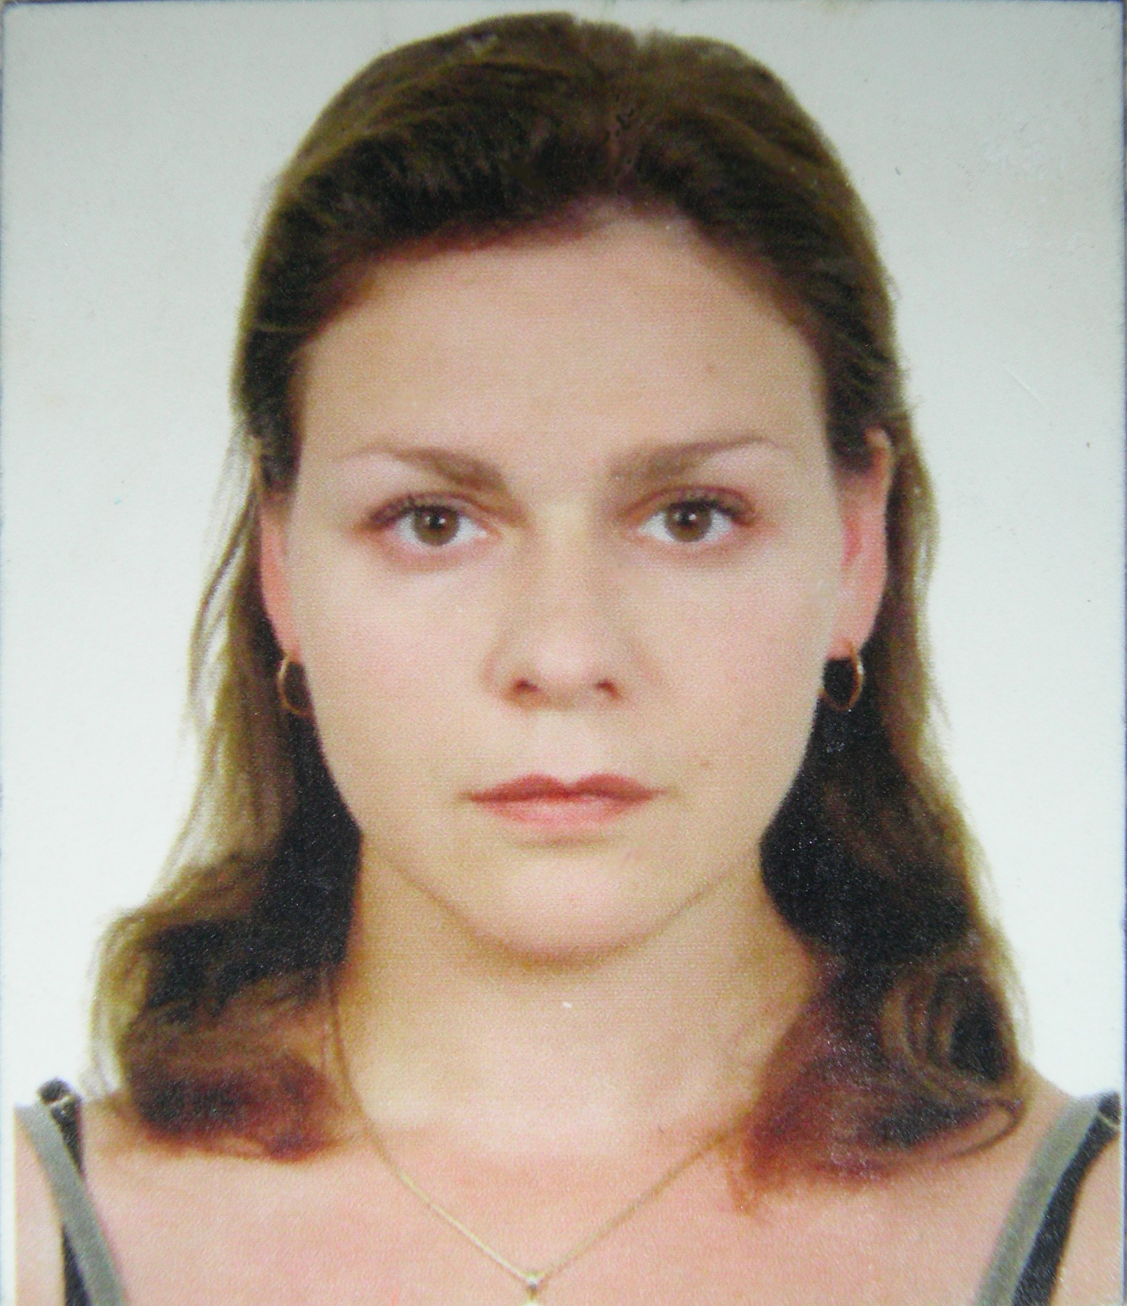

Education:
2012 – 2012 – Program “Support for Socially Oriented NGOs” in Russian Academy of National Economy and Public Administration under the President of the Russian Federation in Moscow, Russia. Project management, Fundraising.
2009 - 2009 – Summer Session student in Paideya Project Incubator in Stockholm, Sweden. Project management.
2007 - 2007 – Summer Session student in Conservative Yeshiva in Jerusalem, Israel. Hebrew, Tradition.
1995-2000 – Russian Academy of Theatrical Art “GITIS”. History of Foreign Theatre.
1991-1993 – Secondary school No. 126.
1983-1991 – Secondary school No. 46 (1205).

Languages:
1. Russian – native.
2. English – fluent.
3. Hebrew – basics.
4. Georgian – basics.
5. Portuguese – beginner.

Work:
2011-present – Board member and Programs Coordinator. NGO “Stichting Respect International. West-East Bridges Foundation” (RI-WEB).
2008-present – Member of the WJC Division of Young Jewish Diplomats.
2005-present – Chairperson. Religious organization “Community of Modern (Conservative) Judaism “Marom”.
2004-present – International Programs Director. NGO “Center for Interethnic Cooperation” (CIC).
1995-2000 – Freelance Journalist. Magazines: “Moskvarium”, “Moto”, “Music Box”, “Pioneer”, “Pulse”, “Selskaya Molodezh”, “Ya-Molodoy”.
1993-2001 – Director’s Assistant. Concert Hall in the Olympic Village.

Participation in trainings and seminars as participant (P), organizer (O), trainer (T), interpreter (I), expert (E):
Seminar “Perspective – Israeli Culture” in Moscow. Organized by the Jewish Agency in Russia, October 2004. P
Conference “Jewish Community life in Europe” in Berlin, Germany. Organized by Masorti Olami, May 2005. P
Training “Cooperation between the authorities, militia, and national youth organizations of Moscow” in Moscow. Organized by “Marom” and CIC, June 2005. O
International conference “Russian and international experience in cooperation of national communities, militia and authorities” in Anapa, Russia. Organized by CIC, September 2005. O, I
Training “Militia and civil society” in Moscow. Organized by “Marom” and CIC, October 2005. O
Seminar “Perspective - Jewish sports and self-defence” in Moscow. Organized by the Jewish Agency in Russia, November 2005. T
Seminar “Jewish youth of Russia and Ukraine” in Kiev, Ukraine. Organized by Masorti Olami, May 2006. P
Participation in the 35th World Zionist Congress in Jerusalem, Israel. Organized by WZO, June 2006. P
International youth tolerance camp in Novosibirsk, Russia. Organized by CIC, July 2006. O, T, I
Conference “The first steps of withstanding xenophobia in Russia network” in Anapa, Russia. Organized by CIC, August 2006. O, I
Training “Network of national organizations of Russia” in Yaroslavl, Russia. Organized by CIC, October 2006. O, I
Training “Tolerance as a component of the civil society” in Chapaevsk, Russia. Organized by CIC, December 2006. T
Training “Prevention of interethnic conflicts and propaganda of ideas of tolerance” in Izjevsk, Russia. Organized by CIC, February 2007. T
Seminar “Young Jewish leadership” in London, England. Organized by Masorti Olami, March 2007. P
Study trip to the Netherlands. Organized by CIC and UNITED, March 2007. O, I
The "All Different - All Equal" campaign symposium in Istanbul, Turkey. Organized by CoE, March 2007. P
The "All Different - All Equal" campaign symposium in Luxembourg. Organized by CoE, April 2007. P
Seminar “Young Jewish leadership” in Berlin, Germany. Organized by Masorti Olami, August-September 2007. P
Seminar “Fighting Anti-Semitism” in Paris, France. Organized by Masorti Olami, November 2007. P
Conference “Youth supporting ideas of tolerance” in Petrozavodsk, Russia. Organized by CIC, November-December 2007. O, I, T
Training “Prevention of Hate Crimes” in Warsaw, Poland. Organized by OSCE ODIHR, May-June, 2008. P
Social Forum in Kiev, Ukraine. Organized by EPA, June 2008. P
Conference “Cooperation of national communities, militia and authorities” in Moscow, Russia. Organized by CIC, October 2008. O
Youth Forum “Intercultural Dialogue and its Religious Dimension” in Kazan, Tatarstan. Organized by CoE, Ministry of Regional Development RF, Ministry of Youth and Sport Tatarstan, December 2008. P
Participation in the World Jewish Congress in Jerusalem, Israel. Organized by WJC, January 2009. P
Training for Trainers “Prevention of Hate Crimes” in Warsaw, Poland. Organized by OSCE ODIHR, September, 2009. P
International conference “UNITED We Build the Future! Empowering Civil Society to Face New Challenges” in Kiev, Ukraine. Organized by UNITED for Intercultural Action, October 2009. P
International conference “Europe All Inclusive? Minorities at the Edge of Society” in Budapest, Hungary. Organized by UNITED for Intercultural Action, May 2010. P
Participation in the 36th World Zionist Congress in Jerusalem, Israel. Organized by WZO, June 2010. P
Study trip to the Netherlands. Organized by CIC and UNITED, June 2010. O, I
Training on Gender Equality in St.Petersburg, Russia. Organized by CIC and SIDE, October 2010. O, I, T
International conference “What Can You(th) Do? Networking for Intercultural Dialogue” in Moscow, Russia. Organized by UNITED for Intercultural Action and CIC, November 2010. O, I, T
Training “Space for Inter-Religious Dialogue” in Struga, Macedonia. Organized by CID, April 2011. P
Training “European Citizen, Where Are You?” in Riga, Latvia. Organized by Culture Goes Europe, September 2011. P
Training “A Leader is Born for Europe” in Kadirli, Turkey. Organized by Fortuna Youth Union, December 2011. P
Training “Inter-Religious Dialogue in Youth Work” in Deutschlandsberg, Austria. Organized by YIPO, April 2012. P
Training “Human Rights in Crisis” in Dilijan, Armenia. Organized by Youth Cooperation Center of Dilijan, June 2012. P
Youth camp “Baikal 2020” in Irkutsk, Russia. Organized by Irkutsk Regional Authorities, August 2012. T
Youth camp “Baikal Rainbow” in Irkutsk, Russia. Organized by Irkutsk Civic Chamber and CIC, August 2012. T
Preparatory seminar “European Youth Campaign Against Hate Speech in the Internet” in Strasbourg, France. Organized by CoE, October 2012. P
Training Course “Intercultural Dialogue in Youth Work. How To” in Utrecht, Netherlands. Organized by RI-WEB, April 2013. O, T
Social Leader Forum in Tbilisi, Georgia. Organized by SLF, April-May 2013. P
Training Course “Intercultural Dialogue among Youth” in Kislovodsk, Russia. Organized by CIC, May 2013. O, T
Training Course “Time to Change. Youth for Volunteering” in Kadirli, Turkey. Organized by Hatay Fortuna Youth Union, May 2013. T
Social Leader Forum Study Visit in Tbilisi, Georgia. Organized by YSG, July 2013. P
Global Research Summer School “The Wars We don’t See” in Sighisoara, Romania. Organized by VIP, July-August 2013. P
Training Course “Unlock your Creativity: Be Entrepreneur” in Antalya, Turkey. Organized by International Relations Studies Association, September-October 2013. T
Training Course “Risk’n’Roll” in Tbilisi, Georgia. Organized by Salto, October 2013. P
Training Course “Inclusion of Youth” in Bar, Montenegro. Organized by ADP-ZID, November 2013. P
Social Leader Forum in Istanbul, Turkey. Organized by SLF, December 2013. P
Training Course “Retro-Respect” in Thessaloniki, Greece. Organized by System and G, March 2014. P
Study Visit “Europeans – Different but Similar” in Struga-Bitola-Skopje, Macedonia. Organized by Volunteers Center Bitola, April 2014. P
Training Course “Short-term Volunteering for Civil Society” in Kobuleti, Georgia. Organized by YSG, June 2014. O, T
Seminar for Young Armenian, Jewish and Roma Leaders “Negotiating Identities” In Tbilisi, Georgia. Organized by AGBU, October 22-26, 2014. P
Police Training of Trainers on non-discrimination with a focus on Roma and sexual orientation and gender identity in Strasburg, France. Organized by CoE, November 19-21, 2014. E
Training Course “Education in Citizenship has to be VIP” in Gandia, Spain. Organized by Gandia Youth Center, November 29-December 7, 2014. P
Training Course “Conflict Transformation” in Gloucester, UK. Organized be ASHA Centre, January 13-21, 2015. P
Training Course “Art to Act” in Komotini, Greece. Organized be System and G, February 10-18, 2015. P
PBA “Next Step – Strategy for Inclusion” in Deutschlandsberg, Austria. Organized by YIPO, May 2-8, 2015. P
Conference FARE in Barcelona, Spain. Organized by FARE, June 11-13, 2015. P
Training Course “Non-Formal Education Tools and Methods for Democratic Changes” in Batumi, Georgia. Organized by RI-WEB, July 2015. O, T
Youth Exchange “Morocco.Co” in Larache, Morocco. Organized by Foreningen Framtidstaget, July 2015. P
Training Course “Tools and Skills” in Newcastle, UK. Organized by OpportUNITY, August 2015. P
Training Course “Training on Quality and Professionalism” in Dusseldorf, Germany. Organized by JUBUK, August 2015. P
Participation in the 37th World Zionist Congress in Jerusalem, Israel. Organized by WZO, October 2015. P
Training Course “Go Non-Formal: Volunteering for Employability” in Yerevan, Armenia. Organized by RI-WEB, October-November 2015. O, T
Seminar “Europe of Diasporas” in Sofia, Bulgaria. Organized by AGBU, January 2016. P.
Seminar “MAROM International” in Berlin, Germany. Organized by Marom Olami, March 2016. P.

