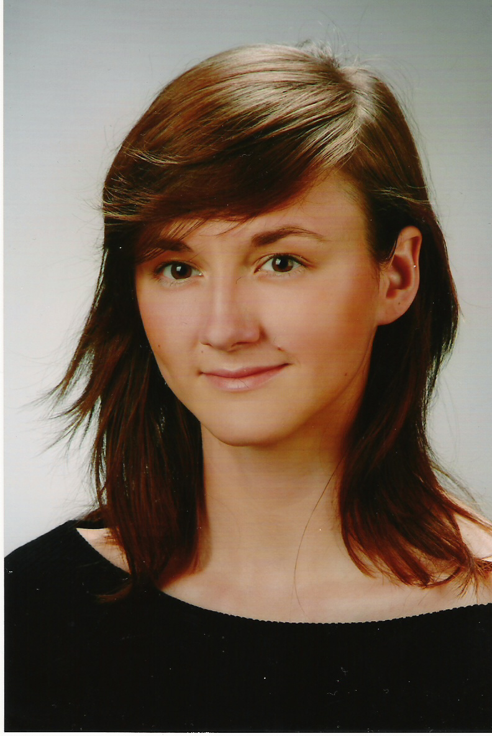
Luiza Czajkowska

e-mail: louisette11@yahoo.com

EDUCATION

2005 current Jagiellonian University, International and Political Faculty, International Cultural Studies; MA
2002-2005 Jagiellonian University, International and Political Faculty, International Cultural Studies; BA degree 2005
2001-2002 Jagiellonian University Professor’s Business and Marketing College, Diploma in Journalism Public Relations

  - Jagiellonian University, International and Political Faculty, Political science

Trainer’s work and non formal education…

October 2006 2nd Voluntary Days in Malopolska Region, I chaired workshops about European Voluntary Service, the responsibilities, rights, disadvantages/advantages of a volunteer work, introduction of Euro Med EVS projects, Krakow, Poland

September 2006 Ready, Steady, Go! Using sport as a method in work with disadvantaged young people, youth exchange PL-11-317-2006-R3, trainer responsible for preparation, implementation and evaluation of the workshops; my work was based on SALTO Inclusion booklet Fit for Life, Bialy Dunajec, Poland

September 2006 How to activate Youth to take actions in youth organizations, seminar PL-511-051-2006-R2 organized by Association of European Integration, Poronin, Poland

September 2006 Sport as a tool in work with disadvantaged youth, seminar PL-511-040-2006-R2 organized by Sport Club Association SOKÓL; trainer responsible for the content of workshops and evaluation, Bukowina Tatrzanska, Poland

September 2006 Youth Camp for disadvantaged youth, this camp was a part of long term project between Poland, Germany, France and Denmark, I was one of 3 trainers responsible for group building and evaluation, Bukowina Tatrzanska, Poland

July 2006 International Conference: „INherit 2 INnovate”
10th Anniversary International Cultural Week in Pécs, over 200 participants from all around the world; I was chairing a workshop titled: Identity in Crisis? Global vs. Local; I was responsible for the preparation, implementation, evaluation and final presentation of the workshops, Pécs, Hungary

June 2006 Intercultural exchange with drama elements organized by KULTURATKA, A.1., I was a trainer responsible for group building, Murzasichle, Poland

May 2006 Participation towards Citizenship, A.5., one of 3 trainers , responsible for group building, organization fair, intercultural communication, presentation of tools for youth workers, EYF presentation, evaluation of the training, Trakai, Lithuania

April 2006 Study Tours Poland for Caucasus Youth Leaders, project supported by RITA, organized by International Initiatives Bureau; trainer, responsible for group building, Krakow, Poland

March 2006 “B.I.G.” Be Idealist Globally, Contact Making Seminar, A.5., PL-511-112-2005-R5 organised by Foundation European Institute Pro Futuro , trainer, responsible for preparation, implementation and evaluation of the workshops; Szczyrk, Poland

January/
February 2006 “Visegrad Youth in United Europe”, youth exchange PL-11-374-2005-R4 organized by SMART; trainer, responsible for the preparation, implementation and evaluation of the workshops; Bialy Dunajec, Poland

October 2005 “Youth empowerment in rural regions”, youth exchange PL-11-354-2005-R3 organized by SIR; trainer, responsible for the preparation, implementation and evaluation of the workshops; Poronin, Poland

October 2005 “Multicultural Europe Towards engagement of youth”, PL-511-048-2005-R3, Training Course organized by Polish Scouting Foundation; trainer, responsible for the preparation, implementation and evaluation of the training; Krakow, Poland

September 2005 Contact Making Seminar organized by ARETE; trainer, responsible for the preparation, implementation and evaluation of the seminar; Bialy Dunajec, Poland
August/
September 2005 “Citizenship Through Education – teaching tolerance and breaking prejudice towards minorities”, PL-11-274-2005-R2, trainer, responsible for the preparation, implementation and evaluation of the exchange, I developed a manual used throughout the workshops; Bialy Dunajec, Poland

August 2005 “Youth Together in United Europe”, youth exchange PL-11-248-2005-R2 organized by Rog Association, trainer, responsible for the preparation, implementation and evaluation of the exchange; Bukowina Tatrzanska, Poland

August 2005 Contact Making Seminar “In search for the motivation” for organizations working with mentally disabled people organized by ESMR; trainer, responsible for the preparation, implementation and evaluation of the seminar; Muszyna, Poland

August 2005 Contact Making Seminar “Dreams Come True” organized by SILESIANA NGO, trainer, responsible for the preparation, implementation and evaluation of the seminar; Poronin, Poland

July 2005 International Student Culture Week – one of the biggest student festivals in Europe (approximately 300 participants each year) – trainer, responsible for preparing, implementing and evaluating workshop for a group of 30-50 people about Globalization, Communication, IT; Pécs, Hungary

April 2005 “Youth Participation in Local and Regional Life” Training Course organized by Polish Youth Council, trainer, responsible for the preparation, implementation and evaluation of the TC, Gdansk, Poland

March 2005 International Summit on Democracy, Terrorism and Security, event organised by Club de Madrid, observer, Madrid, Spain

March 2005 Seminar on Peace and Stability, Youth and Globalisation Project sponsored by the European Comission, Council of Europe and Program Youth, part of the team; Madrid, Spain

February 2005 “Training on Youth Empowerment and citizenship education”, one of 3 trainers, responsible for the preparation, implementation and evaluation of the training; Odessa, Ukraine

January 2005 Contact Making Seminar “New Partners, New Projects” trainer, responsible for the preparation, implementation and evaluation of the seminar, Poronin, Poland

January 2005 “Europe without borders, free from predjudices and racism – workshops on human rights and civic education” – trainer, responsible for the preparations, implementation and evaluation of the workshops, Poronin, Poland

December 2004 Youth Empowerment, training for trainers, Ommen, Holland

October 2004 Contact Making Seminar organized by SMART - trainer, responsible for evaluation of the project; Poronin, Poland

September 2004 ACC- Association for Community Colleges – rapporteur, working on a draft of document about European Identity and Citizenship, Gender Equality, Bio-ethics, Religion and Human Rights; this document should be a base for an ACC curriculum for the next Community Colleges; Florence, Italy

August 2004 Gender Mainstream on the Stream – training for trainers about Gender issues (equality between man and woman, theory and practice); Druskienniki, Lithuania

August 2004 International Student Culture Week – one of the biggest student festivals in Europe (approximately 300 participants each year) – trainer, responsible for preparing, implementing and evaluating workshop for a group of 40 people about European Citizenship and Identity; Pécs, Hungary

June - July 2004 scholarship from Canadian Human Rights Foundation, International Human Rights Training Program - training for trainers supported by CIDA; John Abbot College; Montreal, Canada

July 2004 Computer Course with elements of web design and HTML programming; Human Rights Internet Foundation; Ottawa, Canada

May 2004 Minority Rights Seminar – trainer, responsible for the preparations, implementation and evaluation of the workshops dedicated to all sorts of minorities (ethnic, cultural, sexual, political etc) with strong impact on the role gender plays in our society; Zakopane, Poland

April 2004 European Voluntary Service - training for trainers; Ommen, Holland

March 2004 Contact Making Seminar: Project Management – trainer, responsible for the preparation, implementation and evaluation of the seminar; Vilnius, Lithuania

December 2003 Challenges for Europe – EU Widening; trainer, responsible for the preparation, implementation and evaluation of the seminar; Cracow’s City Council, Krakow, Poland

October 2003 PR & Crisis Management Training for Youth Leaders – trainer, responsible for the preparation, implementation and evaluation of the training; Zakopane, Poland

September 2003 Human Rights Training – trainer, responsible for group dynamics and evaluation of the training; Kościelisko, Poland

July 2001 Training for trainers – Gender Sensitivity and the job market; two weeks training for leaders of NGO’s; Evora, Portugal

August 2000 International Student Culture Week – one of the biggest student festivals in Europe (approximately 300 participants each year) – trainer, responsible for preparing, implementing and evaluating workshop about Culture Diversity and Gender Issues; Pecs, Hungary
1996-1997 Youth Leaders School MCRD (International Centre for Democracy Development)

1997 - 2006 Krakow’s European Club, Member

1997 current European Youth Co-operation Centre - board member (international affairs vice-director; since 2002 PR & training vice-director)

WORK EXPERIENCE

2003 - current Free-lance trainer (non formal education) particular activities described above

2001 - 2004 Cinema City /IMAX customer liaison, Movie Academy trainer

1998 - 2004 I organized several multilateral youth exchanges, the most recent ones included Euro Med countries, Caucasus countries (e.g. Germany, Greece, Cyprus, Jordan, Israel, Egypt, Portugal, Hungary, Romania, Malta, GB, Turkey, Georgia, Moldova, Serbia)

Dec 2002 Internship, Cocoa & Coffee Company; Abidjan, Ivory Coast

1998, 2000,
2002 Main organizer of Euroweek (International Students Conference
for 100 people) I was responsible for negotiations with sponsors, contact with media, and I managed a team of 20 people

SKILLS

Languages English: fluent; German & French: conversational; Spanish: began the course in October 2005

IT Windows, Word, Adobe, Excel, Power Point

Other high interpersonal skills, ability to speak in public, creative, stress resistant

HOBBY Writing diaries from my journeys, learning languages, team sports, cinema (as entertainment), anthropology (indigenous cultures), reading books (Kundera, Zweig, Naipul, Pearl)

