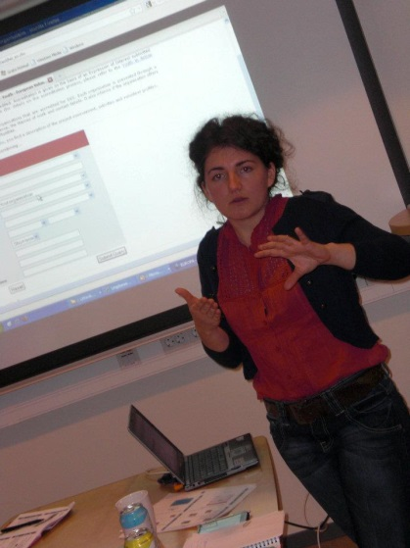
Curriculum vitae

Personal information

Name Andreea Maris
Address Granhäcksvägen 3B
445 55 Surte
Mobile 0046 (0) 762 722 280
E-mail andreea.maris@yahoo.com
Date of birth 19.10.1984
Gender Female
Work experience

November 2015 Project leader at Development Assistance Center
- present Plan, organize, facilitate and report international projects (Break the chain, Project
instruments for Erasmus+, SEEDS)

Project leader at KEKS network (www.keks.se)
January 2015 – Implementation of the strategic partnership project “RISE for common systems for
present documentation of youth work and non-formal education”

March 2014 – Implementation, evaluation and reporting of the Grundtvig project “Tools for
June 2014 documentation, assessment and development of youth work” and project writing -
strategic partnership grant proposal “RISE for common systems for documentation of youth
work and non-formal education”

September 2015 - International coordinator at Mölndals Stad, Sweden (www.molndal.se)
February 2016
October 2012 - International coordinator at Mölndals Stad, Sweden (www.molndal.se)
December 2013 Offering consultancy and project writing, implementation and reporting support;
organizing and facilitating events (courses, visits etc.); developing new working methods.

October 2014 – Youth leader at Mölndals Stad
November 2015 Support youngster in organizing activities and events for them and other visitors of the
youth center Kållered.

September 2011- International Youth Worker at Mölndals Stad
July 2012 administration of international projects; financial administration (Agresso); organizing
presentations about EU financial lines; development of educational materials and
course facilitation; visiting high schools and promoting the international activities.

April 2006 - Project manager at ACSCVJ, Petrosani, Romania (www.acscvj.org)
April 2011 writing projects proposals; project implementation (http://tinyurl.com/7tqhy8a), financial
management; project team management; ccommunication management (inside the team,
with the partners, sponsors, mass-media); evaluation and final report; developing financial
lines for youngsters and cooperation programmes for NGOs.

October 2007 - Information multiplier for Youth in Action programme. Member of the Resource Persons
June 2009; Network for Youth in Action programme (www.anpcdefp.ro)
October 2009 - contacting organisations, institutions and informal groups; organizing info-sessions;
December 2010 evaluating the info-session; reporting.

February 2009 - Intern (Erasmus practice scholarship) at the Institute of Innovation for Human Wellbeing,
September 2009 Malaga, Spain (www.i2BC.es)
Project writing/development; designing project activities; drafting budgets;
communicating with the partners; translation of documents in/from English, Romanian,
Spanish; drafting meetings' reports; other tasks like research, drafting strategies.

December 2005 - Local Coordinator for the project Democratic Citizenship at Centrul Educatia 2000+ ,
September 2007 (www.cedu.ro)
contacting mass-media, high-schools, institutions and participants (Parliament member in
the electoral circumscription, local councillors, county councillors, NGO representants);
organizing monthly meetings with the participants; making presentations in high-schools
related with Human Rights and active citizenship; reporting; budget administration.

March 2004 Interview operator for Daedalus Consulting, Mediapro, AB Research Group,
October 2005 Profile Communications
applying questioners for market research companies; control interviewers’ visits.

Education

October 2013- Training of Trainers
June 2014 Organized by the European Commission’s SALTO Information Center and The Swedish
Agency for Youth and Civil Society (MUCF)
April 2014 Facilitate the course USEE+ (Using social entrepreneurship in Erasmus +) organized in
Gothenburg Sweden. The facilitation of the course was a part of the ToT programme.

October 2008- Master in Project management; University of Petrosani, Romania
December 2010 Erasmus student (practice scholarship at i2BC in Malaga, Spain and study scholarship at TU
Bergakademie Freiberg, Germany)
Courses: Managerial communication, HRM, Project management, Structural funds.
Master thesis: Project management’s contribution to international cooperation.
How to make things work - ODA in Haiti. (Approved with 10/10)

October 2003 - Bachelor in International Relations and European Studies; Faculty of Political Science,
June 2008 National School of Political and Administrative Studies, Bucharest, Romania.
Courses: International Relations, European Studies, Sociology, Social Psychology,
Theory of IR, European Construction, Political Doctrines, Human Rights, Law.
Bachelor thesis: Energy’s geopolitics. Study case: Persian Gulf. (Approved with 9.66/10)

May 2009 Course “Introduction to project management for Development Cooperation” organized by
Assamblea de Cooperacion por la Paz and University of Malaga, Spain.

September 1999- Informatics High-school, Petrosani, Romania
June 2003 mathematic – informatics

Personal skills and competences

Languages English, Swedish, Spanish, Romanian, Italian

Social skills and good communication capacity; negotiation skills; adaptation to different multicultural
competences environments; team spirit and constructive discussions; fast learner; able to manage stress;
spirit of initiative; proactive and result oriented.

Organizational mentorship, coaching, leadership, coordination of local and international volunteers;
skills event organizing (international meetings, workshops, conferences etc).

Computer skills Microsoft Office instruments (Word, Power Point, Excel), Agresso, Free Mind mapping,
Google drive, working with printer, copy, scanner and fax

References Bettan Svelander, Mölndals Stad 0706 360 606 bettansvelander@gmail.com
Jonas Agdur, KEKS nätverk 0703 403 471 jonas.agdur@keks.se

For a detailed CV or any other information, don’t hesitate to contact me!

