Brais Fernandes Álvares
data nacemento / date of birth: 01/08/1975
nationality: Galego / Galician
enderezo / address: Rúa Arzúa 13, 4º esquerda 15704, Santiago de Compostela, GALICIA (Spanish State)
mail: brais@xandobela.info
tlf: 0034663007395 / 00351931761975

Licenciado en Historia pola Universidade de Santiago de Compostela / Degree on History by the University of Santiago, 1999.
Especialista en Teoría e Práctica da Interpretación pola Universidade de Santiago de Compostela / Specialist degree on Theater by the University of Santiago, 2000.
Monitor de Actividades de Lecer e Tempo Libre, pola Xunta de Galicia / Non Formal Educator on leisure activities, by Xunta de Galicia, Galician Government, 1993.
Responsable da Aula de Teatro Municipal “Ánxel Casal” de Arzúa, dende o 2003. / Arzúa public Theatre School responsible, since 2003. (Arzúa is a rural county close to Compostela)
Membro da Asociación Xuvenil e Cultural ITACA, Compostela, Galiza, dende 1996. / civic reference
Membro fundador da SL XANDOBELA; xestión e dinamización sociocultural, 2005 / professional reference http://www.xandobela.info
Contacontos e espectáculos de animación teatral “Consello de Galegos Ilustres”, dende 2002 / Storytelling and performances “Consello de Galegos Ilustres”, since 2002. http://consellodegalegosilustres.blogspot.com
SALTO TOY Database http://trainers.salto-youth.net/BraisFernandes/

Languages
Galician, mother tongue
Portuguese and Spanish, very good.
English and Italian, average good
Some French and a bit of German
Pretty skilled on non verbal communication

Exchanges as leader within Youth in Action CE program:
Compostela, Galicia-Portugal (Cultural awareness) 1996; Brussels, Belgium (Theatre meeting related to the City of Culture) 1999 and 2000; Avignon, France (Theatre meeting related to the City of Culture) 2000; Druskininkai, Lithuania (Performing in Nature) 2002; Druskininkai, Lithuania (Environment) 2002; Piran, Slovenia (Fairy tales and Theatre), 2007, Caserta, Italy (Theatre, common creation), 2008, Arzúa, Galicia (Theatre for understanding), 2009.

Trainings as participant within Youth in Action CE program:
Ireland (ethnic conflict management), 1996; Hungary (pedagogic adventure), 1997; Poland (social inclusion), 2007; Romania (SALTO TIC-TAC, 2008); Lithuania (SALTO ATOQ, 2009).

European policy trainings:
Curso de especialización “Axentes de Mobilidade / Mobility Agents” TC, 150h. INTERREG III A Esp-PT, Galicia.

Trainings as trainer:
Xunta de Galicia, Direción Xeral de Xuventude / Galician Government, DG of Youth: “Xornadas de divulgación do programa Xuventude en Acción / Promotion of the YiA program”, Galicia, 2008, 2009.
YEU Long Term Training Course: “Small actions can change the world”. Seminar, in Alvito, Portugal, 2008; TC in Allariz, Galicia, Spain, 2009; Evaluation Seminar in Mosty, Poland, 2009.
CNJ Portugal cooperation strategy among European and African NYC. Seminar in Bissau, Guinea-Bissau, 2009; Training Course in Tarrafal, Cabo Verde, 2009 (within the 1st African University of Youth & Development); Evaluation Seminar in Almada, Lisbone, Portugal, 2009.
Portuguese and Guinea-Bissau NYC cooperation: “1st Training on NFE in Guinea Bissau”. Bissau, 2009.
Aventura Marão Clube : “Sustainable Development – Fair Trade and Responsible Consumption”, within EUROMED, in Amarante, Portugal, 2009.

International camps as educator:
Portugaliza cross-border summer camp. Aged 15-17. Galicia, 2007, 2008, 2009
Portugaliza cross-border Work Camp. Portugal, Aged 18-30. 2007, 2009
CJ Amarante Work Camps. “Sustainable development”, Portugal, 2008, 2009

International art&performance trainings:
“Laboratorio Teatral”, with Franco Passatore, Portomarín and Cangas do Morrazo, Galicia, 1998.
“Cleaning the House”, with Marina Abramovic. Centro Galego de Arte Contemporáneo / Galician Contemporary Art Museum, 2002.

Storytelling and performance. “Consello dos Galegos Ilustres”
-Visita do Consello de Galegos Ilustres. Contacontos de educación para a paz / Education for peace storytelling/performance. +8anos/age
-Os Ilustres das Letras. Divulgación cultural en torno aos persoeiros da cultura galega / Popular divulgation of Galician culture features and main writers. Diversos espectáculos / several shows. +8anos/age
-Xan e Perillán, ou a Boina Roída. Contacontos de sensibilización ambiental / Storytelling promoting Enviromental care. +6years/age.
-O Misterio de Xela. Contacontos traballando a violencia e a violencia de xénero / Performance dealing with violence and gender isssues. +8anos/age
-Choran os homes? Contacontos traballando a frustración e a masculinidade / Storytelling dealing with frustration and the esence of real men: Can men cry?. +6anos/age
-O Gran de Millo. Conto existencial / Existential tale. Conto formato libro xa á venda. Espectáculo en preparación / Book already on the stores. Performance under preparation.
http://consellodegalegosilustres.blogspot.com
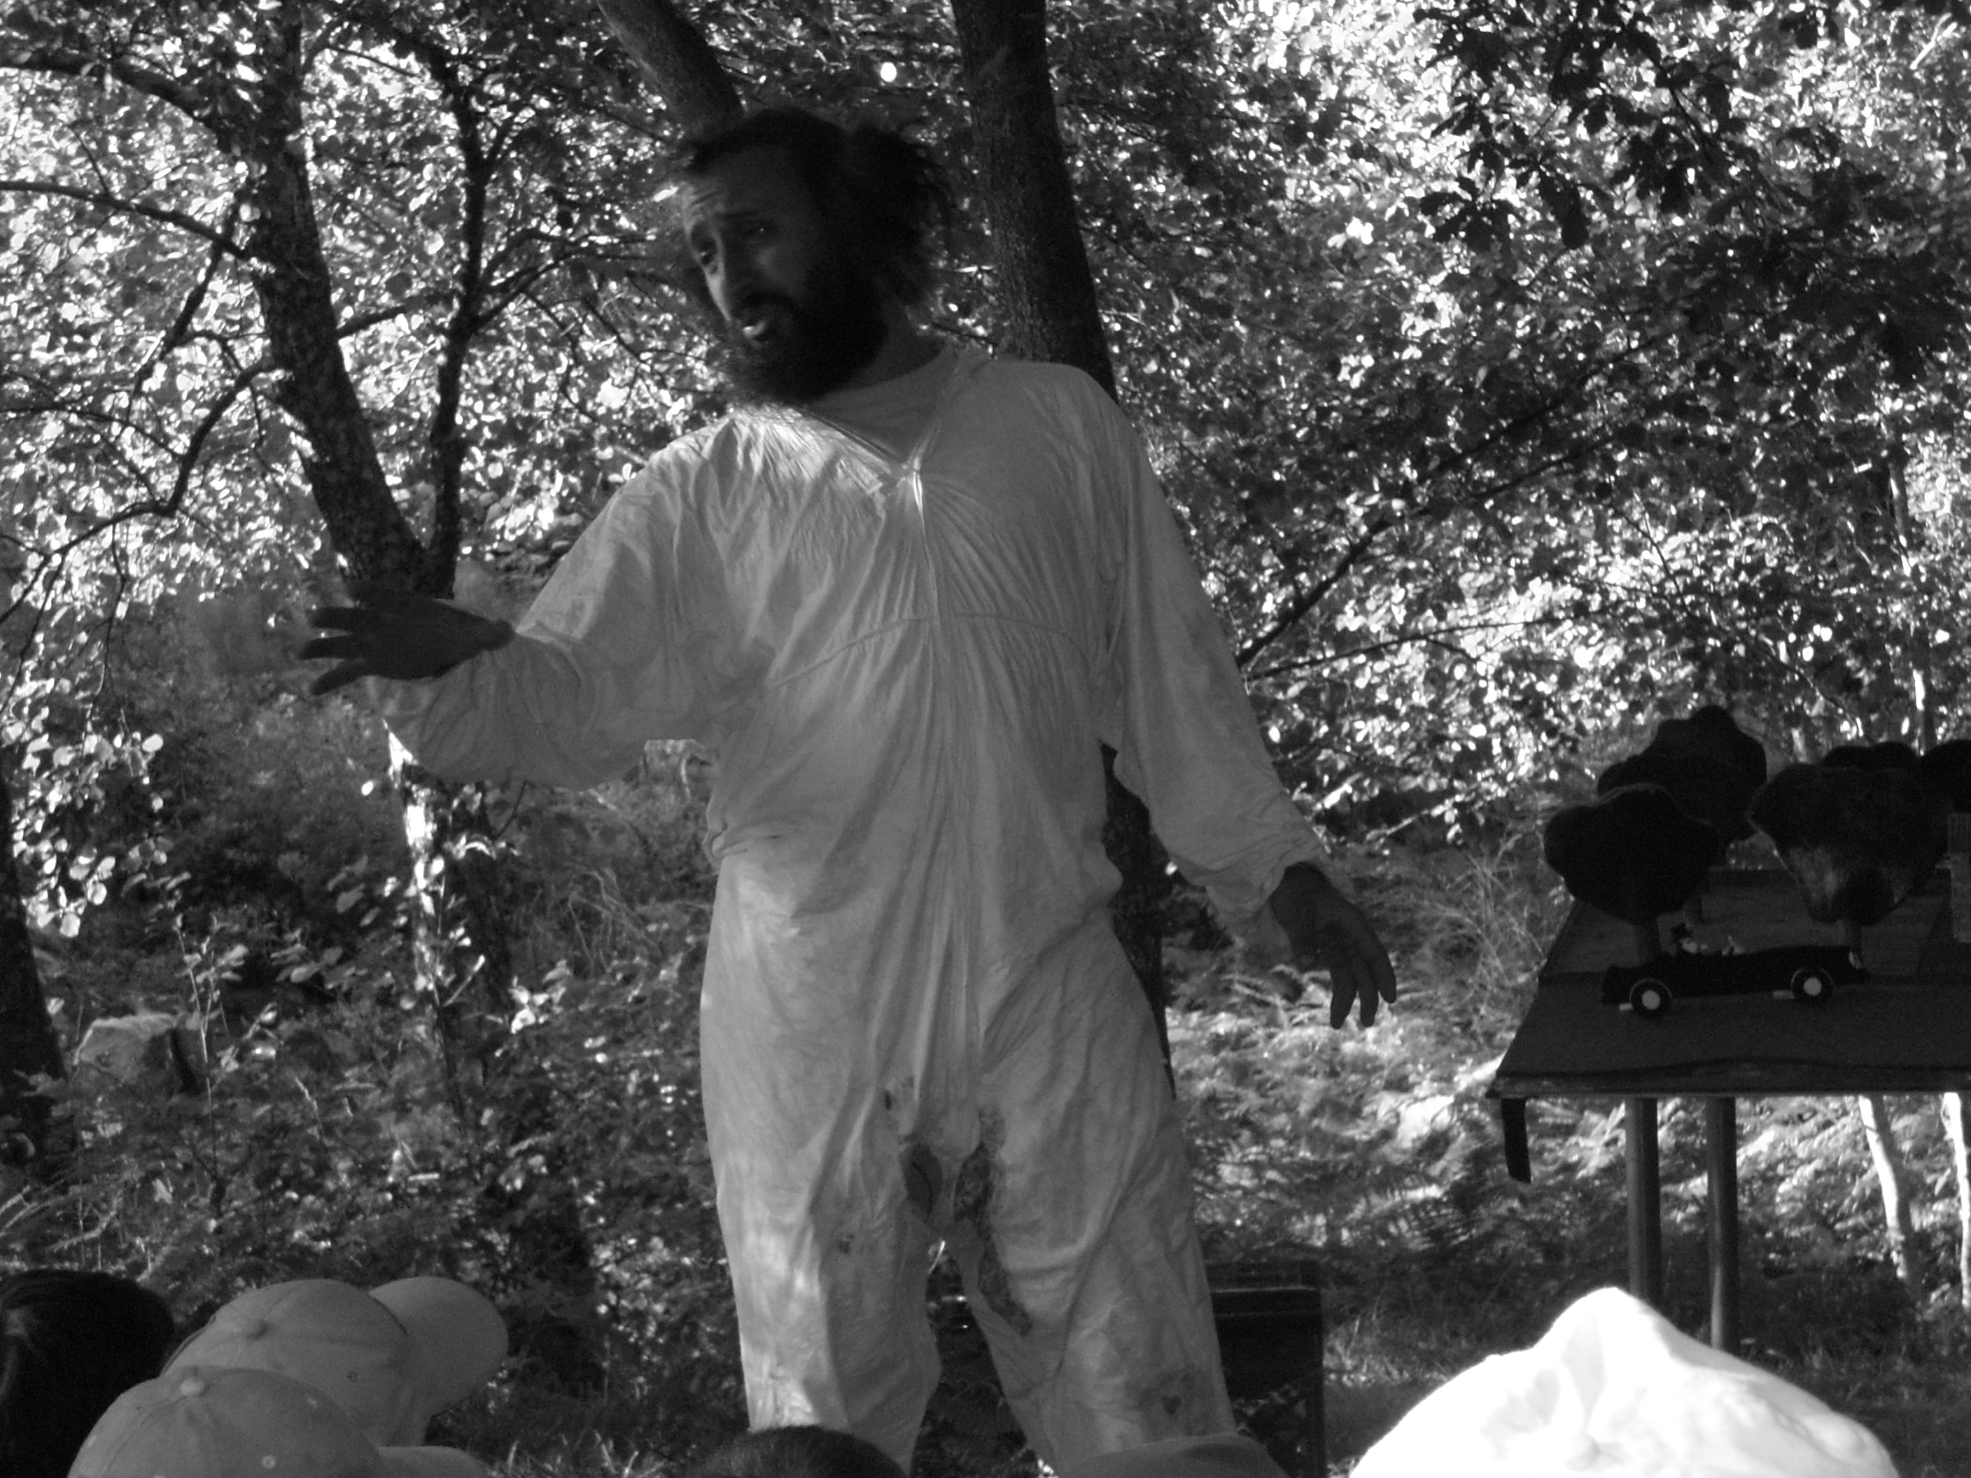
I Brais / Falcón declare that all what´s said on this document is true.

