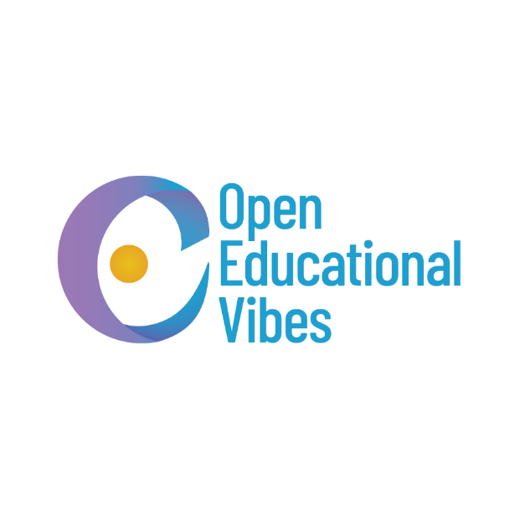

Erasmus+ Partner Identification Form (PIF)

Open Educational Vibes

|  |  |
| --- | --- |
| 1. **PARTNER ORGANISATIO** | |
| **PIC Number** | **881367900** |
| **Organization ID** | **E10337169** |
| Full legal name (National language) | Otvorene obrazovne vibracije |
| Full legal name (Latin characters) | Open Educational Vibes |
| Address (Street and number) | Gavrila Principa 18/10 |
| Country | Serbia |
| Region | South Serbia |
| Post Code | 18000 |
| City | Niš |
| Website | www.openeducationalvibes.wordpress.com |
| Email | office.oev@gmail.com |
| Facebook | www.facebook.com/oev.ngo |
| Instagram | www.instagram.com/oev.ngo/ |
| LinkedIn | www.linkedin.com/company/oevngo/ |
| Telephone | +381 63 747 1849 |
| 1. **PROFILE** | |
| Type Of Organisation | Non-governmental organization |
| Is the partner organization a public body? | No |
| Is the partner organization a non-profit? | Yes |

|  |  |
| --- | --- |
| 1. **BACKGROUND AND EXPERIENCE** | |
| Please briefly present the partner organization | Open Educational Vibes was established in Serbia on Europe's Day, 9th May, 2023. Therefore, Open Educational Vibes is non-governmental, non-profit, and non-political organization. The main goal is to support education, mobility and digitalization. They are specially created and selected based on the preferences of the target groups, in order to be able to respond to their needs as best as possible. Respect for inclusion, freedom of speech, freedom, human dignity and solidarity are guaranteed. Open Educational Vibes provides opportunities for multiple groups including students, youth workers, young people, teachers, professors, employed and unemployed people.  A passion for continued education is one of our top priorities, supporting various groups. We believe that sharing knowledge through non-formal and informal education can significantly impact both individuals and communities. By employing diverse methods to explore and acquire knowledge, we foster creativity, teamwork, and a drive for further research. Additionally, we promote different cultures, rituals, and customs to encourage tolerance. Our main activities include education through formal, informal, and non-formal methods, such as workshops that emphasize inclusion, ethics, and European values. We also advocate for learning through "learning by doing" and promote skills in entrepreneurship, marketing, ecology, digital literacy, and other areas.  Mobility plays a crucial role in supporting individuals to participate more actively in development and education, as well as in promoting values, customs, creativity, learning, resourcefulness, and the adoption of new techniques. Through travel, participants gain incredible opportunities to discover new perspectives, enhance language skills, and acquire or improve knowledge and competencies. In a new environment, individuals cultivate independence, adaptability, and problem-solving abilities, all of which are valuable for future endeavours. The organization promotes mobility by encouraging participation in domestic and international projects, hosting events and online promotions, and organizing workshops, art projects, and more.  Digitalization is a key objective of the European Union, as well as our organization. By promoting digital tools and resources, we facilitate daily work, enhance education, foster tolerance, and connect people more effectively. Improving digital skills and utilizing programs and software are essential in modern life. Additionally, artificial intelligence and its capabilities can be leveraged for beneficial activities. However, it's crucial to prioritize online safety, as the internet, while full of opportunities, also presents risks like phishing, malware, and viruses. To address these concerns, our organization promotes digital literacy through various initiatives, projects based on modern solutions, and the use of digital programs. We are also promoting a paperless office.  Supporting youth work is a paramount activity aimed at creating new opportunities through projects, workshops, public art installations, exhibitions, performances, conferences, seminars, gatherings, and other scientific and educational events. The goal is to strengthen opportunities for young people and provide them with support for further development. Our focus includes participation in and organization of international exchanges that cover topics such as psychology, promotion of tolerance, interreligious dialogue, and support for youth as well as other groups.  The promotion of ecology is achieved through a sustainable and ethical approach to raising awareness and engaging the public. We focus on eco-friendly practices in all promotional activities, such as using digital platforms to reduce paper waste, selecting local and recycled materials for physical promotional items, and partnering with environmentally conscious organizations. This approach is implemented by creating campaigns and activities that involve participants and partners, thereby benefiting the community.  Other areas of cooperation include promoting tolerance in society, creating opportunities for personal and professional growth, and respecting individual integrity. Interreligious dialogue fosters a better understanding of the attitudes, values, and customs of diverse cultures and beliefs. This dialogue supports tolerance, reduces hatred within society, and enhances community cooperation, ultimately improving the environment. Collaborative efforts can help overcome challenges, paving the way for peace. Through participation in international projects, participants from different countries.  As previously written, we are also focused on the implementation of ideas of multicultural communication, cultural diversity, interreligious dialogue, tolerance in a civil society, tolerance, open minded, avoiding cultural barriers, promotion of debates, European values and the European Union, improving skills, youth position in country and abroad, creating unique opportunity for promoting through non-formal and informal activities. Working with youth, the founders concluded that many groups of people, especially young people do not have enough incentives for improvement and change. Creating a good energy for all parties can be beneficial for supporting local and national economy, being able to better to respond to challenges and fostering entrepreneurial community for education and development. |
| What are the activities and experience of the organization in the areas relevant for this application? | Open Educational Vibes is formed on Europe's Day, 9th May 2023 in Serbia. During that period, we were focused on the education of our members, creating social media campaigns for the promotion of European Values. Also, we are focused on expanding our own capacities. During the past period, our members took part in multiple Erasmus and other projects funded by the European Union.  We have created our goals and opportunities for further development and improvement in detail. In the following period our plans are to participate in activities that are organized by Erasmus plus, and it is expected to gain enough experience and skills in writing and accomplishing similar projects. |
| What are the skills and expertise of key staff/persons involved in this application? | Organization is founded by three 3 founders who have perennial experience in international activities, including programs organized by EU and Erasmus +.  Zdravka Majkić is an experienced language teacher who has worked in formal education for more than twenty years. Zdravka is not only an English teacher but also an edu-enthusiast. She believes that working in a small rural school requires enthusiasm and perseverance to teach great things with little resources  In Serbia she works as a teacher trainer (coauthor of certified training), and she has delivered many different workshops in Serbia and many other European countries. She is attending training for EU trainers - Media Literacy, organized by the EU. She believes in inclusion and diversity, which she shows through her work with youth. Her fields of interest are: social media, digital tools, mental wellbeing with the focus on SEL (Social Emotional Learning).  Dragana Vasilijevic-Valent is an experienced online language teacher, certified teacher trainer (University of Sheffield), and a former university teacher. She holds a PhD in educational linguistics. She believes that education shapes the way we see the world and she tries to share the values she believes in through youth work and training for teachers. Her fields of interest are: social media, digital tools, digital citizenship with the focus on digital emotional intelligence.  Andrej Janković, president and co-founder is a student at Belgrade Metropolitan University, department of Business and Marketing. His Erasmus+ journey started in late 2021, and since then he has taken part in numerous projects in Serbia and Europe, whose main topics were digital technologies, creation of Erasmus plus workshops and projects, additional education in work with vulnerable groups from different backgrounds. Besides being mentioned, he continuously tends to further development and improvement, which is certified by numerous participations and certificates from seminars, trainings. He has also attended many marketing and computer technology courses. He speaks Serbian and English fluently, and he is learning German and Italian. He did Erasmus Traineeship in an organization Mimma Dreams APS based in Trieste, Italy. He was on position of Social Media Management and Marketing for 3 months.  All three founders have excellent experience and well-developed skills in mobility, youth work, teacher training, inclusion and diversity, using web-based tools, marketing, photography and video including editing of it etc. |
| 1. **LEGAL REPRESENTATIVE** | |
| Title | Mr. |
| Gender | Male |
| First Name | Andrej |
| Family Name | Janković |
| Position | President |
| Email | andrej.jankovic.mr@outlook.com |
| Telephone | +381 63 747 1849 |
| Adress | Gavrila Principa 18/10 |
| Country | Serbia |
| Region | South Serbia |
| Post Code | 18000 |
| City | Niš |
| LinkedIn | https://www.linkedin.com/in/andrej17/ |
| 1. **CONTACT PERSON I** | |
| Title | Dr. |
| Gender | Female |
| First Name | Dragana |
| Family Name | Vasiljević-Valent |
| Position | Facilitator |
| Email | dr.vas381@gmail.com |
| LinkedIn | https://www.linkedin.com/in/draganapro/ |
| **CONTACT PERSON II** | |
| Title | Mrs. |
| Gender | Female |
| First Name | Zdravka |
| Family Name | Majkić |
| Position | Facilitator |
| Email | zdravkamajkic@gmail.com |
| Telephone | +381 63 9589 3418 |
| LinkedIn | https://www.linkedin.com/in/zdravka-majkic-3aa76714b/ |

|  |  |  |  |
| --- | --- | --- | --- |
| **Our members took part in following projects:** | | | |
| Name of the project | Period | Place | Coordinator |
| EduLARP | 20 - 28 February 2024  5 - 11 May 2024 | Zlata Idka, Slovakia | Saplinq, O.Z. |
| ETSPERT: Level Up Your Youth Work Competencies | 7 - 14 April 2024 | Trakai, Lithuania | Innovative Generation |