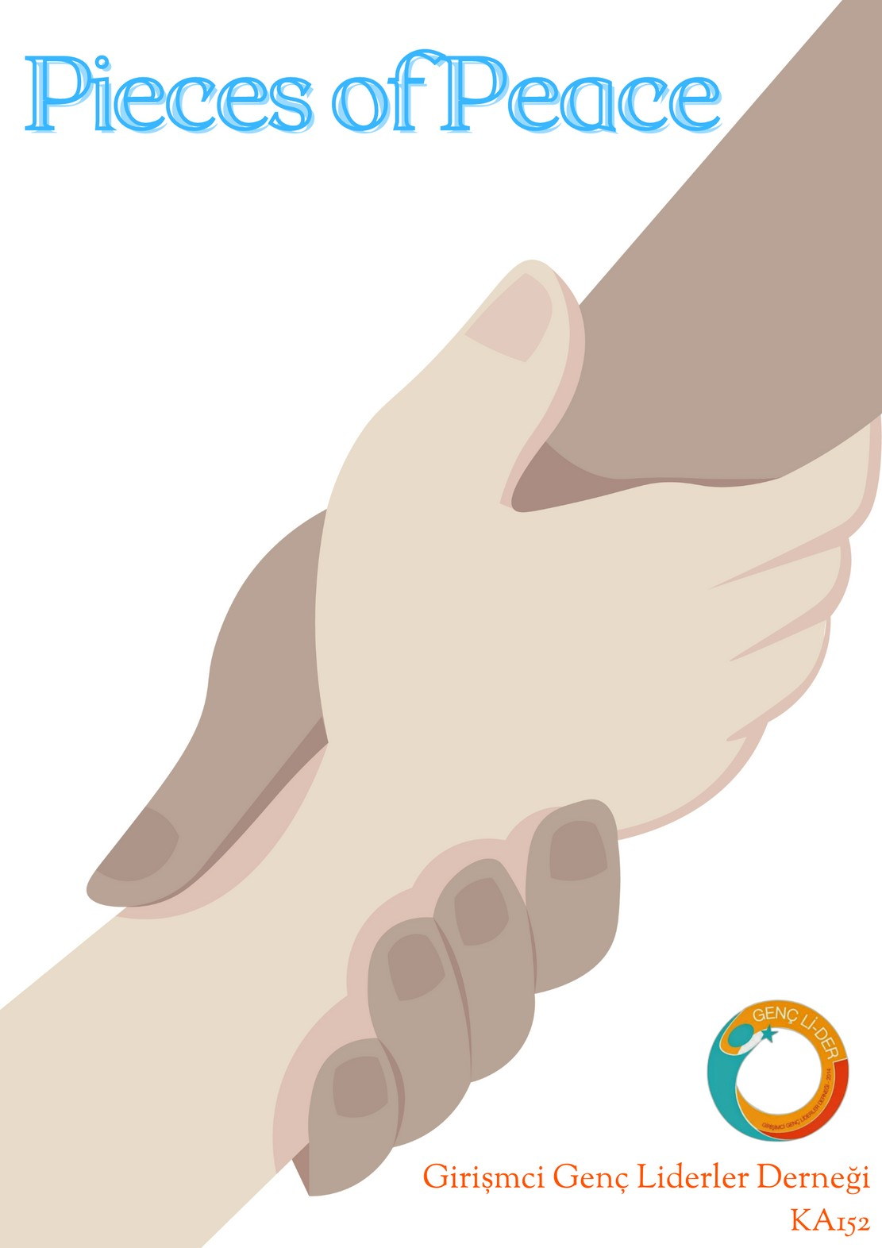

Project Summary

Europe is once again faced with the tragedies of war. Regardless of the historical process, the importance of protecting the sovereignty of all borders accepted by

Project Summary

international law and the sovereignty of the states within these borders has emerged once more in these days. The basis of all these pains is the feeling of hatred towards

the existence, ideas, wishes or cultures of the other

person. This sad situation has shown that respecting the sovereignty of people living in different countries,

different beliefs, different cultures, different religions, different thoughts and learning to live with them will be

the most effective method to prevent such tragedies from happening in the future.

Project Summary

However, cases of xenophobia, anti-immigrant and cultural racism are increasing, even in European countries, which are seen as the most important representatives of human rights, human values and equality. In fact, political parties that make promises on these issues have increased their votes in the last 20 years. While parties in a radical position could not show any presence in European politics before, they have now become the main opposition parties in some countries, and they have become successful parties in the parliament in some countries.

Radical right parties, which had an average of 1 percent of the vote in Europe in the early 1980s, started to receive an average of 13 percent of the vote, according to the data of 2016. When we come to 2022, these rates have increased even more.

The mainstay of the radical right parties has been xenophobia. Radical right parties, which have lost their privileges with the arrival of these immigrants in the last 20 years, which have increased the number of immigrants coming to Europe, and have identified those who are uncomfortable with immigrants as the target audience, shape all their policies on this principle. Radical right-wing parties strongly oppose the existence of different cultures and different beliefs and advocate that their countries should be made monocultural immediately. It is quite clear that this view completely contradicts the European Union's understanding of "differences are richness". In fact, these parties are also against the existence of the European Union, and they sharply criticize the European Union's tolerant attitudes towards different cultures and open border policies. The increase in the number of voters who voted for these parties is an indicator of the increase in the number of people who have negative attitudes towards foreigners, different cultures, different languages and different beliefs. Therefore, the increasing opposition to different cultures, foreigners and different beliefs is a source of concern both for the European Union and for all humanity. Verbal and physical attacks against foreigners, hate speech, radicalization are incompatible with human rights and values represented by Europe.

Project Summary

It is mostly in the hands of us young people to change this unfortunate future. Because those who are hostile to differences try to influence especially young people and for this reason, they spend a lot of money to advertise on social media and platforms where young people show great interest. Informing and raising awareness of the young people of Europe on this issue will lead to a great defeat of such views.

We believe that it is possible to create an environment of peace by accepting our differences and realizing that these are riches. For this reason, the main goal of our project is to bring together young people from different languages, different cultures, different sects and religions, and to create a great awareness towards creating an environment of peace by reducing hostilities against foreigners, immigrants, people living in different borders, different countries and different cultures.

Our project is compatible with the 7573rd Meeting of the UN Security Council on 9 December 2015 with the decision numbered 2250. That decision stated that “youth should be actively involved in shaping lasting peace and contributing to justice and reconciliation, and that youth will play a positive role in preventing and combating violent extremism that leads to terrorism and fuels conflict, hinders socio-economic development and fosters regional and international insecurity”.

-Promote intercultural dialogue, learning about different cultures and the feeling of living together with different cultures

Project Goals

-To inform the youth against the populist and xenophobic movements that are affecting Europe

-Young people should have the necessary equipment to strengthen and protect the values that the European Union attaches great importance to, such as human rights, cultural integration, cultural cooperation, and freedom of expression.

-To break down the prejudices of young people towards different cultures

-To spread the awareness that the participation of young people who respect different cultures in democratic life is extremely important and effective in establishing peace, tranquility and justice in Europe.

-To develop the attitudes of young minds, who will take part in decision- making mechanisms in the future, towards different cultures and foreigners.

-It is to increase the knowledge and skills of these young people, who will spread peace and cultural reconciliation, on both political and cultural issues.

-Learning of Young People to Work in Multicultural Teams and Developing Their Perspectives on Different Views

-Encouraging young people to reflect on European issues and values

Within the scope of our project, it is planned to organize an activity that will last 10 days, excluding travel days, and will include 42 participants from 6 different European countries, between the ages of 20 and 30. The participant profile is people who are between the ages of 20-30 and are citizens of countries considered as EU member or partner countries.

Everyone can participate in this activity, and there will

be no other restrictions on identity, gender, belief or culture. Participants will be divided into several teams with at least 5 participants. It is planned that each of the participants in these teams will consist of participants from different countries.

MAIN ACTIVITY OF THE PROJECT

1. Day Camping Activity

8-18 August at Kayseri/Turkey

Camp of the Peace

**Activities Planned During the Camp**



# -Placement of the participants in the activity area

- Meeting Bingo

# Presentation: The participants will present to introduce their own countries



-Distribution of participants to teams

* + Presentation Studies, which include the information and problems of the participants about foreigners, immigrants and minorities in their own countries

-Speeches and Question- Answer Activities by Local Organizations, Political or Public Officials

-Movie Quiz with awards



·Mixed Sports Competition

·Presentation and Question-Answer Events by the Officials in International Institutions

·Karaoke Night where participants will sing songs of their country with their language



·Visiting the local and cultural places in the place where the activity is held

·Conversation on Racism and the Increase of Xenophobia in Social Media

·How Can We Reduce Hostility Towards Foreign Individuals and Different Cultures?” Themed Debate Competition



·Story Completion Game (Mad Lib)

·Workshop where each team's unique ideas on Xenophobia and Cultural Integration are discussed

·Music Quiz with awards

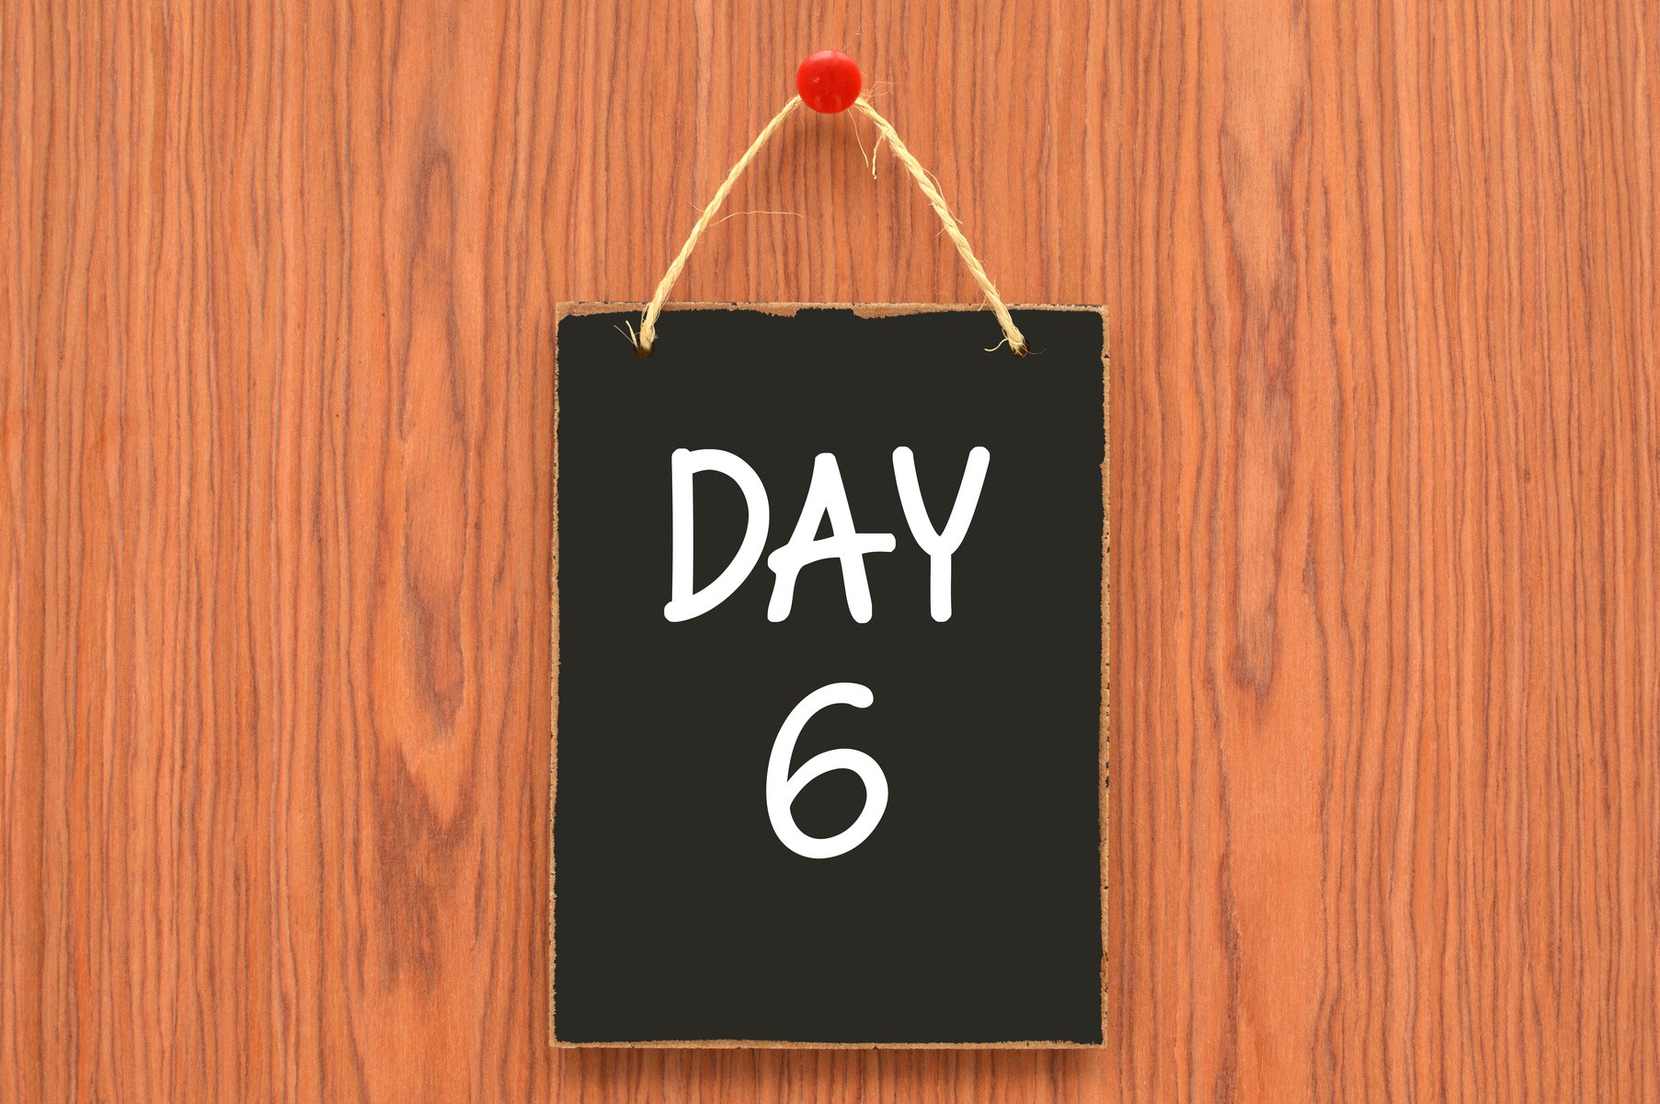·Question-Answer Activity with a Foreigner or Immigrant Person Living in the Region where the Activity is Held

·Geography-History Quiz with awards

·“Open Mic Stand-up” Event to Understand Differences Between Cultures in Humor

·Educational Presentations on Erasmus+ Projects

·Watching a Movie About Xenophobia And Cultural Racism And Evaluating This Movie From Different Perspectives By Each Team

## ·Culture Night, where the participants exhibit the unique dishes, dances and clothes of their own countries.



·Interviews with Local People About Immigrants and Different Cultures and Presenting and Discussing the Results of These Interviews

·Inter-Team Cooking Competition with awards

·Song Contest in Different Languages

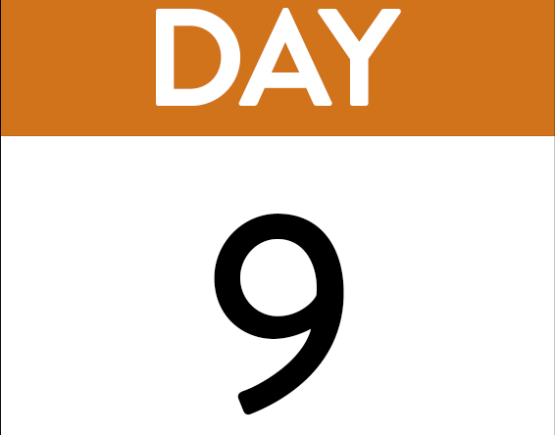

·Short Film Contest About Xenophobia and Cultural Racism

·Project Idea Contest

·Each group should write an article on how to prevent xenophobia and cultural racism.

(Later, these articles will be brought together and turned into the report of the Project)

If possible, making an agreement with a publishing house and turning this report into a book.

·Coming up with a “Youth Manifesto” as a result of this project together with all the activities

·Camp Oscars- In categories such as Funniest Participant, Most Talkative Participant, Most Sportive Participant.