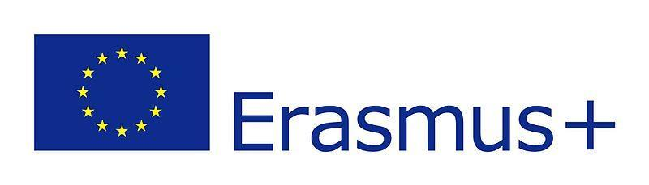
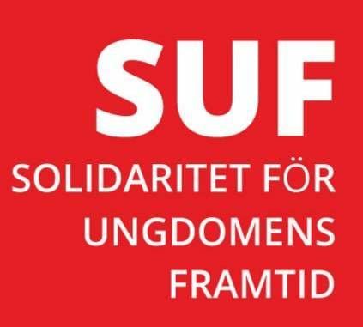

PARTNER IDENTIFICATION FORM

A. PARTNER ORGANISATION
PIC |  |  |  | 88 75 72 214
OID |  |  |  | E 10 258226
Full legal name (National Language) |  |  |  | Solidaritet för Ungdomens Framtid
Full legal name (Latin characters) |  |  |  | Solidaritet för Ungdomens Framtid
Acronym |  |  |  | S U F
Address (Street and number) |  |  |  | C/O Etu AB  Västra Storgatan 6
Country |  |  |  | Sweden
Region |  |  |  | Jönköping
Post Code |  |  |  | 553 15
City |  |  |  | Jönköping
Website |  |  |  | www.solidaritetungdomensframtid.org
Email |  |  |  | info@solidaritetungdomensframtid.org /suf@solidaritetungdomensframtid.org
Telephone 1 |  |  |  | +46 36187942
Telephone 2 |  |  |  | +46 76 556 1264
B. PROFILE
Type of Organisation
Is the partner organisation a public body? |  |  |  | No
Is the partner organisation a non-profit? |  |  |  | Yes
C. ACCREDITATION
Has the organisation received any type of accreditation before submitting this application? |  |  |  | - No
Has the organisation received/applied for any EU grants? |  |  |  | - No
D. BACKGROUND AND EXPERIENCE
Programme | Year |  | Project identification |  | Project title | SUF
Erasmus | 2022 |  | Project No:101051412-YEP-Erasmus-Youth -2021-Youth -TOG |  | Youth Empowerment and Participation | Participant
Erasmus | 2023 |  | 2022-3-SE02-KA210-YOU-000092850 |  | Digipreneurship Education to Bridge Skills Gap in Youth Work | Applicant
Erasmus | 2023 |  | 2022-3-TR01-KA153-YOU-000094875 |  | Workshop on improving the Rights of the young people working from home | Participant
Erasmus | 2023 |  | 2022-3-NL02-KA152-YOU-000099740 |  | Integration and social inclusion through sport | Participant
Please briefly present the partner organisation. |  | Who are we?  Solidaritet för Ungdomens Framtid is a Swedish non-profit organization involved in the promotion of the United Nations Convention on the Rights of the Child and the World Programme of Action for Youth.  Our mission  Solidaritet för Ungdomens Framtid aims at promoting an integral evolution of all children and youth by safeguarding their human dignity mainly through the United Nations Convention on the Rights of the child and the World Programme of Action for Youth.  Our vision  The organization recognizes that any child and any youth possesses dynamism of life and resources which can be better shown when the conditions of life are good.  Every child and youth must benefit from a protective environment granted by their family and their community in which they live. Their integral development requires a set of gathered conditions.  Therefore, a wide range of institutions, including the family, educators, civil society and the government must strive to create an enabling environment that favours the development of psychological, cognitive and physical capacities of the child and the youth which will lead to a better future.  Main domains of action  The superior interest of the child and the youth is in the centre of engagement of the organization. It caters for all children and youth without discrimination in respect of their nationality, gender, their ethnicity, culture and religion.  Attentive to the real needs of the child and the youth, the organization professionally intervenes in the priority areas of education, hunger and poverty, health and HIV/AIDS, drugs abuse, the youth  delinquency, integration, leisure, art, sport and culture, ICT, human rights and environment but can also intervene in other domains of interest to the child and youth.  We are also interested in Erasmus+ and European Solidarity Corps Programs:  -Youth Exchanges ,  -Volunteering,  -Training and Network,  -Transnational Youth Initiatives,  -Strategic partnership,  -Capacity building,  -Meetings between young people and decision-makers.  Country of intervention: all countries
Activities and experience of our organization in the areas relevant for this application? |  | Solidaritet för Ungdomens Framtid is a non-profit making organisation involved in various activities such as: the training of young people and adult learners. The age group of the beneficiaries is between 13 and 30. The young people and adult learners who benefit from training are from different nationalities and are mainly migrants and people with less opportunities. Since 2019 we have trained 260 young people in various fields such as: ICT; E- commerce, Entrepreneurship;  languages, Project planning and management, project Monitoring and evaluation. We also organize activities such as promoting inclusion of social migrants, learning Swedish, sports and cultural activities. As part of the activities, the projects that we implement contribute to the promotion of the values ​​of the European Union, as well as objectives for European youth and the European Union' strategy in favor of youth.  In addition, Solidaritet för Ungdomens Framtid is an organization that promotes the protection and preservation of the environment. In our activities in favor of young people, education in the fight against climate change and soil degradation is one of our concerns for a better future for everyone and young people in particular. Within our organization we are aware that the fight against environmental degradation is an essential condition to achieve sustainable development as stated in the Sustainable Development Goals of the agenda 2030. Our concern is that the young people become aware in other to participate massively in different activities of protection and preservation of the environment.  Since 1st june 2022, Solidaritet for Ungdomens Framtid participate in international project . The project title is: Youth Empowerment and Participation.  In january 2023 start of a project :  - Digipreneurship Education to Bridge Skills Gap in Youth Work.
Skills and expertise of key staff/persons involved in this application? |  | RESPONSIBLE MONITORING AND EVALUATION  Legal Representative : Thaddée NZIGENDAKO is the founder of an organization called Association pour la Promotion de la Santé et le Développement. Created in 1999. This organization is based in BURUNDI. Thaddée NZIGENDAKO created also in 2019 an organization named “ Solidaritet för Ungdomens Framtid” in Sweden.  Now, he is the Public Relations in charge in the “Association pour la Promotion de la Santé et le Développement ”; and the chairperson of Solidaritet för Ungdomens Framtid. Concerning his education, Thaddée NZIGENDAKO holds a degree in Nursing Sciences, 2 masters: one in Management and Planning, another in Project Monitoring and Evaluation. Thaddée NZIGENDAKO has attended several trainings and workshops in the field of health, planning, monitoring and evaluation of projects. He has worked as a nurse in various infrastructures of healthcare in Burundi, in addition he was a Pedagogical Advisor to the Ministry of Public Health in Burundi. He has also worked with different organizations in different projects in Burundi and in other countries. He has held several positions of responsibility either as a Project Manager, Director or Project Coordinator. Currently he works as Responsible Monitoring and evaluation of Union European projects within the organization “Solidaritet för Ungdomens Framtid”.  PROJECT MANAGER  Erik Abrahamsson: has worked as a manager for several Swedish NGO:s since 2010 and has experience of both national and international work. Areas of focus have been integration, outdoor life, cultural understanding and development work. He has a One-year Master Degree in Social Anthropology and has made extensive fieldworks among the sea oriented ethnic group Sama Bajau in Southeast Asia.  PROJECT COORDINATOR  Mina Prokic: has expertise in issues related to the management of cultural and religious diversity, the promotion of intercultural relations and projects related to immigration, refugees and the inclusion of minorities.  Ella defended a doctoral thesis titled "" Intercultural Relations and Family - School Trust: Immigrant and Native Families in Schools of Barcelona "at Pompeu Fabra University in Barcelona. In addition, she has a Masters in Immigration Management (Pompeu Fabra University) and another in international cooperation (Ortega y Gasset) and she obtained a degree in political science and history at the American University in Bulgaria. She worked on immigration projects in the Spanish research institutes FRIDE and CIDOB In Serbia, she worked in an NGO that provides support and assistance to refugees from wars in the former Yugoslavia.
E. LEGAL REPRESENTATIVE
Title |  | Mr
Gender |  | Male
First Name |  | Thaddée
Family Name |  | NZIGENDAKO
Email |  | info@solidaritetungdomensframtid.org /
Telephone |  | +46 76 556 12 64
Address |  | Skolgatan 21 A
Country |  | Sweden
Region |  | Jönköping
Post Code |  | 566 31
City |  | Habo

F.Contact person
Title | Mrs
Gender | Female
First name | NINON BRONTË
Family name | NIBIGIRA
Telephone | +46 76 556 06 49
Email | suf@solidaritetungdomensframtid.org
Adress | Skolgatan 21 A
Code postal | 566 31
Country | Sweden
Region | Jönköping
City | Habo

