­­ ­­­­­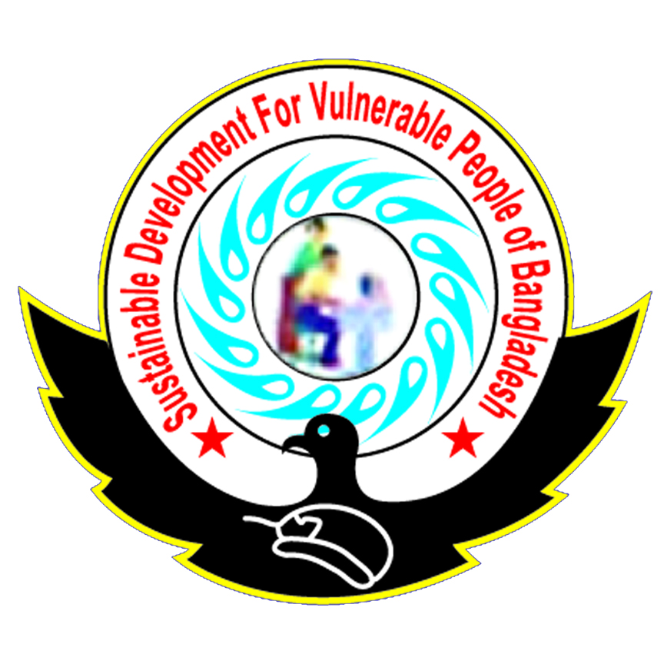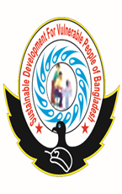



**TITLE**: The Safe pad Project: Restoring the Dignity of

Menstruating Girls in Bangladesh

TO: CORE Group

**FROM:** Sustainable Development for Vulnerable Peoples in

Bangladesh (SDVPBD)

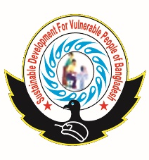

**IMPLEMENTING PARTNER:** Real Relief ApS

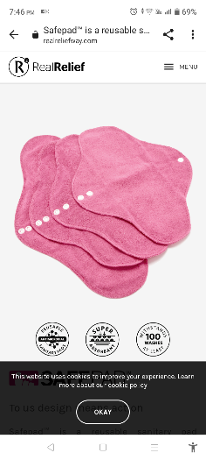

Contact: miah FEOZ, President, to the Executive Committee

Mobile:

+8801715458080.

Email: [miahferoz@gmail.c](mailto:miahferoz@gmail.c)om

Contact: Ms. Trine Angeline Sig, Managing Director

Mobile:

+4528262600. Email: [ts@realreliefway.co](mailto:ts@realreliefway.co)m

**PROJECT COST:** One hundred fifty thousand dollars ($150,000)

**PROJECT DURATION:** One (1) year

**THE SAFEPAD PROJECT: RESTORING THE DIGNITY OF MENSTRUATING GIRLS IN BANGLADESH**

**Project Overview**

**Project Code** SAFEPAD – MHM

**Project Sector** Reproductive health - menstrual hygiene management (MHM)

**Project Area** Informal settlements of Dhaka, Bangladesh

**Partners** Sustainable Development for Vulnerable Peoples in Bangladesh (SDVPBD)

**Main Objectives**:

• To break the silence on menstruation by sensitizing the beneficiaries and other stakeholders on menstruation and debunking the taboos, myths and misconceptions associated with menstruation

• To increase the proportion of young girls who are engaging in sustainable, environmentally friendly and proper menstruation hygiene management through the use of safe, hygienic and reusable sanitary pads

• To improve access to reusable sanitary pads through donations and to distribute information booklets on menstruation and menstrual hygiene management to the beneficiaries and other stakeholders during the project duration

• To improve rates of readmission and retention of adolescents of school going age in selected schools

• To increase the self-esteem of adolescent girls on menstrual matters through open discussions and focused empowerment

**Phase one project duration** One (1) year

**Project target** • 10000 adolescents of school going age from marginalized, under-

served and vulnerable areas

• 500 teachers, community mobilizers and other stakeholders in the target areas

**Project cost** One hundred Fifty thousand US dollars ($150000)

**Introduction**

Nobody deserves the indignity of having to use cow dung, ashes, leaves, newspapers, used socks, old mattress cuttings or rags to catch her menstrual flow. These crude materials are not only ineffective but also unhygienic and uncomfortable in catching menstrual flow. In Dhaka, school going girls of menstrual age are either forced to endure this humiliation or be absent from school. For the brave girls who want to remain in school and build a bright future, a large number of them confess to facing stigma that comes from unhygienic menstrual hygiene management, the odor of improperly managed menstrual blood or shocking stories ofhow they did not know what to do during their first menstrual period. As for those who choose the easy way out, formative research has uncovered shocking statistics of adolescent young girls missing up to 3.5 million learning days per month in Dhaka due to menstruation. Moreover, this state of affairs is worsened by the lack of information on menstrual matters as well as a deep culture of taboos, myths and misconceptions surrounding menstruation and menstrual blood.

At Sustainable Development for Vulnerable Peoples in Bangladesh (SDVPB), we believe that young girls should not be left alone to make these tough choices. They should be supported, empowered and allowed to have their menstrual periods in a safe, confident and dignified manner. In a bid to restore dignity to these girls, retain them in school and enable them to face their periods with confidence, we came up with The Safe pad Project. The aim of this project is to break the silence on menstrual matters, debunk the myths and misconceptions on this subject area, sensitize boys and girls on menstruation and to donate sanitary towels to needy girls of menstrual age. While we have been reaching out to these young girls, we need support in order to reach out to more under-served areas, marginalized populations and vulnerable groups. We need your help.

**Background**

Bangladesh is made up of different ethnics with deeply rooted cultures. In majority of these ethnics, menstruation is a shameful and embarrassing topic to be discussed openly. To further prevent information sharing on menstrual matters, various communities and religious denominations have coined taboos, attributed evil ‘powers’ or associated shame and embarrassment to menstruation and menstrual blood. Statistically, House et al continue to argue that only 12% of the girls in Bangladesh would be comfortable in receiving MHM information from their mothers. As a result, menstruating girls lack enough information about their bodies and adolescent boys tease and stigmatize menstruating girls for failure to understand that menstruation is a normal biological process.

Legislatively, the Constitution of Bangladesh, 1972 guarantees to every person the right to the highest attainable standard of health, including reproductive health care and sanitation. There is even a national policy on the provision of sanitary pads. This notwithstanding, there is a huge proportion of adolescent girls

and women who are unable to access information, safe materials and other facilities for proper menstrual hygiene management. Formative research indicates that 65% of women and girls in Bangladesh are still unable to afford or access sanitary pads. In addition, there have been appalling reports of girls exchanging sex for sanitary pads and that 2 out of 3 of pad users in rural Bangladesh receive them from sexual partners. This not only compounds the problem but also increases the indignity that young girls have to endure.

Further research in Bangladesh schools indicates a very high dependency on Non-Governmental Organizations (NGOs) to support sanitation and hygiene among school going children. According to Kelly Alexander et al, “77% of all hygiene costs were paid for by NGOs - covering the costs of hand washing vessels, soap and sanitary pads.” As an NGO, the Sustainable Development For Vulnerable Peoples in Bangladesh (SDVPBD) is thus committed to be part of the solution in promoting safe and proper menstrual hygiene management. With enough support the SDVPBD can even reach out to those young girls who have dropped out of school and give them a second chance to brighten their future.

**Project Area and Target**

Dhaka is the capital city of Bangladesh. While Dhaka is an urban setting, it has several slums and peri-urban areas. The informal settlements and peri-urban areas are hardest hit by the misconception that people in urban areas have access to adequate resources. In the contrary, SDVPBD sensitization and product donation drives in such areas as Demra informal settlements revealed a critical call for assistance.

On this basis, the SDVPBD is targeting 6625 adolescents in schools (265 groups of adolescents in schools with each group having 25 members) and 3375 adolescents who have already dropped out of school (225 groups of out of school adolescents with each group having 15 members). This will cumulatively lead to a targeted outcome of 10000 adolescents of school going age in Dhaka’s vulnerable areas.

**The Proposed Intervention**

*The Safe pad Project*

Based on the gaps realized and challenges faced with the accessibility, use and disposal of sanitary towels; the proposed feasible intervention is to upscale the sensitization and donation of sustainable menstrual hygiene management facilities to the target group. The SDVPBD has summarized this intervention into The Safe pad Project. The mission of the project is to increase outreach to under-served areas; break the silence and

debunk the myths and misconceptions surrounding menstruation; as well as to equip the adolescents with

the necessary tools to understand and manage menstruation safely.

*Project Goal:*

To restore the dignity of menstruating girls in Bangladesh through sensitization on menstrual hygiene management and provision of sanitary pads.

*Project Objectives:*

• To break the silence on menstruation by sensitizing the beneficiaries and other stakeholders on menstruation and debunking the taboos, myths and misconceptions associated with menstruation by the end of the project

• To increase the proportion of young girls who are engaging in sustainable, environmentally friendly and proper menstruation hygiene management through the use of safe, hygienic and reusable sanitary pads by the end of the project

• To improve access to reusable sanitary pads through donations and to distribute information booklets

on menstruation and menstrual hygiene management to the beneficiaries and other stakeholders during

the project duration

• To improve rates of readmission and retention of adolescents of school going age in selected schools

• To increase the self-esteem of adolescent girls on menstrual matters through open discussions and focused empowerment

*The Partnership Implementation Approach*

The Safepad Project will be spearheaded by the Sustainable Development For Vulnerable Peoples in Bangldesh(SDVPBD) in partnership with Real Relief ApS. SDVPBD is a legally established non-profit and charitable (NGO) under the Laws of Bangladesh with the aim of developing pro-poor programs. SDVPBD works with underprivileged and vulnerable groups in the underserved areas of Bangladesh. Its main focus is on spearheading proper Water, Sanitation and Hygiene (WASH) initiatives such as safe menstrual hygiene management. LHI has extensive local knowledge of the project location, vital connections that will be indispensable for the meeting of the objectives of the Safepad Project and a dedicated team on the ground for technical and administrative support.

On the other hand, Real Relief ApS is a legally existing social enterprise that is incorporated under Danish Laws (Denmark). Real Relief ApS is a reputable manufacturer and supplier of high quality and cost - effective relief aid products like SafepadTM reusable sanitary pads. With a permanently bonded anti-microbial technology that kills bacteria, fungi and other disease causing micro-organisms, SafepadTM reusable sanitary pads offer a safeguard against the risk of infection associated with reusable sanitary pads. Moreover, Real Relief ApS has over 18 years of experience in implementing similar projects in Africa. It is on this basis that the Live Healthy Initiatives entered into a formal partnership arrangement with the Real Relief ApS to not only access the cutting-edge technology but also to benefit from subsidized costs of this essential product and to share skills, experience and expertise for a holistic project implementation.

The staff of the leading organizations will then collaborate with the head teachers of the target schools. For out of school adolescents, the staff of the leading organizations will collaborate with community mobilizers, community health volunteers and locally organized groups to reach out to the adolescent school drop outs. The project team will then focus on sensitizing the beneficiaries and other stakeholders, and thereafter, the participants will be provided with information booklets and feedback tools. In addition, adolescent girls will receive donations of one packs of reusable sanitary pads with four (4) pieces each.

Moreover, the project team will create fairy standard partnerships with the Government of Bangladesh at varying degrees to promote sustainable development.

*Activities*

• Identification and determination of the priority of target areas, beneficiaries and institutions through a Decision Matrix. Indicators including but not limited to the prevalence of absenteeism and school dropout rates, appalling media reports on unhygienic menstrual hygiene management (MHM) and insufficiency of facilities providing affordable MHM products in the under-served areas will be used

• Baseline survey of MHM methods and products• Training of the community mobilizers , community health volunteers, teachers and beneficiaries on safe MHM practices through a wide range of creative, participatory and behavior change approaches. Demonstrations on the SafepadTM will be conducted

• Distribution of the SafepadTM towels to the beneficiaries

• Monitoring of the use and consumer feedback mechanisms

• Reporting and presentation of results, final project evaluation on impact, outcomes, lessons learnt and recommendations

*Expected results*

• Restored dignity of menstruating girls through the increased access to reusable sanitary pads and information on proper MHM by at least 8000 girls in the target areas

• Sensitization of at least 2000 adolescent boys and other stakeholders on MHM to break the silence and support menstruating girls

• Reduction of absenteeism and school dropout rates associated with lack of menstrual hygiene management facilities in the target areas by at least one half

• Increased readmission and school retention of adolescent girls of school going age

• Improved knowledge, attitudes and practices among stakeholders and beneficiaries on MHM and Safepad™ as a better menstrual management product and focus on information channels for ongoing support, mentorship, and knowledge

• A decreased vulnerability of girls to exchange in transactional sex for pads, improved esteem among menstruating girls and increased participation by adolescent girls in school activities

*Sustainability*

Safe menstrual hygiene management has been advocated for under various sustainable development goals (SDGs). In particular, proper menstrual hygiene management is a major component in SDG 3, 4 and 5. In addition, to ensure the sustainability of the Safepad Project, the project team will work closely with and strengthen the existing community based support systems for out of school drop outs and collaborate with teachers in various schools. The community mobilizers, teachers and local public health personnel will also be trained in a Trainer of Trainees model so that they can continue empowering the adolescents on safe menstrual hygiene management. This will promote the sustainability of the capacity building effort.

Moreover, the Safepad Project advocates for the use of reusable sanitary towels. These sanitary pads are long lasting and one pack of four pieces can comfortably serve one girl for up to four (4) years. More still, reusable pads present an eco-friendly alternative due to reduced waste disposal and thus contributing to environmental sustainability.

Furthermore, the financial cost of disposal pads on the market is estimated to be BDT 1300 or 16 USD ($16) per girl per year. In addition, in the low-income settings where majority of the residents cannot afford a regular purchase of commercial sanitary towels, they are rarely stocked and thus posing an accessibility barrier. Disposing these pads also contributes to clogging of poor drainage systems and thus compounding the associated health and environmental risks. On the other hand, one packet of the reusable pads that will be promoted through this project is sufficient to meet the sanitary needs of a girl for more than a year at a cost of BDT 400 ($5) only. The adoption of reusable pads is therefore more likely to be sustainable in the long term.

**The project cost**

While the reusable sanitary pads are a cheaper alternative, majority of the intended beneficiaries fall below the poverty line and cannot readily afford even the subsidized costs of the Safepads. In order to support the initiative, the Sustainable Development for Vulnerable Peoples in Bangladesh’s is requesting for assistance through financial, technical and material support in order to improve universal access to MHM products and promote proper MHM practices in the low-cost and vulnerable settings. The estimated budget is attached in template.

**Monitoring and evaluation**

The project team will carry out monitoring and evaluation of the project throughout its phases based on the M&E framework. The project team will also assess the sustainability of the reusable sanitary towels during and after project implementation to make recommendations on product efficacy. The success of the Safepad Project can be measured by comparing the initial situation and the end impact versus the expected result indicators. Project brief updates, results and verifiable reports will be made and disseminated by the drivers of the initiative at various phases of the project.

A mid-term review will be conducted after the first six months to ensure that the lessons learnt from the first half will be transferred to the second part. Other M&E methodologies to be used include regular visits, Focus Group Discussions, Surveys, Key Informant Interviews and feedback meetings with stakeholders. The Most Significant Change (MSC) technique will be the preferred method for gathering evidence to capture the essence and feeling of the changes that take place as a result of the program.

**Conclusion**

The Safepad Project presents an immediate solution to several challenges facing menstruating girls in needy settings. From the use of unsanitary materials to the rise in school dropout rates, the Safepad Project presents a sustainable solution. It is also the conviction of the Sustainable Development for Vulnerable Peoples in Bangladesh’s that with the goodwill of donors and sponsors, even needy girls from the informal settlements of Dhaka, Bangladesh can safely manage their periods in an informed, confident and dignified manner using appropriate material to catch their menstrual flow. It is on this basis that the Sustainable Development for Vulnerable Peoples in Bangladesh’s is requesting for assistance in order to execute this project. We need your help.

**Bibliography**

**Books**

1. House S, Mahon T, and Cavil S, “*Menstrual Hygiene Matters: A Resource for Improving Menstrual*

*Hygiene around the World*.” (WaterAid, 2012.)

2. Water Supply and Sanitation Collaborative Council (WSSCC) and Government of India, “*WASH and*

*Health for Menstrual Hygiene management: Training of Trainers Manual Version 1.0.” (*WSSCC,

2013)

**Journals and schorlary articles**

1. Alexander K, Mwaki A, Adhiambo D, Cheney-Coker M, et al, ‘The Life-Cycle Costs of School Water, Sanitation and Hygiene Access in Kenyan Primary Schools.’ Published on June 27th, 2016 at the International Journal of Environmental Research and Public Health, Volume 13, Issue 637. DOI:10.3390/ijerph13070637. Available at <[www.mdpi.com/journal/ijerph> and accessed on March](http://www.mdpi.com/journal/ijerph)

16th, 2018. PP 5

2. Femme International, "The Issue: Menstruation, Development & Women's Rights." Available at

<[http://www.femmeinternational.org/the-issue.html> and accessed on February 16](http://www.femmeinternational.org/the-issue.html)th, 2018.

3. Mason L, Nyothach E, Alexander K, Odhiambo F, et al, “We Keep It Secret So No One Should Know’ – A Qualitative Study to Explore Young Schoolgirls Attitudes and Experiences with Menstruation in Rural Western Kenya.” (2013) Published at PLoS ONE, Volume 8, Issue 11. Available at

<[http://journals.plos.org/plosone/article?id=10.1371/journal.pone.0079132> and accessed on March](http://journals.plos.org/plosone/article?id=10.1371/journal.pone.0079132)

16th, 2018.

4. Patkarater A, Aidara R, Winkler I, “From Taboo to Empowerment: Menstruation and Gender Equality.”

Published at the Water Supply and Sanitation Collaborative Council (WSSCC) website and available at

<[http://wsscc.org/2016/05/27/taboo-empowerment-menstruation-gender-equality/> and accessed on](http://wsscc.org/2016/05/27/taboo-empowerment-menstruation-gender-equality/)

March 16th, 2018.

5. Phillips-Howard, Penelope A., et al. "Menstrual Needs and Associations with Sexual and Reproductive Risks in Rural Kenyan Females: A Cross-Sectional Behavioral Survey Linked with HIV Prevalence." Journal of Women's Health 24, no. 10 (2015): 801-11. doi:10.1089/jwh.2014.5031

**Others**

1. Afri-Can Trust, “Empowering Women and Girls through Affordable Sanitary Pads: Strengthening

Health Outcomes through the Private Sector.” Available at

<[http://shopsproject.org/sites/default/files/resources/Afri-](http://shopsproject.org/sites/default/files/resources/Afri-Can%20Trust%20%20Empowering%20Women%20and%20Girls%20through%20Affordable%20Sanitary%20Pads_0.pdf) [Can%20Trust%20%20Empowering%20Women%20and%20Girls%20through%20Affordable%20Sanita](http://shopsproject.org/sites/default/files/resources/Afri-Can%20Trust%20%20Empowering%20Women%20and%20Girls%20through%20Affordable%20Sanitary%20Pads_0.pdf) [ry%20Pads_0.pdf>. P1](http://shopsproject.org/sites/default/files/resources/Afri-Can%20Trust%20%20Empowering%20Women%20and%20Girls%20through%20Affordable%20Sanitary%20Pads_0.pdf)

2. Nyabwa W, ‘Sex for Pads: Girls Targeted by Sex Pests for Lack of Sanitary Towels.’ Published at Citizen

Digital website on October 1st, 2017