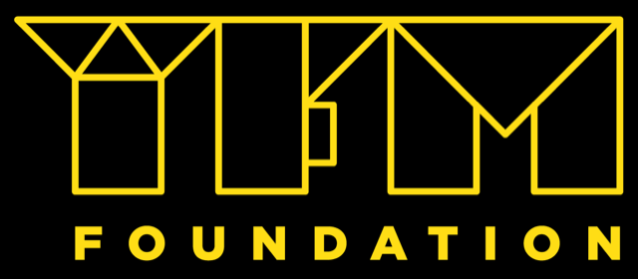Youth Exchange: Building EKO bridges across the euro-strait: DOM June 2023

DEAR POTENTIAL PARTNERS,
Looking at the current situation in Europe, where cross-border solidarity is lowering, while also plastic consumption and unecological habits are threatening the oceans; there is a need for clear European- dialogue among youth people. Our project which is Youth Exchange in Erasmus + highlight that importance of environmental protection in small communities, by putting youth people on the frontline to create concrete actions to reduce the negative environmental impact. This project has a unique approach, namely that it puts youth people on the core of the full organization of the project and all activities and connects them to local youth at the island community where they do activities with.
The project contains two phases: one local project (that is happening in the local countries) and one youth exchange; in where youth is fostered to become European Citizens, develop concrete actions in the timetable of activities such as recycling workshops, community involvement, greening and cleaning areas, making campaigns and videos from scratch and use interactive ways of -by them- delivered non formal education (fairs, flash mobs, theater, workshops) and is thus an true collaborative win-win for both participants, local public and youth. .

Objectives of the YE:
-To reflect on the opportunities in Overseas European Territories- Europe cooperation
-To develop joint initiatives for youth people, local organizations and host organizations and strengthen future corporation
-To increase solidarity for the rural community members, and tolerance for their disadvantages caused by lack of an appropriate environmental education.
-To promote the concept of true European citizenship, reminding young people values such as dialog and solidarity, which they will show in both activities within the group and also when they will interact with the local community. The idea from which we start is that a good European citizen is connected about the problems not only in his community faces and gets actively involved in finding solutions
-To enhance youth consumption and ecological awareness (as this project is fully vegan and sporty)

Target group:
We are currently have already 5 partners who are collaborating, but we are looking for an local partner from an overseas territory such as department outré mer, preferably St Maarten-St Martin, Martinique, Guadaloupe.

Conditions:
10 participants per country:
-where from 2 group leaders who are -also- the one who are staying in touch with us.

Participants under 30 years of age, fully vegan project, travels by ecofriendly ways.
Participation fee: If participants selected between 0-80 EUR.

IF YOU WISH TO BECOME PARTNERS, PLEASE SEND YOUR PIF TO
sohail@youthformobility.com UNTIL 15 Februari 2023

