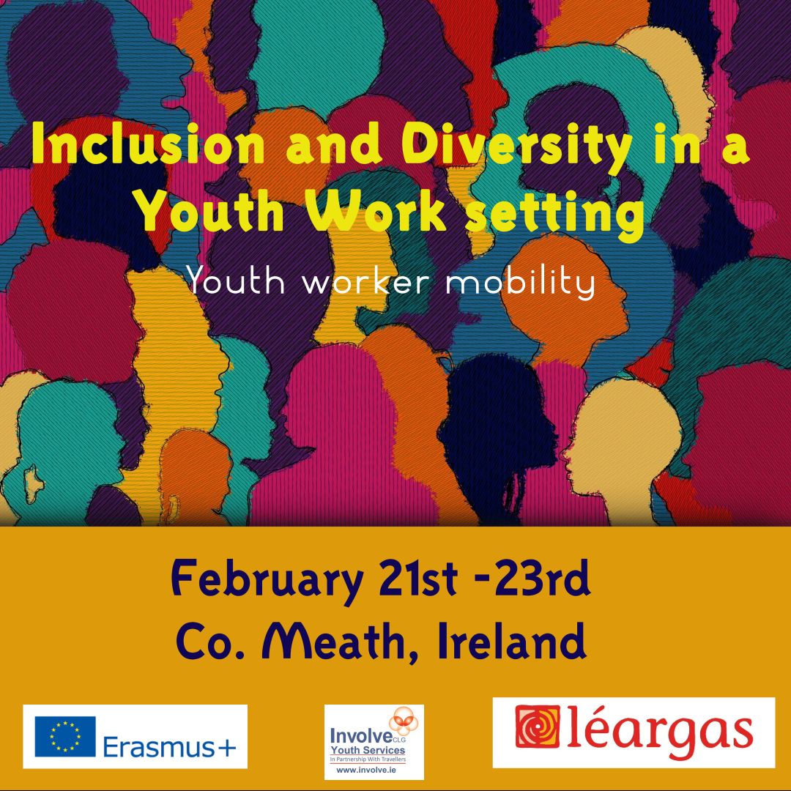

**Who are we?**

We are an Irish Traveller [Ethnic Minority] specific National Youth organisation. We provide 6 Youth projects across Ireland. We facilitate various different non-formal education programmes i.e. arts/Crafts, Science programmes, Summer camps, Community projects, Training programmes to name a few. We work with young people from ages of 6 to 21.

We also participate in European Youth Exchanges, such as in Italy, Belgium, Spain, Bulgaria, and Portugal. Our staff also attend European youth training, seminars and conferences. WE believe in inclusion and diversity for all and youth participation. We see European youth work as a huge opportunity for our young people and organisation to see themselves as European citizens.

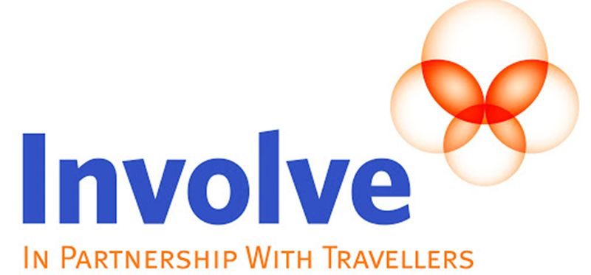

**Objectives of this Project:**

This Action supports the professional development of youth workers and thereby the development of quality youth work at local, regional, national, European and international level, through non-formal and informal learning experiences in mobility activities. The Action contributes to the objectives of the EU Youth Strategy 2019-2027, particularly to the European Youth Work Agenda for quality, innovation and recognition of youth work.

**More specifically this training for youth workers aims to:**

* Provide non-formal and informal learning opportunities for educational and professional development of youth workers, contributing to high quality individual practice as well as to the evolution of youth work organisations and systems;
* Build a community of youth workers that can support the quality of projects and activities for young people in EU programmes and beyond.
* Develop local youth work practices and contribute to capacity building for quality youth work of the participants and their organisation, having a clear impact on the participating youth workers' regular work with young people.

**Theme:**

**Inclusion and Diversity in a Youth Work setting**

By endeavouring to create a welcoming and empowering social environment for young people from ethnic minority groups, organisations can create the conditions so the young people will participate fully and advance with confidence and ready to engage fully in society. By utilising this training and agreeing actions, a youth organisation is taking strategic steps within their services which will ensure better outcomes for young people from ethnic minority backgrounds in their personal life and in society at large.

**Welcome to Slane!**

This training takes place in Rock Farm Slane Village Co. Meath between 20th of February to the 24th of February 2023.

Slane Village Co. Meath is an area situated roughly 40 minutes from Dublin airport. The village stands on a steep hillside on the left bank of the River Boyne at the intersection of the N2 and the N51. The village and surrounding area contains many historic sites dating back to over 5,000 years. The Hill of Slane remained a centre of religion and learning for many centuries after Saint Patrick.

The ruins of a friary church and college can be seen on the top of the hill. It is known that Slane Friary was restored in 1512. The ruins include a 19-metre (62 ft) high early gothic tower.



**Welcome to Slane!**

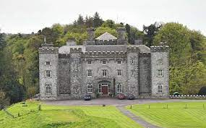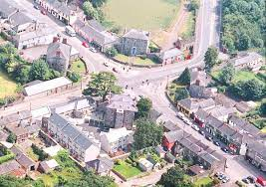Slane Castle Situated in the stunningly beautiful Boyne valley overlooking the River Boyne just a few miles upstream from the site of the famous Battle of the Boyne. The Castle itself is one of the most exciting historic buildings on the island and displays the collective talents of some of Ireland and England’s most distinguished architects. The parklands were laid out by the distinguished landscape architect, Capability Brown.

In the last quarter of a century, music has become central to the tradition of Slane. For years, it has played host to the Festival in Great Irish Houses, but it is for the fabulous open air Rock Concerts in the great natural amphitheatre below the Castle that it has become internationally renowned. On August 16, 1981: Thin Lizzy were the first headline act ever to take the stage at Slane Castle. Over 30,000 rock fans converged from all parts of the country to participate in what turned out to be one of the most successful music concerts ever organised in Ireland.

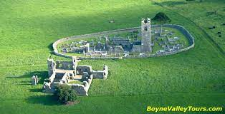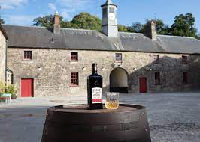Slane is also known for its whiskey and the distillery is located on the ground of Slane Castle.

**Accommodation:**

The accommodation is, Rock Farm, Slane, Co. Meath, C15 FNP4. We will host our workshops in the same building as the accommodation. Participants will be divided into rooms according to gender.

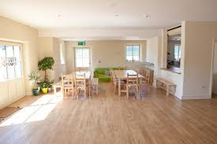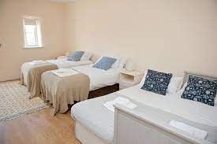 Each morning there will be a continental breakfast for all participants. Lunch and dinner will be provided by a caterer who will come to the accommodation every day.

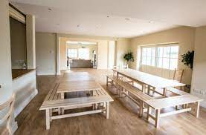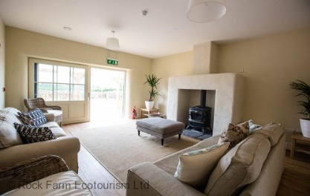

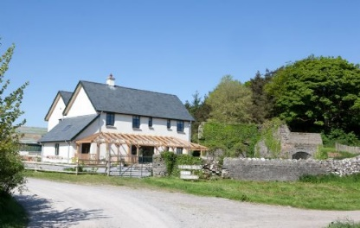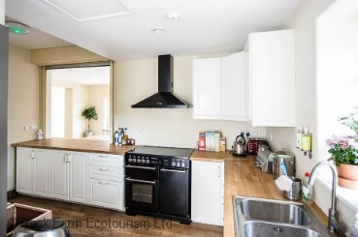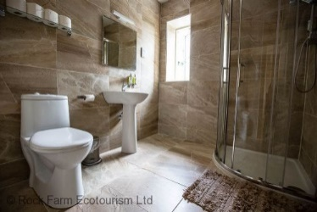

**Timetable**

|  |  |  |  |  |  |
| --- | --- | --- | --- | --- | --- |
| Time: | Monday: | Tuesday: | Wednesday: | Thursday: | Friday: |
| 8am-9am | Arrival Day | **Breakfast** | **Breakfast** | **Breakfast** | **Breakfast** |
| 9.30am-12.30pm | Workshops | Guest speakers | workshops | Departure Day |
| 1-2pm | **Lunch** | **lunch** | **lunch** |
| 2-3.30pm | workshops | Day trip to  Newgrange | workshops |
| 3.30-4pm | Stretch break | Stretch break |
| 4-5.30pm | workshops | workshops |
| 6.30pm | **Dinner** | **Dinner** | **Dinner** | **Dinner** |
| 8-11pm | Meet & greet | Organisation presentation  night | Traditional Irish Pub | Intercultural night |

*All participants must advise Involve CLG of any food allergies or requirements i.e. vegan, vegetarian the week prior to arrival. Breakfast will be a continental breakfast of cereal, yogurts, pastries, tea/coffee/juice. All other meals will be a hot meal.*

**What to bring?**

**Please bring the following items:**

|  |  |
| --- | --- |
| Clothing:  Please bring comfortable clothes and shoes, including a rain jacket/ warm coat. Ireland is cold and wet in February! | Valid documents:  Don’t forget to bring your personal identification card/Passport, visa (if needed) , as well as your European health insurance card |
| Culture Night:  Bring some items from your home country for culture night. This can include snacks, pictures music or dances. | **Hygiene:**  Bring whatever you may need for showering and personal hygiene. Including toothbrush, shower gel, shampoo and sanitary products.  Towels will be provided |
| Organisation details:  Please create a visual presentation of your organisation that you work or volunteer with. This can be a poster or brief slideshow presentation. | **You!!:**  Bring an open mind, enthusiasm, your joy, your fun and your knowledge!!! |

**Rules**

**PLEASE NOTE YOU ARE REQUIRED TO ABIDE BY AL RULES BELOW.**

* Respect all participants, including Facilitators & guests.
* Respect the facility we will be using.
* All participants are required help to clean up after meals.
* Please respect other people’s opinions, and don’t judge.
* Always respect the timetable and be on time to workshops.
* It is **FORBIDDEN** to smoke or vape inside the building at all times.
* The use of illegal substances that alter the normal psychological or biological functions, consumed in the building or on the grounds if **FORBIDDEN**.
* You are required to attend all workshops where possible.
* Any damage caused to equipment in the building, you will be directly responsible for it.
* If you have any allergies or need to take medication for any reason, please notify the facilitators before your arrival.
* The use of candled not being used in the lanterns provided is also **FORBIDDEN.**
* There is a strict noise curfew after 11pm.

**PLEASE NOTE THAT THERE WILL BE A DEDICATED AREA OUTSIDE FOR ALL PARTICIPANTS WHO SMOKE OR VAPE**

**IF ANY ISSUES OR CONCERNS ARISE DURING THE TRAINING PLEASE REPORT TO THE FACILITATORS/ SUPERVISORS [ PATRICK OR KAY.**

**Terms & Conditions**

**Of Rock Farm Accommodation**

**Liability**

* Rock Farm Slane & Facilitators/organisers accepts no liability for theft, loss or damage, of whatever nature, during or as a result of a stay at Rock Farm Slane for the training.
* Any damaged caused to any equipment you will be held responsible.
* Use of Candles – The use of candles inside accommodation units is permitted – all candles must be used inside provided Lanterns and never left unattended or lit overnight.

**Assumption of Risks**

* You will be staying on a working farm with live animals and potentially dangerous farm equipment amongst other hazards. Whilst we take great care to keep you safe, accidents can happen, and we are not held responsible for such accidents

**Guest behaviour:**

Guests undertake to behave in a proper, appropriate, and legal manner with due respect to the owner, the Property and other guests and their property. If any guest behaves inappropriately or improperly (of which the management will be the final judge on their Property), or illegally, the management reserves the right to ask the guest and their party (at their discretion) to leave the Property before the end of the holiday period.

**Emergencies & Useful Contact numbers**

|  |  |
| --- | --- |
| **EMERGENCY NUMBERS** | **Useful Contact numbers** |
| Emergency Police [Garda], Fire, or Ambulance call 112 or 999 and tell the call taker which emergency service you require and what county your in.  When calling emergency services, you will be asked to provide   * The exact address or Eircode of the incident or emergency and/or any noticeable landmark nearby. C15 FNP4 * Directions to the scene of emergency [if known] * The telephone number you’re calling from * Details on the incident/emergency itself. | Patrick McDonagh- Facilitator/Organiser  Contact Number: + 353 86 078 5558  Email: [statustoolkit@involve.ie](mailto:statustoolkit@involve.ie)  Kay McCabe: - Facilitator/Organiser  Contact Number: +353 85 757 2010  Email: [Kay.McCabe@involve.ie](mailto:Kay.McCabe@involve.ie) |

**Travel**

**Please note if you require a Visa for your travel to Ireland, you must pay for your Visa from your own funds. Once you attend the training for the full duration, we will then reimburse you the cost of your Visa.**