ERASMUS+ PARTNER IDENTIFICATION FORM

PARTNER ORGANISATION
OID number |  | E10307077
Full legal name (National Language) |  | AKDENİZ GENÇLİK KLUBÜ
Full legal name (Latin characters) |  | MEDITERRANEAN YOUTH CLUB
Acronym |  | MYC
National ID (if applicable)
Address (Street and number) |  | AKDENIZ UNIVERSITY MANAVGAT TOURISM FACULTY
Country |  | TURKEY
Post Code |  | 07600
City |  | ANTALYA
Website
Email |  | e10307077@gmail.com
Telephone |  | +90 532 443 1943
Telephone |  | +90 530 667 9308
PROFILE
Type of Organisation |  |  | Informal Youth Group
Is the partner organization a public body? |  |  | NO
Is the partner organization a non-profit? |  |  | YES
Main sector of activity |  |  | EDUCATION, SUSTAINABLITY, ENTREPRENEURSHIP
Please specify the main sector |  |  | Digital Learning, Sustainability, and Entrepreneurship
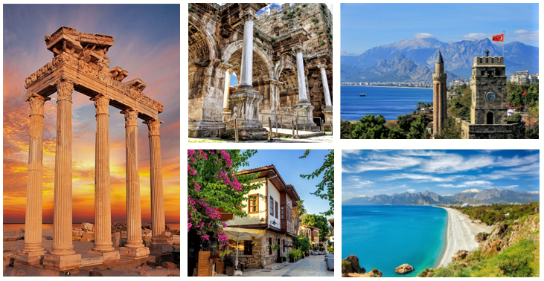
ACCREDITATION
Has the organization received any type of accreditation before submitting this application? |  |  |  | No
European Solidarity Corps Quality Label (supporting organization) |  |  |  | No
Has the organization received/applied for any EU grants? |  |  |  | No
BACKGROUND AND EXPERIENCE

Please briefly present the partner organization.
Mediterranean Youth Club is an informal group consisted of five people who has been working in the field of youth, education, and sustainability.
Aim of the group:
To organize events that help young people and youth workers acquire behaviours that will contribute to the sustainability of the world.
To organize events that will help young people and youth workers gain knowledge and skills, which will contribute to the preservation of their place in society economically and socially in the digital transformation that affects the whole world.
To organize events that will ensure the spread of entrepreneurial ideas and entrepreneurial spirit among young people and youth workers.

Location
We are located in Antalya, one of the most breathtaking in the Mediterranean region. It is known as the "capital of tourism" in Turkey.

Team
The founder and legal representative of our group is an experienced academic who has taken part in many national and international research and EU projects. The legal representative of our group is Assoc. prof. Dr. Ramazan EREN conducts research on the tourism sector, food and beverage sector, vocational training, digitalization in education, sustainability, immigrants, and quality in higher education. He has undertaken different roles as coordinator, partner, and participant in more than twenty projects financed by the European Union.

7 different kinds of international projects have been organized by our team under the umbrella of Akdeniz University. We also took part as a partner in more than 20 different projects organized by other institutions. We have been coordinator, participant and partner in KA1 and KA2 projects.

The topics of the projects we have taken part in so far are as follows.

- Molecular Gastronomy
- Food and Beverage
- Development of Digital Education Tools
- Tourism Industry
- Immigrants
- Environmental psychology
- Sustainability in F&B Industry
- Home economics
- Green Wellbeing
- Blue Wellbeing
- Arts education
- Folk dances
- Cuisines
- Vocational Education
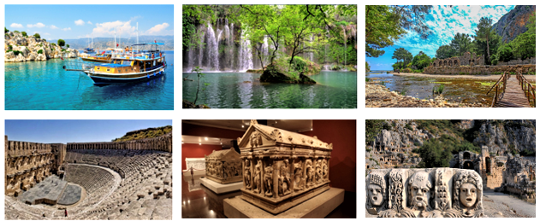

What are the activities and experiences of the partner organization in youth work? Please provide information on your organisation’s / group’s regular youth work activities at local level.
Members of our team still work with university-level youth. We take part in activities at state universities in the Antalya region that we can give as examples, such as giving lectures, organizing youth meetings and organizing activities to raise awareness of youth on sustainability.
European, national, and local governments are moving towards digitization across the entire sector of our society. Educational institutions are also face-to-face with this reality. The group we have established takes education as its main purpose.
The group we have established is a newcomer. The experiences of our members will quickly improve our new group forward. The most important thing of our vision is to have a good time with our new friends by experiencing education in the most fun way.

Please give information on the key staff/persons involved in this application and on the competencies and previous experience that they will bring to the project.
Our manager and legal representative Assoc. Prof. Dr. Ramazan Eren is experienced in organizing and running national, international and EU projects. He graduated from Gazi University, Department of Tourism Management Education and completed his master's degree in Institute of Educational Sciences. In addition, he holds his philosophy of doctorate degree at the Institute of Educational Sciences Department of Tourism Management at Gazi University in 2016. He is currently the head of the tourism management department at Akdeniz University.
The founder and legal representative of our group is an experienced academic who has taken part in many national and international research and EU projects. The legal representative of our group is Assoc. prof. Dr. Ramazan EREN conducts research on the tourism sector, food and beverage sector, vocational training, digitalization in education, sustainability, immigrants, and quality in higher education. He has undertaken different roles as coordinator, partner, and participant in more than twenty projects financed by the European Union.
He has been the author of webs of Science Indexed Publications, Refereed Journal articles, Refereed Publications in conference Proceedings, and books published so far. He has also been the coordinator, team leader, and researcher of many projects. There is an ongoing project in which he is the coordinator, two projects in which he is a researcher and two projects in which he is the team leader.

Our project coordinator İlkyaz Akdemir graduated from Akdeniz University, Manavgat Tourism Faculty, Department of Tourism Guidance in 2022. She took part in the Star Project in Hungary as part of the youth exchange project. She has experience as a hotel guide and as an educator in hotel children's clubs.
She received training on trekking, baby care, the role of women in the family, yoga, and children's education.

LEGAL REPRESENTATIVE
Title | Mr.
Gender | MALE
First Name | RAMAZAN
Family Name | EREN
Position | GROUP LEADER, MANAGER
Email | ramazanerengazi@gmail.com
Telephone | +90 532 443 1943
PRIMARY CONTACT PERSON
Title | Mrs.
Gender | FEMALE
First Name | İLKYAZ
Family Name | AKDEMİR
Position | GROUP MEMBER, PROJECT COORDINATOR
Email | ilkyaz.akdemir@outlook.com.tr
Telephone | +90 530 667 9308

