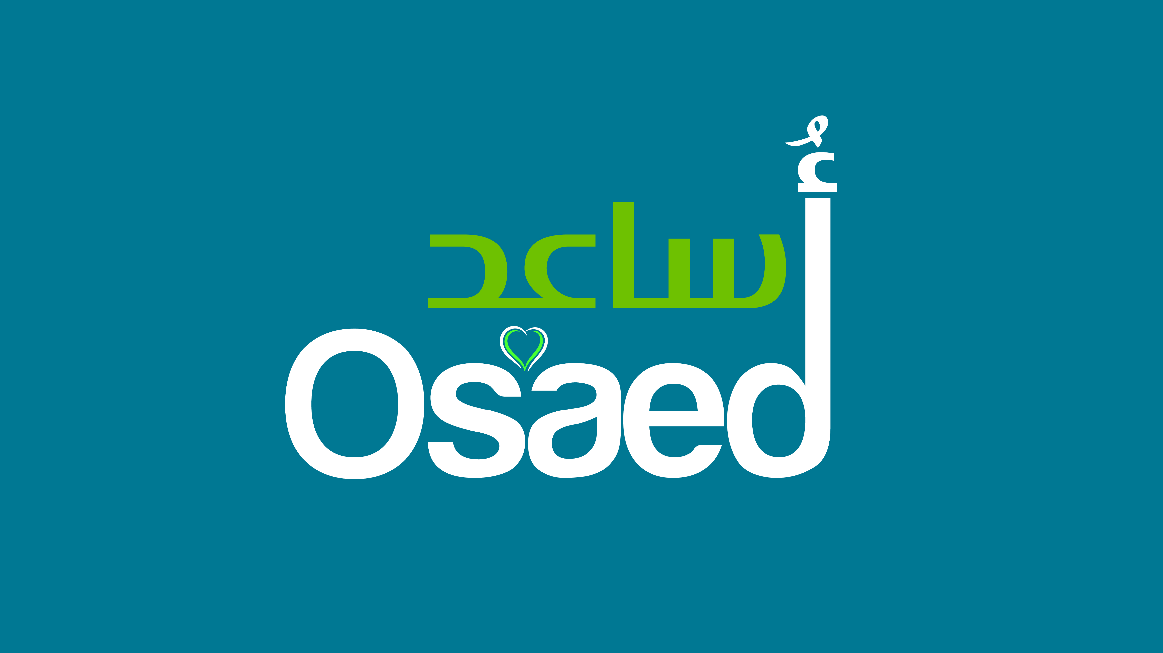
ERASMUS+ PARTNER IDENTIFICATION

Partner organisation
PIC |  | E10258256
Full legal name (National Language) |  | Organisation for Social Actions and Effective Development
Full legal name (Latin characters) |  | Organisation for Social Actions and Effective Development
Acronym |  | OSAED
National ID (if applicable) |  | W751256676
Department (if applicable)
Address |  | 37 rue Washington
Country |  | France
Region
P.O. Box
Post code |  | 75008
CEDEX
City |  | Paris
Website
Email |  | Osaed.online@gmail.com
Telephone 1 |  | 0033613921591
Telephone 2
Fax
Profile
Type of organization |  | Non-Governmental Organisation
Is the partner organization a public body? |  | No
Is the partner organization a non-profit? |  | Yes
Accreditation
Has the organization received any type of accreditation before submitting this application?
Accreditation type |  |  | Accreditation reference
No – In process ESC sending |  |  | No
Background and experience
Please briefly present the partner organization.
OSAED is an independent, non-political, non-governmental, social, development, charitable and humanitarian association concerned with building the human being and activating the energies of the individual and society to achieve self-sufficiency.
OSAED is activist in the fields of humanitarian aid and economic empowerment who focuses her work on developing the skills and capabilities of young men and women to improve their living conditions.
OSAED contributes to alleviating the suffering of the targeted communities through humanitarian, charitable and developmental projects and programs, and is committed to providing humanitarian aid to the poor, needy, and invisible families, and empowering local communities through the implementation of long-term projects, finding durable solutions, and disseminating values, science and useful skills.

Our vision
Living in a society where the basic needs of vulnerable groups are met, and where peace, love and respect for human rights are prevalent.

Our mission
Promoting human values ​​by combating poverty and empowering women and youth in the educational, developmental and professional fields to bring about social change in the lifestyle of vulnerable groups to enhance their role in society.

We aim to empower youth physically, socially, educationally, culturally and professionally through arts, non-formal education and participation in local and international programs and project.

Through Erasmus+, we aim to develop youth projects through national and international partnerships.

What are the activities and experience of the organization in the areas relevant for this application?
OSAED implemented many projects including: Humanitarian Aid after the Beirut port blast, volunteering activities and "Gender Equality through Sports" in Lebanon as part of a consortium in partnership with IECD and funded by the French Ministry for Europe and Foreign Affairs and the Government of the Principality of Monaco.

We are active in Lebanon through partnership with local Lebanese NGOs.

OSAED is young NGO (established 2020) but the founders and members are experienced in project management, youth work and trainings.
What are the skills and expertise of key staff/persons involved in this application?
Bassam Baki, having a PhD in Computer Sciences and more than 12 years of experience in project management and about 7 years in women and youth empowerment.
He is experienced in proposal writing, fundraising, reporting and finance issues of NGOs.

Hussain Noun has a master in telecommunication but active in youth empowerment domain. He has 4 years of experience in Humanitarian domain.
Legal representative
Title |  | Dr.
Gender |  | Male
First name |  | Bassam
Family name |  | Baki
Department |  | Youth
Position |  | Co-Founder and treasurer
Email |  | bassbaki@gmail.com
Telephone 1 |  | 0033613921591
 | If the address is different from the one of the organization, please tick this box
Address
Country
Region
P.O. Box
Post Code
CEDEX
City
Telephone 2

