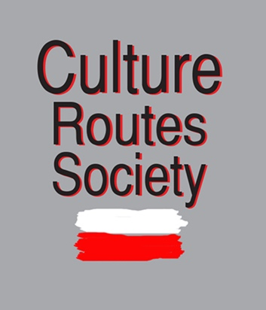 St Nicholas Ways Volunteering group 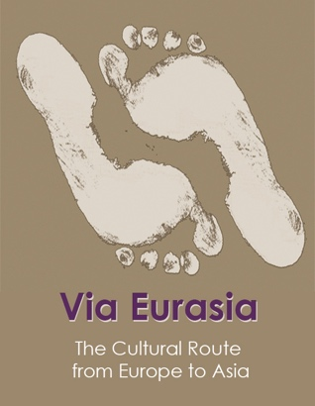

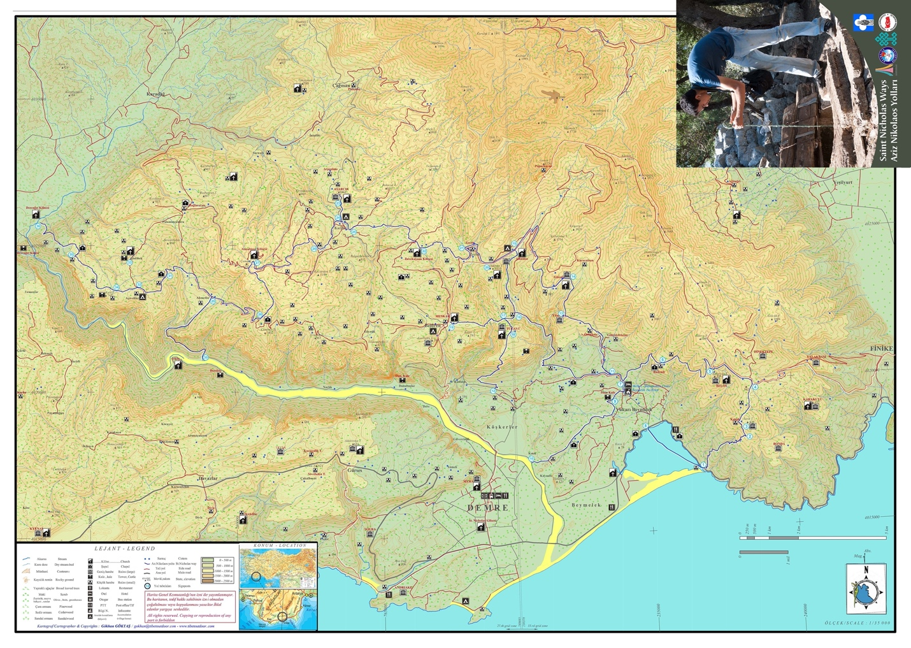

Culture Routes Society
Haşım İşcan Mah 1297 So no 14 Antalya
Tel: +90242 2431148 (landline) +905325885358 (Kate) +905326044487 (Hü)
www.cultureroutesinturkey.com
youtube: https://www.youtube.com/channel/UCWm3ZOfL4Zpxs3MybmvIHfA

ESC work camp number: ESC11-St Nick between 11th Sept and 4th Nov 2021 (42 days).

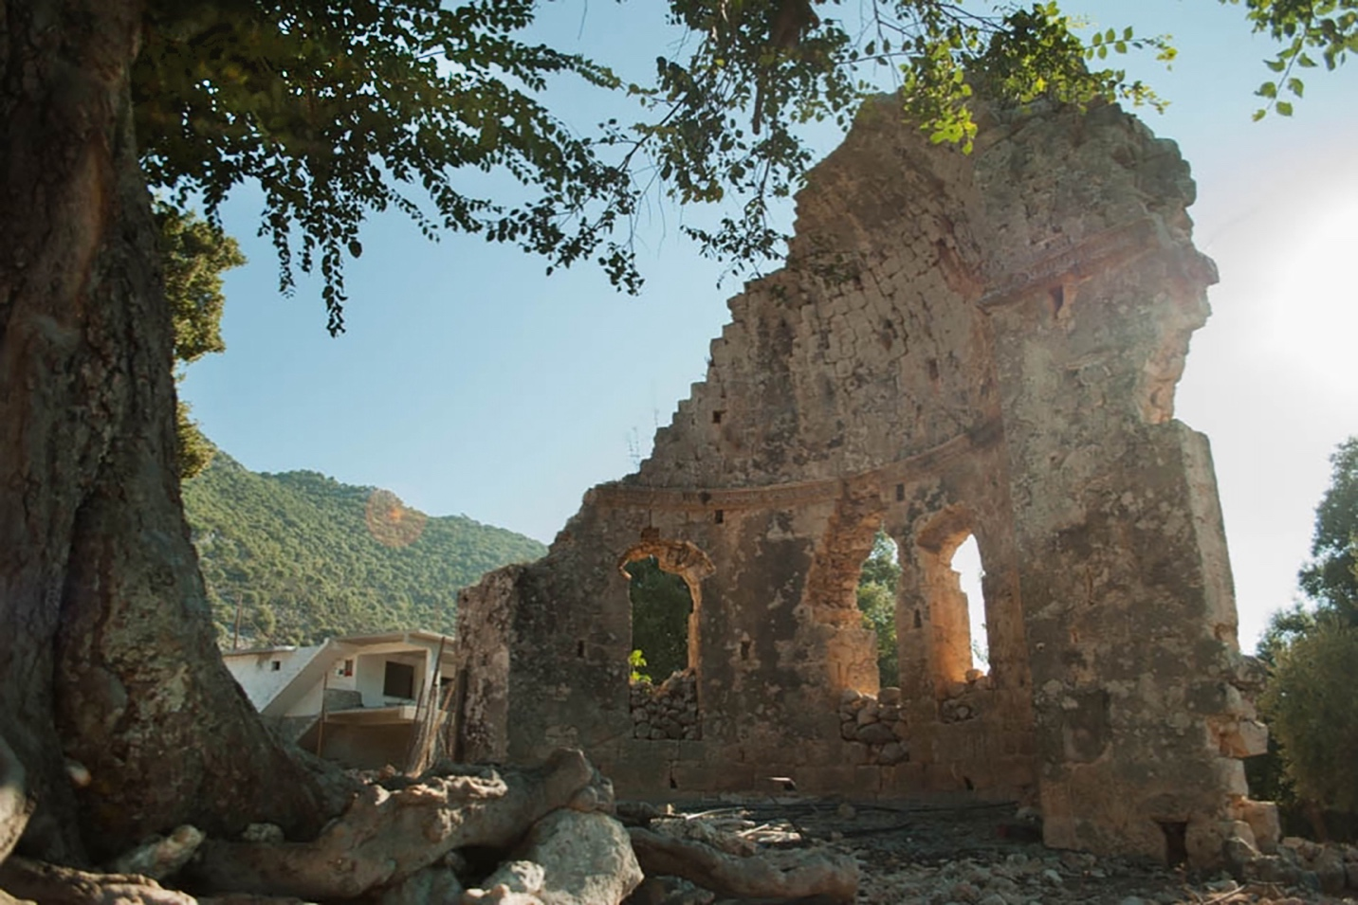

Start and end dates:
Start: You can arrive any time you like after 11th and before 17th Sept, according to your flights, etc. We will all meet at the CRS offices in Antalya (where there is some accommodation). This gives you a chance to explore Antalya before we move to the work site, which is 3 hours away. Anyone who arrives before 17th will also help the leaders prepare equipment and shopping.
On 17th we will travel to Demre (3 hrs) and stay at a campsite close to the sea. You have a chance to explore Demre/Andriake.
On 19th there is an art performance near the campsite, so we will go to that.
On 20th, we will move to the work-site - we will set up home in a building in a small village called Muskar. This area will be our base for the next few weeks.

End: the camp officially ends on 4th November, but you could choose your outbound flight from Antalya just before that date. In this case, you will return by yourself to Antalya, but you may be able to stay at the office before you fly out. The last people to leave will help pack up all equipment and return it to the office in Antalya.

Travelling:
We need to know where you will travel from and where you will return to and the most convenient dates for you. If you want a particular flight, please tell us. Charters direct to Antalya are best; Pegasus and Turkish Airlines are the main airlines flying from everywhere into Antalya, but you might have to change at Istanbul. Since it's the end of season, you may have to come by charter and go by scheduled flight. We have a limited budget for flights, but we will try to offer you a choice.
We will check flights and send you info before we buy your tickets; you need to confirm immediately.
Antalya airport is huge. It has direct flights from many places in Europe. There is a high-level tramway just outside the domestic terminal 1, but it is closed from about 10pm to 6 am. The tram runs from the airport to a point 10 minutes walk from the office.
There are buses that run between those hours.
Taxis are also outside the domestic terminal; about 70-80 TL to the office.
Tramway start point (airport) 36.913866°, 30.803418° (all trams take the same route)
Tramway stop for office (İsmetpaşa) 36.893428° 30.701703°
CRS Office (1297 Sok no 14, Haşım İşcan Mah). Next to Antalya Lisesi (High School). 36.883219°, 30.710090°

Leaders and communications:
There will at all times be 2 leaders with the group; sometimes 3; (Erdinç, Onur and Murat); all speak English and Turkish; Murat speaks Dutch. This is because the group will be divided into two workgroups for much of the time. In addition, a volunteer may stay behind at base to prepare food, work on photos or films, prepare blogs, etc. Villagers will be around, but do not speak English, so you have to learn to communicate!
The leaders are responsible for arranging the work and the groups; tell them your skills and ask them about your preferences. The leaders will show you how to use the tools; if you are using sharp tools, don't work too close together.
You should never work or walk on your own; stay close to the group and make sure the leader knows where you are. You must have a phone with the leaders' phone numbers with you at all times. We will use a whatsapp group to message. In a few places, telephones may not work well or you may have no signal at all. Check the signal before you set out walking!
Leaders will have first aid kits; there are health clinics and state hospital at Demre. COVID tests and treatment (and all other treatments) are available there.

Working times and places:
You will work 5 days per week; you may not have the same days off each week. It's very difficult to plan your working hours exactly, because the routes are spread out like a spider's web! So one day you may be working close to base, so you can walk to the work place; another day you may have to travel there by pickup or minibus, or be collected after the work.
On some days, the travel time may be long, or you may have to wait for transport, so you may have a long day.
Some parts of the route are far from base camp. So for parts of the project, the leaders will set up camp at separate locations, and one team will sleep, cook and eat there for a few days. Normally, this will be at the edge of a village, so you will have access to a toilet and shower.

Geography and history:
The area is a hilly limestone area about 300-500 m above sea level, on the north side of the Demre gorge. Above/north is Alacadağ (many-coloured mountain), which rises to about 2000m. So in many places there are great views. The area is partly forested with pine, and partly ancient terraces or slopes, and partly areas of mediterranean scrub, with spiny bushes. There is only one asphalt road; other roads are unsurfaced and rough. The paths are rough and stony.
In the 2nd C BCE, the first (Lycian/Roman) settlements were built in this area - usually defensive towers. They spread gradually northwards. In the 5th-6th C CE, groups of monks started building monasteries here. There are about 10 large churches, all built to a similar plan, and many smaller chapels, village buildings, workshops etc. The monks and villagers built paths and roads between churches, terraced the hillsides and built wells; our network follows the old paths between the churches. We are still finding more churches and chapels, at least one a year. We expect you to discover something!

In the 9th C, the area was abandoned and not re-occupied until the 18th or 19th C, so the remains are a snapshot of a specific Byzantine period. You will learn a lot about Byzantine history and how to identify ancient ruins.
Today there are scatttered villages and camps of shepherds with their flocks of sheep and goats, and forestry workers.

Working conditions:
You will be away from base or camp for the whole day, so you will take a picnic and enough water to last all day. You will also take work gloves, hand-tools and paint and brushes for waymarking. It's your responsibility to make sure you have everything you need before you leave base and to look after your equipment (eg. refill paint bottles) when you return.

You will be outside all day, so you should have sunscreen or sunblock, sunglasses, a long-sleeved shirt and long trousers, a sunhat and scarf. Your feet are most important - you need comfortable boots or thick-soled walking shoes and good thick socks. Your clothes will get torn or marked with paint - bring plenty of old clothes!

We want you to record what you are doing. One of the group or the leader will record a gps track on their phones. We have the following equipment - movie camera, tripod, etc, drone, a good-quality pc for uploading and editing film and photos. If you have some media skills, you are welcome to make a film, blogpost, social media posts or whatever you want to do. We will use the gps tracks to update the maps; if you have previously worked with QGIS or open street map, then please let us know! If you use the equipment, take care of it!

One of the leaders may take a small group on foot to do some difficult/inaccessible work or look for new routes; this area has many ancient ruins so this gives you a chance to find something new. Exploring groups may carry extra food and sleep out for a night.

Base:
Our working base is about 45 minutes by bus, up a steep hill, from Demre, in Muskar village.
Demre has the nearest shops, bank, reliable internet and restaurants etc. The village is small, with mainly stone houses, but our base is a two-storey building. The top floor is one big room which will be the sleeping area, so there is very little privacy! (You can sleep in a tent if you wish).

The ground floor has a shower, toilet, terrace where you can eat, indoor space where we can set up a kitchen. We may cook for ourselves, or one of the village women may prepare evening meals. Opposite is the forestry firefighters' depot; they have a terrace where they will offer us tea and gossip. We will arrange to use their shower/toilet too. The firefighters will help with water, transport, etc. The school bus goes from outside our building down to Demre (45 mins) each morning and comes back at around 3.30pm, so you will meet the schoolkids. The bus drivers will also help us with transport.

We will have a full set of tents, sleeping mats, some sleeping bags (if you don't want to bring your own), cooking equipment, a few spare rucksacks and all the work equipment. You need to bring a small rucksack to carry your equipment and water for the day.

There is no shop in the village, so you have to organise personal shopping on your days off. There is internet, but not always reliable.

Days off:
You will have 2 days off each week and can spend them at the Andriake camp site at Demre. It has showers, washing machine, beer, snacks, internet and there are shops and a cafe nearby. The campsite is close to a beach, river and a harbour. From there you can visit the Lycian Civilisation Museum, the historic site at Myra, the church of St Nicholas, or walk on the Lycian Way, organise a boat trip, take a bus to Kaş or Üçağız, etc etc. Your days off may not be at the weekend, and you may not all be off at the same time. Your leaders will help you arrange activities.

ESC and Money:
This is a European Solidarity Corps project, so officially has to be organised with a sending organisation (insurance, etc). Normally all the volunteers would come from one country, but you come from 6 different countries!!! So we are still arranging sending organisations. More later.

Apart from a payment to the sending organisation for your insurance etc, we pay:
- flights. At this moment, you need a covid test for entry to Turkey, but the rules may change. You are responsible for checking the rules on the Turkish embassy site for your country. We have no specific money for COVID tests.
- transport from office to Demre and back after the camp
- transport to different work areas and to Demre/Andriake for your time off
- all your food and drink while you are working
- all tools and equipment, paint, first aid, etc
- camp site for days off (if you want to spend a night somewhere else, then it's at your expense).

We give you 45 euros per week (pocket money plus some money for food on your days off).
Remember that there is nowhere to spend money in the village. 45 euros is about 450 lira; a can of beer from a shop is about 15 lira; cigarettes are about 18 lira.

-

