Let’s explore the labor market Youth Exchange
Zakopane, Poland
11-24.06.2021
Daily plan
 | 11.06 | 12.06 | 13.06 | 14.06 | 15.06 | 16.06
8-10 Breakfast | Arrival | Breakfast | Breakfast | Breakfast | Breakfast | Breakfast
10-13 |  | Getting to know each other  Presentation of the program | Erasmus +, Youthpass | Job hunting tolls  Cultural work stereotypes | Mountains trip | Dragon’s dean
13-15 Lunch |  | Lunch | Lunch | Lunch |  | Lunch
15-18.30 |  | Fears and expectations  Team building | What is entrepreneurship  Who is successful in business | Business ideas  Promotional campaign |  | Business negotiation
18.30-19 |  | Team leaders meeting | Team leaders meeting | Team leaders meeting | Team leaders meeting | Team leaders meeting
19-20  Dinner |  | Dinner | Dinner | Dinner | Dinner | Dinner
 |  | Integration Evening | Intercultural evening | Free evening | Free evening | Free evening

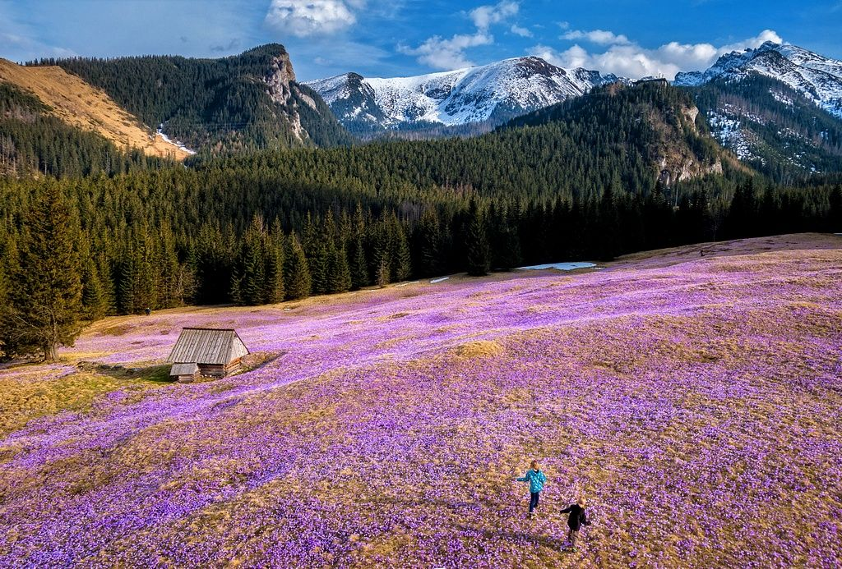
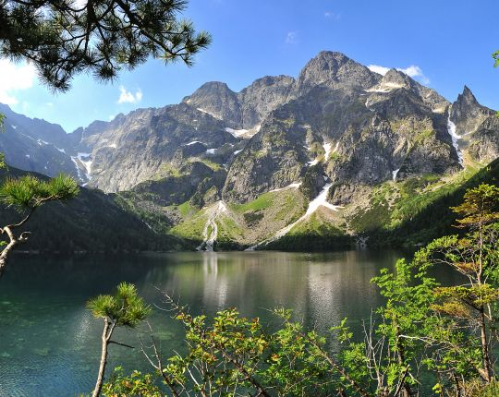

 | 17.06 | 18.06 | 19.06 | 20.06
8-10 Breakfast | Breakfast | Breakfast | Breakfast | Breakfast
10-13 | Greek workshops | Mountains trip | City game | City game results  Fighting with unemployment
13-15 Lunch | Lunch |  | Lunch | Lunch
15-18.30 | Italian workshops |  | City game | Polish workshops
18.30-19 | Team leaders meeting |  | Team leaders meeting | Team leaders meeting
19-20  Dinner | Dinner | Dinner | Dinner | Dinner
 | Free Evening | Free Evening | Free Evening | Free Evening

 | 21.06 | 22.06 | 23.06 | 24.06
8-10 Breakfast | Breakfast | Breakfast | Breakfast | Departures
10-13 | Mountains Trip | Bulgarian workshop | Follow-up and dissemination activities for project  Youth pass preparation
13-15 Lunch |  | Lunch | Lunch
15-18.30 |  | Erasmus+ project proposals | Reflecting and feedback activity
18.30-19 | Team leaders meeting | Team leaders meeting
19-20  Dinner | Dinner | Dinner | Dinner
 | Free evening | Free evening | Farewell Party

