CVs of project team

Position in project | President of the association
Surname, First name | Samil Mrkonja
Organisation | Youth club “Dijamant” Jajce
Position/Category | Youth club
Telephone | +38761 562 199
Email | ok.dijamant1@bih.net.ba | Website | ocd.dijamant.net
WORK EXPERIENCE (please include all relevant positions):
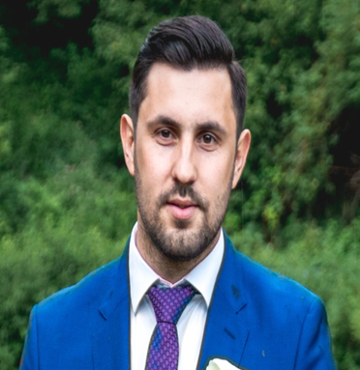

- 5 years of experience in non-government, non-profit civic organizations.
- 10 years of experience in working with young people, and the implementation of large and small projects
- 4 years of experience in working with the Sportina group as a sales person

Technical skills:
- Excellent knowledge of Microsoft Office tools (Word, Excel, Powerpoint)
- Good knowledge of graphic design applications (PhotoScape, Pixler o matic)
- Good knowledge of working on the Internet

Foreign languages:
- Good knowledge of English (basic level of speaking, writing and reading)
- German (A1.A2, currently)

Personal characteristics
- Excellent communication skills
- Ability to work in stressful situations
- Rich experience in working with people and team work
- Responsibility and meticulousness in work
- Excellent motivation
- Creativity and efficiency

EDUCATIONAL BACKGROUND (please detail all relevant studies):
Samil Mrkonja

- 2006 - 2010 Secondary vocational school / Construction technician, Jajce
- 2010 - 2016 Faculty of Criminology / Criminology, Sarajevo

PUBLICATIONS (list publications with a links)
MEMBERSHIPS (list names and websites of the organizations/associations you are member in)

Position in project | Member of the Board of Directors
Surname, First name | Maida Makić
Organisation | Youth club “Dijamant” Jajce
Position/Category | Youth club
Telephone | +38762-645-156
Email | majda.makic89@outlook.com | Website | ocd.dijamant.net
WORK EXPERIENCE (please include all relevant positions):
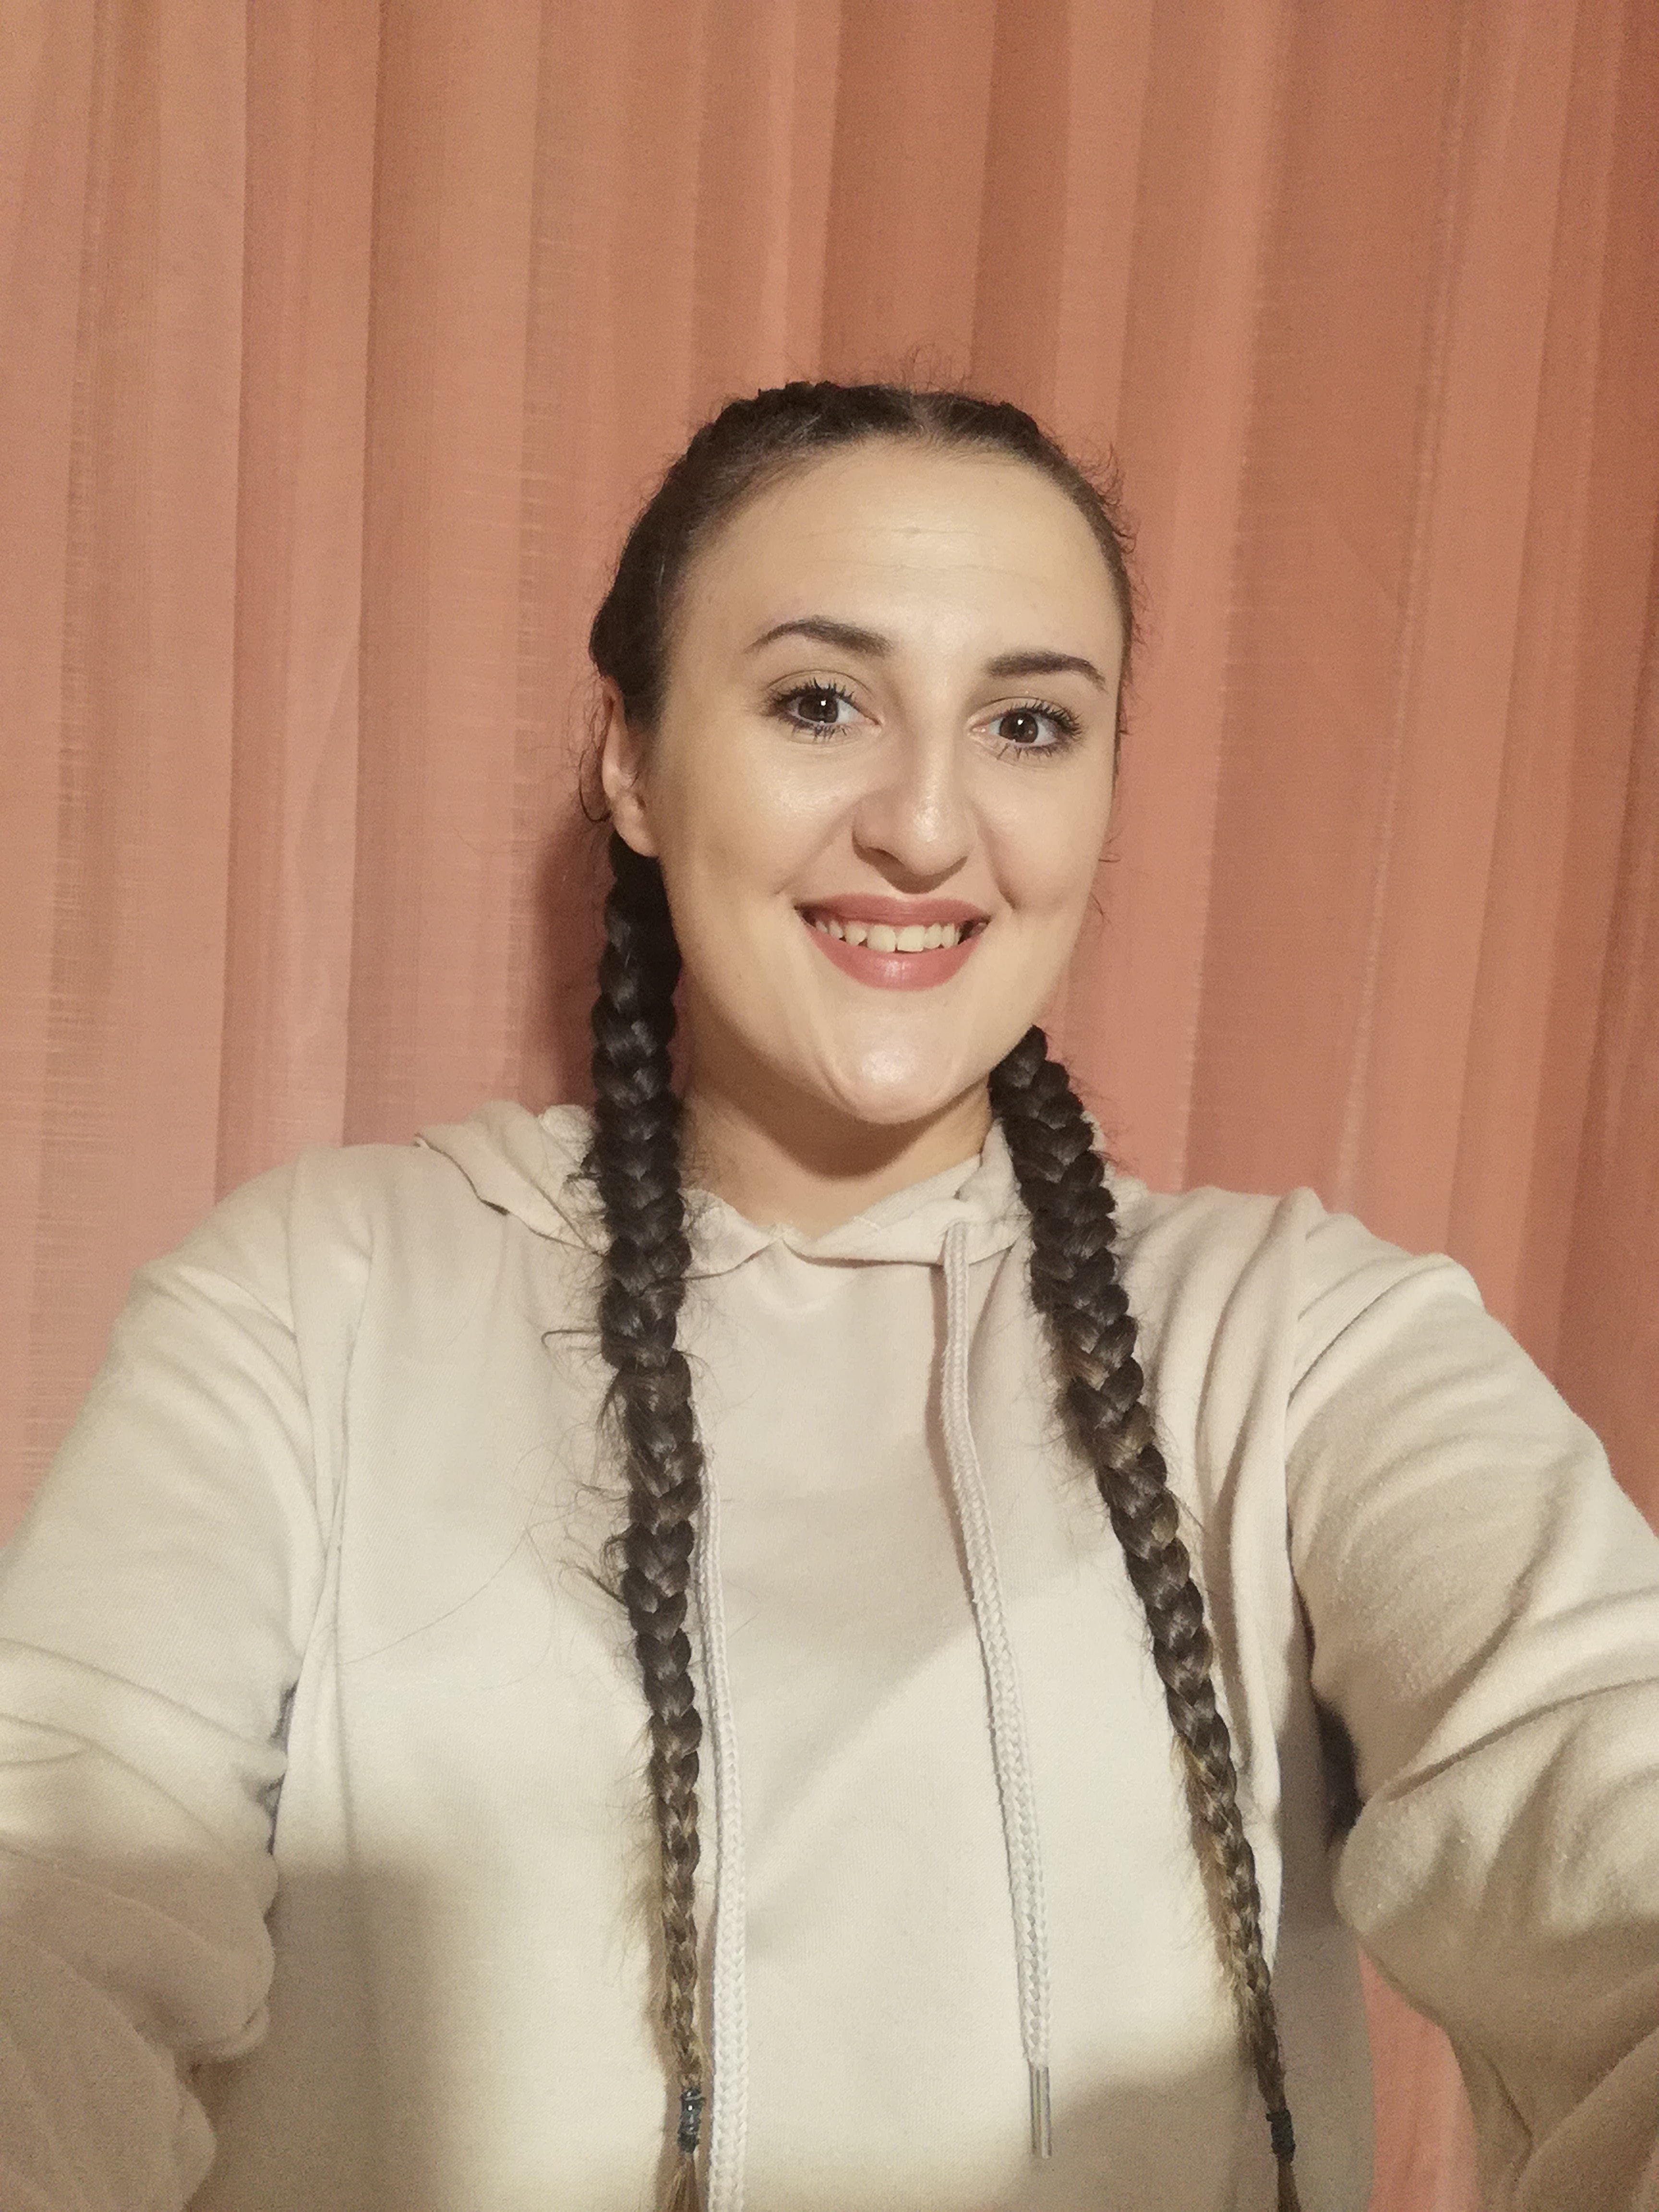

- 4 years of experience in working in the youth club “Dijamant”
- 1 year of experience in working in the Center for Education and Socializing – volunteer

During my volunteer engagement, she participated in the implementation of more than 30 projects, such as "Interethnic dialogue of young people in the community", "Young drivers of local community development", "Sport is the best communication". a lot of new skills in youth work.
Participated in the international meeting "Data me", Erasmus + program in Germany in Magdeburg.
She has been active in the field of sports for many years. Assistant coach at the Jajce Nansen volleyball club. Has extensive experience in working with young people, active through the cultural and artistic society and has been leading a folklore and dance group for 5 years. International volunteering in Germany, bastard Achen, 12 months 2019/20. Areas of interest: Education sector, sports education and training, marketing, management

Foreign languages:
- English A1
- German B1

Personal characteristics
- Excellent communication skills
- Ability to work in stressful situations
- Rich experience in working with children and young people, as well as in teamwork
- Responsibility and meticulousness in work
- Excellent motivation
- Creativity and efficiency

EDUCATIONAL BACKGROUND (please detail all relevant studies):
- 2014 – 2018 High school of economics "Nikola Šop" Jajce

Seminars:

"Interethnic dialogue of young people in the community", - seminar
"Young drivers of local community development" - seminar
"Data me" Magdeburg - International meeting

PUBLICATIONS (list publications with a links)
MEMBERSHIPS (list names and websites of the organizations/associations you are member in)

Position in project | Member of the Board of Directors
Surname, First name | Makić Šekib
Organisation | Female Volleyball Club "Jajce - Nansen", Jajce
Position/Category | Female Volleyball Club
Telephone | +38761179209
Email | makicsekib84@gmail.com | Website
WORK EXPERIENCE (please include all relevant positions):


- Over 30 years of experience as a sports team coach,
- Over 15 years of experience in non-government, non-profit civic organizations.

Project manager on the following projects:

PROJECT | YEAR | DONATOR
Construction of street lighting from home to school | 2007 | Foundation "MOZAIK"
Let's build our playground | 2008 | Foundation "MOZAIK"
Creating more favourable conditions for more active youth work in the community | 2009 | Danish Refugee Council  IRISH-AID
We are for an environmentally friendly environment | 2009 | Ministry of Physical Planning, Reconstruction and Return of SBK
Spreading environmental awareness among young people | 2010 | Ministry of Physical Planning, Reconstruction and Return of SBK
Roadmap for Customs and Tradition | 2010 | SBK Ministry of Education, Science, Culture and Sports
Strengthening youth activism and youth rights | 2010 | CPCD,Sarajevo
Equally the same | 2010 | BH Telecom
Young drivers of local community development | 2010 | American Embassy, ​​Sarajevo
Why not what is important | 2012 | European Commission
Be a volunteer | 2012 | Foundation "MOZAIK"
Games on Bosnian Carpet | 2012 | SBK Ministry of Education, Science, Culture and Sports
Preservation of Cultural Heritage through handicrafts | 2013 | UNDP BiH
We live healthy and active | 2013 | Jajce Municipality
We Are Change | 2013 | American Embassy, ​​Sarajevo
We live healthy and active! | 2013 | Jajce Municipality
Youth in Action! | 2013 | Ministry of Physical Planning, Construction, Environmental Protection, Return and Housing of SBK
Come into the circle | 2013 | SBK Ministry of Education, Culture and Sports
Preservation of cultural heritage through handicrafts | 2014 | Federal Ministry of Culture and Sports
Guardians of customs, culture and tradition through participation in the EKOBIS fair | 2014 | Jajce Municipality
Preserving cultural heritage by attending the manifestation “Our days” | 2014 | BK Ministry of Education, Culture and Sports, Culture Sector
Action for recreation | 2014 | Center for the Promotion of Civic Initiatives (CPCD) Sarajevo (Sport Association Donji Vakuf)
From tradition to craft, from weaving and sewing to profit | 2014-2015 | Federal Ministry of Environment and Tourism
Thank you for protecting your environment | 2016 | Ministry of Physical Planning, Construction, Protection, Returns and Housing of SBK
Creating more favourable conditions for quality youth life | 2015 | Federal Ministry of Culture and Sports
Days of Our Return (13th manifestation) | 2016 | Jajce Municipality
Cultural Days through Manifestation “Days of Our Return” | 2016/17 | Federal Ministry of Culture and Sports
Days of Our Return (13th manifestation) | 2016 | SBK Ministry of Education, Culture and Sports, Culture Sector
Days of Our Return 1992-2016 | 2016 | „JP BIH POŠTA“ d.o.o. Sarajevo
Days of Our Return (13th manifestation) | 2016 | Cantonal Ministry of Education, Science, Culture and Sports
Old crafts for a new age | 2016 | Federal Ministry of Environment and Tourism
Affirmation of Returnee Population through Education and Training for Employment and Self-Employment | 2016 | Ministry of Human Rights and Refugees
Let's make them dream through an open fun volleyball school | 2016 | Federal Ministry of Culture and Sports
Days of Our Return (14th manifestation) | 2017 | Jajce Municipality
Sport is the best communication | 2017 | US Embassy in BiH
Affirmation of unemployed young people through education and training for employment and self-employment | 2017 | Federal Ministry of Culture and Sports
Making souvenirs and decorative packaging to a better tourist offer | 2017 | Federal Ministry of the Environment and Tourism
Education to suppress drug abuse | 2018 | Federal Ministry of Education and Science
Direct @ motivated | 2018 | Federal Ministry of Education and Science
Diversity connects | 2018 | Ministry of Education, Science, Culture and Sports-the SBC / KSF Culture Sector
Days of Our Return (14th manifestation) | 2018/19 | JP BH POŠTE
Partners on the project ”BHRI 158-In Pursuit of Bosnian Riches”  Institute ”Perpetuum mobile” Banja Luka | 2020 | IOM BiH
Participation in the project “STEP” (Systematic transparency in the election process)  Implemented by the Coalition “Under the Magnifier” | 2020 | European Union

EDUCATIONAL BACKGROUND (please detail all relevant studies):
- Elementary school in Divičanima year 1977 Jajce

- Hospitality and Tourism Middle School Novo Mesto Slovenia

- May 26, 2001 graduated and obtained the right to a diploma and the professional title Teacher of preschool education.

- February 14, 2006, obtained the right to a diploma of higher education and professional title: Professor of Preschool Education.

- 2002/04 completed his studies and part-time at the "Basketball Center", Banja Luka
- Title, Senior Basketball Coach;

- School year 2007/10. Pedagogical course, graduated from the Faculty of Sport Sciences Banja Luka, and obtained the title: Professor of Physical Education

PARTICIPATION AT SEMINARS:

- Participation in several workshops, trainings organized by local and foreign institutions, NGOs.
- «General Elections 2010»: Perspectives and Expectations »National Endowment for Democracy» Banja Luka International Press Center 11.09.10.
- "Corruption - Causes and Consequences" Transparency International BiH 28th and 29th 10 / 10 Banja Luka.
- Professional and ethical standards in reporting on marginalized groups »Helsinki Committee of Citizens of Banja Luka, from 29th to 30th 10/10 in Sarajevo, Hotel Bosnia.

ACKNOWLEDGMENTS:

Gold plaque of the Ministry of Education, Science, Culture and Sports of the SBK. Sports worker 2008.
Acknowledgment of the SBK Sports Federation, Sports Worker 2008.
Acknowledgment of the Jajce Sports Association for the development of Volleyball Sport in Jajce 2018.
Acknowledgment of the Sports Association of the Municipality of Jajce, for active work in sports 30 years in 2019.
More other social honors before 1992

CERTIFICATES:

- «Nansen LILLEHAMER Academy»Norway »Inter-ethnic Dialogue and Meditation»
- Human Resources Development EU Projects 2012.
- Education Center for Democracy and Human Rights CIVITAS ”, for successful participation in the cantonal competition" PROJECT CITIZENS "2008.
- IPAK youth builds the future, writing projects for the European Commission Youth in Action 2010 program.
- Nansen Dialogue Center Sarajevo, successfully completed the workshop "Gender Equality" 2018.
- Finland SSS pp Bosnia and Herzegovina, vocational training program for enhancing social work skills 2003.
- ProBeniFit Consulting-Business Consulting Agency. “Drafting a Project Proposal.” Gradačac 18.11.2011.
- Nansen Dialogue- Lillehamer, Norvay, 25th May to June 1st 2010 “Inter-ethnic Communication.
- Zusammenarbeit-dvv Internationale. “Education of Personnel for Educational Work with Adults” 2006/2007, Sarajevo.
- Center for Promotion of Civil Society CPCD, Sarajevo “School for Leaders” 2013.
- UNDP in BiH, “Training for Local Development Moderators and Promoters, 2013
- Sarajevo Peacebuilding Network “Communication as a Basis for Relationships, Trauma in the Reconciliation Process and Identity and Mourning in 20012.
- Nansen Dialogue Center Sarajevo “Writing a project using the LFA method” Sarajevo 2014

MEMBERSHIPS (list names and websites of the organizations/associations you are member in)
o Founder and member of the Association "Omladinski klub DIJAMANT" in Jajce, 2004. President of the association since 2004.
o Founder and Member of the Basketball Club "Vodopad" Jajce (2004).
o Founder and member of the Jajce Women's Volleyball Club, (2009).
o Chairman of the Board of Directors of BC "Vodopad" 2004-2012
o Coach of the Basketball Club "Vodopad" Jajce from 2004-2012
o Coach of the Jajce Women's Volleyball Club since 2009 junior category
o Secretary of the Sports Association of Jajce Municipality, since 2008.
o Member of the Governing Board of the SBK Sports Federation since 2009.

