Infopack for ESC volunteer
Key in action 1
Learning mobility of individuals
"Build your future"

2020-10-01 – 2021-09-30
Telšiai, Lithuania
TELŠIAI YOUTH CENTRE
Description of organization
Telšiai Youth Center - non-formal educational institution engaged in open work with youth. There are four directions where we are working to: Youth center of Telšiai, Mobile youth work in rural areas of Telšiai, Youth space of Varniai and Learning through experience center.
Our goals:
- to develop a conscious personality, capable to find responsible and creative solutions of their problems and to participate actively in society;
- to enable youth to express themselves;
- to accompany young people in initiating and organizing activities, events, projects;
- to reach passive, non-organized young people from the risk families, at the same time to pull them from the negative impact of the street and give them assistance;
- to develop communication skills and work with the themes emerging from everyday situations;
- to encourage socialization processes, self-knowledge, develop imagination, reflection, relaxation;
- to reach youth in rural area of Telšiai;
- to use outdoor (hikes, camps, height activities, etc.) as a tool for learning;
Organization exists since 2007 and it is one of the main youth centers of attraction. Here come young people who have very different interests, experiences and social position. Youth Center activities include a variety of areas: place to come and just be without any particular activities, communications, and meetings with friends, playing music, sports activities (camps, hiking, height activities, outdoor), healthy living, healthy food, and access to the Internet, themed evenings, training, creative workshops. Youth workers are available for every young person who wants to get help in depressive, difficult situations or just to have chat about something anxious.
All activities follow principles of non-formal education - attempting to create a safe, secure environment, do the move, reflect on experience, make conclusions and try once more. We are encouraging young people to active participation, learning from the experience, reflecting on what is going on, informal communication and teamwork. It is not intended for results. Everything is focused on the process.
Youth Center is available to all young people of both sexes from 14 to 29 years, who is looking for a safe environment, new communication, stay together forms, who have free time, but do not know how and where to spend it. Young people run various projects and implement them. Ongoing projects include a variety of fields: music (playing guitar, drums), sports (sports, games, board games, orienteering, hiking), art (workshops), organizes thematic afternoons and evenings (if needed). We do summer camps (healthy lifestyles, survival, and military), hiking, biking, using forests, night time, and height construction in Learning through experience center.
The duration of this project – 12 months. We have two volunteers at the same time. One volunteer will work with young people at Telšiai Youth Center and another volunteer will work in mobile work and go to meet young people every evening in different 9 villages arround of Telšiai. Volunteers will be actively involved in the activities - will help administrate activities of hosting organization for youth workers, will be in contact with young people, in the small daily activities (developing social skills of young people - cooking day, housekeeping day and so on), in organizing thematic workshops , camps, hikes, height tasks in Learning through experience center, in spreading information about the organization out in public, preparing presentations in other institutions (Unemployment Centre, schools), on the street. Work schedule and tasks for volunteers will go together with the season - spring and summer activities will be outdoors (next to the Open Telšiai Youth Centre, in the area of Learning through experience center, in the rural areas - stadiums, parks, where young people like to be). During the cold season, more indoor activities inside the Youth Centre. In the rural areas - schools, halls of sport, houses of community, centres of culture etc.
One of the biggest challenge for volunteers is to understand that most of all youngsters are not motivated to do something at youth centre. So the main task is to learn to communicate with them. To try to be in good contact and find activity which is interesting for the youngsters. Here you don‘t find every day super active at youth center. We play table games and just talk with the youngsters most of the days. But every week we think and plan what we can do more, how we can change daily routine. And giving a chance to participate in different activities.
About working hours in mobile work with youngsters:
Monday – Friday:
12.00 – 15.00 pm - at office (reports, writings, planning activities, evaluation and etc.);
15.00 – 16.00 pm - free time;
16.00 – 20.00 pm – going to one of 9 villages, time with young people (communication, activities);
Saturday – Sunday – off days (sometimes we work when we organise activities).
Info video about the youth centre: https://www.youtube.com/watch?v=FV0vpwVgzDw&t=2s
https://www.youtube.com/watch?v=4Hp69YQBg-8
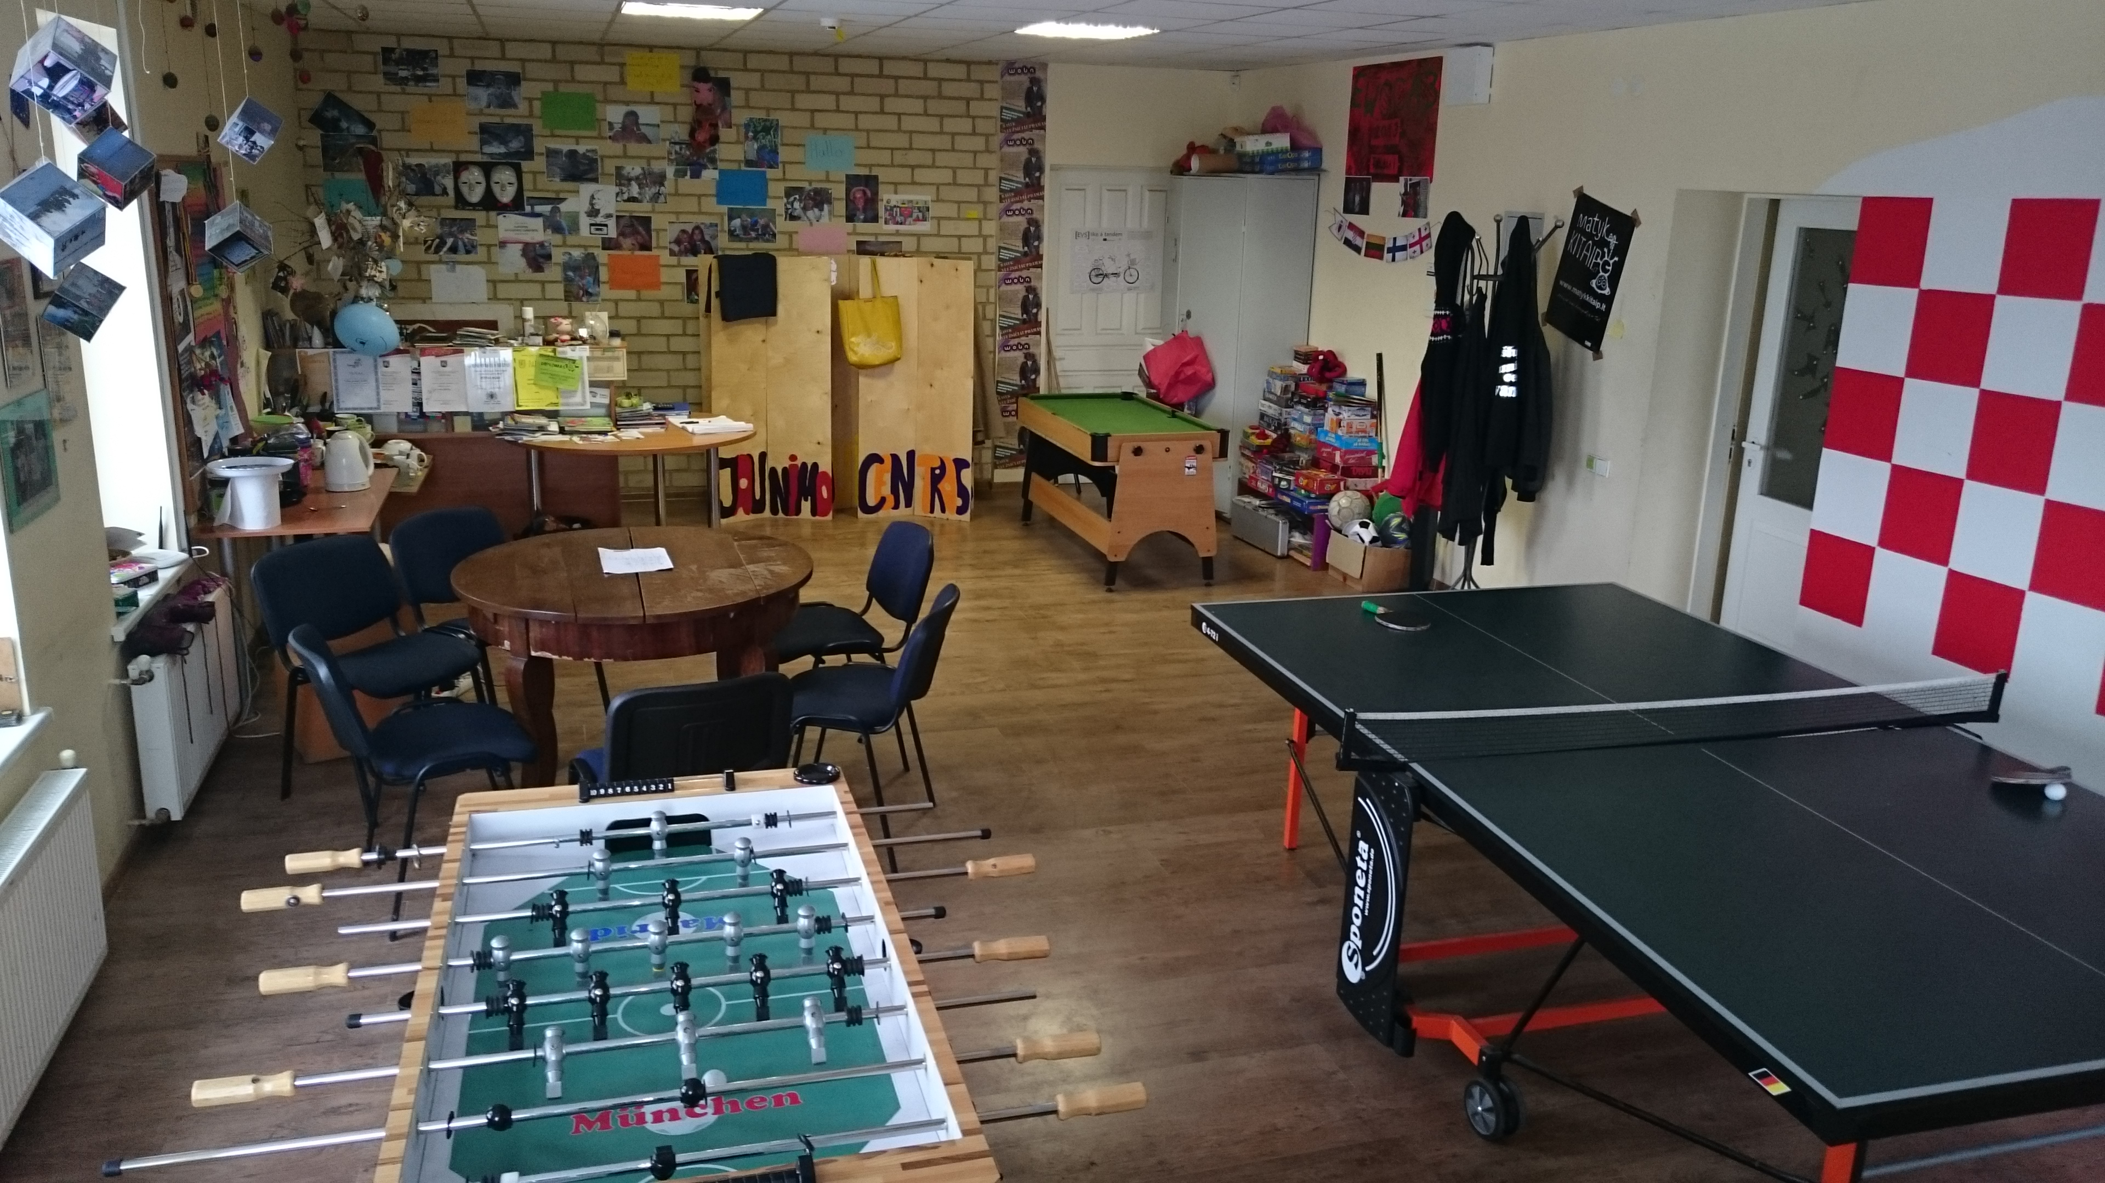

Organization topics | Contact details | Reference | Money for one month | Date of ESC
Youth (Participation, Youth Work, Youth Policy) | VsI Telsiu jaunimo centras  Plunges st., 29, LT-87329 Telsiai, Lithuania  Web: www.tjc.lt  Phone:  Director of youth center - Saulena Pilitauskaite +37061854817  Project coordinator - Daiva Rubaviciene  +37067420915  e.mail: jaunimodarbuotojai@gmail.com | PIC no: 947684375 | Pocket money - 120€;  Food money – 200€ | 2020-10-01 – 2021-09-30  (12 months)

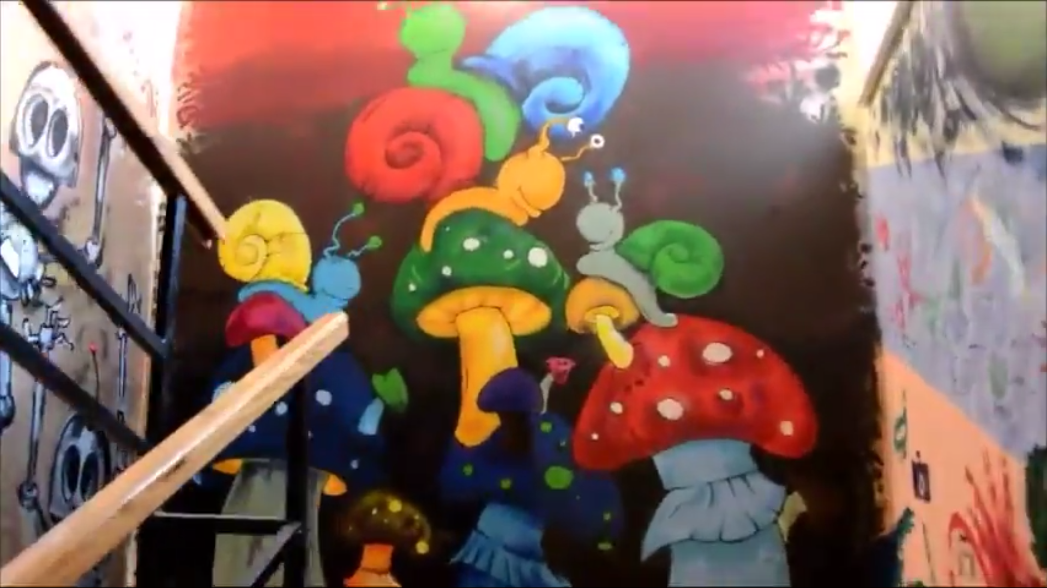

ACCOMMODATION
You will live in a single room in 3 rooms apartment. The apartment is around 25 minutes by foot to the work place; 5-7 min till shopping mall; 10 minutes to the city center; 2 minutes to the train station; 20 minutes to the bus station. The apartment has 2 bedrooms and 1 living room, balcony, kitchen, separate bathroom and toilet, washing machine, Wi-Fi. We will provide linens, pillows, blankets and towel. You will live with other volunteer together (different country) in this apartment in different rooms.

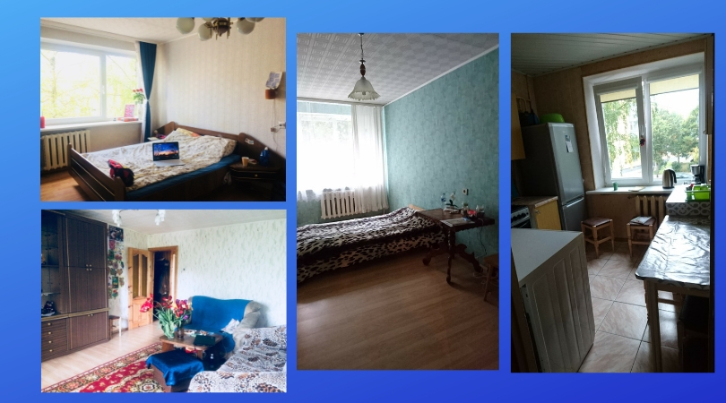

TELŠIAI CITY
Telšiai is the capital of Samogitia region, and it was built on seven hills on the shores of Lake Mastis in the middle of the city. Here live about 21,294 inhabitants. It is one of the oldest cities in Lithuania, probably dating earlier than the 14th century.
It is really cold here in winter time. So you need wear warm clothes.
It is important to say not so much people speak in English here in Telšiai. Sometimes it is difficult to understand each other in a shop for example.
Telšiai is a small city, not so crowded (some cafes, cultural center, shops, library, but nice nature). So if you want more entertainment you can go to other cities. Kilometers to bigger cities:
To Vilnius (The capital of Lithuania) – 285 km (3 hours by train)
To Klaipėda (The Baltic sea) – 90 km
To Kaunas – 190 km
To Šiauliai – 70 km

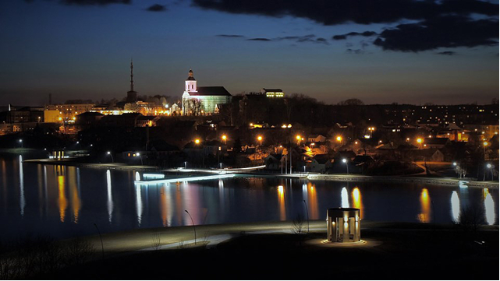
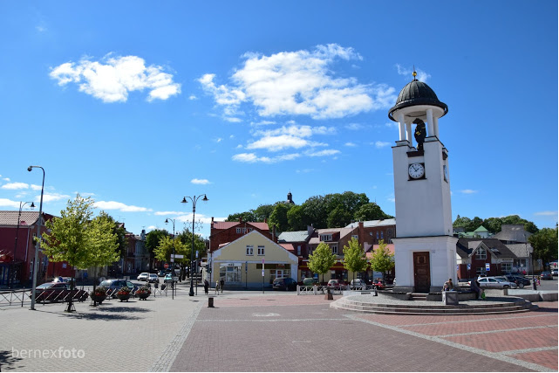
More information: http://www.telsiaitic.lt/1530/=module=-v-i-r-s-u-t-i-n-i-s/about-telsiai.html or in Vikipedia wich knows everything ;D
Photos: http://telsiai.net/

Welcome to Lithuania, welcome to capital of Samogitia

