Skills Art Lab

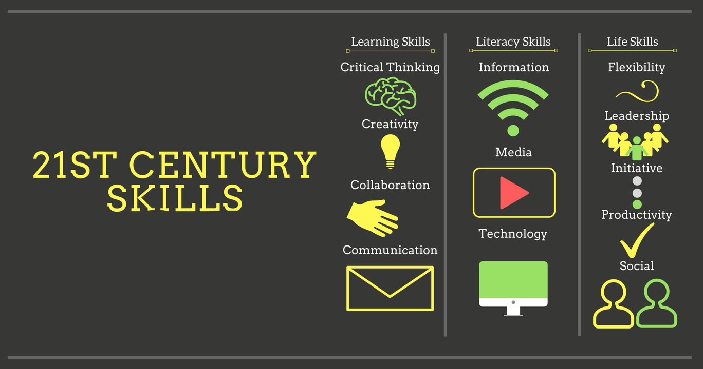

Source: https://cceflorida.org/

Erasmus +
Key Action 1/Youth Exchange
When: January 2021 (APV) / March 2021 (YE)
Where: Messinia, Greece

Organizer: KOUKOUVA Social Cooperative Enterprise

Description:

In the later years of the last century, academics, government officials, non-profits and corporate entities, in view of the changing reality of societies and the labour market, started researching the key skills and competencies that the current and the next generation need to improve their position in all fields, personal, social, professional. Thus, they came up with what is now called the 21st century skills.

The 21st century skills include skills, abilities and knowledge that a person can acquire in and outside the school system and throughout their life and are crucial for success in the modern society and labour market.
There are different theories on the 21st century skills, but they seem to be grouped mainly in the following 3 areas:
• Learning and innovation skills: critical thinking and problem solving, communications and collaboration, creativity and innovation

• Digital literacy skills: information literacy, media literacy, Information and communication technologies (ICT) literacy

• Career and life skills: flexibility and adaptability, initiative and self-direction, social and cross-cultural interaction, productivity and accountability

Especially in the field of Social Entrepreneurship these skills are crucial for the creation and sustainability of initiatives and social enterprises, aiming at promoting a better way of life for the community, by implementing actions towards a positive impact on social, cultural and environmental issues.

In this Youth Exchange, we will try to explore how different kinds of Art can be used as a tool to successfully promote the development of the 21st Century Skills in an entertaining way, encouraging the inclusive participation in the learning process. We will also explore how these skills can support young people to take their own initiatives, become more efficient and have a comparative advantage in the field of social entrepreneurship.

Objectives:

- Introducing participants to the 21st century skills
- Exploring the connection and usage of 21st century skills in the field of social entrepreneurship
- Exploring ways to develop 21st century skills through arts

- Promote active participation of young people in civil society activities that support the development of 21st century skills

- Foster and develop the 4Cs: creativity, critical thinking, communication and collaboration
- Offer a safe environment for young people to develop their skills and learn from each other
- Promote the importance of international collaboration

- Create a network of organisations and young people with common values for future collaboration.

Target group: 5 young people and 1 youth leader, all active and enthusiastic with an interest in different art forms (music, painting, dance, ceramic, photography, video etc) as well as social entrepreunership.
We will also host an Advance Planning Meeting with the participation of the youth leaders from all countries.

Costs and Logistics: This youth exchange will be implemented in the framework of the ERASMUS+ programme, thus food and accommodation costs will be covered fully. Travel costs will be reimbursed up to the amount allocated by the European Commission, using the Distance calculator tool, after the end of the activity and after reception of all necessary travel documents.

Deadline: If you are interested please fill in the partner information form (PIF) that you will find on the next page of this document and send it to us at koukouva.koinsep@gmail.com until 04th of May 2020.

Partner Form

Organization ID (OID)
Full legal name (National Language)
Full legal name (Latin characters)
Website
Email
Telephone 1
Type of Organisation
Is the partner organisation a public body?
Is the partner organisation a non-profit?.
Please briefly your organisation.

What are the activities and experience of the organisation in the areas relevant for this application (work with young people, youth activation and empowerment, art etc)

What are the skills and expertise of key staff/persons involved in this application?

Please, specify your experience in working with young people – with emphasis on your specific fields of work (work with disadvantaged youth groups, leisure activities, carreer guidance, etc).

Describe your target group(s).

How are the young people directly involved in your activities?

Describe the profile of the participants you would find for this project.

We encourage the involvement of participants with fewer opportunities in this project. Please, also describe the difficulties the participants may be facing

What do you think will be the impact of this youth exchange on the participants/ your organisation / local community.
How would you disseminate the results of the project to your members, local community, other organisations, etc.
What dissemination means do you have in your disposal? (website, contact with media, social media pages)
What reach to they have?

Legal Representative

Title.
Gender
First Name
Family Name
Department
Position
Email
Telephone 1

Contact Person

Title.
Gender
First Name
Family Name
Department
Position
Email
Telephone 1

Has the organisation participated in a European Union granted project in the 3 years preceding this application?

Eu Programme | Year | Project Identification or contract number | Applicant/beneficiary organization

