E – NEWSPAPER

A DIFFERENT COUNTRY, A DIFFERENT LIFE
FARKLI ÜLKE, FARKLI YAŞAM

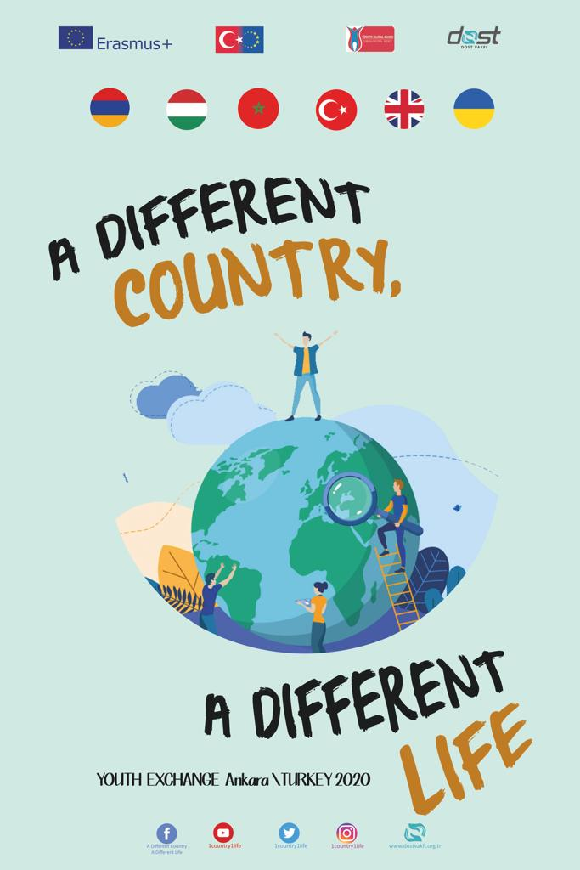

Project Title: A Different Country, A Different Life
National Title: Farklı Ülke, Farklı Yaşam
Project Number: 2019-1-TR01-KA105-071065
Applicant Organization: Dost Vakfı
Venue: Ankara / Turkey
Participants: 6 persons (18-30 ages) + 1 leader (no age limit).
Date: 20.01.2020 – 28.01.2020
Partner Organizations:
- Youth Opportunities Club (Armenia)
- Hungarian Youth Union (Hungary)
- Seeds of Change (Morocco)
- UK-Certified Knowledge Association (United Kingdom)
- Resursnyi Tsentr Staloho Rozvytku (Ukraine)
PROJECT SUMMARY
"A Different Country, A Different Life" focuses on the difficulties that international students experience in order to make them to live a more comfortable life. All along the project awareness studies are done. Also this project is strong to disseminate through the media.
International students face many financial and moral problems. The main reasons of this are the accuracy problem of the information they obtain on the internet and the money greed of education consultancy agencies.
In addition, cultural shock, homesickness, loneliness, incompatibility, shyness, psychological problems, visa, equivalence, lack of dormitory and scholarship are also some of the difficulties experienced by many international students. It is not easy for every young person to adapt to the culture, social life, laws and general rules of a different country. They need to be aware of their own rights and laws and know how and where to use them when necessary.
Within the scope of our project, international students from 13 different nations shared their experiences. In interviews conducted through Dost TV, international students talked about the positive and negative aspects of “being an international student”. In addition, our participants from 6 different countries studying in their own country shared the subject of “studying in their own country” with all the details. We aim to ensure that international students do not feel alone, and that their problems are reduced by sharing as much as possible. So we hope that international young students will be more successful in their schools. This will have a positive impact for both international young students and the educational institutions they study.
AT THE END OF THE PROJECT:
- We take a step forward to improve the living conditions of international students,
-We announce the problems they experienced to a wider audience through social media, television channels and radio stations,
-We can be an icon for other countries which host international students,
-The project partners are able to create such awareness in their own country, like we did in Turkey,
-With the opportunities of Erasmus +, international young students can have the feeling that they are interested.
- We recognize different cultures & different people,
- We increase our foreign language competence,
- We increase our experience of Erasmus+ projects.
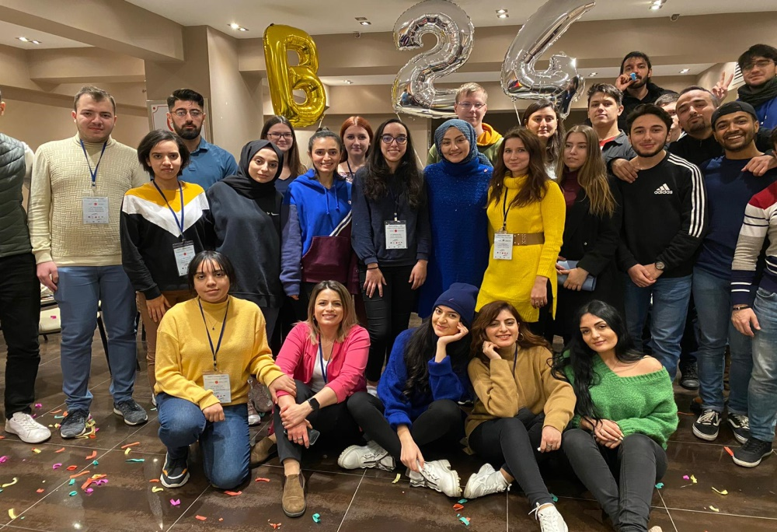
ACTIVITIES
In this context, we organized activities with our participants for 1 week. We talked with our participants about being international students. We discussed what arrangements could be made to make the life of international students’ easier.

1st Day
- We welcomed the guests coming from each country and met together throughout the day. We helped them to check in the hotel.
2nd Day
- The aim of the second day is to integrate the participants, get to know each other, make friends, and be informed about schedule and city. We organized ice breaker activities and games to learn each other better.
- Also we introduced EU Erasmus+ Projects, our foundation Dost Vakfı, our country Turkey and our city Ankara. In addition we made a small trip around Kızılay where our hotel is settled.
- We had Turkish and UK teams cultural nights.
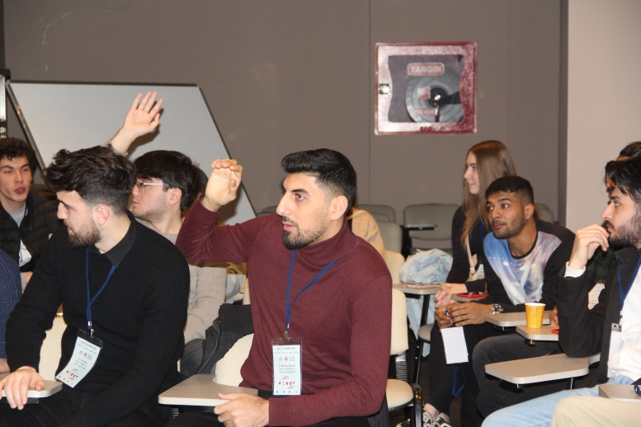
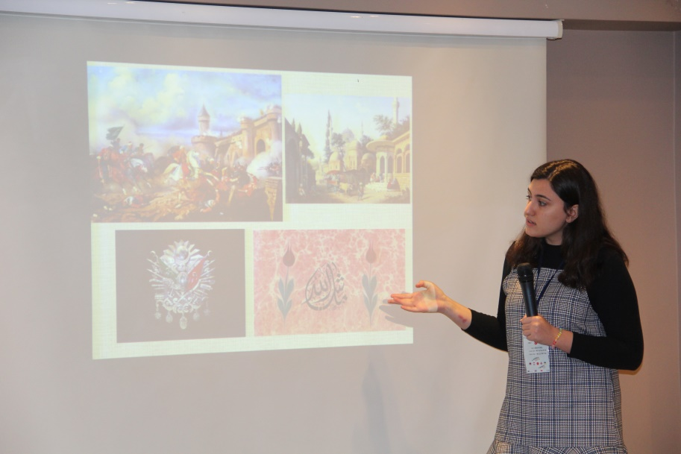
3rd Day
- We started to discuss of the advantages and disadvantages of being an international student, and having education in your own country. We made small group discussions, and then we realized that some disadvantages can be an advantage for some of us.
- We created interview questions all together and we studied on them.
- Also we worked on how to give an interview. Then we started to interview in Dost TV. We divided our participants into groups of three. Each group had both international students and students studying in their own country. During the interviews we observed different answers to the same questions.
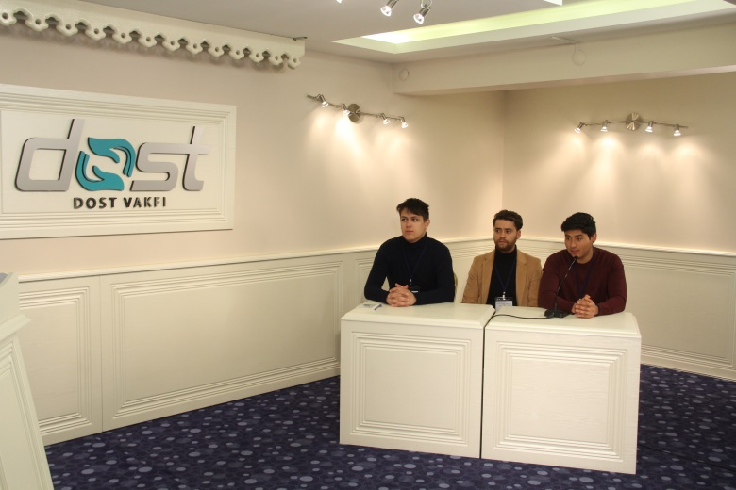
- Moroccan team made a presentation about Morocco. They presented the data they gathered from the field related with international students. Morocco is a multicultural country so it hosts thousands of international students. All of the participants were informed about Moroccan educational system.
- We had Armenian cultural night.
4th Day
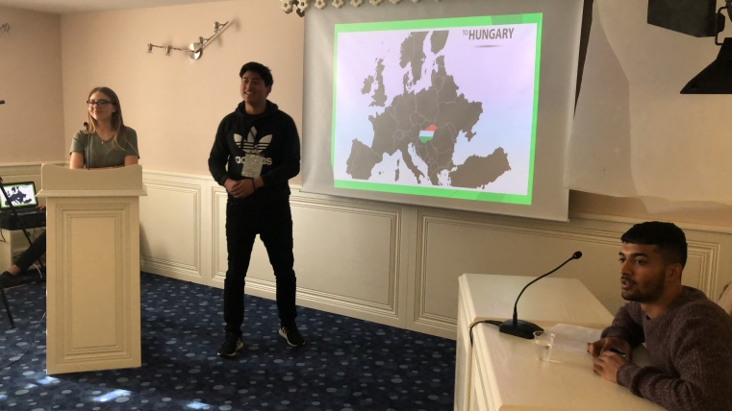
- Day started with an energizer like we did every day.
- Participants continued broadcast on the TV and radio. This publication had two purposes; the first was to ensure that the problems of the students are audible, and the second objective was to learn the radio and television broadcasting. Learning by doing and experiencing were realized.
- 2 of our participants (1 Moroccan and 1 Armenian) were young teachers in their own country. We debated international students’ struggles from their perspective.
- Hungarian team presented the results of the needs, problems and suggestion analyzes of the field studies conducted with the international students in Hungary.
- We had Ukrainian team cultural night.

5th Day
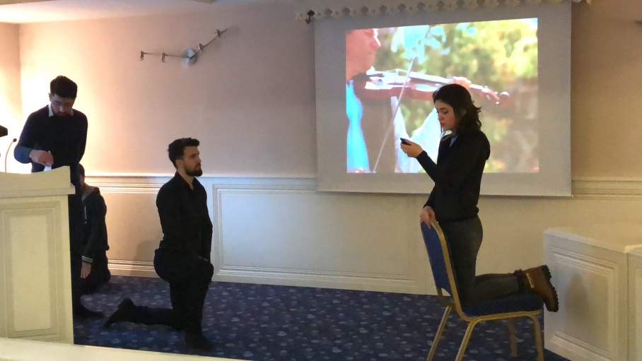
- It was our last day of broadcasting. We did Turkish broadcasts with international students in Turkey. They were from Syria, Iraq, Morocco and Afghanistan. Also some of our British participants were originally from Turkey. We discussed being a Turkish student in United Kingdom.
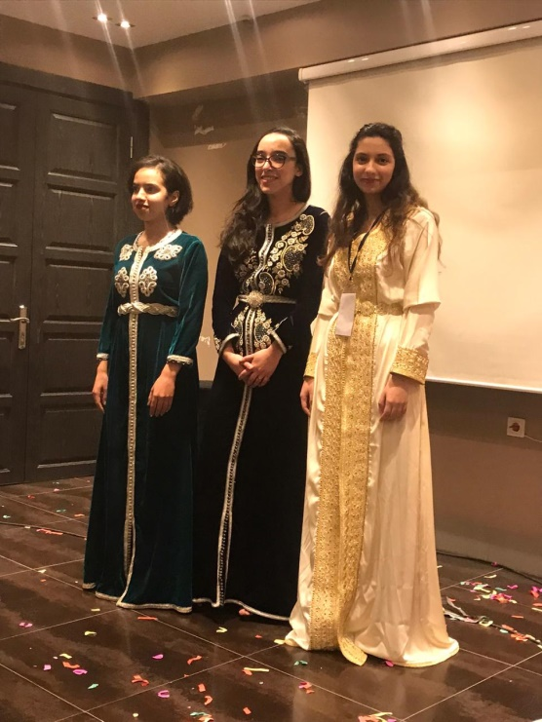
- UK team made a presentation about international students in UK. In this session, they presented interesting facts about UK and shared information about educational system to the other participants.
- We had a trust building activity. It was fun and we saw the positive energy all around the participants.
- We had Moroccan team cultural night.

6th Day
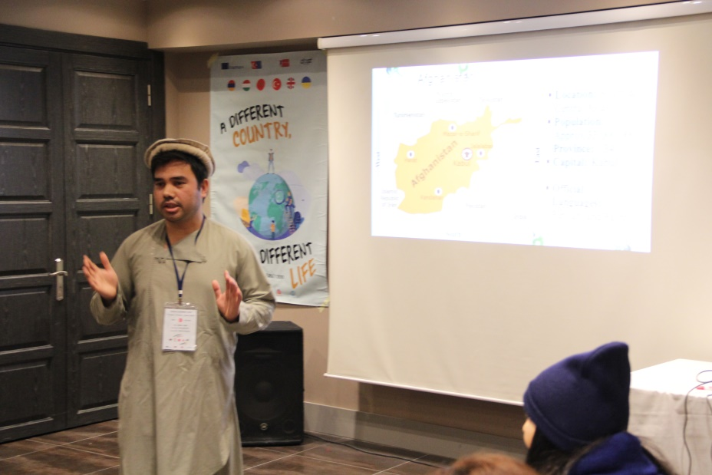
- Our Afghan participant, Maruf, made a presentation about educational system in Afghanistan and being an Afghan student in Turkey. He has been in Turkey for 6 years and he had many struggles about being an international student. He shared his own experiences with us with his traditional clothes.
- We played “Chinese whisper” with all of the participants. We played the game 6 times so we could start with a different language every time. It was great funny.
- Armenian team made a presentation about Armenia and they used question – answer method. They had little gifts for every question. Then they gave information about Armenian educational system and international students in Armenia. We had the chance to observe every participant country’s education circumstances.
- We had evaluation and close up part like we did every day.
We had 4 main questions to all of the participants; what was the best part of today? What did you want to change? What did you want to add? What did you learn new today? Every day we close the project with these questions and we cared about our participant’s suggestions.
- We had Hungarian team cultural night.

7th Day
- It was the sightseeing day around the city. We had a trip all around the Ankara;
Ankara Castle, Museum of Anatolian Civilization, Hacı Bayram Veli Mosque, The First and The Second Parliament of Turkish Republic, and Hamamönü Square. Also some of our participants went to Turkish Bath.
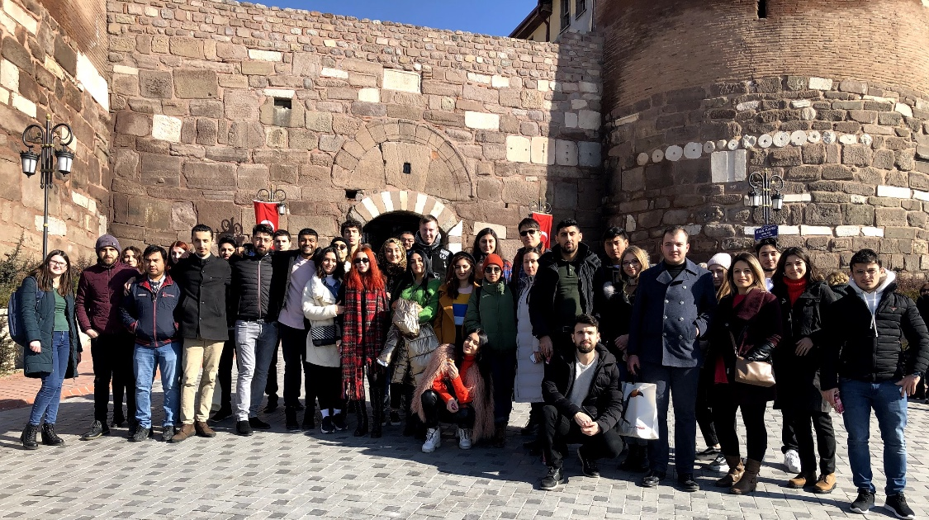
8th Day
- We had a trip to Middle East Technical University. It is biggest and the oldest university in Ankara. We walked around museums, amphitheaters and library of the university with a tour guide. METU is one the best universities about hosting international students in Turkey.
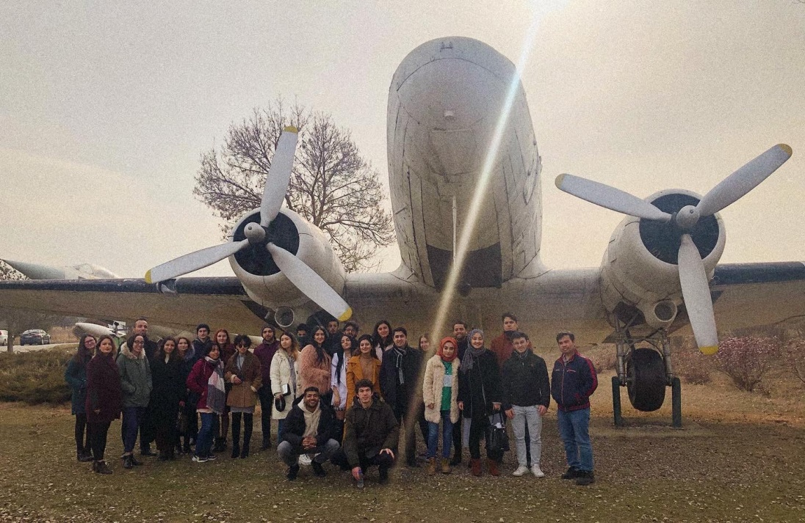
- After the tour we returned to conference hall and we had Ukrainian team country presentation. They made an enjoyable presentation with their cultural clothes.
- Lastly there were solution recommendations to problems of international students. With small groups we had a brain storming activity. We tried to find solutions to the struggles both in society and schools for international students.
- In the evening, we gathered together for dinner to the restaurant that we went every day. Our certificates were presented to all participants with love and thanks. A farewell celebration of Turkish culture and cuisine was held with our participants.
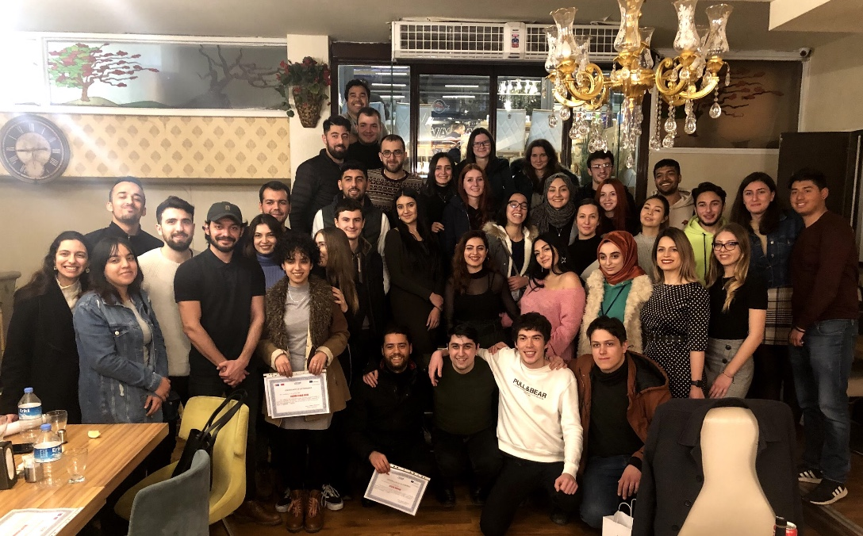
9th Day
- Everyone's returning day. Turkey team happily helped for everyone to return.
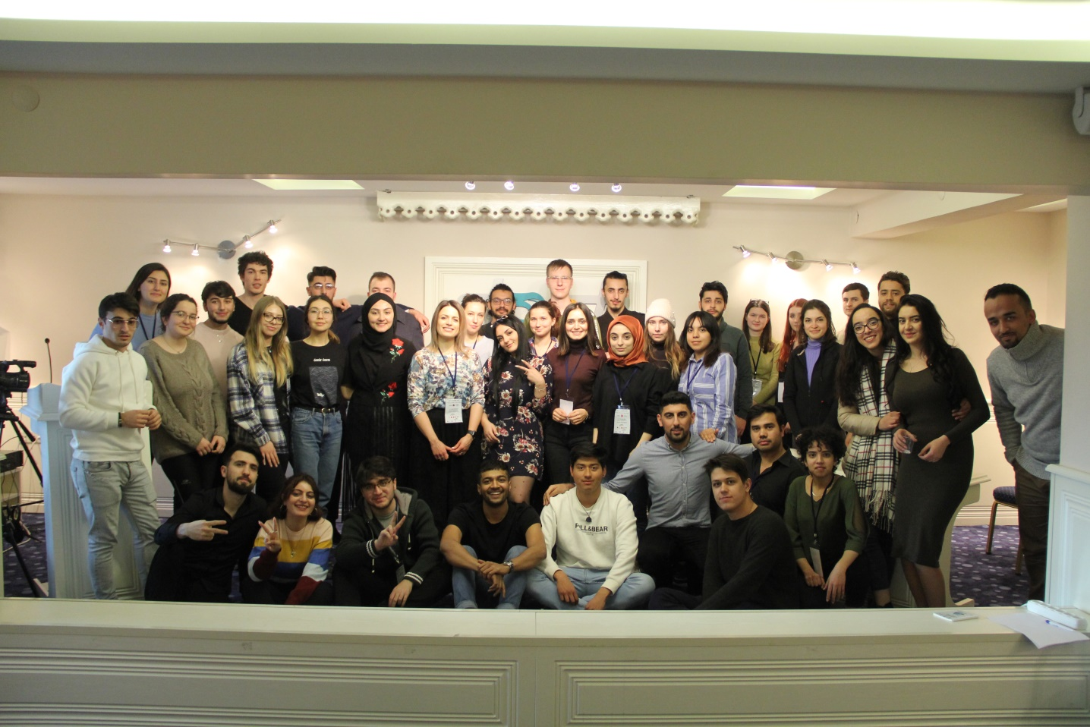

In our project, social media (Instagram, YouTube, Facebook), electronic communication networks (WhatsApp, E-mail, Dropbox, Skype), websites of our project and our foundation, television and radio programs (Dost TV, Dost FM) are used.
Project internet and social media accounts:
~ Facebook: https://www.facebook.com/groups/425007678208942/
~ Web: http://www.dostvakfi.org.tr/?u_event=farkli-ulke-farkli-yasam
~ Instagram https://www.instagram.com/1country1life
~ Youtube Channel: https://www.youtube.com/channel/UCthk1DW2qKn35Yz7sA94PHA?view_as=subscriber

