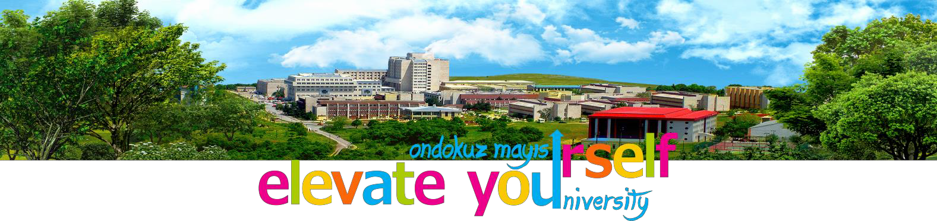

ERASMUS+ Partner Identification
A. PARTNER ORGANISATION
PIC number | 986299784
Organisation ID | E10175946
ECHE 2021-2027 (Project) | 101012443 - OMU
Full legal name of the institution  (National Language) | Ondokuz Mayıs Üniversitesi
Full legal name of the institution (Latin characters) | Ondokuz Mayıs University
Acronym | OMU
Erasmus ID Code | TR SAMSUN01
Official Legal Status | Public University
Official Registration Date | 01 April 1975
Official Registration No | 1873
Vat Registration Number | 6430014673
Postal address | Ondokuz Mayıs University, Kurupelit Campus, Atakum- Samsun, 55200, TURKEY
Region | Black Sea
Head of Institution | Prof. Dr. Yavuz Ünal, Rector
Institution’s web site | www.omu.edu.tr
Email | erasmus@omu.edu.tr
Telephone | +90-362-3121919
Fax | +90-362-4576091
B. PROFILE
Type of organisation | Higher Education Institution

Is the partner organisation a public body? |  | Yes
Is the partner organisation a non- profit? |  | Yes
Size of organisation/institution  Number of students/staff |  | Large.  50596 students  2616 academic staff  4018 employees
C. ACCREDITATION
Has the organisation received any  type of accreditation before submitting this application? |  | Yes. Erasmus+ Volunteering and the European Solidarity Corps.
Has the organisation received any EU |  | Yes. Our ongoing projects are:
Erasmus grants?
 |  | - 2020-1-TR01-KA204-093850
 |  | - 2020-1-TR01-KA202-094374
 |  | - 2019-1-TR01-KA107-073493
 |  | - 2019-1-TR01-KA103-067400
 |  | - 2019-1-TR01-KA103-067404
 |  | - 2018-1-TR01-KA103-050061
 |  | - 2018-1-TR01-KA107-054774
 |  | - 2018-1-TR01-KA103-050060
 |  | - 2019-1-TR01-KA202-075412
 |  | - 610528-EPP-1-2019-1-TR-EPPKA1-JMD-MOB
 |  | - 613159-EPP-1-2019-1-RO-SPOSCP
 |  | - 2020-2-FR02-ESC11-018080
D. BACKGROUND AND EXPERIENCE
Please briefly present the partner organisation. | Ondokuz Mayıs University (OMU) is a well-established local state university. It was founded in 1975 in order to make a contribution and bring a new breath to the Black Sea region’s economic, cultural and social life. The University’s mission is to adopt universal values to bring about innovation to the benefit of individuals and society, working with intellectual rigor. The University gives great importance to science, education and research and is one of the strongest research and teaching institutions in Turkey.  The main campus of the University is located in Samsun, a coastal and harbour city situated on the border of the Black Sea. The university has in total 10 small and large campuses in 7 different districts of Samsun.  The university has 18 faculties, 2 schools (first cycle), 12 vocational schools (short cycle), 2 graduate schools, 26 research centres and one conservatoire. It has 50596 (5156 full time international students from 112 different countries) students (including postgraduate and distance learning students), 2616 academic staff and 4018 employees.  The University’s first and largest faculty, the Faculty of Medicine, has two university hospitals (adult and children). Similarly, the Faculty of Dentistry is a

 | Dental Hospital. Serving the inhabitants of the entire Black Sea region, both faculties provide treatment in all areas of health and dental care. Our Faculty of Veterinary Medicine also has an animal hospital again serving the local and regional wild animals and domestic pets.
What are the activities and experience of the organisation in the areas relevant for this application? | Ondokuz Mayıs University International Relations Office (IRO) was established in 2001 with the mission of coordinating and carrying out activities related to the internationalisation of the university and improving the participation of the university in cooperation activities and raising the reputation of the university in the international area. It consists of six different offices including International Student Recruitment, nationally supported exchange programmes and IAESTE. One of the main offices is the Erasmus Office.  The main objective of the Erasmus office is to assure the effective participation of the university in the Erasmus programme by coordinating the necessary activities to fulfil the requirements of the programme. The office carries out promotional activities to inform the university students and staff about the programme, to encourage participation and to manage the mobility activities. The IRO has been actively involved in the Erasmus Programme since 2004. The International Relations Office also coordinates other EU Education Programmes.  OMU is an accredited Erasmus+ Volunteering and the European Solidarity Corps institution. Our university is open to other projects within the outlined areas of voluntary service; such as, environment, health and inter-religious dialogue.  Our University has an Institutional Development strategies Quality Assurance department http://kalite.omu.edu.tr/en/
What are the skills and expertise of key staff/persons involved in Sport project applications? | Our University Faculty of Sport Sciences was established in 1990 and has four departments: Department of Physical Education and Sports Teacher Education, Department of Coaching Education, the Department of Sport Management and the Department of Recreation. The faculty offers undergraduate and post graduate courses in these departments. It consists of 3 professors, 7 associate professors, 6 assistant professors, 11 lecturers and 13 research assistants. All of the Faculty members have a considerable and valuable number of scientific publications in their areas of expertise.  On the point that sport sciences is an interdisciplinary field, the faculty plays a key role in bringing together the University and the city of Samsun by applying the theory of sport to daily life. Throughout each year, the faculty organises and carries out many activities in different sport branches, such as, tennis, table tennis, archery, swimming, tower jumping, pilates, zumba and step-aerobics. Particularly in winter, teachers and students are given special training in skiing. Participants of all ages can take part in the mentioned activities and sports.  In light of the structure, function and responsibilities of our Faculty and Faculty members we can quite confidently say that we have the experience and expertise to assist in the success of the project.
What level of courses do you offer? |  |  | All levels.  -Short Cycle  -First Cycle  -Second Cycle  -Third Cycle
Course Catalogue |  |  | http://ebs.omu.edu.tr
E. LEGAL REPRESENTATIVE
Title |  | Prof. Dr.
Gender |  | Male
First Name |  | Yavuz
Family Name |  | Ünal
Department |  | Rectorial Office
Position |  | Rector
Email |  | rektor@omu.edu.tr
Telephone 1 |  | +90-362-4575870
Address |  | Ondokuz Mayis University, Rectorial Office, Atakum,  Samsun, 55200
Region |  | Black Sea
Telephone 2 |  | +90-362-4575878
F. CONTACT FOR INTERNATIONAL PARTNERSHIPS
Office |  | Ondokuz Mayıs University  International Relations Office
Staff Details |  | https://uib.omu.edu.tr/en/contact
E-mail |  | erasmus@omu.edu.tr

