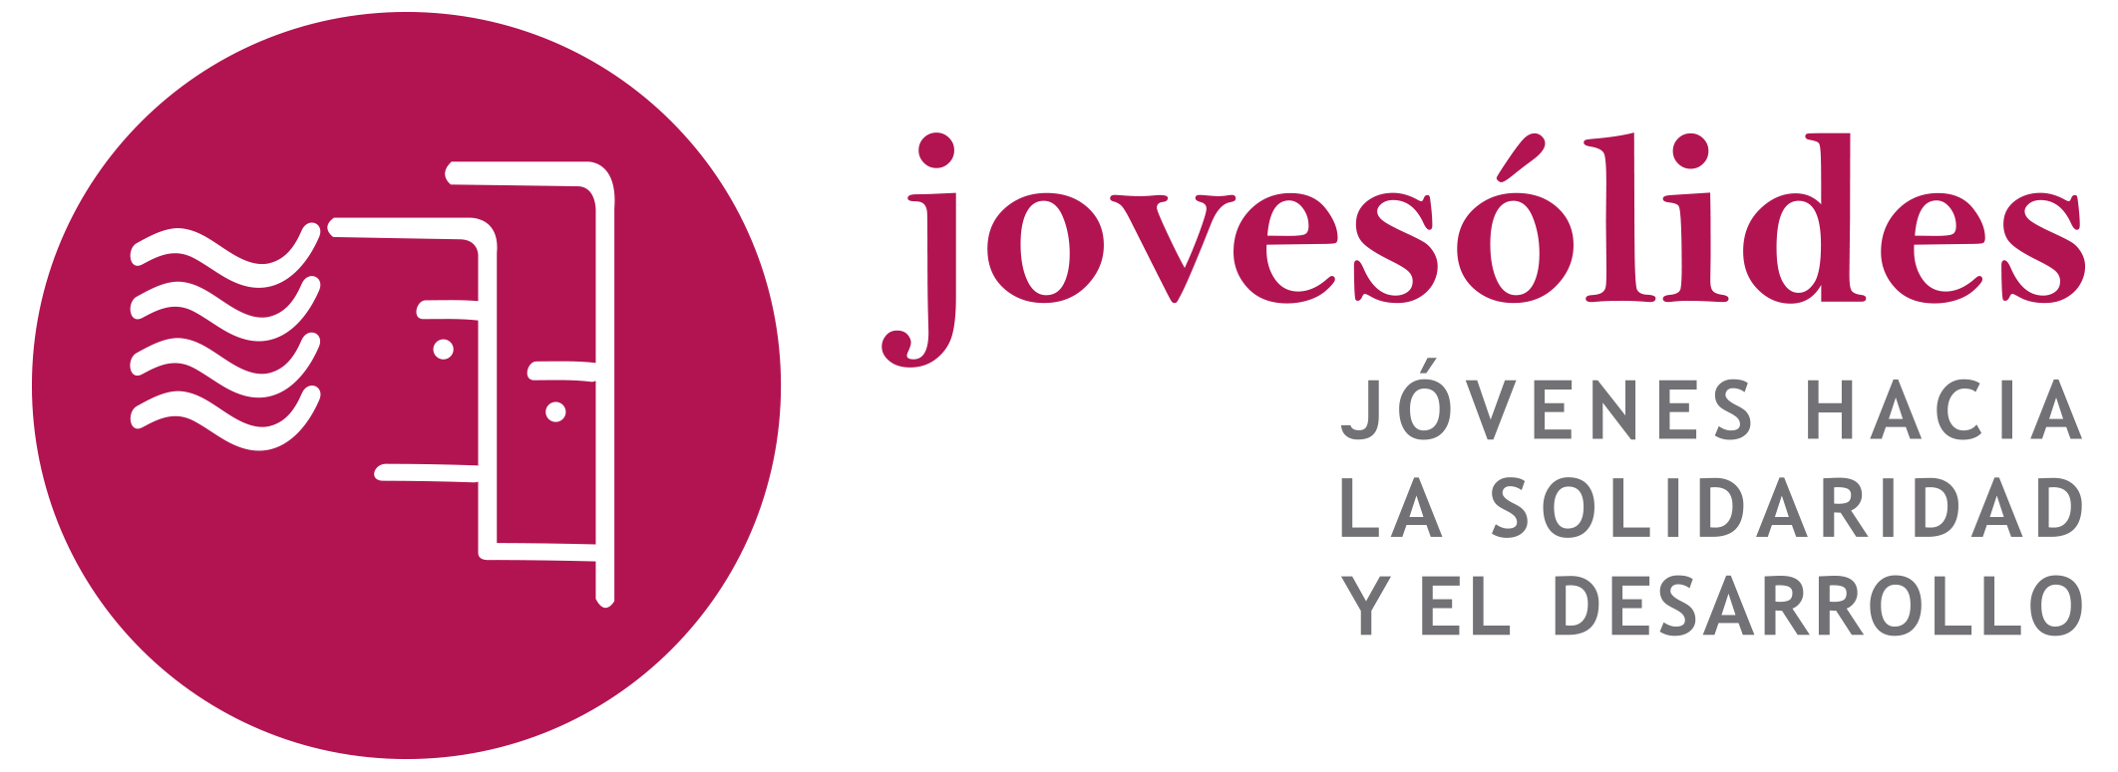

PROJECT DRAFT DESCRIPTION

Applicant | JOVESOLIDES
Project | Surfing Safe Together (SST)
Call of proposals | REC Specific Objective: to prevent and combat all forms of violence against children, young people and women, as well as violence against other groups at risk, in particular groups at risk of violence in close relationships, and to protect victims of such violence (Daphne).  Priority: 4. Preventing, combating and responding to peer violence amongst children
Deadline | 15th April

Main idea of the project:

The project aims to create a transnational wide educative and raising awareness strategy to prevent and combat violence among children generated by a non-responsible use of the internet and social networks, and which translate into problems such as bulling and cyberbulling
This project is implemented within the framework of the educational system, specifically in schools, and with students in the last grades of primary school, understanding that education is the key and the appropriate environment to work on violence prevention, especially among children
To respond to this priority, the project bases its action on promoting a responsible use of the internet and social networks preventing the appearance of possible victims, perpetrators and/or witnesses of violence, as well as helping parents, professionals in schools, to be better prepared to guide children, detect and respond to cyberbulling. The actions is specially focus online violence that comes from the school environment

Objectives:
The main objectives of the project are:
OG Prevent and combat violence among children, especially cyberbulling and bulling actions, through providing training, tools and materials to children, parents and teachers, as well as carrying out communication actions aimed at raising awareness and disseminating the population in general regarding this topic.
O.E. 1 Provide training to children, parents and teachers for the prevention, detection and approach of bulling and cyberbulling situations in the school context by promoting responsible use of the internet and social networks
O.E. 2 Provide awareness and action tools to prevent and combat bulling and cyberbulling situations through a guide for children, parents and teachers
O.E.3 Sensitize children and the general population regarding bulling and cyberbulling, through a specific communication campaign.

Structure of the project (Work Packages):

The planned activities are detailed below, following the work packages structure to facilitate their understanding:
Work Package 1: PROJECT MANAGEMENT AND COORDINATION
1.1 Kick-off meeting: the meeting will provide the detailed planning of the project activities, creating a partnership management guide, and clearing all questions from financial administration and reporting side. Valencia, 3 days, 3 participants per partner.
1.2 Create consortium work system and structure: tools, work system and on-line structure to file documents and follow-up the processes will be developed to ensure a coordinated work.
1.3 Transnational meeting to close the Guide and prepare workshops. Location: X, 2 days, 2 participants per partner
1.4 Intermediate evaluation: The aim of this activity is evaluate the process in order to ensure the final expected outputs and decision making. Valencia, 1 day, 3 participants per partner
1.5 Project audit: the account auditing process will ensure correct financial management and provide transparency (month 22 and 23)
1.6 Final evaluation: This activity will collect all the outputs of the project, including the beneficiary’s satisfaction and the process learnings. Location: X, 2 days, 3 participants per partner

Work Package 2: IMPLEMENTATION: Surfing Safe Together Guide
2.1 Guide development: Development of a Guide aimed to children, parents and teachers. The guide will have a learning by doing methodology approach, using practical and group exercises
2.2 Guide translation: The guide will be translated to English, Spanish and XXXX in order to ensure its comprehension in the different partner countries and other European countries
2.3 Design and edit Surfing Safe Together Guide: Create a friendly design to further comprehension and be attractive for children

Work Package 3: IMPLEMENTATION: Surfing Safe Together Workshops
3.1 Create Surfing Safe Together Package Workshops: Create a package of workshops aimed to parent, teachers and children in schools using the guide to lead them
3.2 Selection of Schools: The workshops will be implemented in partner countries schools. The schools will be selected and proposed to participate in the programme. Each partner will work with at least 10 schools (XXX in total in the project)
3.3 Recruitment of facilitators: facilitators with experience in prevention of bulling and other forms of violence among children will be recruited to implement workshops. TICS Knowledge and positive approach about technology, as well as sensitivity towards working with children will be required.
3.4 Permissions and requirements application: This activity will consist in apply for permissions and requirements required for the development of workshops in schools
3.5 Workshop development: The activity will consist in develop workshops aimed to children, parents and teacher. Each partner will develop the workshops at least in 10 schools in its city (10 schools and at least 400 children, 100 parents and 20 teachers each partner)

Work Package 4: COMUNICATION AND DISSEMINATION
4.1 Communication Plan: a communication plan for the project will be designed and developed
4.2 Sensitize and dissemination campaign: Design and develop a Campaign aimed to sensitize populations, and specially children, parents and teachers about the responsible use of technology and social networks to prevent bulling and cyberbulling.
4.3 Multiplier events: A multiplier event will be developed in each partner country in order to disseminate outputs and goals of the project.
4.4 Multiplier Final Event: A high impact multiplier event will be design and develop. This event will raise the visibility of the context and overall objective: prevent and combat cyberbulling and bulling

Main Intelectual products. Draft proposal of Intellectual products:

Training methodology (Training of trainers)
Training package for replication in Schools
Guide of proposals forward a Culture of Peace – towards Human Rights
Social Communication campaign
Guide for replication – other partners a part from project partners

Timeline planned: 24 months: From December 2020 / December 2022 (aprox. To be defined!)

