
“STAY STRONG AND DON’T GIVE UP TO STEREOTYPES!” (focus on facts vs harmful general opinions)
YOUTH EXCHANGE - Training for youth with fewer opportunities, Poland
20.03.2020 – 28.03.2020 (with 2 additional days for travel)

Training course is dedicated to youth who feel they are strong part of European society, willing to build relationships between European citizens, between 18-25 years old. Course will cover the topic of misleading stereotypes with emphasis on consequences in real life.
Where do Stereotypes come from? It can have many sources: lack of information on particular subject, strong influence of narrow political views, closed groups, deep historical biased background.
One part of youth exchange will focus on negative stereotypes about ourselves (f.e. I am from poor family, so I am worse than other youngsters) and how to overcome them. Goal of that part will be strengthening self-esteem of youngsters with fewer opportunities. Second part of training will focus on general stereotypes that we own and it will lead to strengthening the sense of being European.
Stereotypes can be connected with negative influence of European organisation on particular countries development (nationalistic movements), between citizens of different countries (neighbour countries, western countries vs eastern ones), misunderstanding between religions believers (catholics, jews, muslims) or intellectual and social role potential of youth depending on educational spendings (reach and poor youngs). Training will take place in Poland at Tatry mountain region.
For this activity we are looking for organized groups of 4 youngsters with 2 leaders (first with no age limit, second between 18-30 years old); group leaders should have at least 1 year of experience in the topic and such kind of partner organizations who are leading activities dedicated to families and young people.
The main goal of the training is to gain knowledge and better understanding, how to openly and respectfully build relations with other people and their different views. Integral part of course would be understanding fake news subject and ways how to protect against them. Youngsters will lead workshops on :
- building and developing communication and interpersonal skills,
- building the capacity to respond to inappropriate and disrespectful behaviour,
- gaining knowledge and awareness of harmful stereotypes in everybody’s life,
- acquiring the ability to use the network to check facts vs fake news
The participant are both trainees and mentors, so they should prepare workshops or other activities giving opportunity to share experience. All the activities will be discussed and analyzed with participants during the course.
Dissemination:
During the course participants will prepare a spot (music or social media videos) to distribute them after completing the course in their local environments.

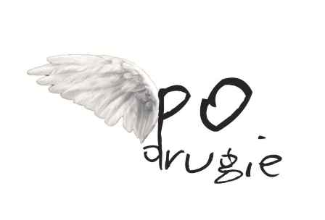

Foundation “po DRUGIE”
The “po DRUGIE” Foundation (FpD) is a nationwide non-profit organization. Its mission is equalization of opportunities and exclusion prevention of lower chance youth by increasing systemic resolutions addressed for the group, the group social impact as well as social awareness of its problems. The focus group of FpD activity are correctional facilities wards - in age of 13-21 often of social, material and/or health problems families of origin. The organisation cooperates with correctional facilities in the entire Poland and with departments of social integration. Main goals of FpD activity are: social adaptation, re-adaptation and support in process of achieving every day freestanding of youth, prevention against social exclusion, demoralization and social pathology, improvement of professional activity leading to social inclusion of youth and its families, improvement of entering into opened society preparation level of former juvenile correctional facilities pupils. On a daily basis FpD also provide young people with legal help and deal with juvenile justice system in general.
Regular activities of FpD are:
- connected to risky behaviour prevention and skill development of youth educational activities based on non-formal education tools,
- research, lobbying, and systemic change activities connected with focus group,
- skill development and growth of awareness of professionals working with lower chance youth,
- individual help for present and former wards of correctional centres. The Foundation conducts interventions in individual cases involving juvenile justice system and offers them legal, educational and social assistance,
- building national and international network of professionals working with lower chance youth,
- organization of conferences, meetings and debates on legal issues that gathers young professionals, experts and youth from several institutions,

All the costs in the project will be covered by ERASMUS+
If you are interested in the project please fill the partner form. We will contact only with selected organizations.

CONTACT: wiktor.sierocinski@podrugie.pl

