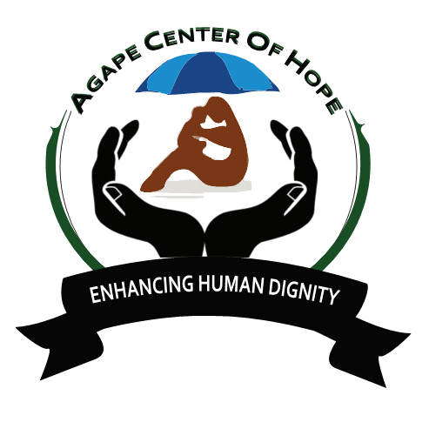 Moi Avenue, Magereza Chambers.
P.O BOX 361-00202 Nairobi
mohammedagapesaid@gmail.com
infoagapecentreofhop@gmail.com
mohammedagapesaid@gmail.com
+254702818338
ACoH INTERNATIONAL MID AND LONG TERM PROJECT 2019
Long Term Projects are specifically designed to give volunteers an opportunity to develop and promote their skills and services and in the process serving and promoting the development of the hosting community structures.

THESE PROJECTS LAST FOR A PERIOD OF 1-12 MONTHS.

ACoH: MLTV01/01 MARA OSERO WILLD LIFE CONSERVANCY.
Code: ACoH 01/01
Name: Mara Osero Maasai Mara Game Reserve Project
Type: EDU/KIDS - Wildlife, Culture, Conservation, Renovation, Environment & Education
Project dates: All year round

Location of the camp: Narok County
Community: Maasai tribe
Languages: English & Kiswahili
Number of volunteers:20 locals and internationals
Disabled: No

Age: 18+

BACKGROUND OF MAASAI LAND
The Maasai tribe (or Masai) is a unique and popular tribe due to their long preserved culture. Despite education, civilization and western cultural influences, the Maasai people have clung to their traditional way of life, making them a symbol of Kenyan culture.

Maasai's distinctive culture, dress style and strategic territory along the game parks of Kenya and Tanzania have made them one of East Africa's most internationally famous tourist attractions.

The Maasai people reside in both Kenya and Tanzania, living along the border of the two countries. They are a smaller tribe, accounting for only about 0.7 percent of Kenya's population, with a similar number living in Tanzania. Maasai’s speak Maa, a Nilotic ethnic language from their origin in the Nile region of North Africa.

The Samburu tribe is the closest to the Maasai in both language and cultural authenticity.
Through rituals and ceremonies, including circumcision, Maasai boys are guided and mentored by their fathers and other elders on how to become a warrior. Although they still live their carefree lives as boys

- Raiding cattle, chasing young girls, and game hunting - a Maasai boy must also learn all of the cultural practices, customary laws and responsibilities he'll require as an elder.

The wildlife, culture, conservation and education village centre offers volunteers the ultimate opportunity to explore, learn and interact with the Maasai community and their culture. The Mara conservation gives them a platform to serve, interact and also live like the Maasai people. Above all, the conservancy is managed according to a model that protects the delicate eco-system and benefits the landowners who are the Maasai people.

The wildlife, culture, conservation and education in Kenya is home to the big cats situated on the mararienda most point of the Greater Mara Ecosystem; borders the Olchorro Oiroua Conservancy to the south, and MMNC to the East. The important focus of the conservancy is livestock improvement through innovative cattle management programs, running alongside novel tourism projects.
The habitat comprises wooded acacia savannah with open plains on flat plateaus, riverine acacia forest and rocky, undulating hills which provide a varied habitat for browsing and grazing ungulates, as well as hideout thickets for the predators. The Mara River runs alongside the conservancy. There is a large number of giraffe and resident buffalo that live close to the Olerai boundary along the Mara River. Elephants frequent the conservancy and there is a pride of lion based on the edge of oloisukut. There are many hippos and crocodiles in the section of the river that borders the conservancy and the riverine forests which provide an area popular with leopards. Rare species such as Aardvark, Caracal, serval cat and Aardwolf are

Occasionally found. Colobus monkeys have been spotted in the valleys on the Kileleoni Hill and there have also been sightings of wild dog in Enonkishu. There is no doubt that Mara Osero offers an incredible game viewing experience.
Back Ground OF THE PROJECT
The oloisukut Conservancies offer visitors the ultimate safari: the lowest tourism densities; incredible day and night game viewing; and authentic cultural interactions. But above all, these Conservancies are managed according to a model that protects the delicate eco-system and benefits the landowners themselves – the Maasai people.
The oloisukut Conservancy in Kenya is home to the big cats situated on the malarienda most point of the Greater Mara Ecosystem; oloisukut borders the Olchorro Oiroua Conservancy to the south, and MMNC to the East. The important focus of the conservancy is livestock improvement through innovative cattle management programs, running alongside novel tourism projects.
The habitat comprises wooded acacia savannah with open plains on flat plateaus, riverine acacia forest and rocky, undulating hills which provide a varied habitat for browsing and grazing ungulates, as well as hideout thickets for the predators. The Mara River runs alongside the conservancy. There is a large number of giraffe and plains game and resident buffalo that live close to the Olerai boundary along the Mara River. Elephants frequent the conservancy and there is a pride of lion that is based on the edge of oloisukut. There are many hippos and crocodiles in the section of river that borders the conservancy and the riverine forests provide an area popular with leopards. Rare species such as Aardvark, Caracal, serval cat and Aardwolf are occasionally found. Colobus monkeys have been spotted in the valleys on the Kileleoni Hill and there have also been sightings of wild dog in Enonkishu. There is no doubt that oloisukut offers an incredible game viewing experience.

ESSENTIAL DUTIES AND RESPONSIBILITIES
- Oloisukut scouts patrol within the conservancy
- Security on conservancy borders and within; day and night
- Data collection
- Monitoring wildlife movement
- Control cattle grazing
- Human movement control
- Ensure upkeep of the conservancy
- Community awareness on wild protection.
Treatment and rescue of orphaned wild animals with collaboration with other stakeholder’s i.e wwf, Mara elephant project, community and others

- Do joint patrol within and outside neighbouring Mara conservancy in collaboration with other rangers from neighbouring conservancy.
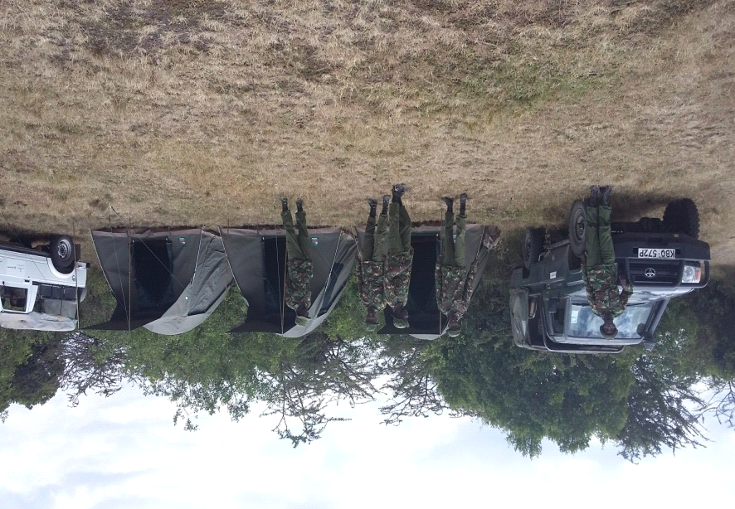

- Safari walks and game drives
- Bird watching
- Educational support i.e. outreach programme to enrich formal education
- Medical outreach services activities
- Research programmes all around fields allowed but information generated may be shared with the conservancy.
- Filming may be done on the conservancy but all rights reserved courtesy of Oloisukut conservancy
Photo shooting on our scenic landscape that include wild animals, siria/oloololo escarpment, beautiful mega rocks hanging on escarpment, very beautiful bushes and forest and our pride the Mara river that borders us with other conservancy.
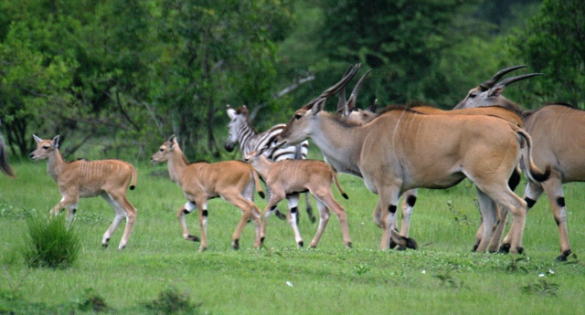

We showcase the Maasai cultural activities, we have manyattas bomas, our women doing beadwork ,our system of slaughtering and meat eating in places famously known as orpul, maasai dance and so on.

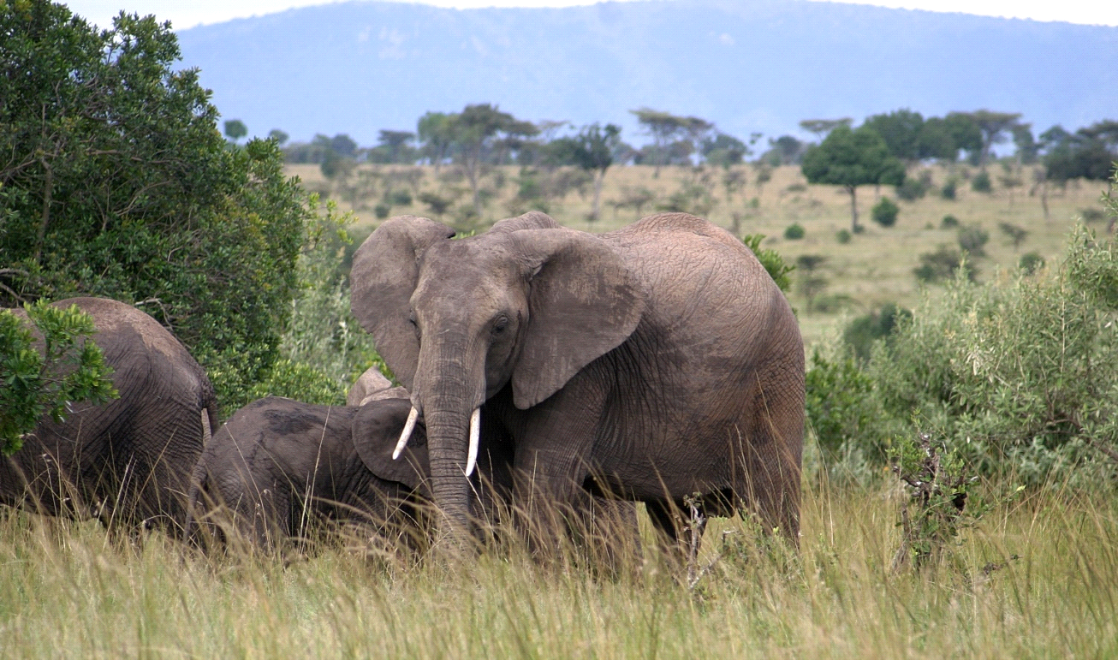
Day 1: Arrival and pick up from the Jomo Kenyatta International Airport, in Nairobi, Kenya and transfer to host family home or hostel.
Day 2: Morning: registration and start of orientation. About 4 hours lecture at the home of your host. Topics covered during orientation lecture will include East African culture, history, customs, politics, geography, and necessary health precautions, and various other topics, such as the diversity of Kenyan life. Afternoon is free for exploring rural Kenyan life and getting to know your host family.
Language: English but also ready to learn Swahili and Maasai.
Duration of the project: 1 to 12 months. The program is running throughout the year.
Orientation: Orientation meeting will take place in Nairobi before proceeding to the project.

Accommodation: volunteer will be hosted in the respective bomas where they live. There will be a solar lamp and water are available

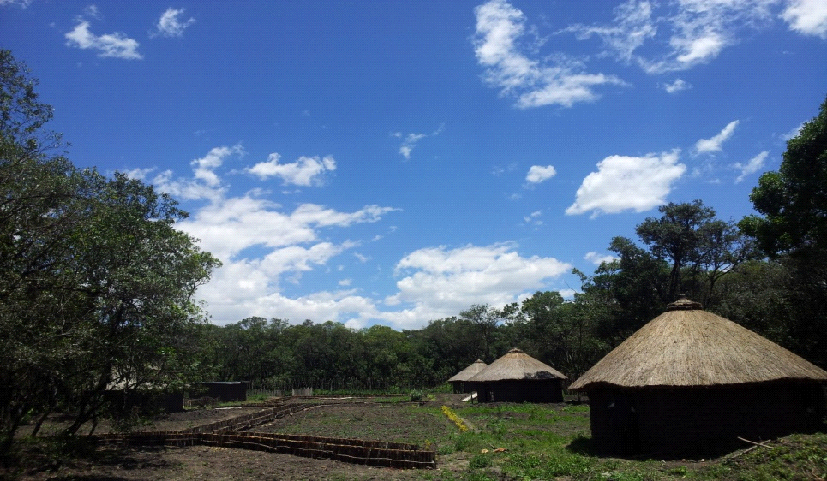

Location: Narok County Maasai Mara National game reserve.
Age range: 18 and over
Participation fee: 300 Euros per months (12 months)
Project dates: All year round
ACoH: MLTV 010/1: KAKAMEGA FOREST AGRICULTURAL CENTRE SUSTAINABLE AGRICULTURE, FOOD SECURITY EDUCATION AND RESEARCH
Back Ground Kakamega forest is a rain forest the largest East African forest that used to stretch from Kenya to Democratic Republic of Congo now reduced to Kenya all the way to Uganda.
The forest including reserves encloses about 238 square kilometers, a little less than half of which currently remains as indigenous forest. The forest is elevated at predominantly between 1500 m and 1600 m above sea level. In the north of the forest is the 4,468 hectares (45 km²; 17 sq mi) Kakamega National Reserve, given national forest reserve status in 1985. Just to the north is the Kisere Forest Reserve. Throughout the forest are a series of grassy glades, ranging in size from about 1 to 50, with a few larger clearings. The origins of the glades are uncertain. Some are certainly recent clearings, but others predate recent records. These may have originated from past human activity such as cattle grazing or may be the result of herbivory and movements by large mammals such as buffalo and elephants (both now extirpated from the region). The glades vary a great deal in structure, some being open grass and others having a considerable number of trees or shrubs. A number of streams and small creeks run through the reserve. The larger creeks are usually bordered by a few to tens of meters of forest on either side which divide the glades, while the smallest creeks flow through open grasslands, often forming small marshy patches.
Kakamega rainforest is the only tropical rain forest in Kenya of the Guineo-congolian type that once stretched across from West Africa to East Africa.
The forest is penetrated by network of walking trails silent with only a melody of singing birds, whispering threes, rasp of butterflies as they fly on by, the chattering of monkeys, and gurgling streams nearby.
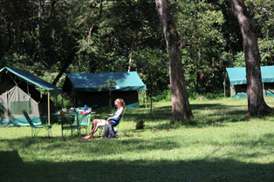
Kakamega forest is located in Western Kenya, 418 KM from Nairobi city through, Nakuru, Kericho, Kisumu Kakamega town then Kakamega Isecheno forest station.
Kakamega rainforest has over 360 species of birds, 380 species of plants, 400 species of butterflies, 7 species of primates.
Kakamega forest plants, 80% are of highly medicinal plants that traditionally local people use them to cure Malaria, prostate cancer, common cold and many others.
Kakamega forest is an Ornithologist's dream where many different rare birds’ species are found including Great blue turaco, Blue headed bee-eater, Turners Eremomela, Yellow bellied wattle-eye, African shrike-flycatcher, Petit's cuckoo-shrike and many others.
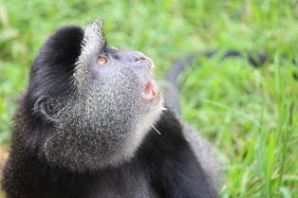
Mammals of Kakamega forest Includes Primates, Bushback, Red and blue Duikers, Bush pigs, Porcupines and at night Flying squirrels, Hammer Headed fruit bats, Tree pangolins, poto, Mongoose along the rivers Clawless otter.
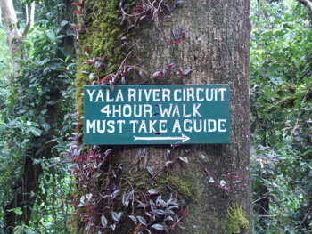
Who will explain or interpret Tropical rainforest Biodiversity including; Birds, Primates, Medicinal plants, Butterflies and cultural activities of local people staying around the forest.
ESSENTIAL DUTIES AND RESPONSIBILITIES
The volunteers will be expected to participate in:
- Tree Nursery caring/ Tree Nursery Planting, filling the gap in the forest
- Environmental Education in Schools and within the local Luhya communities.
- Food security education
- Bio diversity monitoring
- Counting and noting the different species of birds
- Feeding the colobus monkey and other species of monkeys.
- Community capacity building.
- Butterfly farm
- Work in the snake park farm.
Other activities include Agro-forestry and nursery management/ grafting, planting: close spacing in diagonal offset in rows by hand in BIA beds, companion planting and crop rotation, practical non-chemical pest and disease management, identification, extraction and establishment of herbs for pest and disease management in crops, the village seed selection and saving of open pollinated crops (indigenous vegetables), mix farming farms, the rural indigenous chicken rearing system (free range), making a bee hive (langstroth and Kenya top bar hive)
Day 1: Arrival and pick up from the Jomo Kenyatta International Airport, in Nairobi, Kenya and transfer to host family home or hostel.
Day 2: Morning: registration and start of orientation. About 4 hours lecture at the home of your host. Topics covered during orientation lecture will include East African culture, history, customs, politics, geography, and necessary health precautions, and various other topics, such as the diversity of Kenyan life. Afternoon is free for exploring rural Kenyan life and getting to know your host family.
Duration of the project: The program will run for a minimum of 6 months. The program is running throughout the year.
Orientation: Orientation meeting will take place in Nairobi before proceeding to the project.
Accommodation: At a host family. Please note that you will share the typical living conditions of a Kenyan family. There will be electricity, but no shower and pipe water/taps at the accommodation. Volunteers will be using buckets for bathing. Water will be boiled for drinking purposes and those who prefer can buy bottled water.
Location: Kakamega forest is located in Western Kenya,
Age range: 18 and over
Participation fee: 300 Euros per months (12 months)

ACoH: MLTV 010/2-GISELLE FOUNDATION
Back Ground Giselle Foundation is a charity registered foundation, the foundation goal is to provide life-changing interventions aimed at improving wellness of disadvantaged persons through promotion of better education, and primary health and economic empowerment primarily to children and youths and women.
We provide educational pathways, health support and shelter to the disadvantage children, initiating and supporting interventions that uplift women through social entrepreneurship and agribusiness and empower youths through education, primary health and economic empowerment initiatives in Kenya, Democratic Republic of Congo, and Rwanda with intentions to move to Philippines, Nepal and Haiti.
The foundation is also committed to other aspect of social life by ensuring that disadvantage communities get clean water close to them hurling poverty/hunger and communicable diseases, access to health services, protecting human rights by ending violence against women and girls and violence against children.
OUR VISION, MISSION AND CORE VALUES
VISION
To realize a sustained, healthy, empowered and vibrant society

MISION
To provide life-changing interventions aimed at improving wellness of disadvantaged persons through promotion of better education, health and empowerment.

CORE VALUES
- Commitment and professionalism
- Concern and passion for children
- Comprehensiveness
- Communal support and cohesion
- Corporate accountability and transparency
- Creativity/Innovation/Differentiation

PROJECTS
- Drug Prevention and Management Project.
This project is aimed at dissemination on the truth about drugs to youths with aim of prevention than treatment. Drugs and related substances is a serious issue in Africa and the entire world.
According to the world health organization the harmful use of alcohol a lone results in 3.3 million deaths each year, and at least 15.3 million persons have drug use disorders.

Giselle foundation partners with drug free world to prevent further harm caused by drug use and abuse through dissemination on the truth about drugs, and engaging youths in activities aimed at preventing the usage of harmful drugs.

- Child and Welfare Support Project

Child and welfare support projects aims to transform the lives of orphaned and disadvantaged children and change their story. With the support of individual donors, we grant educational pathways to orphans, street children and the homeless children without guardians are taken care of in our child centers in Ringa in Homa Bay County, Malindi in Kilifi County and Wundanyi in Taita Taveta.
We believe in giving children opportunity to education, good formation with high self esteem for better leaders of tomorrow.

Provision of psychosocial care and economic support is also offered to the orphans and vulnerable children and to caregivers of children outside the child centers for improved livelihoods

We are also offering teen mothers second chance to a better education and some technical skill through vocational training with their children taken care of by our child centers.

- Women Empowerment Project
We are empowering women through trainings and awareness programmes to enable them acquire a socially change agenda and also provide an environment where change-makers visions and goals are affirmed, supported, promoted, and propelled. We strongly believe that an empowered woman is an empowered community.

On economic empowerment, we aim to empower and advance women entrepreneurs across all marginalized, poverty stricken communities and slums in Kenya. We are developing our own programs, as well as collaborating with select partners on program that inspire, educate, and accelerate success for women to a successful entrepreneurship.

We are also working with women who are core to agri-business and food security. Agribusiness plays a vital role in economic development, contributing a major portion of GDP, employment, and pillar to poverty alleviation, we are supporting women in rural communities acquire farming equipments often sponsored by our partners, the equipments include giving oxen and plough machines and in some areas avail tractors to help women prepare farm at right time at half price or free, in turn the women contribute part of their profit of produce to child centers under Giselle Foundation.

We also connect them to agricultural institutions for agric-advice and trainings to improve their skill for better growth.

- Chase the Music Project
Chase the Music project from Chase the Music Foundation USA aims at using music to comfort sick and disadvantaged children, it also uses music to raise funds for support of children. Giselle Foundation is partnering with Chase the Music of USA to help raise money for the chronically ill children to support their treatment and also support other disadvantaged children.
In Kenya, the foundation is also using music to enable children acquire skills in playing instruments and improve their skills in music as alternatives to destructive concepts that will lure children to crime, children are trained on music and also musical instruments.

- Primary Health Care Project
We are providing primary healthcare services in rural communities and slums to poverty stricken population who cannot access basic health care and we do this to reduce the mortality rate. Our health project also has a positive impact on the fiscal health of a community. We are running health activities with much focus on prevention on HIV/AIDS, Drugs and substances of abuse, cancer and poor sanitation and hygiene to communities, schools and colleges.

We also take free mobile clinics to communities who are unable access health services because of distance and to those who cannot afford because of poverty or inability to pay for the services. Health care services includes; HIV, typhoid, bacterial, malaria and TB prevention services through awareness creation, education and the provision of basic medication, mosquito nets, nutritional supplements, HIV testing and referrals to partners are offered.

- Youth behavior change and support project This project aims to equip the youths with accurate and appropriate knowledge and skills for curbing the spread of HIV/AIDS and STI, and equip young people with knowledge on sexuality and reproductive health. The project also facilitates, establish and support activities among the youth that will enhance their active participation in economic rich though entrepreneurships and occupation training/therapy, advocacy on youth engagement and leadership.

The youths are also engaged in work-camps and exchange with young people across the world for expertise and cultural exchange.

Giselle Foundation is also engaging youth in sporting activities as means of reaching to other youths on health awareness programmes on HIV/AIDS, drugs and substances of abuse, reproductive health and sexuality. Sport is also used as unifying tool to sooth ethnic conflitcs in Kenya and curb crimes.

- Water, Hygiene and Sanitation Project Clean water, basic toilets and good hygiene practices are essential for the survival and development of children, without these basic needs, the lives of millions of children are at risk. For children under five, water- and sanitation-related diseases are one of the leading causes of death. Giselle Foundation works with community groups in partnership with other partners to improve water and sanitation services, as well as basic hygiene practices. Facilitation of drilling water to bring water close to communities hurling hunger/poverty and enhancing agriculture is our priority in this programme as well as sensitizing communities and training them on good hygiene practices.
ESSENTIAL DUTIES AND RESPONSIBILITIES
1. Dissemination on the truth about drugs.
2. Training of educators to disseminate the truth about drugs.
3. Youth engagements in sports and arts.
b) Good choice project.
1. How to make good choices based on the way to happiness (life skills
and value based)
c) Sustainable energy.
1. Sensitization on sustainable energy and climate change.
2. Innovation on alternative source of energy.
3. Campaign for Solar initiative in rural areas.
4. Tree planting.
d) Water, Sanitation and Hygiene (WASH) Project.
1. Sensitization on safe water consumption, clean environment and
health.
2. Awareness on menstrual hygiene.
e) Women empowerment project.
1. Training on entrepreneurial skills.
2. Supporting women groups.
f) Primary health care support.
1. Attend to less privileged community member who can not access health
care.
2. Provide guidance and counseling to HIV/AIDS victims and home
violence victims.
g) Youth behavior change and support project.
1. Life-skills training.
2. Sports and arts engagements.
3. HIV/AIDS sensitization.
Day 1: Arrival and pick up from the Jomo Kenyatta International Airport, in Nairobi, Kenya and transfer to host family home or hostel.
Day 2: Morning: registration and start of orientation. About 4 hours lecture at the home of your host. Topics covered during orientation lecture will include East African culture, history, customs, politics, geography, and necessary health precautions, and various other topics, such as the diversity of Kenyan life. Afternoon is free for exploring rural Kenyan life and getting to know your host family.
Duration of the project: The program will run for a minimum of 6 months. The program is running throughout the year.
Orientation: Orientation meeting will take place in Nairobi before proceeding to the project.
Accommodation: At a host family. Please note that you will share the typical living conditions of a Kenyan family. There will be electricity, but no shower and pipe water/taps at the accommodation. Volunteers will be using buckets for bathing. Water will be boiled for drinking purposes and those who prefer can buy bottled water.
Location: Kisumu County is located in Western Kenya
Age range: 18 and over
Participation fee: 300 Euros per months (12 months)

Being a volunteer can be one of the most rewarding and satisfying things to do with your time.
NOTE: that you can volunteer only 1 to six 6 months, you can extend as much as you want remember all programs runs all around the around the year………
mohammedagapesaid@gmail.com/ infoagapecentreofhop@gmail.com
+254702818338
Schools in Kenya are open for the following months/terms: January to March, May to July and Sep to Nov. enquire more
WELCOME ALL AND ENJOY YOUR STAY IN KENYA

