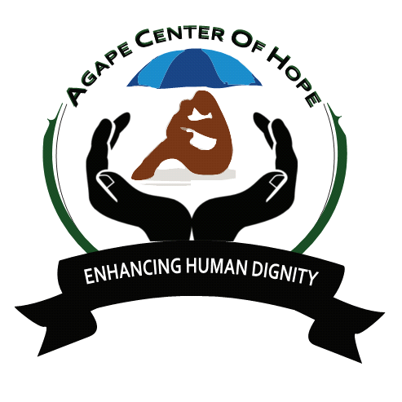Email-infoagapecentreofhop@gmail.com-Contact-0702818338
ACoH: MLTV01/01 MARA OSERO WILLD LIFE CONSERVANCY.
Code: ACoH 01/01
Name: Mara Osero Maasai Mara Game Reserve Project
Type: EDU/KIDS - Wildlife, Culture, Conservation, Renovation, Environment & Education
Project dates: All year round

Location of the camp: Narok County
Community: Maasai tribe
Languages: English & Kiswahili
Number of volunteers:20 locals and internationals
Disabled: No

Age: 18+

BACKGROUND OF MAASAI LAND
The Maasai tribe (or Masai) is a unique and popular tribe due to their long preserved culture. Despite education, civilization and western cultural influences, the Maasai people have clung to their traditional way of life, making them a symbol of Kenyan culture.

Maasai's distinctive culture, dress style and strategic territory along the game parks of Kenya and Tanzania have made them one of East Africa's most internationally famous tourist attractions.

The Maasai people reside in both Kenya and Tanzania, living along the border of the two countries. They are a smaller tribe, accounting for only about 0.7 percent of Kenya's population, with a similar number living in Tanzania. Maasai’s speak Maa, a Nilotic ethnic language from their origin in the Nile region of North Africa.

The Samburu tribe is the closest to the Maasai in both language and cultural authenticity.

Through rituals and ceremonies, including circumcision, Maasai boys are guided and mentored by their fathers and other elders on how to become a warrior. Although they still live their carefree lives as boys.

- Raiding cattle, chasing young girls, and game hunting - a Maasai boy must also learn all of the cultural practices, customary laws and responsibilities he'll require as an elder.

The wildlife, culture, conservation and education village centre offers volunteers the ultimate opportunity to explore, learn and interact with the Maasai community and their culture. The Mara conservation gives them a platform to serve, interact and also live like the Maasai people. Above all, the conservancy is managed according to a model that protects the delicate eco-system and benefits the landowners who are the Maasai people.

The wildlife, culture, conservation and education in Kenya is home to the big cats situated on the mararienda most point of the Greater Mara Ecosystem; borders the Olchorro Oiroua Conservancy to the south, and MMNC to the East. The important focus of the conservancy is livestock improvement through innovative cattle management programs, running alongside novel tourism projects.

The habitat comprises wooded acacia savannah with open plains on flat plateaus, riverine acacia forest and rocky, undulating hills which provide a varied habitat for browsing and grazing ungulates, as well as hideout thickets for the predators. The Mara River runs alongside the conservancy. There is a large number of giraffe and resident buffalo that live close to the Olerai boundary along the Mara River. Elephants frequent the conservancy and there is a pride of lion based on the edge of oloisukut. There are many hippos and crocodiles in the section of the river that borders the conservancy and the riverine forests which provide an area popular with leopards. Rare species such as Aardvark, Caracal, serval cat and Aardwolf are.
Occasionally found. Colobus monkeys have been spotted in the valleys on the Kileleoni Hill and there have also been sightings of wild dog in Enonkishu. There is no doubt that Mara Osero offers an incredible game viewing experience.

ESSENTIAL DUTIES AND RESPONSIBILITIES
- Oloisukut scouts patrol within the conservancy
- Security on conservancy borders and within; day and night
- Data collection
- Monitoring wildlife movement
- Control cattle grazing
- Human movement control
- Ensure upkeep of the conservancy
- Community awareness on wild protection.
Treatment and rescue of orphaned wild animals with collaboration with other stakeholder’s i.e wwf, Mara elephant project, community and others

- Do joint patrol within and outside neighbouring Mara conservancy in collaboration with other rangers from neighbouring conservancy.
- Safari walks and game drives
- Bird watching
- Educational support i.e. outreach programme to enrich formal education
- Medical outreach services activities
- Research programmes all around fields allowed but information generated may be shared with the conservancy.
- Filming may be done on the conservancy but all rights reserved courtesy of Oloisukut conservancy
Photo shooting on our scenic landscape that include wild animals, siria/oloololo escarpment, beautiful mega rocks hanging on escarpment, very beautiful bushes and forest and our pride
the Mara river that borders us with other conservancy.

We showcase the Maasai cultural activities, we have manyattas bomas, our women doing beadwork ,our system of slaughtering and meat eating in places famously known as orpul, maasai dance and so on.
Day 1: Arrival and pick up from the Jomo Kenyatta International Airport, in Nairobi, Kenya and transfer to host family home or hostel.
Day 2: Morning: registration and start of orientation. About 4 hours lecture at the home of your host. Topics covered during orientation lecture will include East African culture, history, customs, politics, geography, and necessary health precautions, and various other topics, such as the diversity of Kenyan life. Afternoon is free for exploring rural Kenyan life and getting to know your host family.

Language: English but also ready to learn Swahili and Maasai.
Duration of the project: 1 to 12 months. The program is running throughout the year.
Orientation: Orientation meeting will take place in Nairobi before proceeding to the project.
Accommodation: volunteer will be hosted in the respective bomas where they live. There will be a solar lamp and water are available
Location: Narok County Maasai Mara National game reserve.
Age range: 18 and over
Participation fee: 300 Euros per months (12 months)
Project dates: All year round

PROJECT PHOTOS

AGAPE CENTRE OF HOPE (ACoH)

