Code: ACoH 06 /01 | Region:Coast | No of vols: 25
Name: WHV – MOMBASA OLD TOWN | Country: Kenya | Age: 18+
Type: WHV–Promotion & Preservation/Culture | Start date: 6rd July 2020 | LANGUAGE ENGLISH
Location: Mombasa Old Town | End date: 21st July2020 | DISABLE NO
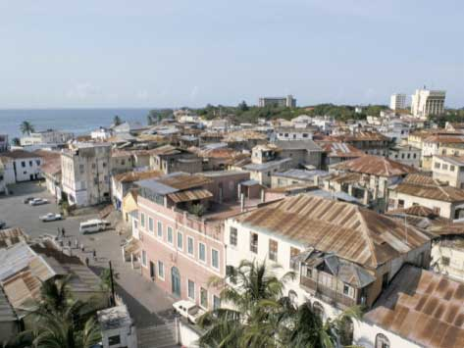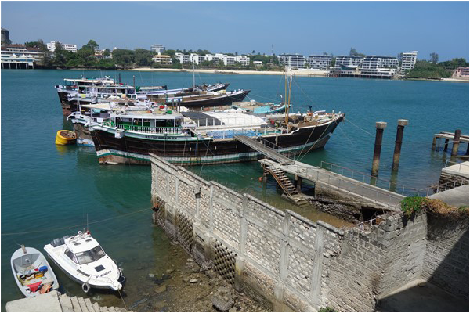
BACKGROUND
Mombasa Old Town is one of the historical tourist attractions on Mombasa Island. It is located on the southeast side of Mombasa and occupies an area of 180 acres. It is inhabited by a mix of local, Arab, Portuguese, Asian and British communities.
Fort Jesus (Mombasa’s most popular tourist attraction) is next to the Old Town. The architecture recaptures a bygone era influenced by the African, Arabic and European cultures, from the narrow streets to the high ornamental balconies.
There are many curio shops that sell arts and crafts, antiques and popular Kenyan souvenirs.
In 1997, the Old Town and Fort Jesus were submitted by the National Museums of Kenya for selection in UNESCO's list of World Heritage
The area is located to the east of Mombasa Island, adjacent to Tudor Creek.
Buildings in the Old Town are influenced by Mombasa's trade culture, with many examples of Portuguese and Islamic architecture.
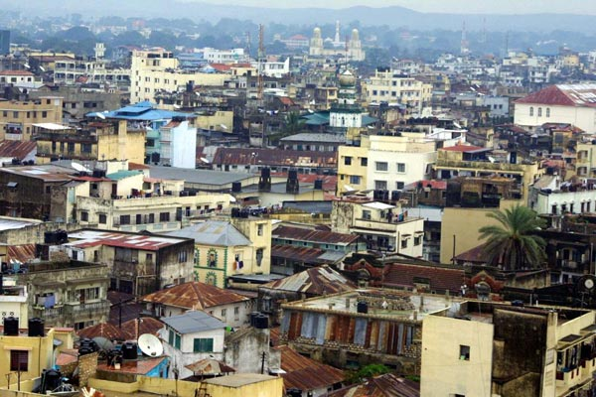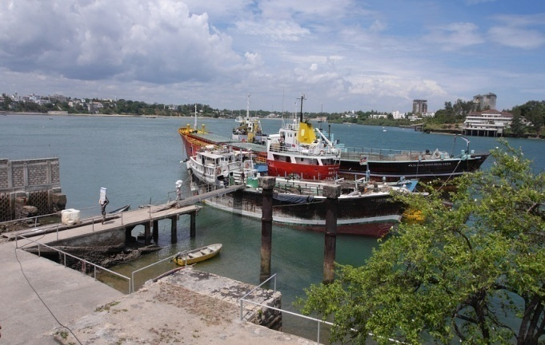

MAIN WORK ACTIVITIES
1. Promotion:
- Mombasa Old Town World Heritage Site both are Pre- 17Th Century settlements •Both have a history of continuous occupation since the 9th Century •A wealth of history and culture that if adequately integrated into the mainstream economy could easily uplift the people’s standard of living. In respect to this, a session where the council of elders who are custodians of culture will have time to talk with the community and young people as well as the international volunteers about the true history of the town where we will use recording to capture this unique intangible cultural heritage.

- We will organize baraza (meeting) where the area leaders, local organizations, council of elders, young people from this area and the locals are going to assemble as we talk about the importance of promoting, preserving and conserving the old town to ensure that the coming generations benefit from it and learn it’s history.

2. Preservation:
In this we have linked with Kenya Museums and Mombasa Municipal Council and the members of the Community, more so who own most of the structures and the general public: -
- Cleanliness and repairs (refurbish/renovations), to attain what we call Corporate Social Responsibility (CSR), we carry out appropriate renovations and clean up all affected old places. Some old houses even have grasses and Shrubs growing on the walls almost rendering most structures to ruins.
The visible aspect of this unique character is a collection of historical buildings dating from the 18th century which combines, African, Arabic and European influences. Many of these buildings still exist, in beautifully carved doors as well as elegantly styled balconies attached to their turn of the century facades. Due to this reason, we shall organize cleaning activities in the building, wiping of the artifacts stored in the building and a day for the people around this WHV site to come together and do a thorough clean up of this WHV site.

- Mombasa County plans to refurbish buildings in the Old Town, in a move intended to improve the image of the ancient town. The county's move comes in the wake of concern by conservationists that structures in the UNESCO listed heritage town were fast wearing out. We have talked to the county boss to be a part of the refurbishing exercise which will be of huge importance to the spread of the conservation message and a strong statement when we talk about Mombasa old town preservation and protection.

-Cleaning up the shipwreck in old port, devising publicity for old town, holding visitor satisfaction questionnaire for old town.

LANGUAGE English is the official language of the work camp

ACCOMMODATION AND FOOD
Volunteers will stay in school dormitories, hostels or host family Accommodations are very simple, there is running water, and meals will be prepared by volunteers. Beds and Mattresses will be provided. Volunteer to carry; mosquito nets, sleeping bag, a pillow and water purifying tablets. Chess, playing and tents are necessary.

ORIENTATION Orientation will begin in the morning of the 2th June 2020 at ACoH offices and you will be picked up from accommodation and taken to the orientation will be conducted by ACoH staff in Nairobi and cover everything you need to know about your project placement. Introduction to Kenya and Mijikenda land, Swahili customs, language and expectations, safety, travel opportunities in Kenya, introduction to your project and placement. The orientation will also give you a chance to meet other volunteers and swap contact details for weekend travel and socializing.

LEISURE ACTIVITY
This will provide opportunities for international volunteers to learn/ enjoy local life and exchange with local people, we have quit a number of tourists attractions and site seeing points e.g. fort Jesus, mama Ngina drive, Mwaluganje elephant sanctuary, Shimon caves, the great Mombasa temples, elephant tusks, haler park, bombolulu cultural centre, bird sanctuaries, Sandy Beaches e.g. Diani Beach, Nyali Beach, Pirates beach, marine parks etc.

EXTRA FEE
350 EUROS which includes project work, accommodation, all Meals, transport from the airport/transfer and to the project site, and 24 hours on side staff support.

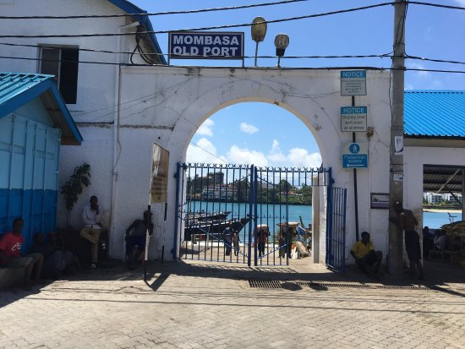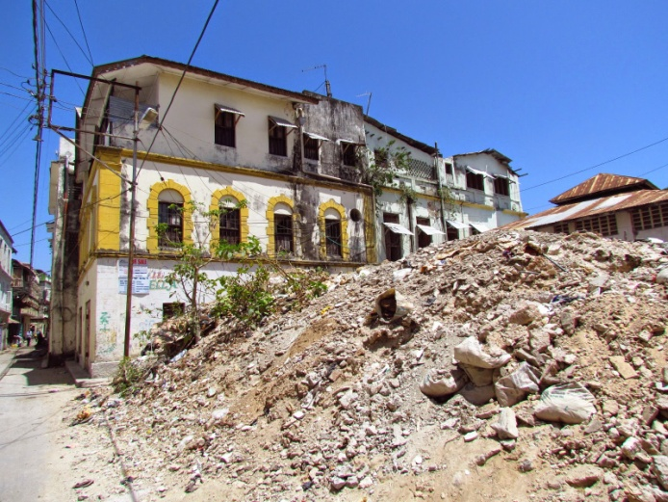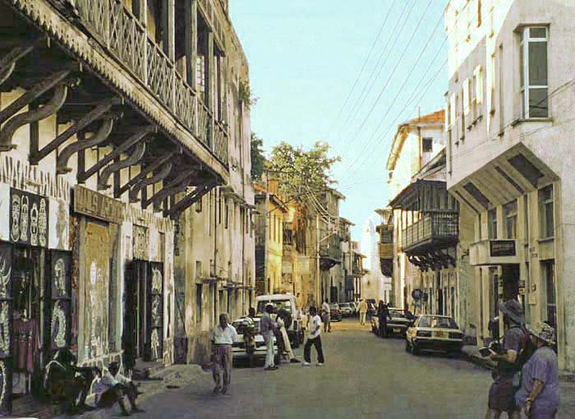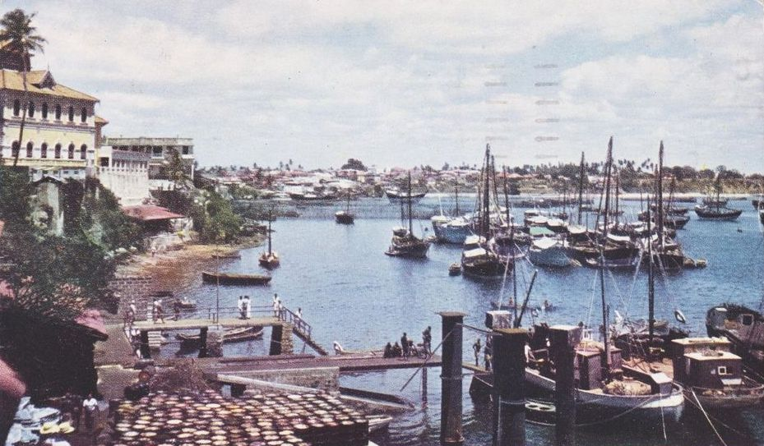
Travel: By SGR from Nairobi to Mombasa through Tsavo East and West National Park as you see the buffaloes, Rhinos, Elephants e.t.c, so keep your Cameras and smart phone Ready all... :)

