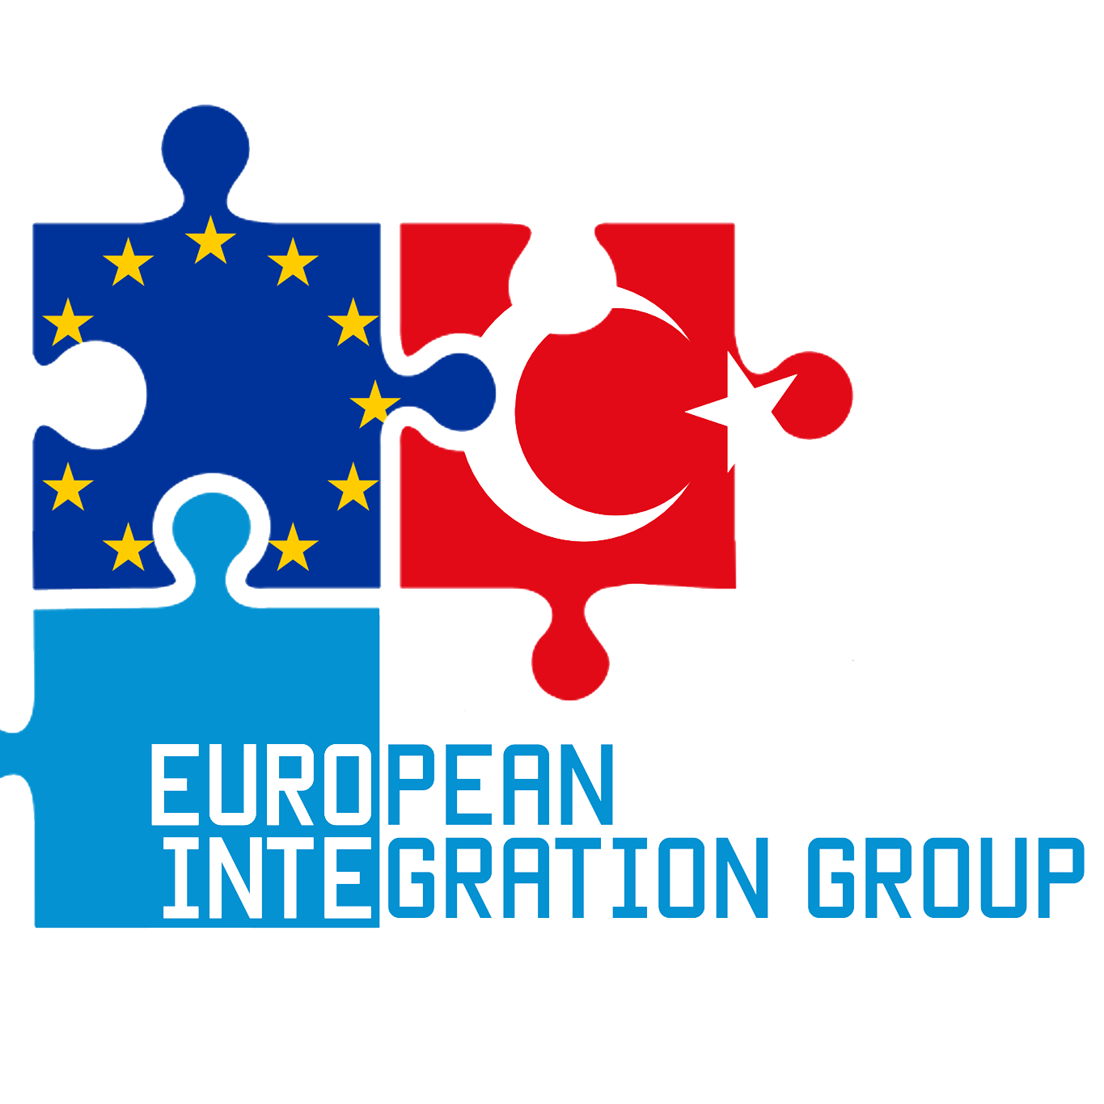
Science, Innovation, Creativity & Entrepreneurship
  - We are non-random partner for you!
Dear Partner,
Thank you for considering us for your project. As an organization we always give our best in everything we do. If we do not know something – we strive to learn that. If we are experts in the field – we share our knowledge.
More importantly, we value honest & straightforward communication. Thus, if you have any questions or simply want to chat, call/email us anytime.
We speak: English, Türkçe, lietuviškai, по-русски, po polsku, Español.
Regards,
Turgut Kaan Akkoca, Co-founder,

OID: E10090622

National Agency identification | Turkish National Agency / The Centre For European Union Education And Youth Programmes (CEUEYP)
Organisation full legal name (national language) | Avrupa Entegrasyon Dernegi
Business name | European Integration Group
Acronym | EiG
PIC number | 926833546
Type of organisation | NGO
Economic sector | Youth Activities
Size (staff) | 10
Legal address | Osmanağa Mah. Şemsitap Sk. No:5 Tırnakçı İşhanı K:17
Postal code | 34714
City | Istanbul
Country | Turkey
Telephone 1 | +905374518218
Facebook | https://www.facebook.com/europeanintegrationgroup/
Instagram | @eig.istanbul

CONTACT PERSON OF PARTNER
Title | Ms
First name | Merve
Family name | Aydemir
Position | Partnership Manager
Telephone 1 | +905067192342
Email | merve@eig.ist

LEGAL REPRESENTATIVE OF PARTNER
Title | Mr
First name | Turgut Kaan
Family name | Akkoca
Organisation | European Integration Group
Position | Director / Co-founder
Telephone 1 | +905374518218
Email | info@eig.ist

BRIEF DESCRIPTION of EiG

European Integration Group (EIG) was established in 2015 in Istanbul, Turkey by few young and dynamic people, who have experience in the sphere of social projects realization on the local and international levels. The group believes that they key to welfare, stability, democracy and tolerance is the successful integration of all the social and ethnic groups into society. Even though the group is itself young, it has simply united experienced professionals working in the sphere of integration in order to help the minorities in Istanbul. Therefore, the experience within the organisation is high.
Besides helping refugee in Istanbul our group promotes active youth participation in elections. In many countries, particularly in Eastern Europe and newly-established democracies, people have expressed deep concern not only about the overall low level of participation, but especially among specific groups like youth, women and the indigenous population. Increasing reluctance among youth to participate in politics and exercise the right to vote is particularly alarming and amounts, according to some, to a weakening of democracy. Therefore, it is imperative to find out the reasons for low youth turnout in order to reverse this trend and re-engage the young in the political and democratic process.
Beside these topics European integration Group has sport background and inclusion through sports activities. EiG has been locally spreading Capoeira dance for social inclusion together with capoeira organizations in Istanbul. Generally, the main aims of our non formal group are:
- education, science and culture project development;
- charity;
- solving of various social problems persisting within the local community;
- development of youth projects, interests and social activities;
- raising social welfare and improving living conditions of the poor and socially disadvantaged groups of people;
- minimizing youth unemployment;
- promote “every single vote matter” campaign;
- educating the youth about entrepreneurship and various opportunities within the EU;
- help minorities (in particular, refugees) in Istanbul to: (1) get used to using all the public facilities in the city; (2) understand how the healthcare and other emergency services work; (3) learn the language so that communication barrier would be gone.
This is done by also promoting Erasmus+ projects and opportunities behind it, because it is one of the best ways to fight the previously mentioned problems.
According to the named aims, here are the issues, which are very interesting for us:
- Volunteer movement (individual and group support and aid to people that need assistance, especially young people, children deprived of parental care and guardianship; the mentoring program for such youngsters).
- Youth development (promotion among young people the ideas of active citizenship and lifestyle, self-employment and entrepreneurship, critical view on the everyday life).
- To achieve our aims and increase our international scope and capacity, we are thus willing to organize a youth exchange on food waste problem involving 5 other European youth organizations.

What are the activities and experience of the organisation in the areas relevant for this application?
The activities of our organization are based on the approaches of non-formal education, experiential and intercultural learning, social inclusion and active participation. The activities include but are not limited to: networking and cooperation; educational projects of different types (e.g. training courses, seminars etc); awareness raising and policy development; capacity building of youth organisations and organisations/institutions working with young people and youth workers; coaching of initiatives, organisational and individual coaching; personal and professional development; mobility. “European Integration Group” collaborates with other European NGOs and international organizations and helping others host activities in a number of countries, promote cultural diversity and contribute to the positive social changes in European continent. Voting is the only form of participation in which each citizen has an equal say (one person, one vote). By voting, youth have the same ability as others to exercise political influence or pressure. EIG takes a first step in that direction by documenting the scope and pervasiveness of the problem internationally, exploring its causes, and identifying possible solutions in the form of innovative ideas and concrete programmes to raise youth interest and participation. We are managing and cooperatig projects under the Erasmus+ Programme.
a) We work especially for mobility of youth workers and young people.
b) We give opportunities to young people in higher education to take on an internship in another European country.
c) We provide opportunities for vocational students and staff to undertake traineeships abroad.
d) We also work closely with adults in terms of their digitalization and closing gap betweeen the generations.
Digital competences are necessary in all aspects of life, whether they are social or personal, relate to labour or leisure, in any sector, public or private. Improved citizenship is the primary aim of developing digital competences. It is our conviction that the education and training on digital competences need a more consistent approach and a cohesive European system of delivery. That is why we are supporting Adults to gain digital skills for valuable future.
We focus to support Adults that have an insufficient level of digital skills. That means that they’re having less chances to find work, to use online services, to have a better quality of life, to be included in today’s society. We empower our member organisations representing non-formal education providers to support millions of Adults to succeed in the digital transformation by providing them with training and advice. We believe that every adult should be able to exploit the benefits and opportunities created by digital transformation.
Our well-experienced trainers organize training for every target groups about non-formal education, european integration, activite citizienship, volunteer opportunities, democracy etc. Furthermore, the volunteers of the group organisation has participated in different Erasmus+ projects abroad (in Romania, Greece, Spain, Italy, etc.) that were aiming to increase people tolerance towards different minority groups.
What are the skills and expertise of key staff/persons involved in this application?
Legal Representative; Turgut Kaan Akkoca is a professional youth worker and entrepreneur. He has been working in the scope of Erasmus+ and YiA since 2009. His experience for the international projects started with “The EU Job Market” Comenius project in 2009 in Spain. He was the leader of high school team for the project and participated all the mobilities in Bulgaria, Italy, Romania, Spain and as well hosted in Turkey. He has the spirit of entrepreneurship thus he founded European Integration Group with the creative and self-driving team. The team reached to 11 people including youth workers, designers and volunteers (http://eig.ist/about/). He is intense and experience about rural entrepreneurship, environmental issues, hate speech movement, minority and immigrant integration.
Other key person, Uğur Keskin takes role as youth worker and exchange manager in the group. He is leading the volunteer team for outgoing projects. He is a youth worker and his Erasmus+ experience started in 2016 in Lithuania. He is expert about food waste prevention and leader for the Finish your plate! Movement.
Also other key person, Merve Aydemir as a Partnership manager of organization had been working as youth worker since 2016. Her first project was Rural Rules about rural development and social entrepreneurship in Lithuania. Since 2016, she had been taking role in European Integration Group about partnership building, social media and marketing. She is biomedical engineer and youth worker focus on drug prevention, inclusion through sports and as well as dance, theatre and art projects.
Our other member Abdulkadir Mülayim is a senior grade Economics student in Middle East Technical University, Ankara with a focus on international economics, environmental economics and development economics. He has a significant field practice and long volunteering experience in emerging countries of Europe, namely Ukraine, Poland, Lithuania and naturally Turkey. His ability to work in international and multicultural environments combined with academic interest provides a competent perspective to our team. On personal level, he is the translator of two published books and has been actively taking part/ facilitating projects since 2018. Since December 2019, Abdulkadir developed a sense of cooperation for Middle Eastern and North African countries and began working on Strategic Partnership and Capacity Building projects with partners from outside of Europe. With the objectives of reaching overseas for humanitarian aid and youth development programs, Abdulkadir works continuously inside and outside of Turkey.
The other member of EIG Hasan Mert İnce is a youth worker and user interface designer. He has taken part in volunteer work in various organizations since 2016. His Erasmus+ world and volunteering career started with non-governmental organizations. He worked as a media team and board member at these organizations, he participated 4 projects before within Erasmus +. Start of the project career the youth radio training course "We Radio" in 2017 and took place in Italy. He has been to other projects in Italy, Norway and the Czech Republic respectively, he was participate in Nantes Creative Generations Forum held in France in 2018 with more than 500 applications and 16 different countries and His project about "raise the awareness about fake media news about immigrants" attracted great attention in during the project contest.He continues volunteering works with European Integration Group since 2019."
WE WERE/ARE LEAD PARTNERS IN THE FOLLOWING PROJECTS:

Programme or Initiative | Identification/contract number | Title of the Project | Project impact and achievements  (provide qualitative and quantitative evidence; i.e. figures, case studies, etc.)
Erasmus+ | 2017-1-TR01-KA105-045198 | Rural Entrepreneurship Heroes | Many of the European Union’s rural areas face a common challenge, as their capacity to create high-quality, sustainable jobs has fallen behind that of urban areas. Generally, incomes are lower in rural regions than in towns or cities and there are fewer job opportunities. Therefore, European Integration Group (EiG) lead a project for the motivated ones from 6 different countries. The project achieved 9.8/10 participant evaluation in terms of hospitality, scope, workshops and project management.
Erasmus+ | 2018-3-TR01-KA105-061486 | 4R's: Reduce, Reuce, Recycle, Recover | Poverty even in the modern society, increasing sizes of the landfills, greenhouse gases emissions are the problems that are all connected with one issue - the ever increasing waste of food. EiG has lead the project for better understanding and awareness of participants. Promoted and disseminated the project results with the attendance of each partner by social media and as well as flash-mob activities during the project.
Erasmus+ | 2018-3-TR01-KA105-062039 | VAM: Villagers are Masters | There a numerous challenges that European societies are facing. One of the sensitive problems that  is widely seen across the EU (however, often wrongly-considered as not acute) is social exclusion of  villagers in urban areas. The inclusion of the discriminated communities was the key aim of the project hence the results brought the several influences over the local community in Turkey and also in EU with the dissemination of partners.
Erasmus+ | 2019-1-TR01-KA105-073581 | EFY: Eco Friendly Youth | The earth can not helf of the populace growth of the World. The waste increase dramatically and youth should take actions hence EiG created a project for plastic waste prevention and its dissemination.
Erasmus+ | 2019-2-TR01-KA105-077990 | SNA: Safety is NOT Automatic | Fast driving is crucial in our lives. The traffic rules and people awareness about the fatal accident. EiG has made a step to create awareness and inform the community about the topic.
Erasmus+ | 2019-3-TR01-KA105-078964 | HHNH: Hate Has No Home | The project aims to create awareness about hate speech and hateful behaviours on LGBTQ members, refugees and minorities.
ESC | 2019-3-TR01-ESC31-079333 | Reuse and Reuse Again | The solidarity project aims to create online platform to spread the techniques for recycling and reusage of the wastes.
ESC | 2019-3-TR01-ESC31-078883 | Finish Your Plate! | The solidarity project improves the EU citizenship spirit of High School students, promote Finish Your Plate! campaign and as well as educate the youth about recycling in order to decrease the food waste.

