Looking for partners? Mersin Metropolitan Municipality is available to join your projects!
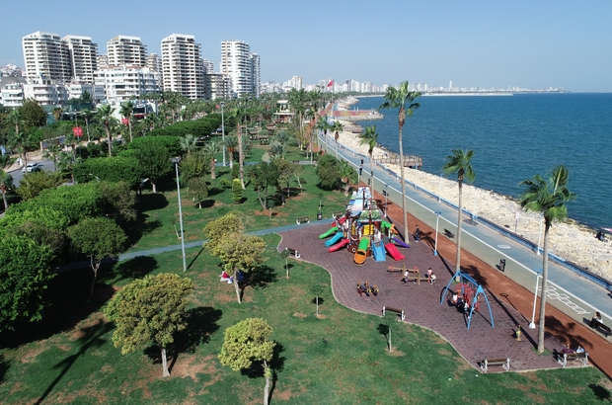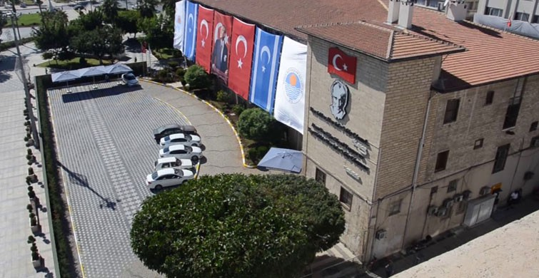

We, Mersin Metropolitan Municipality, are looking for projects to join as a partner within EU Projects as local public body.
Mersin is a large city and a port on the Mediterranean coast of southern Turkey. The population of Mersin is 1.727.255.
Mersin Metropolitan Municipality has previous significant experiences in European funded projects, in particularly within the IPA, Capacity Building in the Field of Climate Change in Turkey Grant Scheme (CCGS) and Town Twinning. We are also ready to prepare many projects related education, culture, youth, disabled and disadvantaged people, children as a target group to ensure realization of all kinds developmental implementation.
To manage the municipality according to strategic plan parallel to EU integration process, to originate corporate strategies of the municipal administration, to undertake preparation and implementation of the activities in conformity with these strategies, to determine, pursue and evaluate performance scales of the municipal activities and personnel, and to submit reports to the municipal council on this subject.
If you are interested to receive more information and/or to liaise with Mersin Metropolitan Municipality, please contact us on argeveproje@mersin.bel.tr or call us on +90 533 31 44
More information available on https://www.mersin.bel.tr/en

