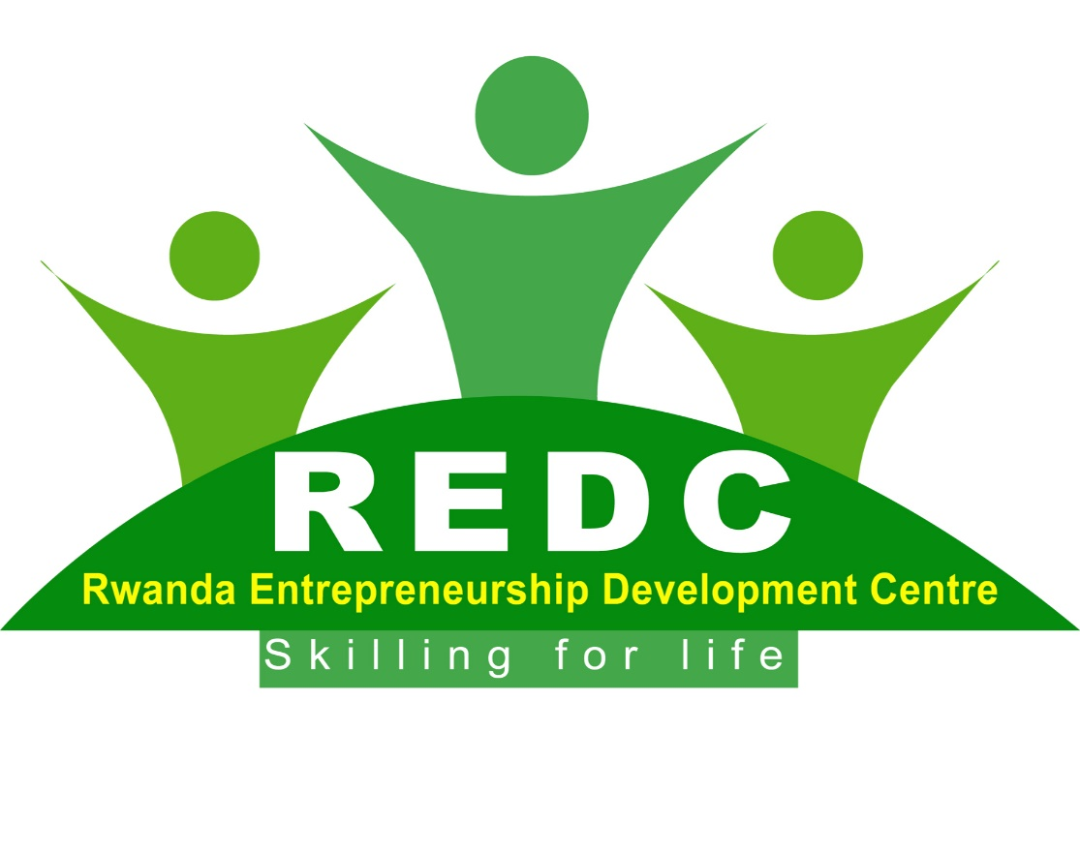**REDC Brochure**

**About us**

The Rwanda Entrepreneurship Development Centre is a local non-governmental organization that was conceived in Rwanda to address challenges of unemployment among youth and women in Rwanda with a vision to promote practical entrepreneurship among youth and women in Rwanda

**What we do**

We support youth and women with age bracket of (18 – 35 years) in entrepreneurship skills as to start, grow and sustain their livelihoods - enabling them to create jobs, build communities and transform lives.

REDC focus is youth and women oriented initiative with a viable practical entrepreneurship & business ideas but with access to the support structures needed to enable them set up and run businesses

We organize entrepreneurship workshops/conferences/boot camps/mentoring programs /business start – up tools / financial literacy/ Business loan management skills/ saving programs/entrepreneurship radio/television talk show for youth and women in Rwanda.

**Our Vision**

The vision of REDC is to become a leading non –governmental organization in promoting entrepreneurship among youth and women in Rwanda

**Our Mission**

To promote a culture of entrepreneurship among youth and women in Rwanda

This will be accomplish by:

* Empowering the youth and women in Rwanda with entrepreneurship skills.

**Meet the team of REDC**

**Mr.Nkurunziza Nicolas**

He is the founder/CEO of Rwanda Entrepreneurship Centre, that champions in promoting entrepreneurship among the youth and women in Rwanda ,and National Coordinator of World Alliance Business Coalition([http://business.worldea.org](http://business.worldea.org/)) and CBMC International([www.cbmcint.com](http://www.cbmcint.com)) Christians centered organization that promote business among Christians. He is a financial consultant with extensive experience of almost 14 years focusing mainly on working small and medium enterprises and non-governmental organizations in Rwanda. He is a Master holder in Finance.

[](https://www.drderrick.org/meet-dr-derrick/)

Dr Derrick Samuels is the Founder and President of Derrick Samuels Leadership Institute (DLSI) and, CGI in USA and also the Co-founder of Rwanda Entrepreneurship Development Centre .He is the ‘Voice against Stagnation’, addressing more than 150,000 people worldwide each year and; the host of ‘Evening with Dr. Derrick’, holds the keys to wisdom that will help you circumnavigate the pull of mediocrity, the temptation to do “just enough,” or to settle for a life less than the best. As a highly passionate speaker, highly regarded business consultant author, professor, and transformationalleader .  
Dr. Derrick, among other places, has spoken at the United Nations as an advocate for Youth Education, Development and Sustainability; he was the Commencement speaker, class of 2014,   
His current published books, among others, include: The Power of Movement;The Power of Your Tomorrow; The Ten Commandments of Success; Christianeurship -Your Spiritual MBA for Business Success; Cutting-Edge Leadership-Style, Substance and Sustenance.Leadership   
He has consulted widely in business and government, as well as within the higher education community. He has served in an advisory capacity to two Universities and two corporate institutions. He is the recipient of numerous awards, honors, and commendations.  
Dr. Derrick Samuels, a Certified Project Management Professional, holds a bachelor’s degree in Mechanical Engineering, an MBA in Management and; PhD in Applied Management and Decision Sciences and; has taught for Embry-Riddle Aeronautical University, American Military University, and Thomas Edison State University among others.

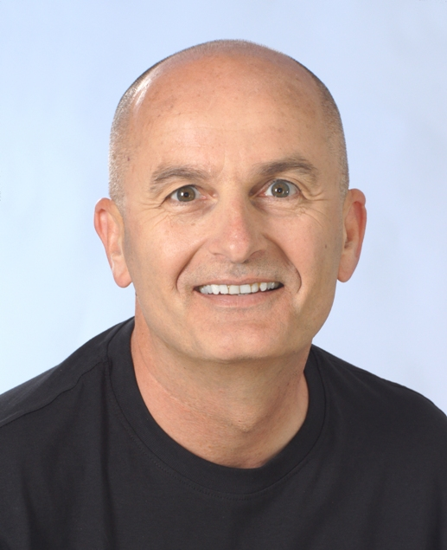

Mr.Ben Kubassek is the founder and CEO of KNOW, GO,GROW International and a senior team member of Rwanda Entrepreneurship Development Centre .He is an author, speaker, and an international expert on entrepreneurship, and the founder of several non-profit organizations with great passion for teaching youth and women in developing countries on how to start their own businesses.

He is now dedicated to teaching, motivating, and inspiring young people in developing countries to know, go, and grow in their own businesses and in their personal lives

Ben believes social entrepreneurship is the cure for poverty and that the missionaries of the future will be self-sustaining mission entrepreneurs who lead by example, showing people how to help themselves and move from victim-hood to victory. From being job-seekers to becoming job-creators.

Partners

KNOWGOGROW International/ knowgogrow.com

World Alliance Business Coalition /www.worldea.org