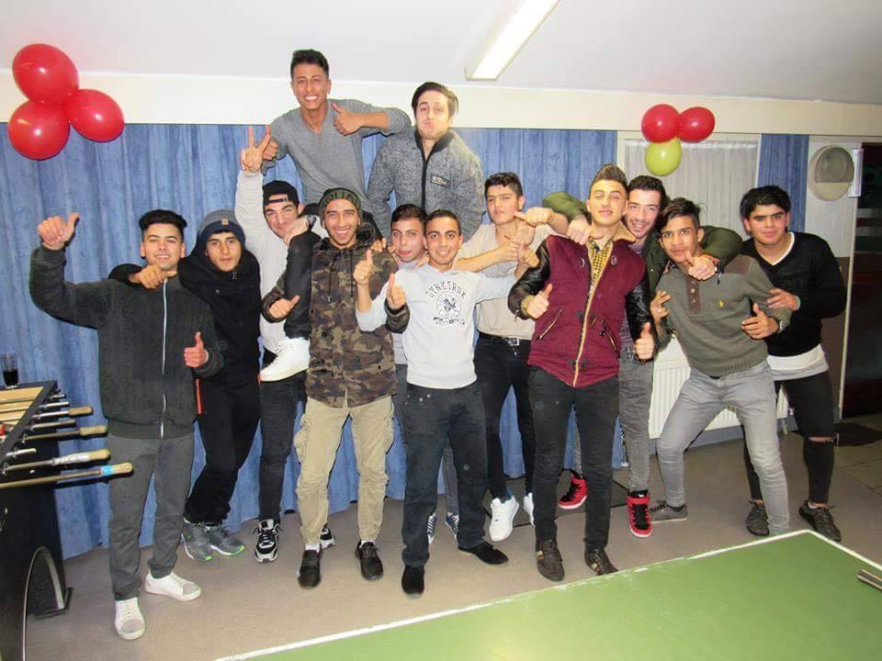
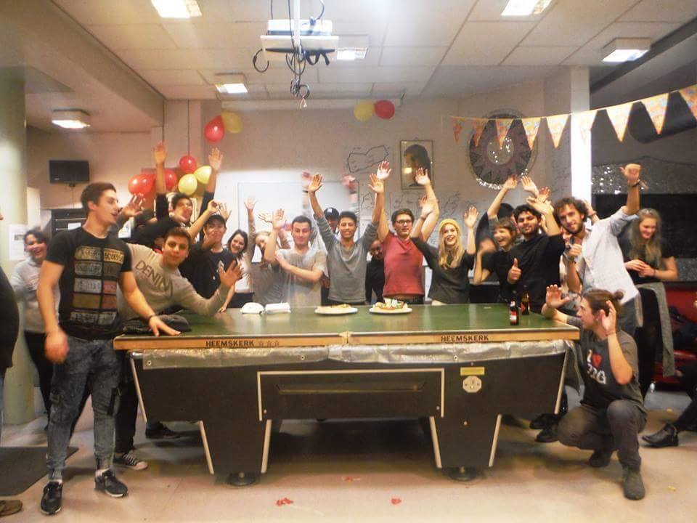
Youth Center De Takel
We want you !!!

ESC-project: Youth Center ‘De Takel’
Organization and task description
‘De Takel’, a Don Bosco center for youth care in Oostende, is looking for 2 European volunteers to do a one year ESC-voluntary service. De Takel is a youth center for young people between 12 and 25 years. It is a place where they can come together for all kinds of activities and socializing. The target group for De Takel consists mainly of: young people from disadvantaged neighborhoods of Oostende, refugees, minors… . This creates a very multicultural audience, with mostly indigenous youths and a large number of vulnerable young people.
The main task of the volunteers is to build up a relationship with the youngsters and to gain their trust. In this respect, the volunteer is expected to accompany them in the activities and their visit to the youth center and take part in the daily activities of the Youth Center. The volunteer will be supported in this by the experienced staff of De Takel. They have been working with ESC-volunteers for some years now, and have developed a good guidance system to work with the volunteers.
In 2018 De Takel started a girls department to reach out to more girls from families living around De Takel. Step by step, with an attractive program and some nice initiatives, De Takel builded up an engaged group of girls who are now coming to weekly activities of De Takel.
More specifically, the tasks of the volunteers will consist of:
- To build up a relationship with the youths visiting the De Takel. Listen to their stories and establishing contacts with them.
- Assistance, being there for the visitors of the Youth Center
- Accompany the young people during their visit and stay at the youth center.
- Homework support
- To plan, organize and supervise creative, relaxing and educational activities in and outside the Youth Center. F.e. cooking activities, different hand crafting activities
- Organize/Guide sport activities for and with the young people
- Maintain the bar in the youth center
- To guide excursions in and outside Belgium during holidays
- To play games with the youngsters (board games, billiard, table tennis, table soccer...)
- To participate in meetings with the youngsters.
- To attend the staff meetings
- Take part in European Don Bosco Youth-net activities www.donboscoyouth.net
- Organize an international project with the young people from De Takel. (2020)
Organizations involved
Jeugddienst Don Bosco will be the coordinating organization of this project. As the supporting organization of all Don Bosco playgrounds and youth centers, JDB has the necessary experience with EVS projects and with the mentoring and guiding of European volunteers. They already appointed one of their staff members to oversee everything with respect to the ESC-project in Oostende.
Youth center De Takel will be the hosting organization where the service will be done. They will support you in your daily (working) activities. Next to this, they will also help the volunteer with practical and administrative issues.
What guidance can you expect?
- Monthly follow-up meetings with the project coordinator of JDB
- Mentoring by a staff member’ of De Takel
- Extra Dutch classes from a volunteer of De Takel + possibility to register for Dutch language school (upon volunteers’ request)
- Task related support by the staff members of De Takel

Volunteers’ profile
The ESC vacancy is open to everyone. We are looking for two (2) European volunteers from 2 different organizations., by preference one boy and one girl.
Some requirements for the ESC-volunteer are:
 | Essential | Desirable
Skills | - strong English communication skills  - strong youth work skills and experience in youth work  - able to live and work as an independent person  - strong intercultural skills | - understanding of Arabic  (or Dutch, Russian language)  - experience in working with disadvantaged youths  - having pedagogical skills build up by studies or working with disadvantaged groups
attitudes | - open towards other cultures and to have an intercultural experience  - motivated and eager to learn  - willing to work in an multicultural environment  - have a pro-active and ‘can-do’ attitude with the motivation to succeed and be able to work as part of a team when required.
extra | - interested in sports (football)  - interested in gaming and other PC games.  - interested in developing an international project with young people.  - can speak Arabic or another language present at the Youth Center (Russian, Albanese, Dutch, Syrian, Pashto…)

-
The youth center is ‘attracting’ mostly a male audience nowadays. This is something the volunteer should be aware of (but not be scared) of.
But as mentioned before, the girls department has been founded in 2019 and is in full development.

Practical and organizational information
Erasmus+ and financial arrangements
Jeugddienst Don Bosco will submit an application to be approved as an EVS-project in the Erasmus+ program. If the project is approved, Jeugddienst Don Bosco will receive a budget to cover next costs:
- Monthly pocket allowance: € 110
- Weekly household money € 50
- Rent of the volunteers’ accommodation
- Travel costs up to € 275
- Extra project costs
The pocket money will be transferred to a Belgian account number which the volunteers will be asked to open upon arrival.
The rent will be paid by Jeugddienst Don Bosco straight to the owner of the volunteers’ house.
Volunteers will also receive a Youthpass at the end of the service. The Youthpass process will be guided by the staff member of Jeugddienst Don Bosco.
Duration
The project will take place between September 2019 and September 2020. Precise duration is flexible and starting dates can be negotiated. First days, the volunteers will receive an on-arrival training from Jeugddienst Don Bosco.
Volunteers are also expected to take part in the on-arrival and mid-term evaluation training organized by the national agency. This is a training with all EVS-volunteers of Belgium – Flanders. An ideal moment to exchange experiences, to plan new things, to reflect and to discuss with peers…
Working schedule
The volunteers are expected to take part in a 25-30-hour week, which also includes the time spent on the language course that will be provided. Compensatory leave will be possible in case of weekend performances. The volunteers will plan their timetable in consultation with the head of De Takel. This means that the volunteers will be able to determine how their working hours hours are puzzled into the opening hours of the Youth Center. These opening hours are.
Monday | Tuesday | Wednesday | Thursday | Friday | Saturday | Sunday
Closed | 19.00-22.00h. | 14.00-18.15h  19.00-  22.00h. | 19.00-22.00h. | 19.00-24.00h. | 14.00-18.15h.  19.30-  24.00h. | 14.00-18.15h.  19.30-  22.00h.
On Tuesdays, Thursdays and Fridays during school holidays, the opening hours can change to those of Sunday.
The volunteers are entitled to 2 days of holidays per month. Together with the flexible working schedule, the volunteers can plan longer weekends off.
Accomodation
During the service, the volunteers will have their personal rooms in shared students and volunteers house. There are max. 4 people living in the house. All basic needs are provided: kitchen, bathroom, tv, internet….
The rent is included in the Erasmus+ grant and will be paid by Jeugddienst Don Bosco.
Language support
Erasmus+ offers every volunteer the possibility to follow an online language course via the OLS-tool. A test will determine the level of Dutch and from this starting point, the volunteers will be offered a course with different challenging but interesting language exercises.
Last years, the ESC-volunteers could also count on the voluntary support of a Dutch teacher to assist the European volunteers in learning Dutch.
Selection procedure and contact details
We would like to give a chance to young people with fewer opportunities to apply for this voluntary service. In this respect, we would be open to accommodate a young person who deals with economic or geographical obstacles and consider them as well as other candidates.
Are you interested in this exciting project, and do you want to become a volunteer for ‘De Takel’? Send us your resume and a cover letter no later than July 1st to Fonny Grootjans : fonny.grootjans@donbosco.be
The most suitable candidates will be selected and invited for a Skype interview. Based on this interview, the most suitable candidate will be selected. Each step in this selection process will be taken through consultations between Jeugddienst Don Bosco and ‘De Takel’.
Do you still have questions? Please send them to Fonny Grootjans and he will answer them as soon as possible.
Finally, all other contact details that might be useful:
Vzw Werk van Don Bosco – De Takel
Center for youth care
Elisabethlaan 221
8400 Oostende
Belgium
+3259 70 20 81
Jeugddienst Don Bosco vzw
Naamsesteenweg 37
3001 Heverlee
Belgium
+32479 50 88 27
fonny.grootjans@donbosco.be
www.jeugddienstdonbosco.be

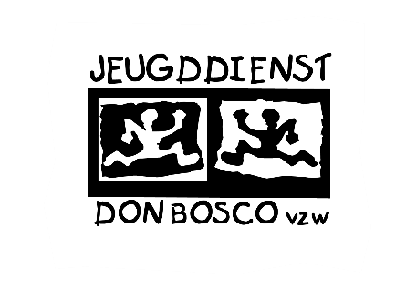
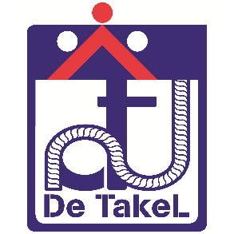
www.donboscodetakel.be

