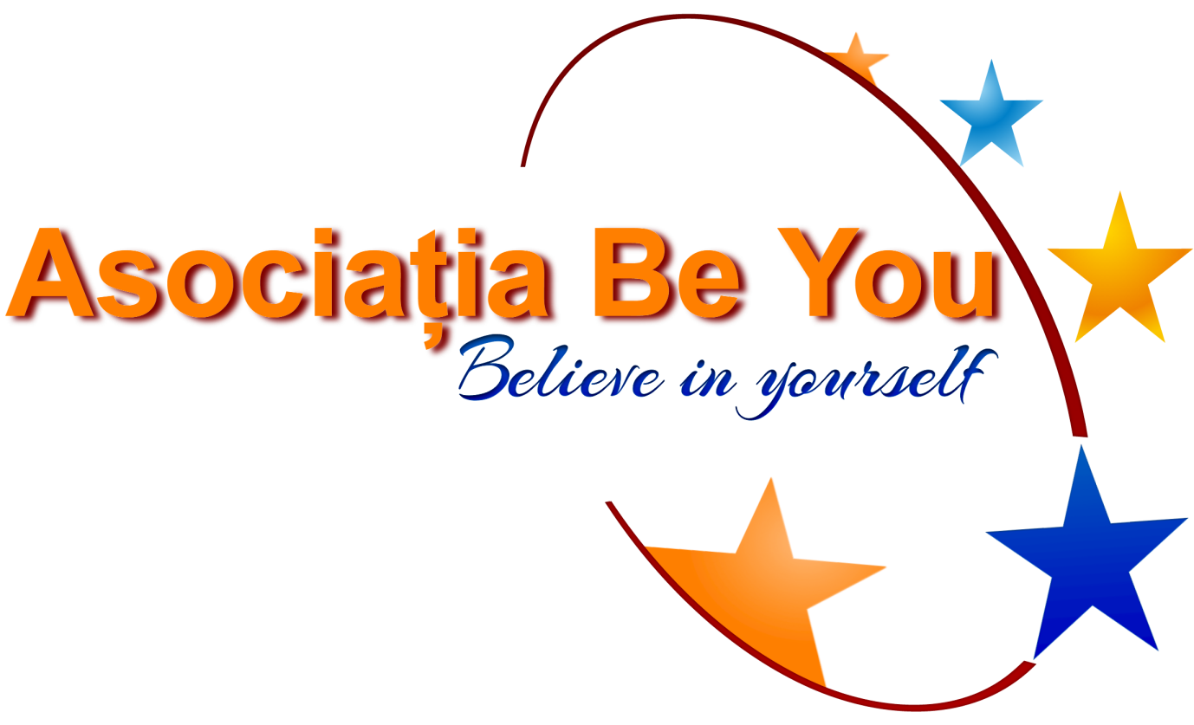Asociatia Be You

CIF: 35276581

Str. Tudor Vladimirescu, 85,Valea Voievozilor

Răzvad,Dâmbovița

Cont lei : RO38BTRLRONCRT0325795201

Tel: 0737842244

Email: beyouroumania@gmail.com

Web: www.beyou.ml

**OUTSIDE OF THE BOX**

**TRAINING COURSE**

**CALL FOR PARTNERS - ERASMUS + KA1 MOBILITY OF YOUTH WORKERS**

**DESCRIPTION OF THE PROJECT**

The era of digitalization has a great impact on young people’s live, they couldn’t imagine their lives without gadgets and Internet. The real problems occur when young people do not use for their benefit the technology and make abuse of internet and gadgets becoming adiccted of games, social media. The abuse of Internet and gadgets become so normal, that young people are not aware about this fact. The statistics show conerning results because young people spend a lot of time on internet, in front of their gadgets - around 7 hours per day. The consequences are visible in the discreasing of social skills, their ability to have face to face communication with their familly, friends and also they suffer from certain diseases becoming depressed, anxious or very impulsive and also they develop serious lack of attention and concentration.

Through our trainig course we want to prevent this phenomenon, to raise awareness on the responsible use of Internet and gadgets among young people.

Outside of the box aim to empower youth workers, activists, trainers, educators to use sport and physical activity to tackle and prevent internet and gadgets addiction among young people,to provide youth workers a place to share and put in practice attractive sports based methods and activities, to promote direct socialization proposing sport based activities and highlight the opportunities of a beneficial use of technology.

The activties are designed especially to show that sport activities have a great positive influence on human being health and behaviour and also can prevent internet and gadgets addiction. The training course allows to participants to share working methods and to design their own project idea related to the topic, to discuss the current issues faced by young people and ways in which sport can be used to solve these issues.

**DATE AND VENUE:**

Venue: Aninoasa-Romania

Date: June 2020.

**PROJECT OBJECTIVES:**

* To develop the knowledge about risks and opportunities of digitalization;
* To demonstrate sport and physical activities power to prevent and reduce Internet and gadget addiction among young people;
* To provide youth workers with skills and methods to approach youth addiction issues in their daily work;
* To empower youth workers to use sport based activities as tools for social inclusion;
* To discuss how can be adapted sport activities to current issues face by young people;
* To conceive own project ideas related to the topic based on sport activities.

**NUMBER AND PROFILE OF PARTICIPANTS:**

We aim to gather 27 youth workers, activists, trainers, educators, 3 from each country, for a 8-day-long training course to improve skills, to acquire new skills, gain more knowledge, exchange good practices in project topic.

**REQUIREMENTS FOR PARTNER ORGANIZATIONS:**

* Belonging to Program Countries;
* Registered in ECAS Portal/ Having PIC Number;
* Experience in the field of non-formal education activities young people;
* PIF completed according to the model requested by us;
* Ability to respect and communicate all stages of the project (vizibility, participants selection and preparation, support, dissemination, etc.);
* The partner organizations should be dedicated to young people and not be interested in projects just to charge participation fees (Be You Association and the Romanian Eramus+ National Agency do not agree this practice).

**EXPECTED RESULTS OF THE PROJECT:**

* Understand the addiction phenomenon among youth and its risks;
* Raise awarness upon addiction;
* Design sport based activities to reduce addictions phenomena;
* Improve the ability to manage addiction cases in daily work with youth;
* Project drafts ready to be improved and implemented;

**CONTRIBUTION TO TRAVEL COSTS:**

According to the Erasmus+ Programme regulations.

For travel distance please consult the Erasmus+ Distance Calculator: <http://ec.europa.eu/programmes/erasmus-plus/tools/distance_en.htm>

**NOTE!**

Please, apply only if you are interested in the topic of the project and you have the ability to participate actively throughout the project.