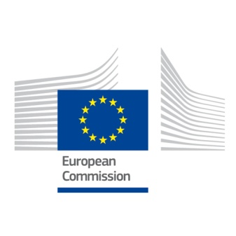
Partner organization
PIC
Full legal name (National language)
Full legal name (Latin characters)
Acronym
National ID number (if applicable)
Department (if applicable)
Address
Country
Region
P.O. Box
Post Code
CEDEX(Onl for france)
City
Webpage
Email
Telephone 1
Telephone 2
Fax
Profile
Type of organization
Is the partner organization a public body?
Is the partner organization a non-profit?

Accreditation
Has the organization recieved any type of accreditation before submitting this appliaction?
Accreditation Type
HOSTING AND SENDING
Background and Experience
Please briefly present the partner organization.
What are the activities and experience of the organization in the areas relevant for this application?
What are the skills and expertise of key staff/persons involved in this application?

Legal respresentative
Title
Gender
First name
Family name
Department
Position
Email
Telephone 1
Contact person
Title
Gender
First name
Family name
Department
Position
Email
Telephone 1

