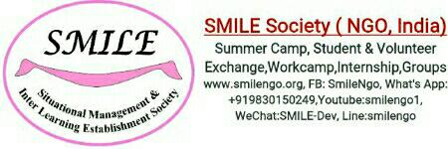

**Yoga and Meditation Workshop with Community Work :**

**(SMILE MLTV06)**

**Important Details:-**

**Project Type:** Permanent

**Duration** :3-5 months

**Living cost for MLTV projects :- US$ 396/head/month**

***Cost includes***:- 3 times tasty home made local food, shared dorm room at local host family,public transportation (train/bus ) to and fro Project if required ,Airport transfer on arrival and departure between 8 am- 6 pm, drinking mineral water , orientation, Limited 24/7 wifi connectivity , training if required( Mon-Fri) , Pre departure orientation , emergency support ,local language training, Project Supervisor support.

**Cost *excluded*** :- Flight ticket, visa,medical cost, if any personal cost ,weekends 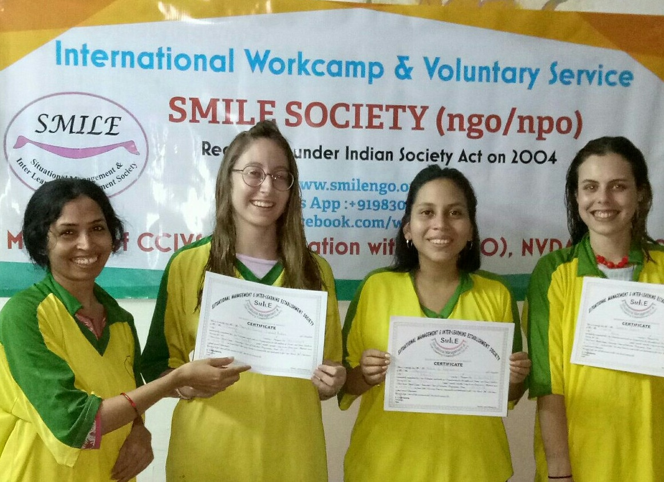trip,special trip at the end of the camp ,gift,any special food / drinks, insurances, vaccination.

***Starting Date*:- A**nytime of the year.

**Accommodation and food :-**

Accommodation: Dormitory basis as per available on arrival ( on cot with mattress/on floor with mattress, 2-4 volunteers in one room, bigger group living also possible Subject to availability ) shared accommodation (normally male & female separate room),Common toilet, electricity, Limited Wifi access in house available. You will get accommodation from 8 am of the first day till 6 pm on the last day of your project.We are unable to provide you any accommodation before or after these dates. Please arrange your own accommodation in case of early arrival or late departure .You are requested to meet our representative at the meeting place on exact time given above. If you arrive early then you can have your stay in any of the different hotels available nearby Airport, within 2 -3 km .on the road popularly 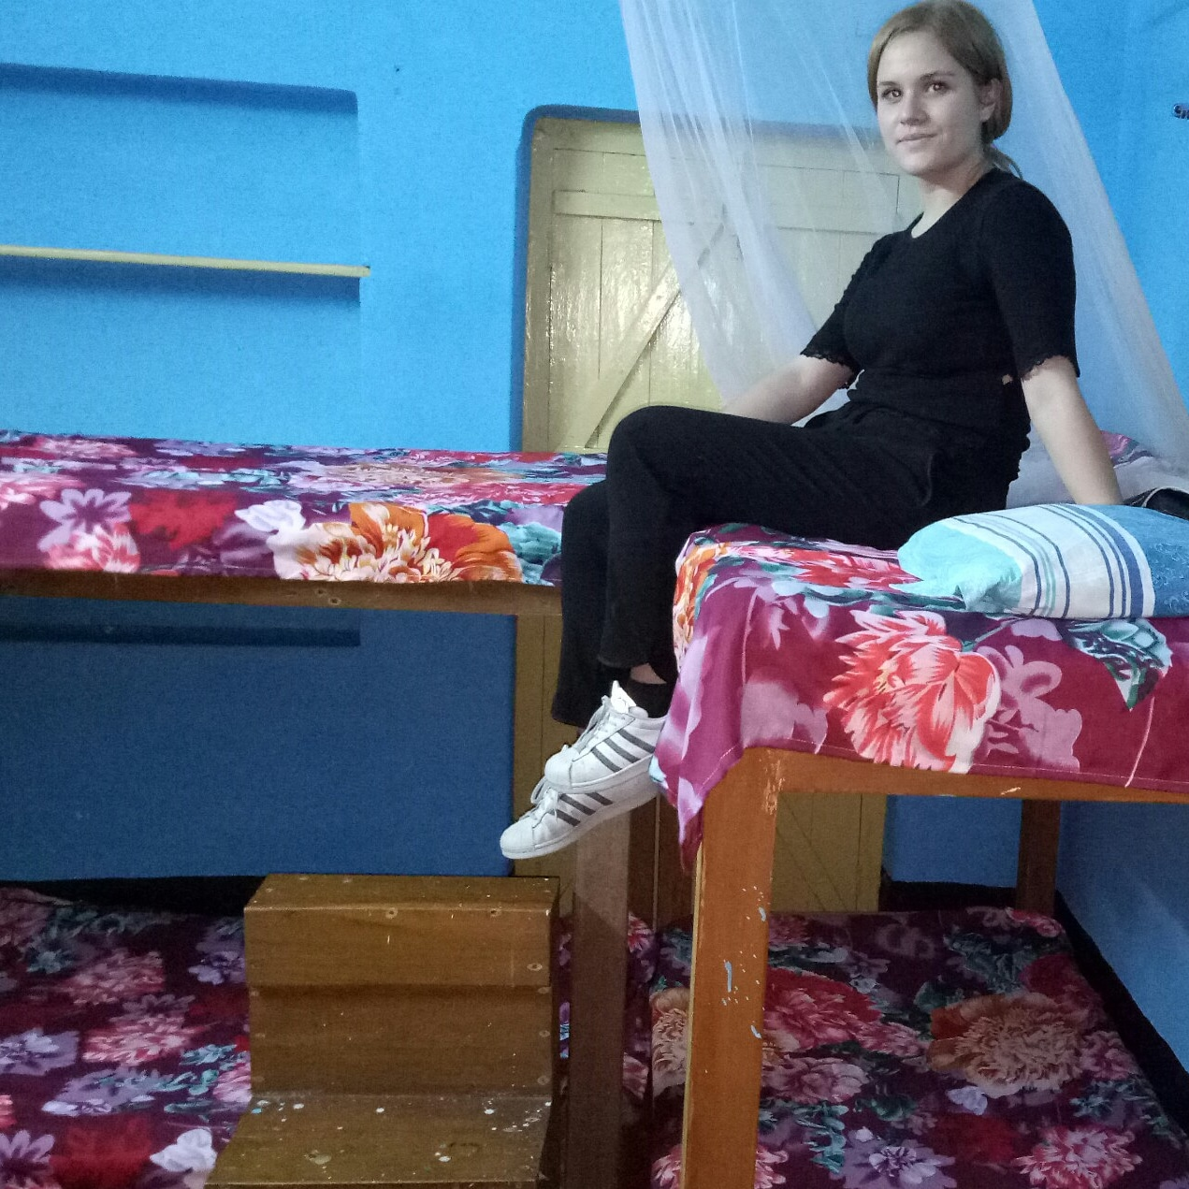called as V.I.P road. You are requested to take any cab to check in any of these hotels. If you arrive at earlier night then you are requested to stay inside the airport terminal and meet at the next morning with our representative as per appointment. Volunteers are not allowed to spend night outside of their accommodation during their full project duration due to safety and security policy.

Food: You will get 3 times local food from host family. Please do not expect air conditioned room, hot water for shower and special food items as per your desire during your term. You are requested to get ready for a simple and challenging life.

**location & leisure :-**

INDIA is an amazing country with diverse culture and tradition .Interesting people ! Explore the country with exciting diversity .Kolkata ,the city of joy was known before as Calcutta since the colonial time. This ancient city was used to be the capital of British colonial period. This city has full of heart ,people are basically belongs to the middle and lower middle class . There are also rich and poor people all around . City Kolkata is known for its busy traffic ,huge population ,warm weather and poverty around the street corners! It is a great place to visit for every tourist coming to India. Kolkata( itself is a great tourist place with its historical value ) is well connected with many famous and attractive tourist places during weekends ...

organised Package trip at the end of the project can be organised by professionals......

* weekends exciting Cultural city ( kolkata ) and around trip can also be organised against extra cost Euro80/head for weekends (8am-4pm).

**Kolkata is one of the 4 biggest city in India and it is connected with every part of the country. You can fly almost any part of the country with in 2-2:30 hrs. So traveling around could try is very easy from Kolkata.

**Requirements**:

*Passport copy

*VISA copy

*Photograph( recent colour copy)

*Parents permission letter if you are below 18 years.

*Living cost as per duration applied..

*Volunteers should not have any criminal record.

***What to bring:*** You can follow traditional packing lists, but here are several items that would be particularly helpful for this volunteer experience:

A bed sheet

Vaccination as per local embassy /hospital

malaria medication

flashlight

umbrella

mosquito repellent with DEET

sunscreen

alarm clock OR watch with alarm clock

journal

sleeping bag

Any games or craft items like Origami would be great for the kids

Rain coat

Snacks from your country for kids and host family

Music/ dress / special souvenir from your country

Medicine and first aid supplies for emergency personal use

***Clothing*:** - fibrous (ex: linen or cotton or anything that is COOL and dries fast in natural sun)

- for women, bring conservative clothing that covers the shoulders (ex: shirts with capped sleeves) NO shorts, bikinis, sleeveless clothes outside your own bed room (strictly). Indian cloth like salwar,sarees would a perfect choice for girls during their stay at SMILE.

sandals

head covering (bandanas, hat)

towel that dries FAST.

Toilet paper, soap, shampoo, mosquito net.

**Laundry and water:** you can use water for washing once in a day .Drinking water and wifi (limited are available in house. Please cooperate with the local members.

**Medical :** All volunteers are requested to look after their own medical expenses and other personal expenses(transportation, medical cost, medicine cost, communicational cost, gift, toilet papers, laundry, drinks or anything that are not mentioned in the living cost section will be volunteers’ own responsibility) . Volunteers are also requested to carry your own medical and travel insurances.

**Water:** Please do not waste water / electricity.

**Hospitals:** There are many good hospitals available near center kolkata ie: Woodlands [24567075-89]; Bell vue Nursing Home[Ph: 2472321].

**Tourist Information centre:** 22289898.

**Railway Booking centre:** Foreigner Reservation Counter at Fairlie place near BBD Bag,very near from Esplanade area,Ph: 22206811 ;

**Airport :** Netaji Suvash Chandra International Airport ,Kolkata[ 8 km away from SMILE office and your accommodation].

**Weekend Trip**: There are many weekend trips organized (against extra cost) by our travel partners. For more details please contact your camp In charge Ms. Kamala.

**Head Office location:** It is located at Madhyamgram ,which is around 20 k.m away from the centre kolkata but just 8 km away from the Airport.

**Accommodation** : Madhyamgram ( 20 km away from center kolkata).

**Nearest Rail Station:** Madhyamgram

**Nearest Bus stand:** Madhyamgram

**Nearest Market :** Just 1.5 km away from the accommodation. There are some western type of markets also available ie: A.C Market, Forum, city centre , New Market around Esplanade and park street etc.

**Tourist places:** Museum, Victoria Memorial Hall, Kali ghat [ Goddess kali temple],Maidan, Howrah Bridge, Ganges River[ Most pious river among Hindus] etc.

**Internet & Phone :** There are many internet café and phone booth at city centre..

**Introduction**: When you are volunteering with SMILE, you are joining a family of fellow volunteers and NGO staff. Everyone is considered equal, and we are all committed to helping each other and most importantly, helping children. Cleaning room,toilet,dining place,living building are mandatory for every volunteer.

**Transportation :** You will have to use the local available group transportation organised for the camp during your term. Airport transfer would be available as per information.

**Emergency Contact** :- 00919830150249(What's App) , coordinator@smilengo.org

**Orientation:** Soon after the Volunteer arrive , they will be taken to host family place for orientation and to get refresh and take bit of rest before the orientation meeting take place. After the Orientation meeting volunteer will be transferred to their room.

There would be orientation after arrival.

SMILE Society ( Situational Management & Inter Learning Establishment Society) is a registered Non profit working for these underprivileged communities around the state of West Bengal since 2003 . On August 31, 2003, a team of volunteers leaded by Mr. Debabrata Chakraborty (Renowned Social Activist) , formed SMILE Society. SMILE mission is to provide volunteers with a customised program (workcamp, medium term, long term) that will enable them to make an important contribution to these poor and needy kids from refugee families. Our foremost goal is to "Bring Smile around" We ensure that all volunteers are provided with a safe and enriching experience. Our flexible approach means that you will be given a placement to suit your needs and time scale. All international students are also welcome to take part in our Programme. Our unique placements could become the trip of a lifetime.

* **Yoga & Meditation Workshop & Social Work Project(SMILE LMTV06) :-**

**Location : Madhyamgram**

**Partner** :-

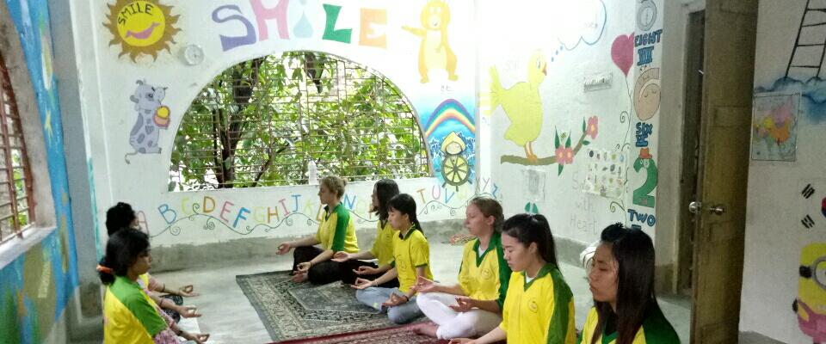Do you like to bring Enlightenment in your mind and health through Yoga & Meditation in India.An international platform to learn Yoga & meditation is the main theme of this project.

**Target** :- Energetic youth from round the world gathered together to learn Indian yoga and meditation to bring Enlightenment in their life and Cure them and learn each other culture.

**Location**: MADHYAMGRAM, 22km from kolkata city center.

Kolkata ,the city of joy was known before as Calcutta since the colonial time. This ancient city was used to be the capital of British colonial period. This city has full of heart ,people are basically belongs to the middle class . There are also rich and poor people all around . City Kolkata is know for its busy traffic ,huge population ,warm welcome and poverty around the street corners! It is a great place to visit for every tourist coming to India. Kolkata( itself is a great tourist place with its historical value ) is well connected with many famous and attractive tourist places during weekends .

**Project Details:-**

India is always been famous for yoga & meditation . While volunteering for neglected children, international youth can have chance to interact with Indian culture . Volunteers and local family together exchange the culture . Youth volunteers have golden chance to know about the ethnic heritage of East Indian tradition . It would a great fun filled time for groups.

In this camp volunteers from round the world would have chance to exchange culture,language,food etc. Yoga and meditation class would be the main part of this project.. It would be fun fill entertainment project where Indian family and international youth can have a platform to each other culture and life style. Camp would take place in the suburb call Madhyamgram which is just 8 km from Kolkata Airport .Transportation, electricity,shopping places are all around.Nearest rail and bus station is with in 2 km .Life is very simple and peaceful around.

Activity Hour: 3-4 hr./day ( Monday to Friday early morning)

Work shop: 2 hrs per day ( afternoon)

Cultural exchange : Evening

**Example Daily Schedule:**

Wake up early morning: 6 am

Breakfast: 6:30 am ( required to prepared by own)

Project hour : As per project In charge.

Lunch at 1:30-2 p.m

late afternoon activity: 3-6pm (meditation/yoga)

Diner : 7:30 pm ( volunteers required help themselves in serving ,washing )

After 8 pm exit door would be closed.No one allowed to go out or come in the accommodation after 8 pm everyday including weekends.

9:30 bed time

** Please remember that programme schedule or project site can be changed or altered by the Project In-charge if required and all volunteers are requested to cooperate with our local members and partners. All schedule should be followed and mandatory for everyone to participate and contribute **

**SMILE Contact Details :-**

[www.smilengo.org](http://www.smilengo.org)

**WHAT’S APP :+919830150249**

**Youtube @smilengo1**

**www.facebook.com/workcamp**

**Line @workcampindia**

**Kakao @smilengo**

**We Chat @SMILE-Dev**

**Instagram @smilengo**

**Twitter @smilengo_india, @workcampindia**