
Street Children Welfare Project
SMILE MLTV02

LOCATION : MADHYAMGRAM (8 km from Kolkata Airport)

ACTIVITIES: Working with Children like Teaching basic English, Any foreign language, Art, Craft, hygiene, playing, creative and entertainment activities. Other activities include like painting on wall, local language learning class, Cultural exchange etc.
Participation fees :€525/head for 6 weeks. Payment should be made by cash (Euro is OK) on arrival for full.
Duration : 6 weeks
REQUIRED to pay by cash on arrival to host family representative.
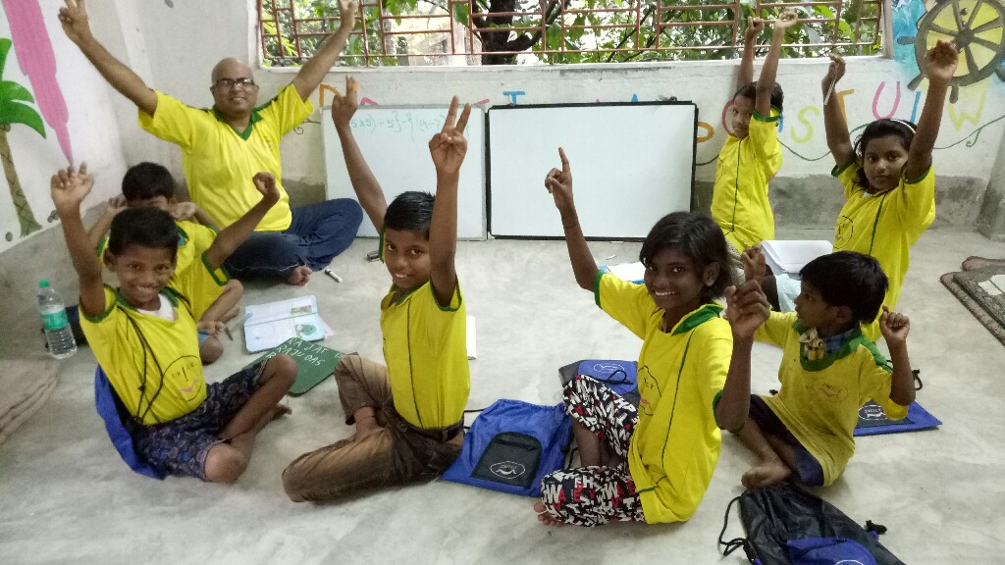
Project Details:-Target Group for these camps:- Helping Children (8-14 years) from the street( mostly refugees) of India to get basic education,vocational and hygienic training etc. Daily many children receives support at our different centres around.
Project Back ground :- India having uncountable numbers of street and slum dwellers . There are thousands of poor refugees coming every year from nearby countries and from different small towns and villages to the big cities and most of these families are living in a very poorly condition at slums or on street corners like insects. Normal societies are so busy to deal with their personal daily problems, so have little time for these unfortunate people. . So it is really a shame of the so called civilised societies. We have got our few projects for these unfortunate street children at the different locations of big cities. Now there are opportunities available to help and support these unfortunate girls and mothers of the street children in and around Kolkata (ccu) city.our target to bring smile on children face .
Kolkata ,the city of joy was known before as Calcutta since the colonial time. This ancient city was used to be the capital of British colonial period. This city has full of heart ,people are basically belongs to the middle class . There are also rich and poor people all around . City Kolkata is know for its busy traffic ,huge population ,warm welcome and poverty around the street corners! It is a great place to visit for every tourist coming to India.
Work & Activities :- Most important target of the project is to bring smile among these children and provide confidence and moral support to their mother .Volunteer would use different way of informal education technique to present a unique and attractive way of education programs for these kids .Most of these kids speaks local Bengali /Hindi language but they are very smart and intelligent.so teaching them with the support of local coordinator would not be so difficult ,just little bit of patience and involvement can solve this problem easily. All volunteers would go through orientation on arrival and two local language session during this camp. There would also be a workshop every evening when volunteers would prepare the next day lesson plan of action . For mothers informal vocational training and basic English teaching would be helpful . Volunteers would also help local coordinator in other activities like giving shower food distribution, organising drama,story telling and entertainment games for the children.whole camp would be run under the supervision of very experienced local project coordinator. Saturday and Sunday would be free days when volunteers can take rest or tour around the city or near by places.More over if anyone get a chance to live with the local host family then that brings extra bonus to any traveller .It helps to learn the culture ,tradition,language while staying within the normal people of the society.Living on any hotel can never give any traveller such wide scope to know the society and communities as a whole. SMILE society always tries to give international volunteers a big scope to know about the local communities and understand the family environment. Smile Society (ngo) had started their activities since 2003 !

Example Daily Schedule:
Wake up early morning: 9 am
Breakfast: 9:30 am
Manual Activities : 10-12 am
Lunch at 1:30-2 p.m
late afternoon project activities with Children : 3:30 - 6:00pm
Lession plan preparing and Cultural exchange ::6-7 pm(solo activities)
Dinner : 7 – 7::30 pm ( volunteers required help themselves in serving ,washing )
After 7:30 pm exit door would be closed.No one allowed to go out or come in the accommodation after 7:30 pm everyday including weekends.
9:30 bed time
** Please remember that programme schedule or project site can be changed or altered by the Project In-charge if required and all volunteers are requested to cooperate with our local members and partners. All schedule should be followed and mandatory for everyone to participate and contribute **

Accommodation: Dormitory basis in host family as per available on arrival ( on cot with mattress/on floor with mattress, 2--4 volunteers in one room) shared accommodation (normally male & female separate room). You will get accommodation till 6 pm on the last day of your camp.We are unable to provide you any accommodation before or after these dates. Please arrange your own accommodation in case of early arrival or late departure .You are requested to meet our representative at the meeting place on exact time given above. If you arrive early then you can have your stay in any of the different hotels available nearby Airport, within 2 -3 km .on the road popularly called as V.I.P road. You are requested to take any cab to check in any of these hotels. If you arrive at earlier night then you are requested to stay inside the airport terminal and meet at the next morning with our representative at 12 noon.
Food: You will get 3 times local home made food from host family as per available on arrival. Please do not expect any kind of special dishes (veg/non veg) or cold drinks or special living room or air conditioned room during your term. You are requested to get ready for a simple and challenging life.
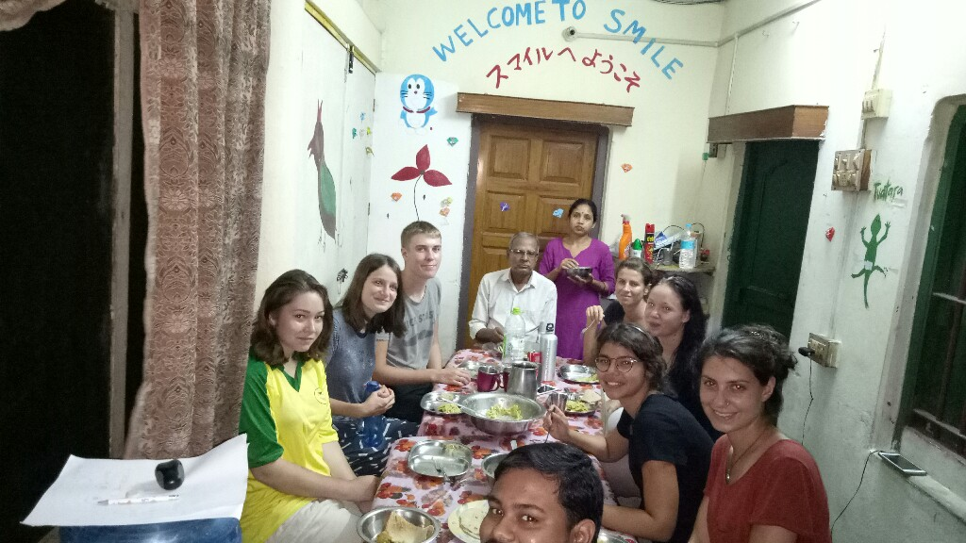
Important Points:--
Please be careful about money and do not carry lots of money while going outside.
Please take the permission before taking any picture, respect all the given time schedule carefully and cooperate others in their work. Keep your luggage locked.
Smoking and alcohol are not allowed in the accommodation
Be careful about your camera, phone, valuables .Do not show your money and valuables.
Volunteers need to help the local members and respect local culture and tradition.
Giving gifts to any individual kid or any single family are not allowed, if you are interested to give any gift please contact with the project in charge and organize enough for all the kids /families . Please do not bring your camera while working in our projects. Photography in project area are not allowed.
All kids are equal to us , please do not give any special attention to any particular kid.
Volunteers are requested to pay their living cost soon after they arrive our place.
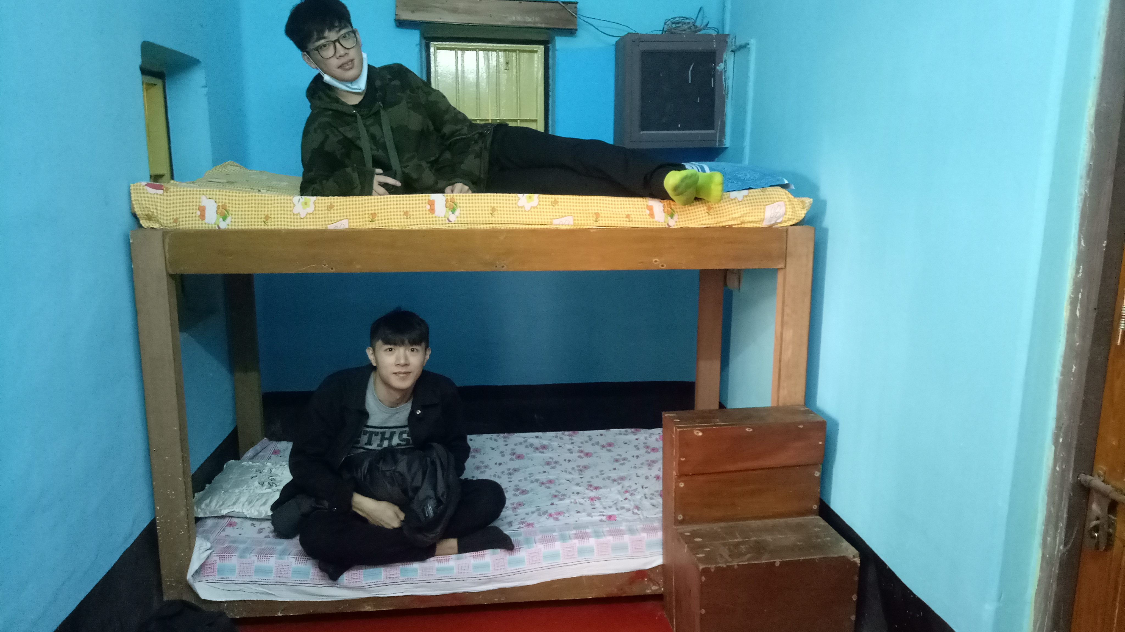
During orientation all volunteers will go through all the points and explain all the details.
Please bargain a lot before purchasing anything from the local market. Please do not bring outsider at your accommodation or show your whereabouts to any unknown people. It is important for your safety and security.
Volunteers are requested to not to involve in any sexual relationship or hugging or kissing in their accommodation with their co volunteers or in work place with any girls or boys (above 6 yrs) .
Please do not make quick friendship with unknown people that can be unsafe for you and always maintain the organization rules ,system and the atmosphere of family during your stay with us. Please do not show your whereabouts to any unknown people. Volunteers are always welcome to inform the camp in charge about their problem if they found any , It is very important for us to know if any volunteer face any kind of problem ,as early as we know about it , would be easier for us to solve it. We expect all volunteers’ kind cooperation during their stay in SMILE. Please be ready to adjust and flexible while staying in India.
All volunteers are requested to follow strictly the given time schedule for their projects ,breakfast, lunch, diner and returning time to the accommodation (if they go out ) should be before 8 p.m if they do not need diner or before 7 p.m if they need diner. Entrance door will be closed at 8 p.m on every night.
Try to bring SMILE among all kids. While going out please always carry the accommodation address and organization contact number with you. Please remember that there will be no guide from the organization during your free hour. In emergency you are requested to contact our contact number.
You are requested to bring required docs like passport copies, visa copies, 2 copies of your recent photos etc. which you requested to submit on your arrival to our representative.

Services that will be offered to all volunteers :---
1. 3 times local food (organized by the local service providers).
2. Shared /dormitory accommodation ,non Air cond. (simple type living standard either at hotel/guest house/school building /community house/host family as per available on arrival organized through the local service providers).
3. Airport pickup (volunteers are requested to meet our rep at the meeting point on time .Meeting details would be given through this info sheet. Train station pickup or hotel pickup are not available. Pickup service and accommodation may not available in case of early arrival. If any volunteer comes late then he/she should contact our office (email preferred) in advance and wait for our next available pickup service. Sometimes pickup service may not available on the same day if anyone miss their meeting time and in these cases volunteers are requested to wait for the next day pickup service. Volunteers are requested to stay at the airport lounge if they arrive at night. If any volunteer wish they can stay at any nearby hotel also. (There are plenty of hotels available on the road called V.I.P road ,within 2 k.m from the airport gate).Any cab driver can easily drop the volunteer at any nearby hotel. In these cases volunteers are requested to purchase pre paid taxi from the airport inside only.
4.Local staff will be available at every project site.
5.Emergency telephonic assistance are available.
6.Emergency personal assistance available (in case of major medical emergency cases only).
Services that will not be offered to volunteers:-----
1. Volunteers should not expect any special food ,fruits or drinks.
2. Air conditioned room or personal room or room of your own choice or changing room or changing project would not be available.
3. Medical cost, hospitalization cost, medicine cost, personal cost, personal transportation, air ticket, visa fees, entry fees, vaccination fees, entertainment cost, weekends trip cost or any other that are not mentioned in the "service that will be offered "section will not be available. All volunteers are requested to have their own medical and travel insurances available up to date with them.
4. Personal physical assistance outside of the project site are not available. Weekends trips and transportation are not included unless specified as it would incurred an extra fee.
What to bring: You can follow traditional packing lists, but here are several items that would be particularly helpful for this volunteer experience:
A bed sheet
malaria medication
flashlight
umbrella
mosquito repellent with DEET
sunscreen
alarm clock OR watch with alarm clock
journal
sleeping bag
Any games or craft items like Origami would be great for the kids
Rain coat
Snacks from your country
Music/ dress / special souvenir from your country
Medicine and first aid supplies for emergency personal use
Any special games or study material for kindergarten standard kids

Clothing: - fibrous (ex: linen or cotton or anything that is COOL and dries fast in natural sun)
- for women, bring conservative clothing that covers the shoulders (ex: shirts with capped sleeves) NO shorts, bikinis, sleeveless clothes outside your own bed room (strictly).
sandals
head covering (bandanas, hat)
towel that dries FAST.
Laundry and water: you can use water for washing once in a day .Drinking water and 2 hours/day wifi available ( maximum 4 person at a time) are available in house. Please cooperate with the local members.
Medical : All volunteers are requested to look after their own medical expenses and other personal expenses(transportation, medical cost, medicine cost, communicational cost, gift, toilet papers, laundry, drinks or anything that are not mentioned in the living cost section will be volunteers’ own responsibility) . Volunteers are also requested to carry your own medical and travel insurances.
Water: Please do not waste water / electricity.
Weekends : Free, You are welcome to travel nearby places but you are requested to join the Monday morning project on time.
Weekends attraction: Darjeeling, Bodh gaya, Puri, Sundarban, Digha etc.
Hospitals: There are many good hospitals available near center kolkata ie: Woodlands [24567075-89]; Bell vue Nursing Home[Ph: 2472321].
Tourist Information centre: 22289898.
Railway Booking centre: Foreigner Reservation Counter at Fairlie place near BBD Bag,very near from Esplanade area,Ph: 22206811 ;
Airport : Netaji Suvash Chandra International Airport ,Kolkata[ 8 km away from SMILE office and your accommodation].
Weekend Trip: There is weekend trip organized (against extra cost) by our travel partners. For more details please contact your camp In charge Ms. Kamala.
Head Office location: It is located at Madhyamgram ,which is around 20 k.m away from the centre kolkata but just 8 km away from the Airport.
Accommodation : Madhyamgram ( 20 km away from center kolkata, 8 km away from the Kolkata (Ccu) Airport ).
Visa : E-Tourist visa is easy and quick as long as you are a short term visitor and purpose of visit is Tourism. If you wish to volunteer for longterm then you should Apply for Employment Visa for Volunteering purpose in registered NGO like SMILE Society. You should apply in advance. Indian visa duration starts from the date of visa issued, so make your plan accordingly. You required some documents from our side which our partner or our Volunteer Coordination Incharge will explain you. If any documents hard copy required to send for visa then you required cover the delivery charges on arrival by cash as well. For some country visa on arrival also available for short term Volunteers.
Nearest Rail Station: Madhyamgram
Nearest Bus stand: Madhyamgram
Nearest Market : Just 1.5 km away from the accommodation. There are some western type of markets also available ie: A.C Market, Forum, city centre , New Market around Esplanade and park street etc.
Tourist places: Museum, Victoria Memorial Hall, Kali ghat [ Goddess kali temple],Maidan, Howrah Bridge, Ganges River[ Most pious river among Hindus] etc.
Internet & Phone : There are many internet café and phone booth at city centre..
Meeting Point:as per arrival details.
Transportation : You will have to use the local available group transportation organised for the camp during your term. Airport transfer would be available as per information.
Emergency Contact of SMILE :- 00919830150249 (What's App) ,coordinator@smilengo.org
Orientation: Soon after the Volunteer arrive , they will be taken to host family place to get refresh and take bit of rest before the orientation meeting take place. After the Orientation meeting volunteer will be allowed to participate in the project only.
Our Social Link details :-
www.smilengo.org,
www.youtube.com/smilengo1,
www.flikr.com/photos/smilengo,
www.facebook.com/workcamp ,
www.twitter.com/smilengo_india,
http://smilengo1.blogspot.in,
Skype:smilengo.india,
ph:0091-9830150249, ( These number is only for What's App)

Basic local language lession :-
Father—Baba ; I / Me--- Ami ; One --- Ak ; Seven---- Saat
Mother—Maa ; You--- Tumi ; Two--- Dui ; Eight ---- Aat,
Younger Brother—Vaai ; He /She ---- Shey ; Three--- Tin ; Nine ---- Noy
Elder Brother--- Dada ; They ---Tahara / Tara ; Four---- Char ; Ten --- Dosh
Younger Sister---- Bon ; This --- Eta ; Five ---- Panch ; Eleven -- Egaro
Elder Sister ---- Didi ; That ---- Ota ; Six --- Choy ; Twelve ---- Baro
My name is Ram -------- Amar nam Ram ; I am 7 years old ---------- Amar saat bochor boyosh.
What is your name----- Tomar nam ki ? How old are you ? --------Tomar boyosh koto ?
You are beautiful / handsome ---- Tumi sundor ; I love you ------ Ami tomake valo bashi .
Where do you live in ? --- Tumi kothay thako ; I live in Japan/Korea --- Ami japan/ Korea te thaki.
How many brother and sister do you have ?----- Tomra koy vai bon ? I know --- Ami Jani .
Do you know ? --- Tumi jano ki ? Sit quietly---- Chup kore bosho .
Do not move ---- Norbe na ; Make a line ---- line kore darao
Draw a picture ---- Chobi aako ; Let’s dance ---- Ekhon nacho.
Let’s sing ---- Ekhon gan koro ; Let’s go ---- Ekhon Cholo.
You are a good boy --- Tumi ekti valo chele ; You are a good girl --- Tumi ekti valo meye.
Write your name --- Tomar nam likho ; Do not shout --- Chitkar koro na .
What is the time now --- Ekhon kota baje ; Now it’s 6 o’ clock – Ekhon choy ta baje.
Wash your face --- Tomar much porishkar koro ; wash your hand --- tomar hat porishkar koro.
Wash your leg – Tomar paa porishkar koro ; wash your head – Tomar matha porishkar koro.
Brush your teeth --- Dant majo ; Now it’s end --- Ekhon eta shesh.
Good Morning --- Shu provat ; Good night --- Shuva rattri.
Good bye – Shuvo biday ; Thank you – Dhonyobad

