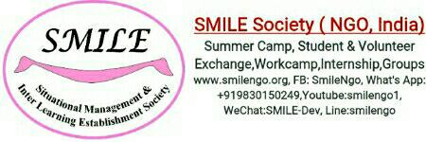

**SMILE Medium Term Volunteering Projects 2019:-**

**Important Details:-**

**Project Type:** Permanent

**Duration** : 1-3 months

**Living cost for MLTV projects :- Euro 350/head** for first month & Every extra month there after **Euro 250**/head/month

***Cost includes***:- 3 times tasty home made local food, shared dorm room at local host family,public transportation (train/bus ) to and fro Project if required ,Airport transfer on arrival and departure between 8 am- 6 pm, drinking mineral water , orientation, Limited 24/7 wifi connectivity , training if required( Mon-Fri) , Pre departure orientation , emergency support ,local language training, Project Supervisor support.

**Cost *excluded*** :- Flight ticket, visa,medical cost, if any personal cost ,weekends 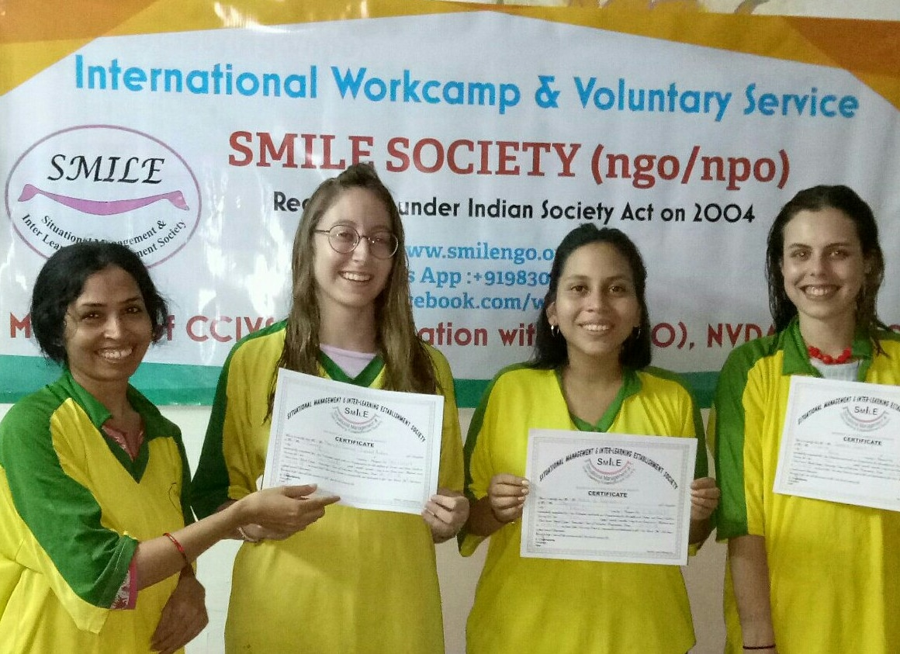trip,special trip at the end of the camp ,gift,any special food / drinks, insurances, vaccination.

***Starting Date*:- A**nytime of the year.

**Accommodation and food :-**

Accommodation: Dormitory basis as per available on arrival ( on cot with mattress/on floor with mattress, 2-4 volunteers in one room, bigger group living also possible Subject to availability ) shared accommodation (normally male & female separate room),Common toilet, electricity, Limited Wifi access in house available. You will get accommodation from 8 am of the first day till 6 pm on the last day of your project.We are unable to provide you any accommodation before or after these dates. Please arrange your own accommodation in case of early arrival or late departure .You are requested to meet our representative at the meeting place on exact time given above. If you arrive early then you can have your stay in any of the different hotels available nearby Airport, within 2 -3 km .on the road popularly 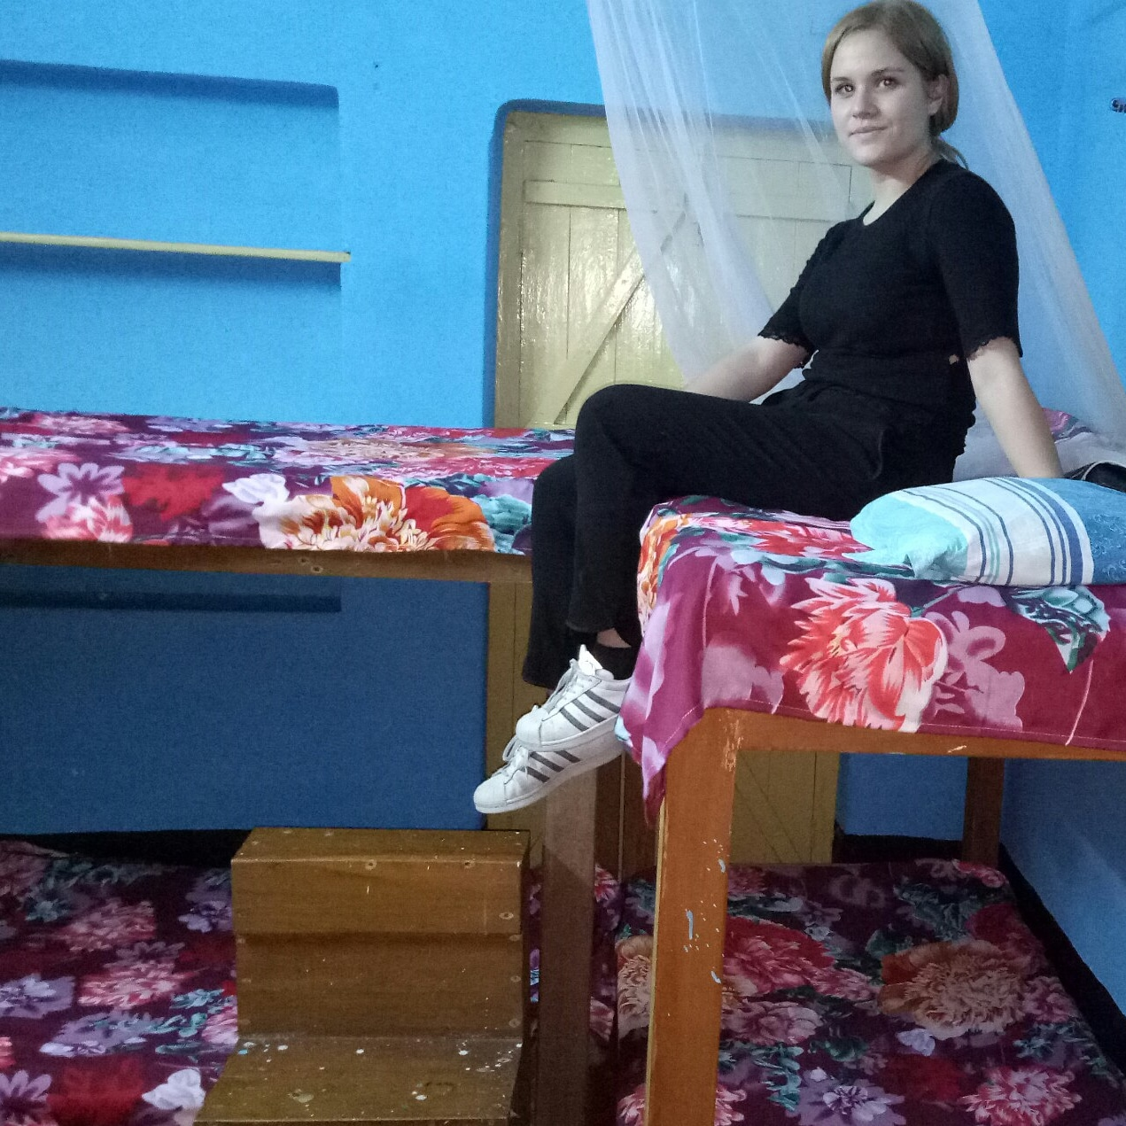called as V.I.P road. You are requested to take any cab to check in any of these hotels. If you arrive at earlier night then you are requested to stay inside the airport terminal and meet at the next morning with our representative as per appointment. Volunteers are not allowed to spend night outside of their accommodation during their full project duration due to safety and security policy.

Food: You will get 3 times local food from host family. Please do not expect air conditioned room, hot water for shower and special food items as per your desire during your term. You are requested to get ready for a simple and challenging life.

**location & leisure :-**

INDIA is an amazing country with diverse culture and tradition .Interesting people ! Explore the country with exciting diversity .Kolkata ,the city of joy was known before as Calcutta since the colonial time. This ancient city was used to be the capital of British colonial period. This city has full of heart ,people are basically belongs to the middle and lower middle class . There are also rich and poor people all around . City Kolkata is known for its busy traffic ,huge population ,warm weather and poverty around the street corners! It is a great place to visit for every tourist coming to India. Kolkata( itself is a great tourist place with its historical value ) is well connected with many famous and attractive tourist places during weekends ...

organised Package trip at the end of the project can be organised by professionals......

* weekends exciting Cultural city ( kolkata ) and around trip can also be organised against extra cost Euro80/head for weekends (8am-4pm).

**Kolkata is one of the 4 biggest city in India and it is connected with every part of the country. You can fly almost any part of the country with in 2-2:30 hrs. So traveling around could try is very easy from Kolkata.

**Requirements**:

*Passport copy

*VISA copy

*Photograph( recent colour copy)

*Parents permission letter if you are below 18 years.

*Living cost as per duration applied..

*Volunteers should not have any criminal record.

***What to bring:*** You can follow traditional packing lists, but here are several items that would be particularly helpful for this volunteer experience:

A bed sheet

Vaccination as per local embassy /hospital

malaria medication

flashlight

umbrella

mosquito repellent with DEET

sunscreen

alarm clock OR watch with alarm clock

journal

sleeping bag

Any games or craft items like Origami would be great for the kids

Rain coat

Snacks from your country for kids and host family

Music/ dress / special souvenir from your country

Medicine and first aid supplies for emergency personal use

***Clothing*:** - fibrous (ex: linen or cotton or anything that is COOL and dries fast in natural sun)

- for women, bring conservative clothing that covers the shoulders (ex: shirts with capped sleeves) NO shorts, bikinis, sleeveless clothes outside your own bed room (strictly). Indian cloth like salwar,sarees would a perfect choice for girls during their stay at SMILE.

sandals

head covering (bandanas, hat)

towel that dries FAST.

Toilet paper, soap, shampoo, mosquito net.

**Laundry and water:** you can use water for washing once in a day .Drinking water and wifi (limited are available in house. Please cooperate with the local members.

**Medical :** All volunteers are requested to look after their own medical expenses and other personal expenses(transportation, medical cost, medicine cost, communicational cost, gift, toilet papers, laundry, drinks or anything that are not mentioned in the living cost section will be volunteers’ own responsibility) . Volunteers are also requested to carry your own medical and travel insurances.

**Water:** Please do not waste water / electricity.

**Hospitals:** There are many good hospitals available near center kolkata ie: Woodlands [24567075-89]; Bell vue Nursing Home[Ph: 2472321].

**Tourist Information centre:** 22289898.

**Railway Booking centre:** Foreigner Reservation Counter at Fairlie place near BBD Bag,very near from Esplanade area,Ph: 22206811 ;

**Airport :** Netaji Suvash Chandra International Airport ,Kolkata[ 8 km away from SMILE office and your accommodation].

**Weekend Trip**: There are many weekend trips organized (against extra cost) by our travel partners. For more details please contact your camp In charge Ms. Kamala.

**Head Office location:** It is located at Madhyamgram ,which is around 20 k.m away from the centre kolkata but just 8 km away from the Airport.

**Accommodation** : Madhyamgram ( 20 km away from center kolkata).

**Nearest Rail Station:** Madhyamgram

**Nearest Bus stand:** Madhyamgram

**Nearest Market :** Just 1.5 km away from the accommodation. There are some western type of markets also available ie: A.C Market, Forum, city centre , New Market around Esplanade and park street etc.

**Tourist places:** Museum, Victoria Memorial Hall, Kali ghat [ Goddess kali temple],Maidan, Howrah Bridge, Ganges River[ Most pious river among Hindus] etc.

**Internet & Phone :** There are many internet café and phone booth at city centre..

**Introduction**: When you are volunteering with SMILE, you are joining a family of fellow volunteers and NGO staff. Everyone is considered equal, and we are all committed to helping each other and most importantly, helping children. Cleaning room,toilet,dining place,living building are mandatory for every volunteer.

**Transportation :** You will have to use the local available group transportation organised for the camp during your term. Airport transfer would be available as per information.

**Emergency Contact** :- 00919830150249, kamala1@smilengo.org

**Orientation:** Soon after the Volunteer arrive , they will be taken to host family place for orientation and to get refresh and take bit of rest before the orientation meeting take place. After the Orientation meeting volunteer will be transferred to their room.

There would be orientation after arrival.

Do you like to help SMILE NGO to bring a smile to the most neglected children living in kolkata ,India.This project is all about bringing smile to all underprivileged refugee kids.Providing informal basic education like english teaching ,hygiene,basics,playing, organising entertainment program ,food distribution for these children of this downtrodden community would be the main target of the volunteers in thi project.SMILE Society ( Situational Management & Inter Learning Establishment Society) is a registered Non profit working for these underprivileged communities around the state of West Bengal since 2003 . On August 31, 2003, a team of volunteers leaded by Mr. Debabrata Chakraborty (Renowned Social Activist) , formed SMILE Society. SMILE mission is to provide volunteers with a customised program (workcamp, medium term, long term) that will enable them to make an important contribution to these poor and needy kids from refugee families. Our foremost goal is to "Bring Smile around" We ensure that all volunteers are provided with a safe and enriching experience. Our flexible approach means that you will be given a placement to suit your needs and time scale. All international students are also welcome to take part in our Programme. Our unique placements could become the trip of a lifetime.

**Following projects available for Medium & Long term Volunteers( MLTV projects)**

* **Happy Home Project (SMILE LMTV01) :-**

**Work Type: TE/SW/HC**

**Location: Madhyamgram**  
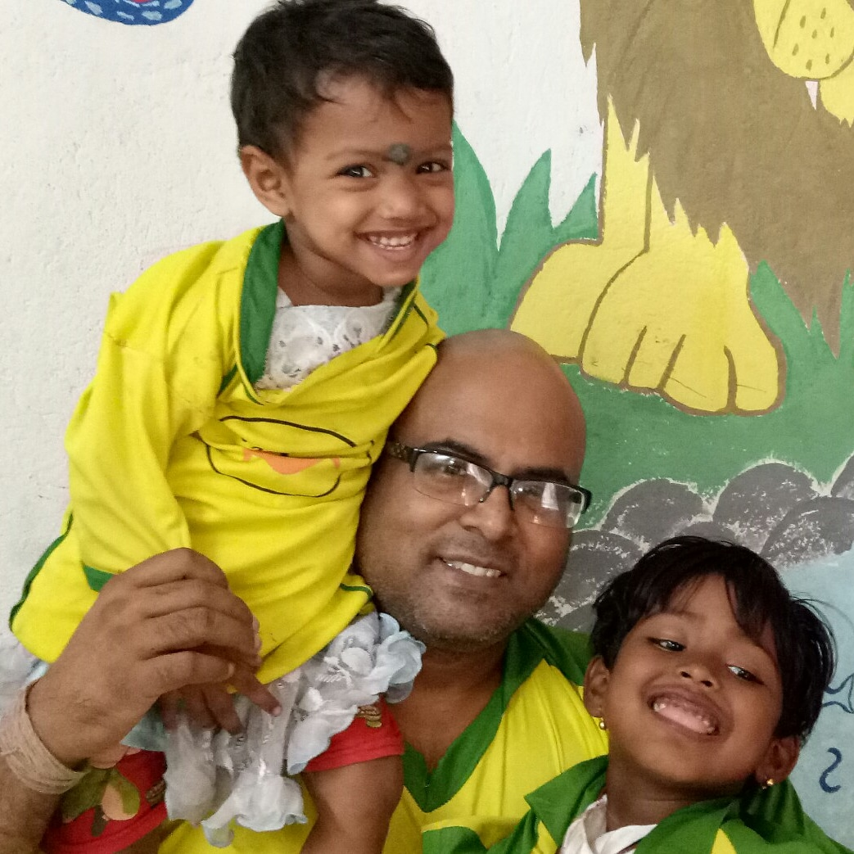

**work:-**

Target Group for these project:- Helping Children between 3-7 years old ( mostly refugees) of India to get basic education,vocational and hygienic training etc. Daily more than 200+ families receives support at our different centres around.

Project Back ground :- India having uncountable numbers of street and slum dwellers . There are thousands of poor refugees coming every year from nearby countries and from different small towns and villages to the big cities and most of these families are living in a very poorly condition at slums or on street corners like insects. societies are so busy to deal with their personal daily problems, thus have little time for these unfortunate people. Often these families bring their children to help them in begging ,household work ,rag picking activities, even some girls been forcibly thrown to the dark life of prostitution. So it is really a shame for so called civilised societies which we part of. We have got our few projects for these unfortunate street children at the different locations of big cities. Now there are opportunities available to help and support these street children in and around Kolkata (ccu) city.our target to bring smile around.

Local City : Kolkata ,the city of joy was known before as Calcutta since the colonial time. This ancient city was used to be the capital of British colonial period. This city has full of heart ,people are basically belongs to the middle class . There are also rich and poor people all around . City Kolkata is know for its busy traffic ,huge population ,warm welcome and poverty around the street corners! It is a great place to visit for every tourist coming to India.

Work & Activities :- Most important target of the project is to bring smile among these children and provide confidence through play school activities .Volunteer would use different way of informal technique to present a unique and attractive way of educational play programs for these kids .Most of these kids speaks local Bengali /Hindi language but they are very smart and intelligent.so teaching them with the support of local coordinator would not be so difficult ,just little bit of patience and involvement can solve this problem easily. All volunteers would go through orientation on arrival and local language lessons during this project .Volunteers would also help local coordinator in other activities like food distribution, organising drama,story telling and entertainment games for the children.whole camp would be run under the supervision of very experienced local project coordinator. Saturday and Sunday would be free days when volunteers can take rest or tour around the city or near by places.SMILE society always tries to give international volunteers a big scope to know about the local communities and understand the family environment. Smile Society (ngo) had started their activities since 2003 !

**Example Daily Schedule:**

Wake up early morning: 6 am

Breakfast: 6:30 am ( self service)

Work : 3-4 hours during week days,Exact work schedule would be delivered with infosheet.

Late afternoon:3:30pm - 6 pm teachhing, cultural exchange with kids.

Evening time: 6-7 pm (lesson. Plan for the children)

Dinner : 7:30pm ( volunteers required help themselves in serving ,washing )

After 8 pm exit door would be closed.No one allowed to go out or come in the accommodation after 8 pm everyday including weekends.

9:30 bed time

** Please remember that programme schedule or project site can be changed or altered by the Project In-charge if required and all volunteers are requested to cooperate with our local members and partners. All schedule should be followed and mandatory for everyone to participate and contribute **

* **Street Children Teaching Project(SMILE LMTV02) :-**

**Location: Madhyamgram**

**work:-**

Target Group for these project:- Helping Children from the street between 8-15 years ( mostly refugees) of India to get basic education,vocational and hygienic training etc. Daily 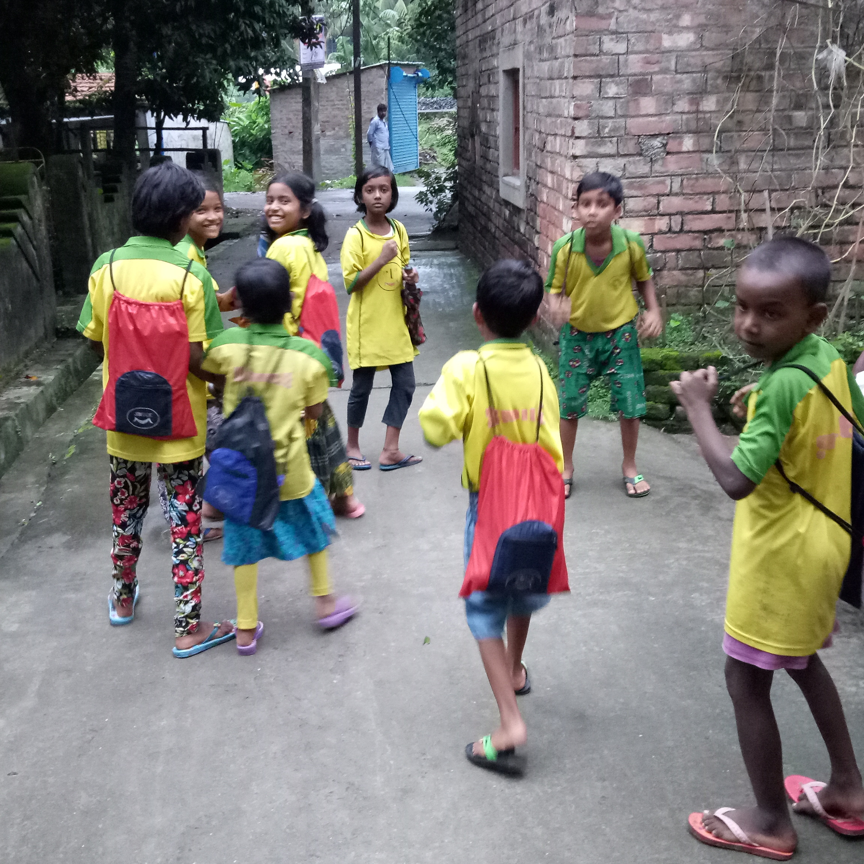more than 300+ families receives support at our different centres around.

Project Back ground :- India having uncountable numbers of street and slum dwellers . There are thousands of poor refugees coming every year from nearby countries and from different small towns and villages to the big cities and most of these families are living in a very poorly condition at slums or on street corners like insects.Often these families bring their children to help them in begging ,household work ,rag picking activities.

Work & Activities :- Most important target of the project is to bring smile among these children and provide confidence and moral support to them .Volunteer would use different way of informal education technique to present a unique and attractive way of education programs for these kids . All volunteers would go through orientation on arrival and local language session during this project . There would also be a workshop every evening when volunteers would prepare the next day lesson plan of action .Volunteers would also help local coordinator in other activities like giving shower food distribution, organising drama,story telling and entertainment games for the children.whole camp would be run under the supervision of very experienced local project coordinator. Saturday and Sunday would be free days when volunteers can take rest or tour around the city or near by places.SMILE society always tries to give international volunteers a big scope to know about the local communities and understand the family environment. Smile Society (ngo) had started their activities since 2003 !

Example Daily Schedule: Wake up early morning: 6 am

Breakfast: 6:30 am ( self service)

Work : 3-4 hours during week days,Exact work schedule would be delivered with infosheet.

late afternoon:3:30pm - 6 pm working at school

Lession plan session: 6-7 pm

Dinner : 7-7:30 pm ( volunteers required help themselves in serving ,washing )

After 8 pm exit door would be closed.No one allowed to go out or come in the accommodation after 8 pm everyday including weekends.

9:30 bed time

** Please remember that programme schedule or project site can be changed or altered by the Project In-charge if required and all volunteers are requested to cooperate with our local members and partners. All schedule should be followed and mandatory for everyone to participate and contribute **

* **Street Girls Empowerment Project (SMILE LMTV03) :-**

**Location:- Madhyamgram**

**Work type: Teaching spoken English,beautician training ,art and craft training, Self defense etc.**

**work:-**

Target Group for these camps:- Helping girls from the underprivileged community( mostly refugees) of India to get basic education,vocational and hygienic training etc. Daily more than 200+ families receiving support at our different centres around.

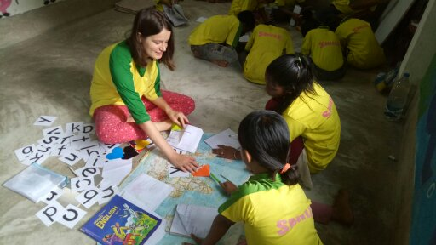

Project Back ground :- India having uncountable numbers of street and slum dwellers . There are thousands of poor refugees coming every year from nearby countries and from different small towns and villages to the big cities and most of these families are living in a very poorly condition at slums or on street corners like insects. Often these families bring their children to help them in begging ,household work ,rag picking activities, even some girls been forcibly thrown to the dark life of prostitution. So it is really a shame of the so called civilised societies. We have got our few projects for these unfortunate street girls to train them and bring confidence in them at our different locations of big cities. Now there are opportunities available to help and support these unfortunate girls of the street in and around Kolkata (ccu) city.our target to bring smile on ever girls too. .Kolkata ,the city of joy was known before as Calcutta since the colonial time. This ancient city was used to be the capital of British colonial period. This city has full of heart ,people are basically belongs to the middle class . There are also rich and poor people all around . City Kolkata is know for its busy traffic ,huge population ,warm welcome and poverty around the street corners! It is a great place to visit for every tourist coming to India.

Work & Activities :- Volunteer would use different way of informal educational teaching technique to present a unique and attractive way of education programs for these girls. . There would also be a workshop every evening when volunteers would prepare the next day lesson plan of action . For girls informal vocational training and basic English speaking teaching would be helpful . Volunteers would also help local coordinator in other activities like food distribution, organising drama,cultural exchange, for these girls. Project would be run under the supervision of experienced local project coordinator. Saturday and Sunday would be free days when volunteers can take rest or tour around the city or near by places.SMILE society always tries to give international volunteers a big scope to know about the local communities and understand the family environment. Smile Society (ngo) had started their activities since 2003 !

Example Daily Schedule: Wake up early morning: 6 am

Breakfast: 6:30 am ( self service)

Work : 3-4 hours during week days,Exact work schedule would be delivered with infosheet.

late afternoon:3:30pm - 6 pm workshop

Lession preparation :6-7 pm

Dinner : 7 :30pm ( volunteers required help themselves in serving ,washing )

After 8 pm exit door would be closed.No one allowed to go out or come in the accommodation after 8 pm everyday including weekends.

9:30 bed time

** Please remember that programme schedule or project site can be changed or altered by the Project In-charge if required and all volunteers are requested to cooperate with our local members and partners. All schedule should be followed and mandatory for everyone to participate and contribute **

* **Intercultural & Language Exchange Project (SMILE LMTV04) :-**

**Location:** Madhyamgram

**Partner**:-

**Target** :- Energetic youth from round the world gathered together to learn Indian culture ,food and bring friendship and learn each other culture.

**Location**: MADHYAMGRAM, 22km from kolkata city center.**Location**: Kolkata city and around

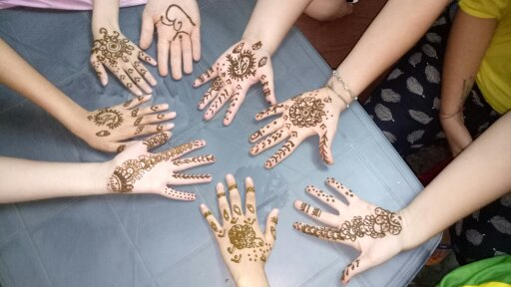

Kolkata ,the city of joy was known before as Calcutta since the colonial time. This ancient city was used to be the capital of British colonial period. This city has full of heart ,people are basically belongs to the middle class . There are also rich and poor people all around . City Kolkata is know for its busy traffic ,huge population ,warm welcome and poverty around the street corners! It is a great place to visit for every tourist coming to India. More over if anyone get a chance to live with the local host family then that brings extra bonus to any traveller .It helps to learn the culture ,tradition,language while staying within the normal people of the society.Living on any hotel can never give any traveller such wide scope to know the society and communities as a whole. Kolkata( itself is a great tourist place with its historical value ) is well connected with many famous and attractive tourist places during weekends .

**Project Details:-**

India is always been famous for its culture ,tradition,language and food cuisine . Different culture ,dress code ,language and cooking style made the country like a continent ! While volunteering in this project youth can have chance to interact with the East Indian ( Bengali ) culture and food . Volunteers and local family together exchange the culture and cook food . Youth volunteers have golden chance to know about the ethnic heritage of East Indian cuisine and tradition . It would a great fun filled time for groups.

In this camp volunteers from round the world would have chance to exchange culture,language,food etc. Local cooking lesson, local language class. It would be fun fill entertainment camp where Indian family and international youth can have a platform to each other culture and life style. Camp would take place in the suburb call Madhyamgram which is just 8 km from Kolkata Airport .Transportation, electricity,shopping places are all around.Nearest rail and bus station is with in 2 km .Life is very simple and peaceful around.

Field service Work Hour: 3-4 hr./day ( Monday to Friday early morning)

Work shop: 2 hrs per day ( afternoon)

Cultural exchange : Evening

**Example Daily Schedule:**

Wake up early morning: 6 am

Breakfast: 6:30 am ( required to prepaired by own)

Project hour : As per project In charge.

Lunch at 1:30-2 p.m

late afternoon: 3pm – 6 pm (workshop for next day plan preparation)

Diner : 7:30 pm ( volunteers required help themselves in serving ,washing )

After 8 pm exit door would be closed.No one allowed to go out or come in the accommodation after 8 pm everyday including weekends.

9:30 bed time

** Please remember that programme schedule or project site can be changed or altered by the Project In-charge if required and all volunteers are requested to cooperate with our local members and partners. All schedule should be followed and mandatory for everyone to participate and contribute **

* **Street Dogs Welfare Project (SMILE LMTV05) :-**

**Work Type: Animal welfare ,Manual**

**Location: Madhyamgram**

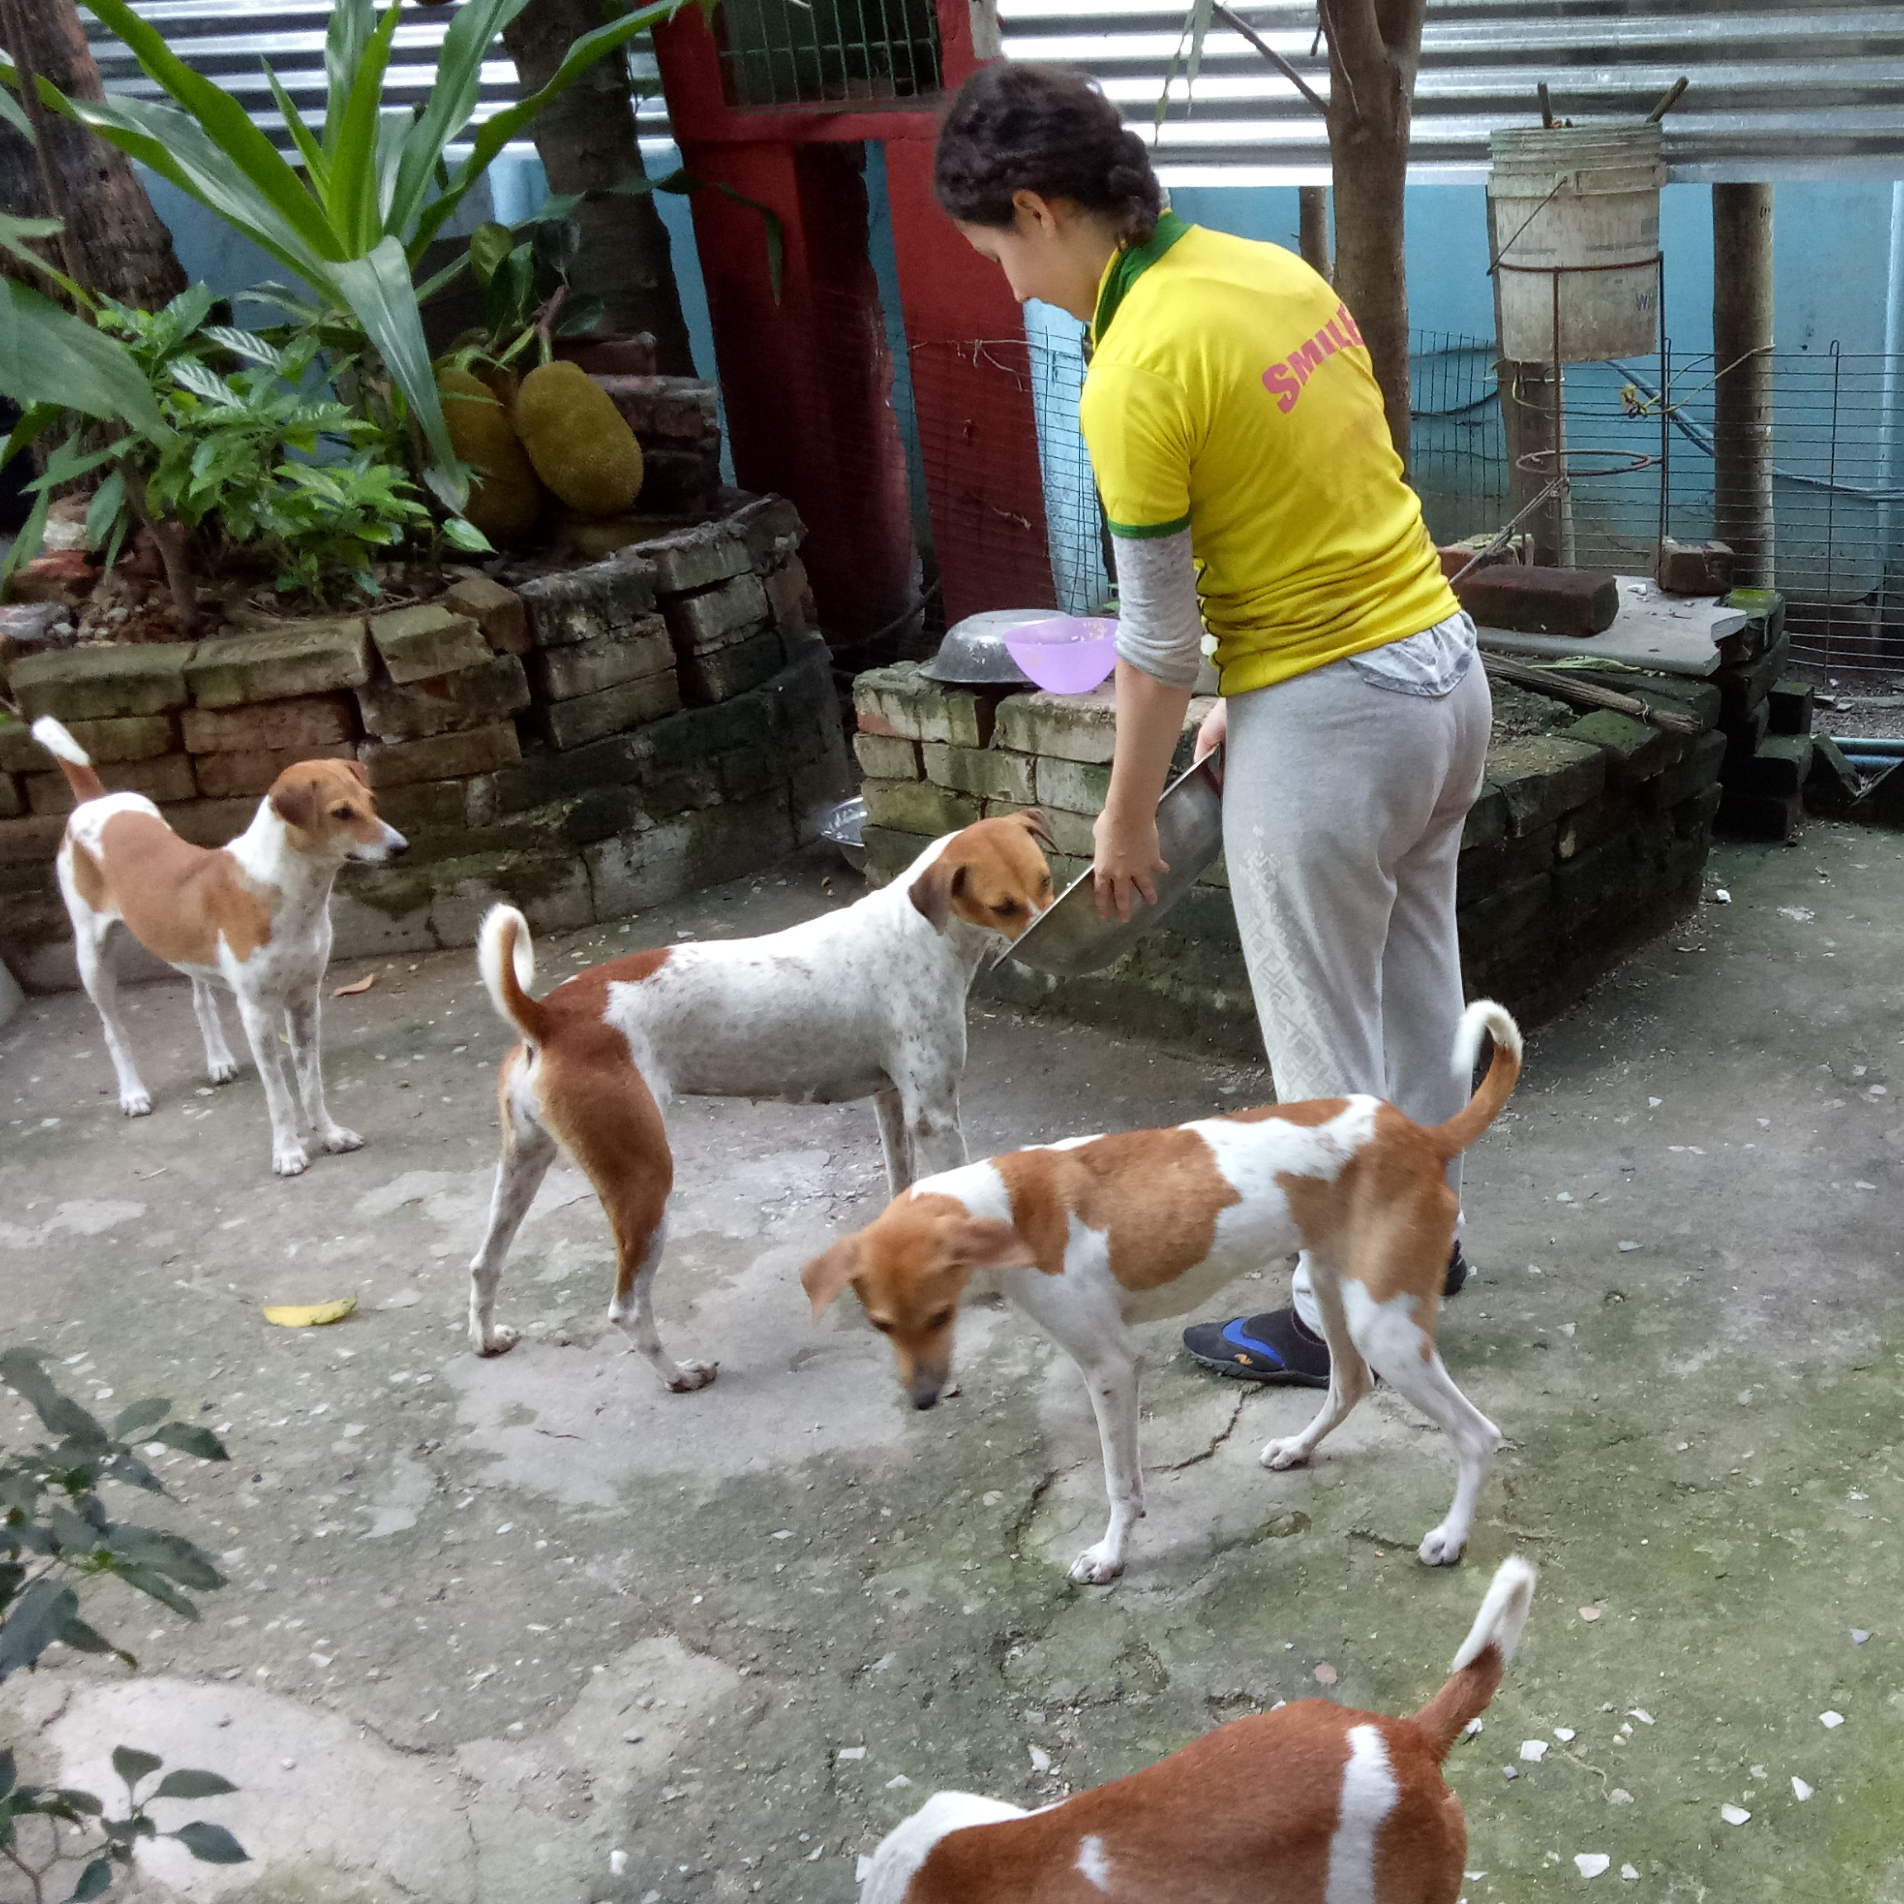

**Partner**:-  
Do you love dogs ? Then this camp is for you.This camp is for bringing welfare service to one of the most neglected domestic animals like dogs in India. SMILE Animal shelter for Domestic Animal welfare project providing shelter to dogs.Volunteers would have amazing time with these cute animal for sure.

Our foremost goal is to "Bring Smile around" We ensure that all volunteers are provided with a safe and enriching experience. Our flexible approach means that you will be given a placement to suit your needs and time scale. There are many other attractions as well. Our unique placements could become the trip of a lifetime.

**Work**:-

Target :- Welfare activities like food distribution,health care,grooming to cats and dogs from SMILE NGO Domestic Animal Shelter.

Project background details:-

In India dogs and cats are every where on the street living under unprotected and abandoned life . In SMILE family we have a big love for domestic animals basically dogs,cats and so we made a small shelter in 2009 where we take care of few dogs and cats on regular basis. There are huge number of street dogs and cats who are roaming unprotected and struggling for the life and shelter.There are almost no management system from local government available for these animal.There are long and short term volunteering opportunities available every year for these poor needy animals.

Activities:- Volunteers job are mostly food preparation,distribution,grooming,shelter cleaning ,taking care of dogs and cats at our shelter. We welcome international individuals or groups to help and look after these domestic animals during the camp. It is a fun filled experience for volunteers!! All volunteers taking this project should take anti rabies vaccination before joining these camps.International youth have chance to experience this unique project ,can help local member in different activities .They can have a change to enjoy with these cute animals. Mainly this projects are those who care about dogs and cats. If you love dogs and cats then this project would give you emense satisfaction and valuable knowledge .Volunteers also can experience the Indian food and culture while living at local host family. There would be local language classes and cooking training given . Experiencing India in different shades .

This project is based at SMILE head office near Madhyamgram town (8 km from Kolkata Airport and 22km from City center. You can find more details about the location on wiki link: https://en.m.wikipedia.org/wiki/Madhyamgram.

Field service Work Hour: 3/4 hr./day ( Monday to Friday early morning)

Work shop: 2 hrs per day ( afternoon)

Cultural exchange : Evening

Example Daily Schedule:

Wake up early morning: 6 am

Breakfast: 6:30 am ( required to prepared by own)

Work hour : 8 - 11 am

Lunch at 1:30-2 p.m

late afternoon: 3pm – 6 pm, plan preparation for next day

Dinner : 7:30 pm ( volunteers required help themselves in serving ,washing )

After 8 pm exit door would be closed.No one allowed to go out or come in the accommodation after 8 pm everyday including weekends.

9:30 bed time

** Please remember that programme schedule or project site can be changed or altered by the Project In-charge if required and all volunteers are requested to cooperate with our local members and partners. All schedule should be followed and mandatory for everyone to participate and contribute **

* **Yoga & Meditation Workshop & Social Work Project(SMILE LMTV06) :-**

**Location : Madhyamgram**

**Partner** :-

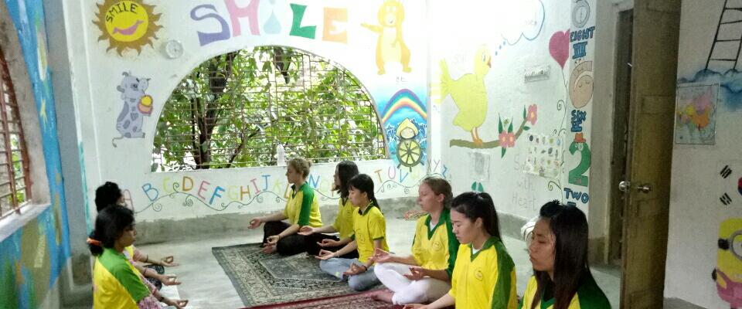Do you like to bring Enlightenment in your mind and health through Yoga & Meditation in India.An international platform to learn Yoga & meditation is the main theme of this project.

**Target** :- Energetic youth from round the world gathered together to learn Indian yoga and meditation to bring Enlightenment in their life and Cure them and learn each other culture.

**Location**: MADHYAMGRAM, 22km from kolkata city center.

Kolkata ,the city of joy was known before as Calcutta since the colonial time. This ancient city was used to be the capital of British colonial period. This city has full of heart ,people are basically belongs to the middle class . There are also rich and poor people all around . City Kolkata is know for its busy traffic ,huge population ,warm welcome and poverty around the street corners! It is a great place to visit for every tourist coming to India. Kolkata( itself is a great tourist place with its historical value ) is well connected with many famous and attractive tourist places during weekends .

**Project Details:-**

India is always been famous for yoga & meditation . While volunteering for neglected children, international youth can have chance to interact with Indian culture . Volunteers and local family together exchange the culture . Youth volunteers have golden chance to know about the ethnic heritage of East Indian tradition . It would a great fun filled time for groups.

In this camp volunteers from round the world would have chance to exchange culture,language,food etc. Yoga and meditation class would be the main part of this project.. It would be fun fill entertainment project where Indian family and international youth can have a platform to each other culture and life style. Camp would take place in the suburb call Madhyamgram which is just 8 km from Kolkata Airport .Transportation, electricity,shopping places are all around.Nearest rail and bus station is with in 2 km .Life is very simple and peaceful around.

Activity Hour: 3-4 hr./day ( Monday to Friday early morning)

Work shop: 2 hrs per day ( afternoon)

Cultural exchange : Evening

**Example Daily Schedule:**

Wake up early morning: 6 am

Breakfast: 6:30 am ( required to prepared by own)

Project hour : As per project In charge.

Lunch at 1:30-2 p.m

late afternoon activity: 3-6pm (meditation/yoga)

Diner : 7:30 pm ( volunteers required help themselves in serving ,washing )

After 8 pm exit door would be closed.No one allowed to go out or come in the accommodation after 8 pm everyday including weekends.

9:30 bed time

** Please remember that programme schedule or project site can be changed or altered by the Project In-charge if required and all volunteers are requested to cooperate with our local members and partners. All schedule should be followed and mandatory for everyone to participate and contribute **

* **Online Promotion, Blogs & Content writing Assistant (SMILE LMTV07) :**-

**Location: Kolkata and around**

Do you like to help SMILE NGO to promote online, writing blogs, on forum and contents for advertising the organization activities round the world. .

**work:-**

Target Group for these project:- Online Promotional activities.

Project Back ground :- . City Kolkata is know for its busy traffic ,huge population ,warm welcome and poverty around the street corners! It is a great place to visit for every tourist coming to India.

Work & Activities :- We are looking for v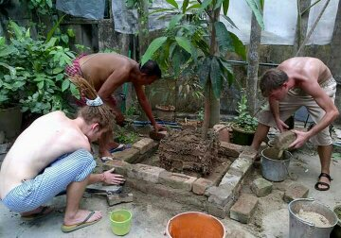olunteers from different countries to help us in online promotion service online. Creative youth with passionate mind are best for the project. . Due to charity status it is really difficult to go for paid advertising. Right now volunteers from native English speaking countries or from other European and Asian countries are welcome to join the SMILE team as a promotional assistant.

Example Daily Schedule:

Wake up early morning: 6 am

Breakfast: 6:30 am ( required to prepared by own)

Project hour : As per project In charge.

Lunch at 1:30-2 p.m

late afternoon: 3pm - 6pm,laundry time for volunteers workshop

Dinner : 7:30 pm ( volunteers required help themselves in serving ,washing )

After 8 pm exit door would be closed.No one allowed to go out or come in the accommodation after 8 pm everyday including weekends.

. 9:30 bed time

** Please remember that programme schedule or project site can be changed or altered by the Project In-charge if required and all volunteers are requested to cooperate with our local members and partners. All schedule should be followed and mandatory for everyone to participate and contribute **

* **Manual Assistant at SMILE House India (SMILE LMTV08) :-**

**Work Type: Manual Helper**

**Location: Madhyamgram**

Do you like to help SMILE NGO kolkata ,India in everyday manual work like cleaning,swiping,shopping,odd jobs etc?Then this project is for you:-)

**work:-**

Target Group for these project:- Helping In domestic assistance at SMILE House ,India.

Project Back ground :- our target to bring smile on ever mother too with their children.Kolkata ,the city of joy was known before as Calcutta since the colonial time. This ancient city was used to be the capital of British colonial period. This city has full of heart ,people are basically belongs to the middle class . There are also rich and poor people all around . City Kolkata is know for its busy traffic ,huge population ,warm welcome and poverty around the street corners! It is a great place to visit for every tourist coming to India.

Work & Activities :- Volunteer would use to help local volunteers in their daily activities like cleaning premises,shopping,organising and supporting local members.

**Example Daily Schedule:-**

Wake up early morning: 6 am

Breakfast: 6:30 am ( required to prepaired by own)

Project hour : As per project In charge.

Lunch at 1:30-2 p.m

late afternoon: 3pm – 6 pm (As per project Incharge)

Diner : 7 pm ( volunteers required help themselves in serving ,washing )

After 8 pm exit door would be closed.No one allowed to go out or come in the accommodation after 8 pm everyday including weekends.

9:30 bed time

** Please remember that programme schedule or project site can be changed or altered by the Project In-charge if required and all volunteers are requested to cooperate with our local members and partners. All schedule should be followed and mandatory for everyone to participate and contribute **

* **Art, Music & Dance Teaching to Street Children (SMILE LMTV09) :-**

**Work Type: Art,Craft,Painting**

**Location: Madhyamgram**  
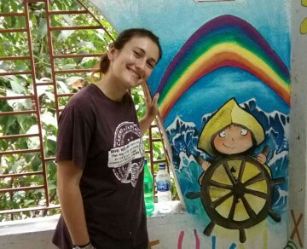

Partner:-

Do you like to help SMILE NGO to bring a smile to the most neglected children living on the street of kolkata ,India.This project is all about bringing smile to all underprivileged refugee children & their mother from the street of kolkata.Providing informal basic education llike teaching them different Art,craft and Painting for these children from this downtrodden community would be the main target of the volunteers in this camp.

**work:-**

Target Group for these project:- Helping Children and Youth to learn Art,craft and Painting .Daily more than 100 families receives support at our different centres around.

Project Back ground :- There are thousands of poor refugees coming every year from nearby countries and from different small towns and villages to the big cities and most of these families are living in a very poorly condition at slums or on street corners like insects. Normal societies are so busy to deal with their personal daily problems, so have little time for these unfortunate people. With every such family Grownup girls and married women (mother of the children) always have to face the problem in their daily life. Often these families bring their children to help them in begging ,household work ,rag picking activities, even some girls been forcibly thrown to the dark life of prostitution. So it is really a shame of the so called civilised societies. We have got our few projects for these unfortunate street children at the different locations of big cities. Now there are opportunities available to help and support these unfortunate girls and mothers of the street children in and around Kolkata (ccu) city.our target to bring smile on ever mother too with their children.Kolkata ,the city of joy was known before as Calcutta since the colonial time. This ancient city was used to be the capital of British colonial period. This city has full of heart ,people are basically belongs to the middle class . There are also rich and poor people all around . City Kolkata is know for its busy traffic ,huge population ,warm welcome and poverty around the street corners! It is a great place to visit for every tourist coming to India.

Work & Activities :- Most important target of the project is to bring smile among these children and provide confidence and moral support to their mother .Volunteer would use different way of informal education technique to present a unique and attractive way of education programs for these kids .Most of these kids speaks local Bengali /Hindi language but they are very smart and intelligent.so teaching them with the support of local coordinator would not be so difficult ,just little bit of patience and involvement can solve this problem easily. All volunteers would go through orientation on arrival and two local language session during this camp. There would also be a workshop every evening when volunteers would prepare the next day lesson plan of action . For mothers informal vocational training and basic English teaching would be helpful . Volunteers would also help local coordinator in other activities like giving shower food distribution, organising drama,story telling and entertainment games for the children.whole camp would be run under the supervision of very experienced local project coordinator. Saturday and Sunday would be free days when volunteers can take rest or tour around the city or near by places.More over if anyone get a chance to live with the local host family then that brings extra bonus to any traveller .It helps to learn the culture ,tradition,language while staying within the normal people of the society.Living on any hotel can never give any traveller such wide scope to know the society and communities as a whole. SMILE society always tries to give international volunteers a big scope to know about the local communities and understand the family environment. Smile Society (ngo) had started their activities since 2003 !

Example Daily Schedule:

Wake up early morning: 6 am

Breakfast: 6:30 am ( required to prepared by own)

Project hour : As per project In charge

. Lunch at 1:30-2 p.m

late afternoon: 3 – 6 pm workshop time,

Dinner : 7:30 pm ( volunteers required help themselves in serving ,washing ) After 8 pm exit door would be closed.No one allowed to go out or come in the accommodation

after 8 pm everyday including weekends

. 9:30 bed time

** Please remember that programme schedule or project site can be changed or altered by the Project In-charge if required and all volunteers are requested to cooperate with our local members and partners. All schedule should be followed and mandatory for everyone to participate and contribute **

**\* Urban Organic farming and Nursery initiative to grow saplings (SMILE LMTV10) :-**

**Work Type: ENV/AGRI/MANU**

**Location: Madhyamgram**

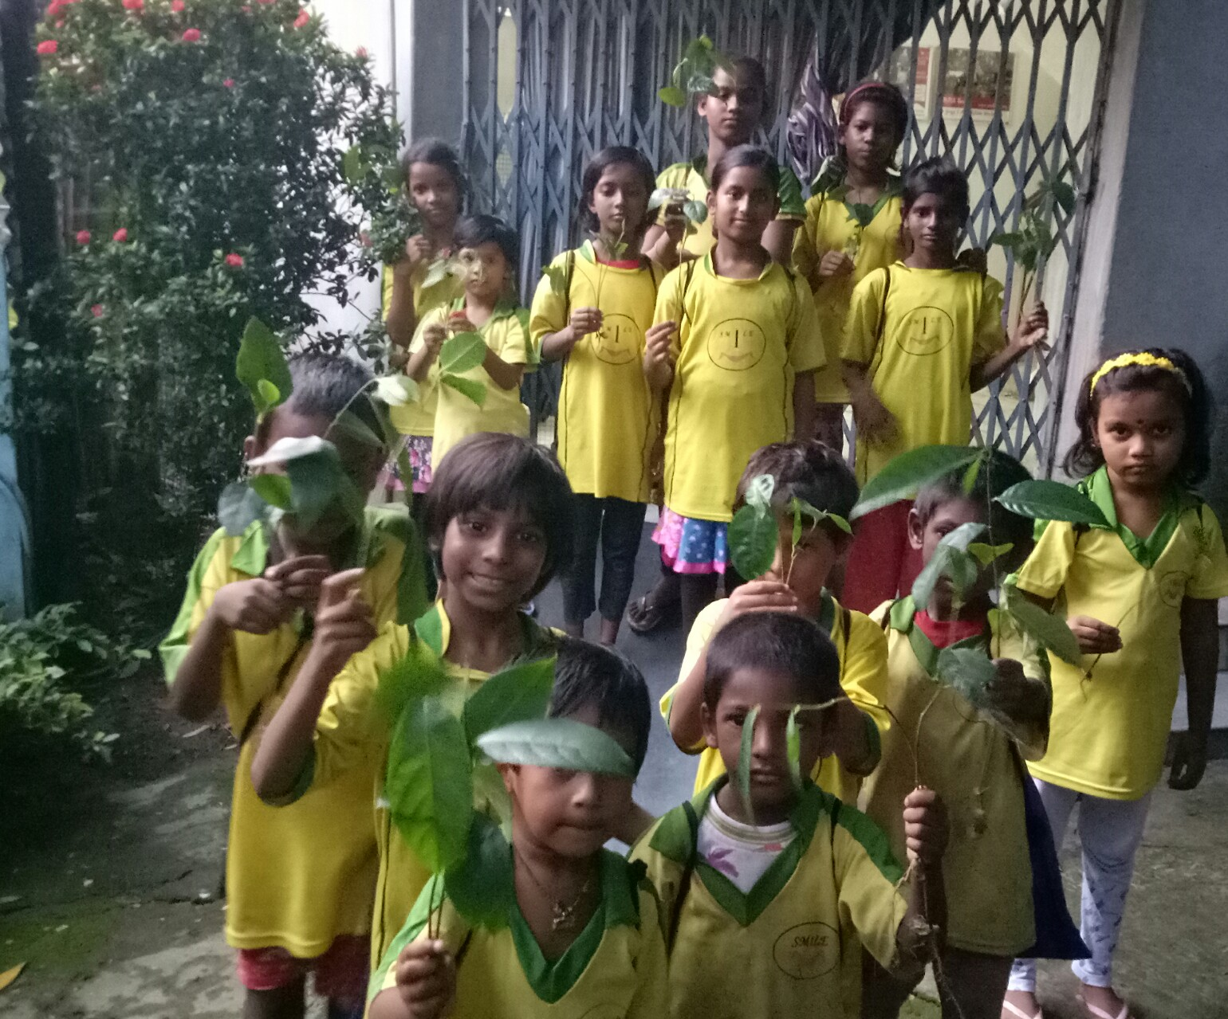**work:-**

Details : Exciting workcamps at Smile ,India !! Save the mother planet !!! Now we are working on to Grow vegetables, fruits and flowers to fight against Climate change in urban areas. at different projects . Group with motivated youth are welcome !! . lets help us to bring revolution in horticulture and floriculture at our place . There would be painting activities as well as cultural exchange programme as well !! Energetic youth group required.

Organic farming in urban areas through Green House and alternative methods are the main target of this project. International youth have chance to work together with SMILE local volunteers in the project.A complete cultural exchange platform would be there while working in a family type environment.SMILE Society ( Situational Management & Inter Learning Establishment Society) is a registered NGO & NPO working in the field of International volunteering from India. Our mission is to provide volunteers with a cu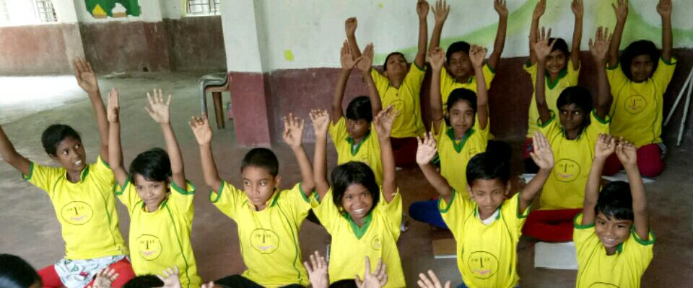stomised program (workcamp, short term, long term) that will enable them to make an important contribution to the poor and needy kids of India. In the past several years, we have placed many volunteers around various parts of India within different projects.

SMILE foremost goal is to "Bring Smile around" We ensure that all volunteers are provided with a safe and enriching experience. Our flexible approach means that you will be given a placement to suit your needs and time scale. All international students are also welcome to take part in our Internship Programme. Our unique placements could become the trip of a lifetime.

Example Daily Schedule:

Wake up early morning: 6 am

Breakfast: 6:30 am ( self service)

Work : 3-4 hours during week days,Exact work schedule would be delivered with infosheet.

late afternoon:3pm - 5 pm workshop

Dinner : 7 pm ( volunteers required help themselves in serving ,washing )

After 8 pm exit door would be closed.No one allowed to go out or come in the accommodation after 8 pm everyday including weekends.

9:30 bed time

** Please remember that programme schedule or project site can be changed or altered by the Project In-charge if required and all volunteers are requested to cooperate with our local members and partners. All schedule should be followed and mandatory for everyone to participate and contribute **

**\*Foreign language Teaching to Street Kids (SMILE LMTV11) :-**

**Work Type: TE/SW/HC**

**Location: Madhyamgram**

**work:-**

Target Group for these project:- Helping Children between 8-14 years old ( mostly refugees) of India to get basic education,vocational and hygienic training etc. Daily more than 200+ families receives support at our different centres around.

Project Back ground :- India having uncountable numbers of street and slum dwellers . There are thousands of poor refugees coming every year from nearby countries and from different small towns and villages to the big cities and most of these families are living in a very poorly condition at slums or on street corners. Often these families bring their children to help them in begging ,household work ,rag picking activities, even some girls been forcibly thrown to the dark life of prostitution. Volunteers have chance to teach their own mother tongue to these kids.

.Kolkata ,the city of joy was known before as Calcutta since the colonial time. This ancient city was used to be the capital of British colonial period. This city has full of heart ,people are basically belongs to the middle class . There are also rich and poor people all around . City Kolkata is know for its busy traffic ,huge population ,warm welcome and poverty around the street corners! It is a great place to visit for every tourist coming to India.

**Example Daily Schedule:**

Wake up early morning: 6 am

Breakfast: 6:30 am ( self service)

Work : 3-4 hours during week days,Exact work schedule would be delivered with infosheet.

Late afternoon:3pm - 6 pm workshop, cultural exchange, yoga

Dinner : 7:30pm ( volunteers required help themselves in serving ,washing )

After 8 pm exit door would be closed.No one allowed to go out or come in the accommodation after 8 pm everyday including weekends.

9:30 bed time

** Please remember that programme schedule or project site can be changed or altered by the Project In-charge if required and all volunteers are requested to cooperate with our local members and partners. All schedule should be followed and mandatory for everyone to participate and contribute **

**\* Self Defense teaching to Street Girls (SMILE LMTV12) :-**

**Work Type: Manu/Cul/Self defense**

**Location: Madhyamgram**

**work:-**

Target Group for these project:- Helping Children between 8-14 years old ( mostly 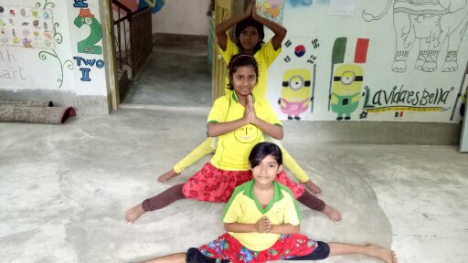refugees girls ) of India to get basic education about self defense and awareness. Daily many grown up girls receives support at our different centres around.

Project Back ground :- Girls living on street and slum always been victims of the cruelties of the societies. We are looking for energetic youth female volunteers to train our girls the basic and advance self defence. We welcome only female volunteers in this project.

**Example Daily Schedule:**

Wake up early morning: 6 am

Breakfast: 6:30 am ( self service)

Work : 3-4 hours during week days,Exact work schedule would be delivered with infosheet.

Late afternoon:3pm - 6 pm workshop, cultural exchange, yoga

Dinner : 7:30pm ( volunteers required help themselves in serving ,washing )

After 8 pm exit door would be closed.No one allowed to go out or come in the accommodation after 8 pm everyday including weekends.

9:30 bed time

** Please remember that programme schedule or project site can be changed or altered by the Project In-charge if required and all volunteers are requested to cooperate with our local members and partners. All schedule should be followed and mandatory for everyone to participate and contribute **

**\*Experimental living & practicing Indian Culture /Cuisine (SMILE LMTV13) :-**

**Work Type: Manu, Reno, Cul**

**Location: Madhyamgram**

**work:-**

Details: SMILE always believes in family type of environment !! It is always been a house of volunteers. Organisation always trying bring all international Volunteers to live together with local volunteers as a big family . It is an experimtal living initiative where volunteers living as an Indian family and follow Indian culture while helping poor children in needs. Such shelter would be our base point to bring smile around through volunteering. . Presently shelter is going on under the observation and guidance of local family of volunteers . We welcome young energetic hard working international volunteers to participate in our mission ! We also welcome groups to come and help us in construction and painting while experiencing living as a family !!

**Example Daily Schedule:**

Wake up early morning: 6 am

Breakfast: 6:30 am ( self service)

Work : 3-4 hours during week days,Exact work schedule would be delivered with infosheet.

Late afternoon:3pm - 6 pm workshop, cultural exchange, yoga

Dinner : 7:30pm ( volunteers required help themselves in serving ,washing )

After 8 pm exit door would be closed.No one allowed to go out or come in the accommodation after 8 pm everyday including weekends.

9:30 bed time

** Please remember that programme schedule or project site can be changed or altered by the Project In-charge if required and all volunteers are requested to cooperate with our local members and partners. All schedule should be followed and mandatory for everyone to participate and contribute **

**SMILE MLTV Projects List:-**

|  |  |  |  |  |  |  |
| --- | --- | --- | --- | --- | --- | --- |
| **Project Code** | **Date** | **Location** | **Project Name** | **Work Type** | **Volunteer Required**  M. F | **Volunteer Open Places**  M. F |
| MLTV02 | Permanent | Madhyamgram | Street Children Teaching | TE, SOCI, CUL | 10 10 | 10 10 |
| MLTV03 | Permanent | Madhyamgram | Street Girls Empowerment | TE, Art, Craft, Cul | 0 5 | 0 5 |
| MLTV04 | Permanent | Madhyamgram | Intercultural Exchange | CUL, Language, Cooking | 5. 5 | 5. 5 |
| MLTV05 | Permanent | Kolkata & around | Street Dogs Welfare | Grooming, Food distribution, Cleaning | 5 5 | 5 5 |
| MLTV06 | Permanent | Madhyamgram | Yoga & Meditation | Yoga & Meditation | 15 15 | 15 15 |
| MLTV07 | Permanent | Madhyamgram | Online Promotion Assistant | Blogging, Social networking, | 2 2 | 2 2 |
| MLTV08 | Permanent | Madhyamgram | Manual Assistant | Manual helper | 2 2 | 2 2 |
| MLTV09 | Permanent | Madhyamgram | Art, Music, Dance Teaching | Art, Music, Dance | 3 3 | 3 3 |
| MLTV10 | Permanent | Madhyamgram | Urban Organic Farming and Nursery | Envi, Manu, Art, | 5. 5 | 5. 5 |
| MLTV11 | Permanent | Madhyamgram | Foreign Language Teaching | TE, Lang, Art, CUL | 3. 3 | 3. 3 |
| MLTV12 | Permanent | Madhyamgram | SELF defence training girls | Manual, CUL, | 0. 3 | 0. 3 |
| MLTV13 | Permanent | Madhyamgram | Experimental Living and practicing Indian Culture & Cuisine | Manu, CUL, Reno | 10 10 | 10 10 |

**SMILE Contact Details :-**

[www.smilengo.org](http://www.smilengo.org)

**WHAT’S APP :+919830150249**

**Youtube @smilengo1**

**FB-smilengo.india**

**Line @workcampindia**

**Kakao @smilengo**

**We Chat @SMILE-Dev**

**Instagram @smilengo**

**Twitter @smilengo_india, @workcampindia**

**Email:** [smilengo.kamala@gmail.com](mailto:smilengo.kamala@gmail.com)