Call for Partners
Project title
ECO CAMPS AS PLATFORMS FOR SUSTAINABLE CAPACITY BUILDING IN FIELD OF YOUTH

Project type
Erasmus+ project, KA2 Capacity building for youth in ACP countries, Latin America and Asia

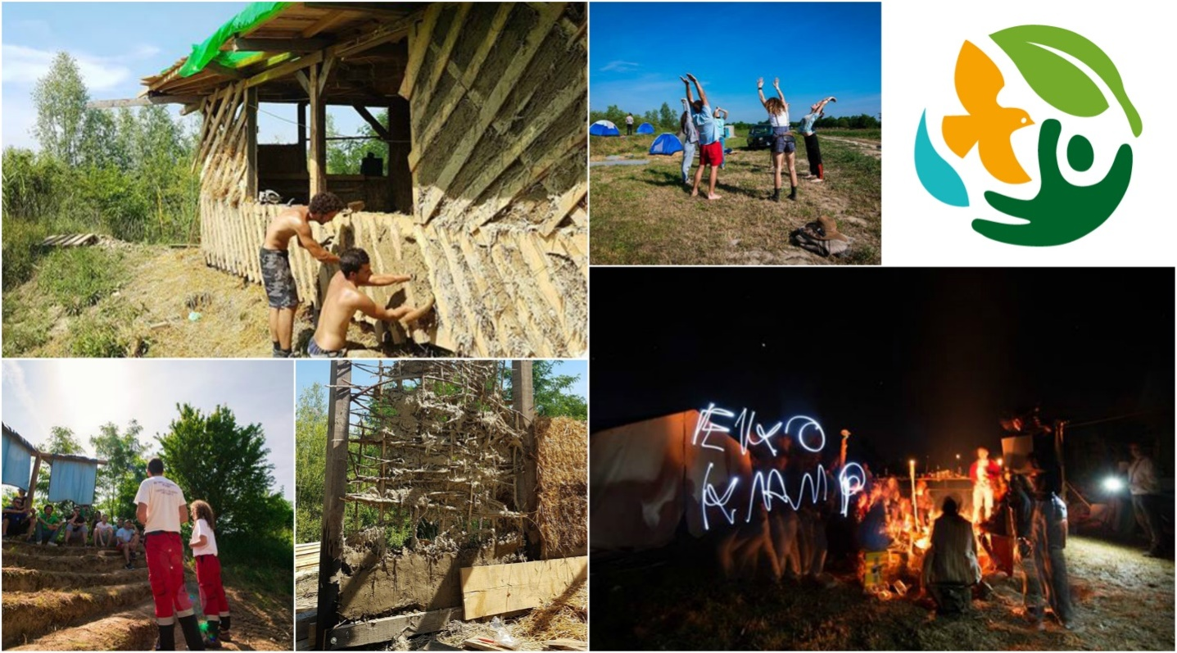
The aim of this project:
The aim of this project is to give young people competences in creating platforms for further sustainable development.

The main idea:
Rising the impact that young people have on sustainable development;
Obtaining complete knowledge on starting and managing new NGO organizations, events, funding them and increasing their growth.
Gaining technical knowledge on sustainable development in the fields of energy, food and housing.
Covering a specter of topics about eco building, environmental awareness and green technologies. Through those activities, aim is to find and create new change makers, who will be a pillar of their local community and expand idea of this concept. Eco Camp can provide education and know how to establish and manage NGO-s, fundraise and logistics background.

Period of implementation of all project activities: 1 August 2019 – 30October 2020.

Project activities

Activity 1 - STUDY VISIT – October 2019.
When partner structure gets established, we will begin online sessions in which partners and project coordinator will plan activities to the detail. Also, every project partner and project coordinator will present their experience in the field of sustainable development. Project coordinator will provide all technical resources.
Together, we will decide which partner country we will visit to have a study visit. We shall focus on organizations with long history and strong background in sustainable development. From that organization we shall receive valuable information on managing such an initiative. The chosen organization will become also a project partner.
We will use the study visit and the fact that we will meet in person to finalize last details before we make the project public. The meeting itself will be an official start of a joint fundrising campaign.

Activity 2 – TRAINING COURSE – May 2020.
Training course will be held in Serbia and will last for 20 days.
It represents an intensive training in fields of project management and sustainable development. Every day of the course participants will go through 6 hours of lectures, 2 hours of writing and 4 hours of work.
Lectures - consisted of two parts. Theoretical knowledge in the field of project management, NGO management, fundraising etc. will be one part. The second part will be lectures in the field of sustainable green development and will cover three main topics, ecological construction, renewable sources of energy and organic food production.
Writing – project proposal writing. Every participant will work with mentors in writing their own project proposal and at the end of the project they will have a finished project proposal.
Work – helping the mentors in preparation and execution of practical workshops.
It will include practice in ecological construction in which we will demonstrate some of the most popular techniques of construction.
Making solar heaters, rocket mass heaters, water filters will be practical workshops in the field of renewables.
Planning and designing your own small organic garden as well as food preparation will be the workshops in the field of organic production.
Besides formal part, the participants will have a continuous opportunity for networking, they will learn how to set up a temporary base camp for manifestations like this one and enjoy in meeting new people around the world, share stories of culture and art.
It is important to notice that the participants will be completely safe at all times because only the mentors will handle dangerous tools.
The idea of this camp is to start the initial fire in the minds of participants and set them off to become new game changers enriched with the valuable knowledge that they received.
Project partners and coordinators will help them along the way through our established network.

Activity 3 – PRACTICAL PLACEMENT – July-August 2020.
After all of the project partners have gone through training course and have acquired all the inputs for realization of such initiatives, each partner organization will implement small scale activity in their local community. Some will use their knowledge to do humanitarian work, some will get involved in youth entrepreneurship, while others will get involved in organizations of civil society, or become engineers and invent the next big thing in climate change products. It does not matter in which are they choose to continue their professional work our network and organizations will be there to help them along the way. Combining our resources we will make the impact of this initiative global and follow the dream of sustainable future.

Activity 4 - EVALUATION MEETING – October 2020.
Activity that has a purpose of gathering results of the project, sharing impressions and recommendations on improving the future projects that will take place in partner countries. Further diversification and impact growth of this and similar initiatives will be planed. It will be an official end of this project but also mark the new beginning with every person changed in the sense of personal development.

Objectives:
Creating a platform for sustainable green development between youth organizations.
Creating a network of highly motivated international partners.
Establish a permanent team of professionals to manage the network.
Dissemination of universal values in the field of environmental protection and ecology with focus ecological construction, green technologies and food production consumption
Stimulation of young people to take initiatives in their local communities
Making an yearly event that will be sustainable on its own in sense of funding.

Target group: Actively involved in work with unemployed young people living in rural areas aged between 18 and 30 years(youth workers, youth leaders, play workers, GREEN NGO activists, school teachers, educators, social workers, volunteers, local businessmen, young entrepreneurs with international experience)

Expected results: - In this project we will get 30 educated youth workers who will use/share their acquired knowledge, experiences and skills working with young people in their local communities
-Making global impact by joining resources of many local initiatives.
- To create an international network of youth organizations in the field of environmental awareness

Products:
-established green NGO in partner countries.
-making the "eco base camp utility kit"- Owning the list of things needed for making a temporary base camp with basic infrastructure
-25 participant project proposals.
-a network of NGOs and individuals active and interested in field of envirnomental protection and sustainable development, self employment and greater employability of young unemployed people from rural areas.
-Example models of green technologies* followed with a complete guide of making different models
-Documentary movie for monitoring off the entire process
-Knowledge transfer of this Erasmus+ long term project.
- Practical guide in which will be presented steps and necessary material for starting green events
- Web platform that will be used for networking, sharing materials, advices, suggestions, good practices.

Profile of partner organizations: We are looking for partners who have experience in the field of ecology and environmental protection.
We also need organizations , who have experience in motivating and empowering unemployed youth in rural areas. Our goal is to create young entrepreneurs, environmental aware, and we are looking for partner organizations who can support that endeavor .
Organizations must be established in Erasmus+ Program countries and Other Partner Countries from Regions 5 to 14 (check in Erasmus+ Programme guide pages 22, 23 and 24).
If you are interested to participate, please send to us your PIC number and Partnership Identification Form on e-mail address balkanyouthecovillage@gmail.com

Deadline for receiving your agreements is 20.January 2019

Host organization:
Green front - is a voluntary, non-profit association, founded in 2015. time to achieve the objectives in the field of environmental protection. The organization is an association of citizens and it was established in Europe, Balkans, Serbia. One of main activities is building of an Youth Eco Village which started in 2018. Some of past activities are environmental festivals, recycling and cleaning actions, international camps and humanitarian activities.

Organization is working on:
-Rising capacities of youth for environmental activism.
-Rising environmental awareness.
-Transfer practical knowledge in field of eco building, green technology, food production and consumption.
-Established cooperation with similar organizations
-Creating a network of local organizations

The objectives of the association are related to: environmental protection, organization of activities on the rehabilitation of affected areas, rising cultural awareness, organization and participation in humanitarian action type, promotion of education, science and information, the impact on local policy development, development of local communities, the impact on youth policy, promotion of youth activism, organization and participation in sports and recreational events, organizing training of all categories of the population in all areas of the stated goals, civil society capacity building, networking with organizations and associations that promote the same or similar goals at home and abroad.
For further Information, please contact us:
Vladimir Stupar/ project manager
Web: www.facebook.com/balkanyouthecovillage
E-mail: balkanyouthecovillage@gmail.com
Mobile: +381 60 3222987

