Call for Partners

Project type
Erasmus+ KA2 Capacity building in the field of Youth (Western Balkan Youth Window)
Project type
Erasmus+ KA2 Capacity building in the field of Youth (Western Balkan Youth Window)
Project type
Erasmus+ KA2 Capacity building in the field of Youth (Western Balkan Youth Window)
Project type

Erasmus+ KA2 Capacity Building for youth in ACP countries, Latin America and Asia

Project type
Erasmus+ KA2 Capacity building in the field of Youth (Western Balkan Youth Window)
DATE

Projects starting from 1 August 2019 until 1 September 2020

PROJECT NAME

YOUTH FOR SMALL URBAN OASIS

before

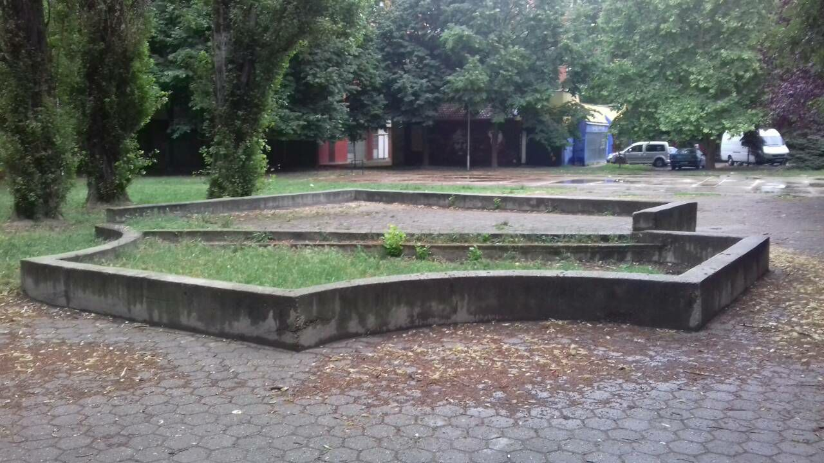

Work in progress
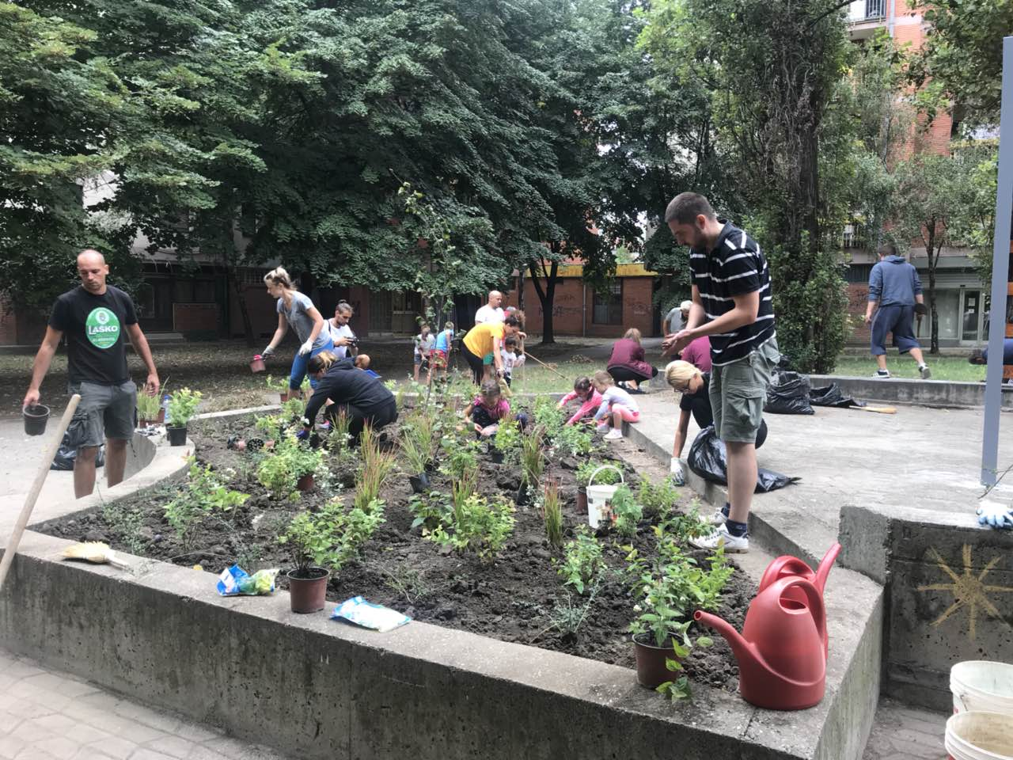

Now

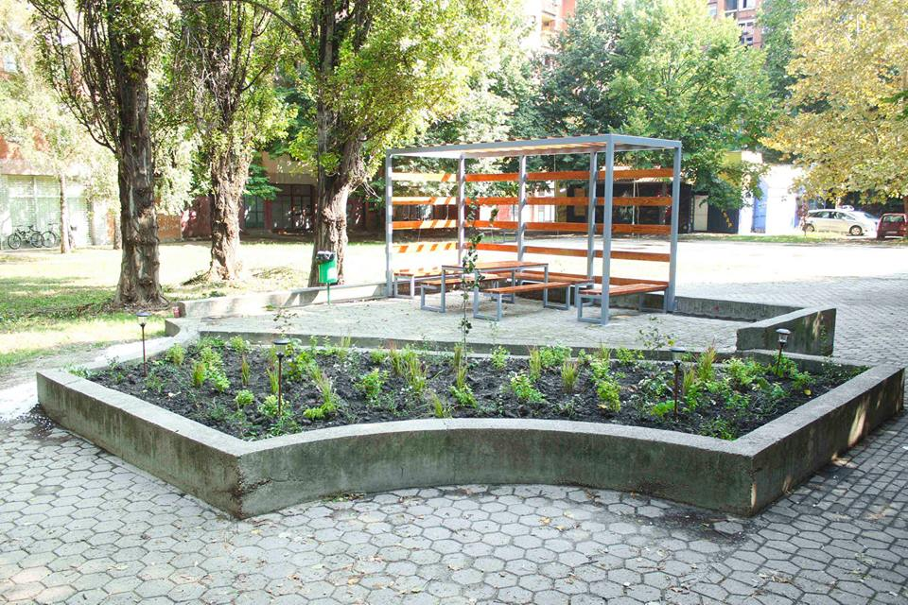

Goal

The main goal of this project, going by the name of “Small Urban Oasis” is the social inclusion of all young people from urban problem zones in active participation in their areas of residence. In this project, young people will be actively engaged in proposing and implementing solutions in their place of residence. The youth from these troubled areas is going to be an agent of positive social change in their communities through active engagement of residents, workers, immigrants and all the other members of the community.

Why we are doing this project

All around the world in densely populated cities people live estranged from one another utterly unaware of their environment. In communities such as these people who reside there have a low awareness of environmental pollution and the local community. They also lack the capacity to organize themselves and tackle the issues they are facing on daily basis.
Small urban oasis is a public space situated between the buildings or constituted by the buildings themselves.
Small urban oasis is intended to be used by residents, workers, people just passing by, young people with fewer opportunities, immigrants, refugees and all the other members of the local community.
Small urban oasis brings a lot to the young people living in urban problem zones. It acts as a hub which invites people to stop, play and relax while having a conversation with their neighbours. Plants and trees create a shade which offers protection from the sun, they also protect the residents from noise pollution and act as air purifiers while benches offer a perfect place for rest. Setting up a small urban oasis is an easy task, costs are low and the benefits are numerous.
Oasis adds additional value to cities and settlements while strengthening the identity of the local community. It also facilitates economic development and enables cultural and other activities in the neighbourhood. The most valuable effect of the small urban oasis is the inclusion of young people with fewer opportunities, immigrants, refugees and other members of marginalized social groups.
Through the activities organized, they will have an opportunity to get additional information, develop new skills and competencies through the interaction with other citizens who frequent the oasis, enticing them to find regular employment and take a more active role in their communities by means of socio-educational and personal development. While developing small urban oasis they will have to actively cooperate with local authorities in charge of managing green spaces in urban areas. Through crowdfunding campaigns aimed at gathering funds necessary for the project, they will improve their ability to negotiate and convey their ideas. Their creativity and critical thinking will be nurtured through cooperation with local companies on tasks such as choosing the construction materials and designing the oasis itself. Through community work, they will learn the official language of the country they live in, improve their existing skills and acquire new ones. Informal education, coupled with socially useful work will help incorporate migrants and young people with fewer opportunities into the existing social structure. Working together with members of the local communities, migrants will be able to make a bond with the locals and help them understand what made them leave their country of origin. Through training, youth workers, who will be tasked with organising similar workshops in their local communities, will have their capacity for influencing marginalised groups, prevention of racism raised. They will also learn techniques that will help them facilitate inclusion of youth with fewer opportunities, migrants and refugees and raise their competitiveness in the labour market as well as the promotion of intercultural dialogue and nurturing of cultural diversity. After the successful training, they will have an opportunity to utilize all of the said skills in the construction of small urban oasis.
The main idea of the project

The main idea of “Youth for small urban oasis” is to empower young people from problem urban zones. This goal will be achieved through several project activities.

Main activities:

1. Gathering data on the state of youth activism in local communities of all the partner organisations respectively. The study will be conducted on a sample of 1000 individuals ages from 15 to 35 throughout the period of 30 days. Each partner organisation will send a representative to present the research data.

2. Contact making event will last for 8 days and it will be held in one of the countries covered by the Erasmus + program where partner organisations will get acquainted, exchange their experience in work with young people from urban problem zones. They will also present the research data gathered in the first activity. This data will be used to adjust the method of work to meet the unique challenges every participating organisation is facing in respect to the unique social structure of their societies.

3. Local activities of partner organisations – the duration of this activity will be 100 work days. The goal of this activity is determining the applicability of good practices established in the contact-making event. In local activities participants will evaluate feasibility / effectiveness of the method of work.

4. Training course – will be conducted in Novi Sad, Serbia.
During 9 days, 30 participants will improve their capacity for youth work mainly by mastering techniques which will help them tackle the issues of social inclusion of young people with fewer opportunities, migrants and refugees. They will also acquire skills that will enable them to promote intercultural dialogue and nurturing of cultural diversity. The skillset learned during this training will have a secondary benefit which comes down to the promotion of cooperation and youth policy.

5. Practical application – will be conducted during the period of 90 work days. All the skills acquired during the training course will be implemented in local communities of partner organisations. Partner organisations are expected to work with young people from urban problem zones, organize the youth from said areas and construct an urban oasis.

6. Evaluation meeting will last for 5 days and it will be held in one of the African or Asian countries (depending on the partner organisations)
During this meeting, we will evaluate all project activities and compare targeted results with all partner organisations.

7. Presentation of the project results – duration 120 days (online) When we finish this long-term Erasmus+ project we will present the final project results on the websites which will be created during the project.

With this project we would like to achieve the social inclusion of all young people who are living in urban problem zones in active participation in their local communities. In this project, young people will be actively engaged in proposing/offering/implementing solutions in their local communities.

Objectives

1. To animate passive young people to be active in their local community.
2. To create a small urban oasis where young people spend their free and leisure time.
3. To create space where all people including young people from urban problem zones will feel fully social included.
4. To promote intercultural values and sustainable development of the living environment.
5. To motivate young people to think/express themselves in a creative way by changing/improving their local environment.
6. To promote Erasmus+ programme possibilities in animating/ activating young people from urban problem zones.
7. To create a new network of partner organisations that are working on activation of young people from urban problem zones.

Target group

Youth workers, youth leaders, peer educators and all others that are working on social inclusion of Young people from urban problem zones.

Expected results

The expected results of this project are engaging, connecting and empowering young people to assume a more active role in their communities and to successfully tackle the problems they are facing.

During this project, 30 participants from Erasmus + program countries and other countries of the world will be trained. Also, the participants will transfer the acquired knowledge to the youth in urban problem zones. The expected number of young people who will benefit from this project is 3000.

Through training, representatives of youth organisations, who will be tasked with organizing similar workshops, raise their capacity and develop techniques for reaching out to socially marginalized youth. This training will also enable them to positively affect youth, migrants and refugees in terms of inclusion and raising their competitiveness in the labour market, as well as the promotion of intercultural dialogue and respect for cultural diversity. While making the oasis in their respective communities they will have an opportunity to use these skills for the betterment of the society. Aforementioned will entice cross-sector collaboration, promote youth policies, and ease the transition of youth to adulthood making them more competitive on the labour market.

The expected result is young individuals with highly developed professional and ethical codex.

Product/s

Participants from partner organisations will create an urban oasis upon their return to local communities.

Manual containing instructions on how to make an urban oasis from scratch available as a print and as an online document.

Designing and publishing a website which will act as a hub for youth who want to share their ideas and experience in regards to solving the problems of local communities.

Short video footage comprised of video recordings of every project activity which will be available to the public.

T-shirts with a simple logo designed during the project activities.

Additional funds for solar stations will be gathered through a crowdfunding campaign. These panels will provide energy for chargers for electronic devices.

Profile of partner organisations

In this project, we are inviting all partner organisations who are dealing/working with young people from urban problem zones who are working on social inclusion of young people with fewer opportunities, organizations that are dealing with eco topics and sustainable development.

Organisations must be established in Erasmus+ Program countries and Other Partner Countries from Regions 5 to 14 (check-in Erasmus+ Programme guide pages 22, 23 and 24).
If you are interested in becoming a partner organisation in our project please send us:
Filled partnership identification form – like word document (.doc) on
E-mail: y.policy.institute@gmail.com
Deadline for receiving partnership identification form is 16 January 2019.
Only selected partner organisation will be contacted and asked for additional information!

Who we are?

The non-profit organisation “Institut za omladinske politike” (Youth Policy Institute) based in Novi Sad, Serbia. The organisation was established in 2017.

Why?

Everything we do, we do to help the youth. We strongly believe that living conditions of youth can be improved.

How?

We help youth by enabling them to participate in all aspects of social and political life.

What?
We provide free seminars, workshops and courses as an institute of youth policies.

To Whom?

Young people ages from 15 to 35 are involved in our project activities

More info about us you can find on our facebook page: https://web.facebook.com/Institut-za-omladinske-politike-1786964471619642/

Contact e-mail address y.policy.institute@gmail.com

