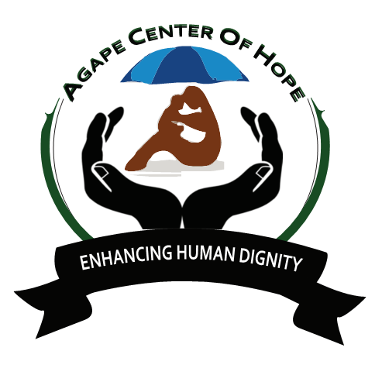

ACoH Workcamps in Kenya
ACoH is recruiting International volunteers around the world to participate in Kenya Project scheduled from January to December 2019; make a big difference in Kenya.
ACoH in collaboration with local communities in Kenya welcomes volunteers motivated to participate in our projects in Kenya that range from 2-3 weeks in the heartland of the African culture.
The work camps will involve teams of local and international volunteers with the maximum of 20 participants in each project.
These projects have been scheduled to be held from January to December 2019 with at least two international work camp every month for the stated duration of time.
The volunteers will be involved in any of the following activities:
¬ Intercultural education
¬ Peace building and conflict transformation
¬ Manual work together with community members
¬ Development education that would feature awareness on environmental, gender, formal education, empowerment of local community with specific focus on women, men and the youths,
¬ Non formal education including animation on challenges of development
¬ ICT infrastructure development at the grassroots in Kenya
¬ Face to face meetings with the local people on thorny issues like the repugnant practice of female genital mutilation that is rampant in some communities in Kenya
¬ Other project will be designed and tailor made to suit the interests of the specific group that motivated to participate in this project in Kenya
Target Groups
¬ Scouts and Girl Guides Associations
¬ Universities and institutions of higher learning
¬ High Schools, tertiary and vocational colleges
¬ Professionals ranging from teachers, social workers, medical practitioners, social scientists and freelancers
¬ Individuals motivated to make a big difference in the lives of the needy in the society through volunteering.
Placements
¬ There will be mutual agreement on the structure of this program and the requisite participation procedures that will discussed with the institutions making the requests and ACoH will handle the placements on needs basis depending on the applications
¬ We have variety of projects throughout the country and both the sending and receiving organizations will play the pivotal role to enhance the partnership and develop together the structure of cooperation for this program
¬ Each work camp will have the thematic focus with the overall objective of strengthening the structures at the local communities to enable them to respond appropriately to the challenges of development.
Past Experiences
¬ ACoH has vast experience in organizing work camps with the track record of working in a multicultural setting to enhance social justice and solidarity across humanity.
¬ Since inception in 2012 ACoH has successfully hosted over 100, 000 volunteers on our projects in Kenya with spectacular acclaim and the teams have been recruited from Kenya, Uganda, Tanzania, Zimbabwe, Togo, Nepal, South Africa, Denmark, Netherlands, South Korea, Czech Republic, Spain, Germany, Slovenia, France, Belgium, Taiwan, USA, United Kingdom, Japan, Italy, Mexico, Greece, Turkey and Nepal that are among the leading nations that have deployed the majority of the volunteers
¬ ACoH is open to new partnerships to enhance its capacity in service delivery and we will highly appreciate to establish this partnership
