Project Profile.
Project name. : Buguta Community Health Unit
Project location: Buguta village, Taita Taveta
Project type: Community lead youth group
Project contacts: Mohammed Said Omar, +254702818338, mohammedagapesaid@gmail.com
Projects date: Run all round the year.
……………………………………………………………………………………………………………………………………………………………
Project background.
Community Lead Youth Group is a youth initiative that supports behavior change and communication among the adolescent youth and increase accessibility to service delivery at the facility.
The youth group is affiliated at Buguta Health Center and operates under Buguta Community Health Unit.
The youth group has 74 members and support adolescents youth access services at Buguta Health Center. 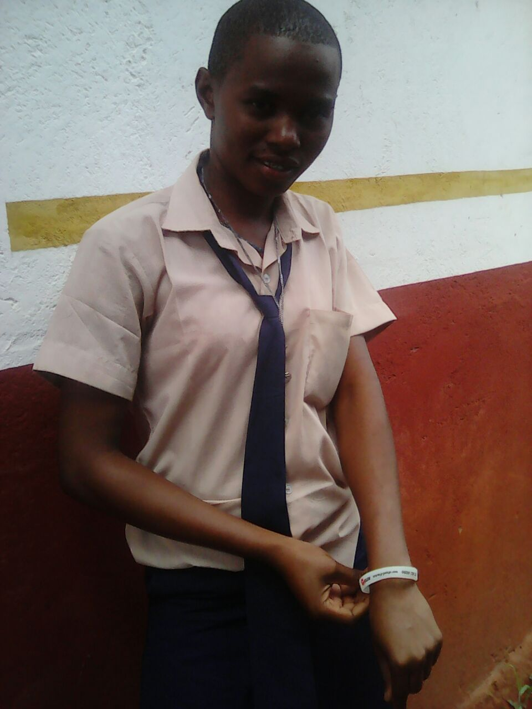
- Project activities.
- Community Health Unit
- Home visits focus on Health indicators.
- Monthly Feedback meetings on health issues.
- Community dialogues meetings.
- Community Health Action Days.
- Community Health referrals.
- Health talks on behavior change.
- Data analysis and reports writing to facilitate quarterly plan of action.
- Community lead youth group.
- HIV counseling and testing.
- Sporting activities.
- Talent identification and nurturing.
- Fund raising and Proposal writing.
- Discussions on viable ideas on income generation and implementation.
- Peer to peer education among the school going children and adolescent youths
- Women empowerment for young mothers-basket weaving, knitting, tailoring, beauty and salon, Cookery.

- Project accommodation (accessibility of water, security, nearest health center, accommodation type etc)
The volunteers will be hosted within Buguta sub location which has a population of approximately 15,000. Buguta Sub location comprises of 7 villages namely, Kisimenyi, Magwede, Kulkila, Saasenyi, Mkamenyi, Buguta East and Buguta West. The community has Buguta Health Center which is within Buguta town, there is water scarcity in the community but currently Kenya Red Cross is working with the community on Water and Sanitation program hopefully by mid June, 2017 piped water will be available. The village is very secure with Administration Police Camp adjacent to the health facility.
For short term volunteers accommodation will be available to the health facility while for long term volunteers, accommodation will be in host families with lockable rooms

- Project needs
The project is currently looking for volunteers to fill the following needs:
- Long term volunteers with a health background, environmental background or a business background that can work with the various departments of the group to explore and implement impactful activities.
- Short term volunteers who can help in the various activities the group is involved in such construction of toilets in the community, community health mobilization etc
- Any person who is interested to work with the rural communities to uplift them from their current challenges.

- Project pictures.

- ORIENTATION

Orientation will begin in the morning at ACoH offices and you will be picked up from accommodation and taken to the orientation will be conducted by ACoH staff in Nairobi and cover everything you need to know about your project placement. Introduction to Kenya and Taita land, Taita Taveta customs, language and expectations, safety, travel opportunities in Kenya, introduction to your project and placement. The orientation will also give you a chance to meet other volunteers and swap contact details for weekend travel and socializing.

- LEISURE ACTIVITY
This will provide opportunities for international volunteers to learn/ enjoy local life and exchange with local people, we have quit a number of tourists attractions and site seeing points e.g. fort Jesus, mama Ngina drive, Mwaluganje elephant sanctuary, Shimoni caves, the great Mombasa temples, elephant tusks, haller park, bombolulu cultural centre, bird sanctuaries, Sandy Beaches e.g Diani Beach, Nyali Beach, Pirates beach, marine parks etc.

- EXTRA FEE
350 EUROS which includes project work, accommodation, all Meals, transport from the airport/transfer and to the project site, and 24 hours on side staff support.

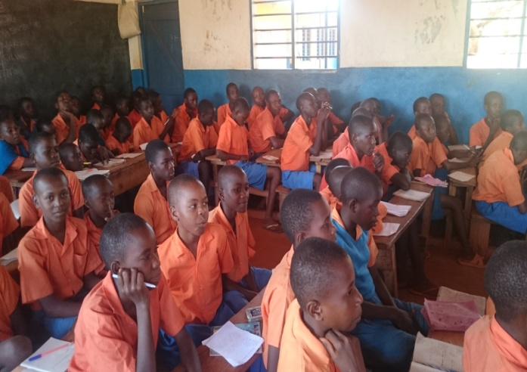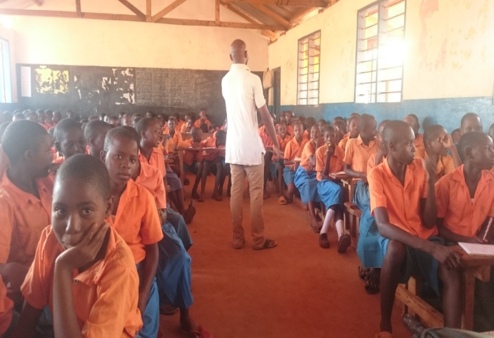School Health Program on Reproductive Health and Hygiene.
