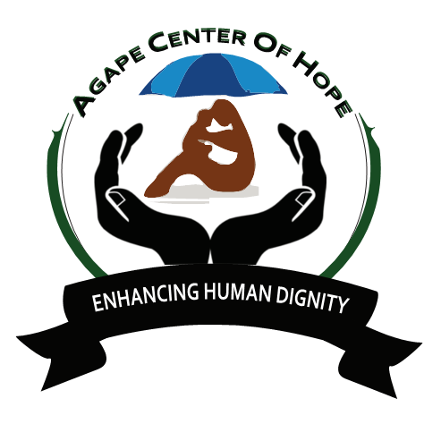ACoH Group Volunteering in Kenya
ACoH has launched group volunteering program from January to December 2019, WE welcomes ALL applications to build a fordable platform to transform society to action.
ACoH in collaboration with local communities in Kenya welcomes group volunteering in joining all projects in Kenya from January to December 2019.
This program is tailor-made with the respective partner organization wishing to recruit volunteers for this project.
ACoH will organize a 2-week to 3-weeks work camp where the team of local and international volunteers will participate in the project hosted by local community either in the urban or rural setting according to the preference of the specific project location.
The group should consist of the minimum of 10 volunteers and the maximum of 30 volunteers regardless of the age groups.
The volunteers will be involved in any of the following activities:
¬ Intercultural education, Art & Wild Heritage
¬ Manual work together with community members
¬ Development education that would feature awareness on environmental, gender, formal education & None Formal Education, empowerment of local community with specific focus on women, men,Children,vulnerable people and the youths.
¬ Non formal education including animation on challenges of development
¬ ICT infrastructure development at the grassroots in Kenya
¬ Face to face meetings with the local people on thorny issues like the repugnant practice of female genital mutilation that is rampant in some communities in Kenya, like kisii,Turkana And Samburu.
¬ Other project will be designed and tailor made to suit the interests of the specific group that motivated to participate in this project in Kenya

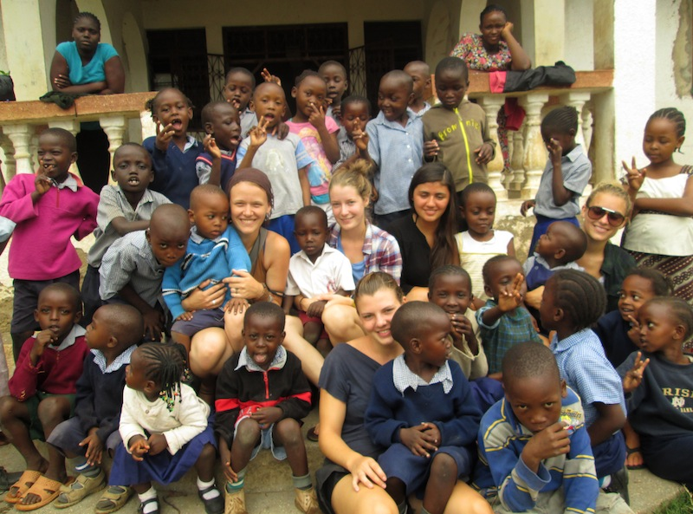

Target Groups
¬ Scouts and Girl Guides Associations
¬ Universities and institutions of higher learning
¬ High Schools, tertiary and vocational colleges
¬ Professionals ranging from teachers, social workers, medical practitioners, social scientists and freelancers.
¬ Individuals motivated to make a big difference in the lives of the needy in society through volunteering
Placements
¬ There will be mutual agreement on the structure of this program and the requisite participation procedures that will be discussed with the institutions making the requests and ACoH will handle the placements on needs basis depending on the applications
¬ We have variety of projects throughout the country and both sending and receiving organizations will play the pivotal role to enhance the partnership and develop together the structure of cooperation for this program
Past Experiences
¬ ACoH has vast experience in organizing work camps with the track record of working in multicultural setting to enhance social justice and solidarity across humanity.
¬ Since inception in 2012 ACoH has successfully hosted over 100 groups of volunteers on our projects in Kenya with spectacular acclaims and the teams have been recruited from Kenya, Uganda, Tanzania, Zimbabwe, Nepal, Denmark, Netherlands, South Korea, Czech Republic, Spain, Germany, Slovenia, France, Belgium, Taiwan, USA, United Kingdom, Japan, Italy, Mexico, Greece, Turkey and Nepal that are among the leading nations that have deployed the majority of the volunteers
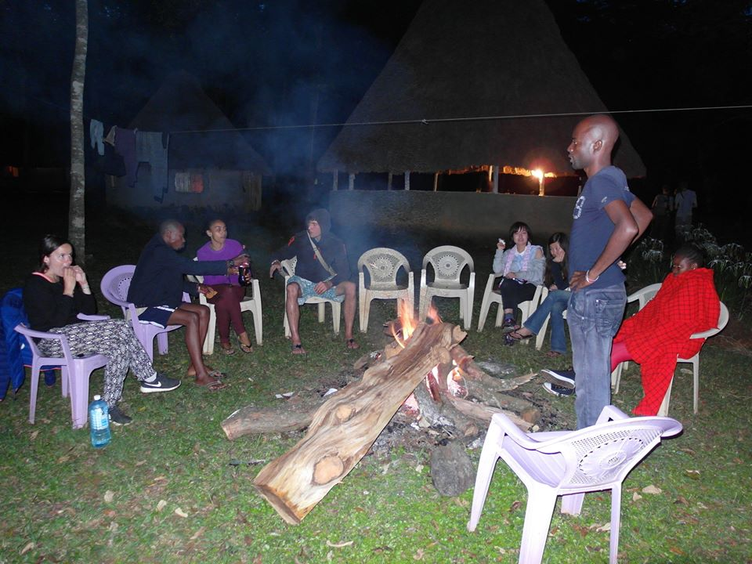
¬ ACoH is open to new partnerships to enhance its capacity in service delivery and we will highly appreciate to establish these partnerships

