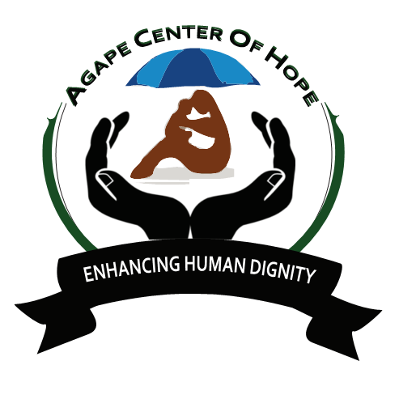
ACoH: MLTV02/2 GELI COMMUNITY ACADEMY
History and Background
Geli Community Academy orphans project was started in the year 2015.We started by donating clothes, food and uniforms to poor orphans in Kisumu Mowlem Community.

In the year 2016 we had supported about 30 children to get clothes, uniforms books and food. in the year 2017 we managed to receive school supplies to all our orphans donated by a school in Poland through Agape centre of Hope (ACoH)

In the year 2018 we have managed to open a new school which is Geli Community Academy
Aiming at providing quality affordable education to all our poor orphans within Mowlem Community. We have 4 volunteers e.g teachers,Director,cook and Cleaner right now we have a total of 38 orphans 8 learning in our school and 30 in other schools.

VISION
Our Vision for the orphan’s project is to provide quality affordable education to all orphans and vulnerable children within Mowlem Community.

MISSION
To ensure that all children get quality education food protection
To produce better leaders in the community
To change life of all orphanage

OBJECTIVE
Provision of quality service to the community
A society where all orphans and vulnerable children are educated.

ESSENTIAL DUTIES AND RESPONSIBILITIES
Placing 38 orphans to in the morning and pick them after school
Teaching
Ball Games and physical education
Feeding program, breakfast and lunch.
Home Visitation
Singing/Dancing and poems tales.
Washing utensils and home visits.

Day 1: Arrival and pick up from the Jomo Kenyatta International Airport, in Nairobi, Kenya and transfer to host family home or hostel.

Day 2: Morning: registration and start of orientation. About 4 hours lecture at the home of your host. Topics covered during orientation lecture will include East African culture, history, customs, politics, geography, and necessary health precautions, and various other topics, such as the diversity of Kenyan life. Afternoon is free for exploring rural Kenyan life and getting to know your host family.

Duration of the project: 1 to 6 months. The program is running January-June and July- December.

Orientation: Orientation meeting will take place in Nairobi before proceeding to the project.

Accommodation: Accommodation is provided in the hostel in the orphanage or host family, tap water and electricity available.
Location. Kisumu County, Mowlem.

Leisure time: Excursions at Kakamega Tropical Rain forest for beautiful sunrise and sun set, Lake Victoria for boat ride, hippo point and bird watch in Kisumu, visit kit mikai, crying stone.

Age range: 18 and over

Participation fee: 900 Euros for 3 months

