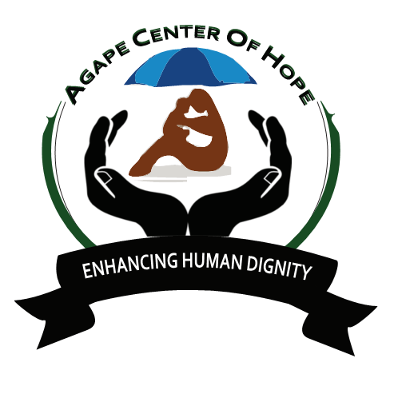
ACoH: MLTV07/2: JARAMOGI OGINGA ODINGA TEACHING AND REFERRAL HOSPITAL, NYANZA PROVINCE
Back Ground
Volunteers are needed in Jaramogi Oginga Odinga teaching and referral hospital, located in Kisumu City, Nyanza Province. Volunteers will be involved in most areas of the hospital, which involves working in different departments such as Pharmacy, Laboratory, Pediatric, General, HIV/AIDS, and Morgue. Orientation will be conducted for the volunteers to understand the objectives and expectations of the program. The volunteers will be supervised/guided by the doctors and clinical officers. Other duties will be counseling patients, feeding patients, therapy, giving health talks, Prevention of Mother to Child Transmission (PMTCT).

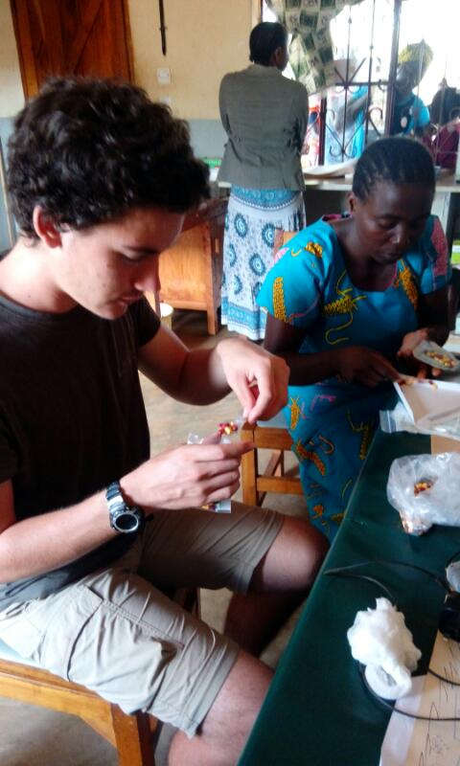
ESSENTIAL DUTIES AND RESPONSIBILITIES
Volunteer will be working and engage different target groups within the communities explaining to the community how T.B is a social problem, it is not just for those who are ill. Volunteer will be working with local medical doctors and support the health delivery system and will be attending to TB patients HIV/AIDs, giving drugs and recording, booking patients. Attending to pregnant mother clinic/family planning, giving children injections and weighing and Laboratory services. Social Bench and VCT, Reception and Recording Room, Community bench and enrollment Room, Women’s & Children's Health, Mother and Child Care, Patient Support Centre (PSC HIV), Gender based violence recovery Centre, Group therapy and Adherence Room. Also, Assist doctors, Nurses and medical staffs, Assist doctors Examine and treat the patients, Treat minor injuries, Volunteers can also participate in hospital programs like record keeping, Educate patients on the importance of sanitation, nutrition, etc.
Day 1: Arrival and pick up from the Jomo Kenyatta International Airport, in Nairobi, Kenya and transfer to host family home or hostel.

Day 2: Morning: registration and start of orientation. About 4 hours lecture at the home of your host. Topics covered during orientation lecture will include East African culture, history, customs, politics, geography, and necessary health precautions, and various other topics, such as the diversity of Kenyan life. Afternoon is free for exploring rural Kenyan life and getting to know your host family.
Leisure activities: Lake Victoria, cultural exchange, excursions. The visits are done during the

weekends.
Special requirements: Doctors, nurses, paramedics, pre-med students and medical students are required for this project. However, we have an open policy and applicants with other ideas to share are also welcome to apply and will be considered. Participants should have a positive attitude, be ready to adopt and enjoy simple living conditions, and be flexible and patient.

Language: English

Duration of the project: The program will run for a minimum of 1 month and a maximum of 6 months. The program is running throughout the year.

Orientation: Orientation meeting will take place in Nairobi before proceeding to the project.

Accommodation: At a host family. Please note that you will share the typical living conditions of a Kenyan family. There will be electricity, but no shower and pipe water/taps at the accommodation. Volunteers will be using buckets for bathing. Water will be boiled for drinking purposes and those who prefer can buy bottled water.

Location: Kisumu County Kibuye Market.

Age range: 18 and over

Participation fee: 900 Euros for 3 months

