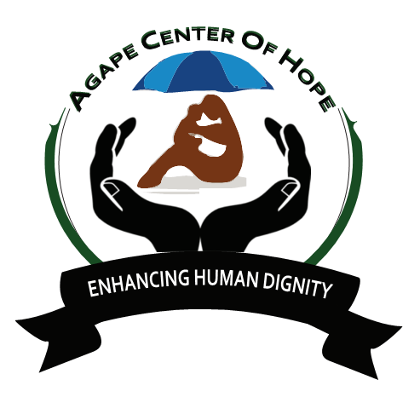
ACoH: MLT01/4 NYALI PRIMARY SCHOOL EDUCATION
Back Ground The school was founded as a result of the First World War which came nearest to the coastal strip making Mombasa a base of military activities. As a result there was over-crowding and shortage of housing and on the other hand a very large increase of military service traffic, etc, making the children’s lives more precarious. Many mothers became engaged on part time or full time war work and had to think of Nursery School to take care of the children while they were at work. Thus the Parents’ Club may have been an outcome of the war; but it is an outcome that has now come to stay. The school has three streams per class and the enrolment currently stands at 960 pupils.

ESSENTIAL DUTIES AND RESPONSIBILITIES
The volunteers will be mostly needed in teaching: also French teacher is needed
English, All 8.4.4 subjects, Creative Activities, Language Arts, Oral Reading & Writing, Science/Agriculture and Nature study,Hand-Writing,Physical Education, Swimming as a Lesson all classes from PG to std eight, French as a subject from std one to eight, Computer from KG2 to std eight, Teach English at local school, Home stay, Develop Lesson plans, Use and share own teaching methodologies, Coordinate with local teachers, Help them develop conversational skills in English, Learning about different cultures at close quarters.

Extra Curricular Activities The basic curriculum is extended and enriched by:-
- School field trips, Art & Craft, Swimming Competitions, Drama to National Level,Scouting,Traditional Dances, Keep Fit, Home Craft
To encourage competition in the co-curricular activities, children have been divided into four different houses namely Chui, Simba, Nyati and Kifaru.
Day 1: Arrival and pick up from the Jomo Kenyatta International Airport, in Nairobi, Kenya and transfer to host family home or hostel.

Day 2: Morning: registration and start of orientation. About 4 hours lecture at the home of your host. Topics covered during orientation lecture will include East African culture, history, customs, politics, geography, and necessary health precautions, and various other topics, such as the diversity of Kenyan life. Afternoon is free for exploring rural Kenyan life and getting to know your host family.

Language: English
Duration of the project: 1 to 6 months. The program is running throughout the year.
Orientation: Orientation meeting will take place in Nairobi before proceeding to the project.
Accommodation: Accommodation to the host family or in school, electricity, tap water.
Location: Mombasa county, Nyali sub-county, coast province Kenya
Age range: 18 and over
Participation fee: 900 Euros for 3 months

