ACoH: MLTV 05/1 –FORT JESUS WORLD HERITAGE MOMBASA
Back Ground
The Fort, built by the Portuguese in 1593-1596 to the designs of Giovanni Battista Cairati to protect the port of Mombasa, is one of the most outstanding and well preserved examples of 16th Portuguese military fortification and a landmark in the history of this type of construction. The Fort's layout and form reflected the Renaissance ideal that perfect proportions and geometric harmony are to be found in the human body. The property covers an area of 2.36 hectares and includes the fort's moat and immediate surroundings.

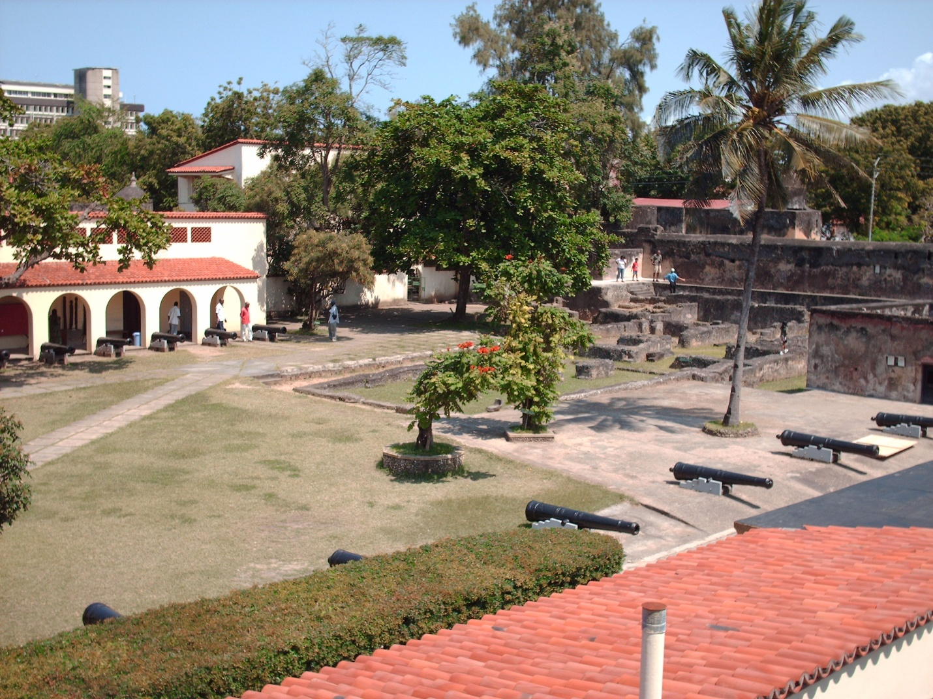

ESSENTIAL DUTIES AND RESPONSIBILITIES
Cleaning up the shipwreck in fort Jesus, devising publicity for fort Jesus, holding visitor satisfaction questioner for fort Jesus. Teach English in Primary Schools organize games and drama festivals, attend to visitor. Volunteers will facilitate educational activities with young children in the host community to promote culture, Sensitize the international and local volunteers the local community as well as the concerned authorities around issues related to world Heritage.
Day 1: Arrival and pick up from the Jomo Kenyatta International Airport, in Nairobi, Kenya and transfer to host family home or hostel.
Day 2: Morning: registration and start of orientation. About 4 hours lecture at the home of your host. Topics covered during orientation lecture will include East African culture, history, customs, politics, geography, and necessary health precautions, and various other topics, such as the diversity of Kenyan life. Afternoon is free for exploring rural Kenyan life and getting to know your host family.
Duration of the project: 1 to 6 months. The program is running from January to December.

Orientation: Orientation meeting will take place in Nairobi before proceeding to the project.

Accommodation: Accommodation is provided with a host family. There is shower and tap
Water at the accommodation, and with electricity.

Leisure time: This will provide opportunities for international volunteers to learn/ enjoy local life and exchange with local people, we have quit a number of tourists attractions and site seeing points e.g. fort Jesus, mama Ngina drive, the old town, Mwaluganje elephant sanctuary, shimoni caves, the great Mombasa temples, elephant tusks, Ngomongo village, haller park, Nguuini wildlife sanctuary, falconry bird sanctuary, Akamba curving centre, the great Indian ocean swimming beaches and marine wildlife park having good times on the beach side, enjoy swimming in the white sand beach, pirates beach,diani beach,nyali beach.

Project fee: 900 for three months

