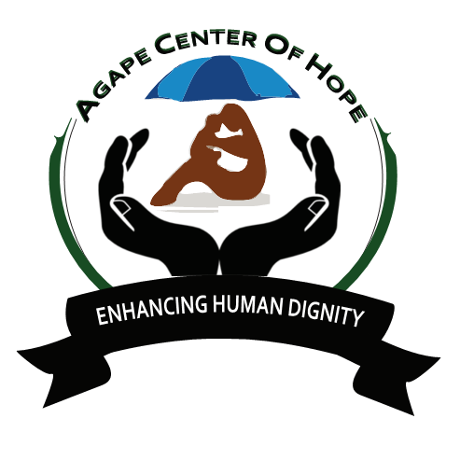

ACoH: MLTV01/2 - MAMA NGINA ORPHANAGE HOME KISUMU
Back Ground
EDUCATION/PHYSICAL PROGRAM FOR CHILDREN
This project is organized in support of Children's Rehabilitation Home in Kisumu Town. The home was established in 2002 with the aim to rehabilitate 38 destitute children. With support of local churches, individuals, donors and organizations, the project has continued to pursue its objectives of providing parental care, quality education and health services to orphans and vulnerable children.

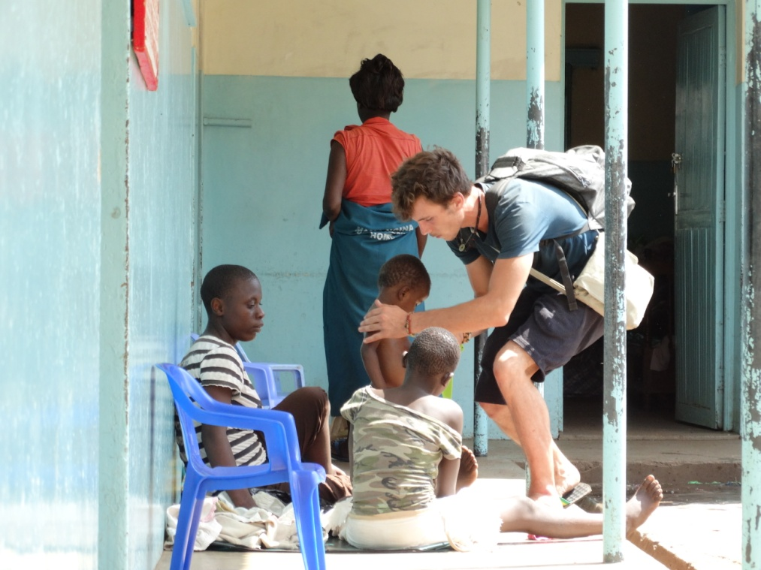

Since its inception, the home has experienced remarkable growth and is currently supporting 120 children. Children in the home are provided not only with food and shelter, but also with significant emotional and spiritual support, education and guidance. We need motivated volunteers to assist in the primary school and in the orphanage.

ESSENTIAL DUTIES AND RESPONSIBILITIES
The volunteers will work with the children, teaching English, Math, Social Science, singing, drawing and making crafts, helping them with their homework, and counseling.
The volunteers will work 5 hours in the morning and 2 hours in the afternoon. Saturday and Sunday are free. Sometimes, depending on the nature of work, the time can be extended. Teaching English (1-2 hours a day) to children. Organizing games, drawing, singing, dancing, and other creative education and extracurricular activities. Taking kids on Playgrounds. Helping kids to do homework, monitor academic progress, and make sure kids complete their homework. Sanitation (helping kids in brushing teeth, shower, and personal hygiene).Child care services for orphans who cannot go to school. Help kids to dress up and reach school safely. Help with administration, running errands etc. Help in other activities or programs designed for kids.
Day 1: Arrival and pick up from the Jomo Kenyatta International Airport, in Nairobi, Kenya and transfer to host family home or hostel.

Day 2: Morning: registration and start of orientation. About 4 hours lecture at the home of your host. Topics covered during orientation lecture will include East African culture, history, customs, politics, geography, and necessary health precautions, and various other topics, such as the diversity of Kenyan life. Afternoon is free for exploring rural Kenyan life and getting to know your host family.

Leisure activities: Visit to Lake Victoria, cultural exchange, excursions. Language: English Duration of the project: 1 to 6 months. The program is running throughout the year. Orientation: Orientation meeting will take place in Nairobi before proceeding to the project. Accommodation: Accommodation is provided in the orphanage, or host family. There is electricity and shower at the accommodation. Location: Kisumu county, kikuyu market close to Kisumu town. Approximately 6hrs drive from Nairobi. The closest Hospital and Market is 5 minutes’ walk; Post Office, Banks (ATMs), Internet and other social facilities are located in Kisumu Town Age range: 18 and over Participation fee: 900 Euros for 3 months

