Moi Avenue, Magereza Chambers.
P.O BOX 361-00202 Nairobi
mohammedagapesaid@gmail.com
infoagapecentreofhop@gmail.com
mohammedagapesaid@gmail.com
+254702818338
ACoH INTERNATIONAL MID AND LONG TERM PROJECT 2019
Long Term Projects are specifically designed to give volunteers an opportunity to develop and promote their skills and services and in the process serving and promoting the development of the hosting community structures.

THESE PROJECTS LAST FOR A PERIOD OF 1-12 MONTHS.
ACoH: MLTV01/1-AMALEMBA PRIMARY SCHOOL
Back Ground Amalemba Primary School is located in Lurambi constituency in Bukhungu. The school is part of the Kakamega district in the Western province of Kenya. Amalemba Primary School is a Mixed Day Only school. The school is sponsored by A Religious Organization. The School Institution Type is classified as – Ordinary. This Primary School in Kenya has an enrollment of 592 with a student teacher ratio of 34.8 and this means there is 37 pupils per classroom in 16 classrooms. There are a total of 17 Government of Kenya Teachers at this school.
ESSENTIAL DUTIES AND RESPONSIBILITIES
Assisting teaching in daily classes, also help in office work, physical education, Creative Activities, Language Arts, Oral Reading & Writing, Science/Agriculture and Nature study,Hand-Writing,Physical Education, Teach English l,Develope Lesson plans, Use and share own teaching methodologies, Coordinate with local teachers, Help them develop conversational skills in English, Learning about different cultures at close quarters,
Day 1: Arrival and pick up from the Jomo Kenyatta International Airport, in Nairobi, Kenya and transfer to host family home or hostel.
Day 2: Morning: registration and start of orientation. About 4 hours lecture at the home of your host. Topics covered during orientation lecture will include East African culture, history, customs, politics, geography, and necessary health precautions, and various other topics, such as the diversity of Kenyan life. Afternoon is free for exploring rural Kenyan life and getting to know your host family.
Leisure activities: Visit to Lake Victoria, cultural exchange, excursions, Kakamega forest for sunrise, sunset, crying stone,dunga hill camp in Kisumu for sun set, kit mikai,rusinga island. Language: English also you can learn local languages. Duration of the project: 1 to 6 months. The program is running throughout the year. Orientation: Orientation meeting will take place in Nairobi before proceeding to the project. Accommodation: Accommodation is provided in the host family. There is electricity and tap water at the accommodation. Location: Kakamega county, Kakamega town Western Kenya. (ATMs), Internet and other social facilities are located in Kakamega Town Age range: 18 and over Participation fee: 900 Euros for 3 months

ACoH: MLTV01/2 - MAMA NGINA ORPHANAGE HOME KISUMU
Back Ground
EDUCATION/PHYSICAL PROGRAM FOR CHILDREN
This project is organized in support of Children's Rehabilitation Home in Kisumu Town. The home was established in 2002 with the aim to rehabilitate 38 destitute children. With support of local churches, individuals, donors and organizations, the project has continued to pursue its objectives of providing parental care, quality education and health services to orphans and vulnerable children. Since its inception, the home has experienced remarkable growth and is currently supporting 120 children. Children in the home are provided not only with food and shelter, but also with significant emotional and spiritual support, education and guidance. We need motivated volunteers to assist in the primary school and in the orphanage.

ESSENTIAL DUTIES AND RESPONSIBILITIES
The volunteers will work with the children, teaching English, Math, Social Science, singing, drawing and making crafts, helping them with their homework, and counseling.
The volunteers will work 5 hours in the morning and 2 hours in the afternoon. Saturday and Sunday are free. Sometimes, depending on the nature of work, the time can be extended. Teaching English (1-2 hours a day) to children. Organizing games, drawing, singing, dancing, and other creative education and extracurricular activities. Taking kids on Playgrounds. Helping kids to do homework, monitor academic progress, and make sure kids complete their homework. Sanitation (helping kids in brushing teeth, shower, and personal hygiene).Child care services for orphans who cannot go to school. Help kids to dress up and reach school safely. Help with administration, running errands etc. Help in other activities or programs designed for kids.
Day 1: Arrival and pick up from the Jomo Kenyatta International Airport, in Nairobi, Kenya and transfer to host family home or hostel.
Day 2: Morning: registration and start of orientation. About 4 hours lecture at the home of your host. Topics covered during orientation lecture will include East African culture, history, customs, politics, geography, and necessary health precautions, and various other topics, such as the diversity of Kenyan life. Afternoon is free for exploring rural Kenyan life and getting to know your host family.
Leisure activities: Visit to Lake Victoria, cultural exchange, excursions. Language: English Duration of the project: 1 to 6 months. The program is running throughout the year. Orientation: Orientation meeting will take place in Nairobi before proceeding to the project. Accommodation: Accommodation is provided in the orphanage, or host family. There is electricity and shower at the accommodation. Location: Kisumu county, kikuyu market close to Kisumu town. Approximately 6hrs drive from Nairobi. The closest Hospital and Market is 5 minutes’ walk; Post Office, Banks (ATMs), Internet and other social facilities are located in Kisumu Town Age range: 18 and over Participation fee: 900 Euros for 3 months

ACoH:MLTV01/3-WERNAR TALENT ACCADEMY
BACKGROUND Werner Talents Academy is a private primary school that was established in the year 2013 and first opened on 7th January the year 2013.It is located in Western province, Kakamega County, Butere district Marama central location. Through support, the school provides day care, primary level education for pre-primary classes, Class and lunch feeding programme, it has 2 paid cooks and 10 teachers the school targets at different objectives, mainly the child being the main beneficiary and the community around. The main objectives of the school was to reach most people who are not able and need everyone in the community at least to give the children knowledge and feel comfortable like others To ensure that the child receives quality
Education and skills that will give the child.
A strong foundation enabling him/her to pursue the rest of the Education channel without a struggle.
To promote and build talents of our pupils in order to use them accordingly and realize their full potential and influence in the society around them.
To create a fair platform for competition among children from diverse backgrounds and compete with their colleagues worldwide.
Ensure that the society around benefits a lot i.e. employment opportunities to trained personnel as teachers among others
ESSENTIAL DUTIES AND RESPONSIBILITIES The main activity in our school is teaching and learning. Apart from that, pupils are trained on improving their talents in games and various fields. A minor activity of farming goes on the school shamba.Construction of a three door classroom for Early Childhood Education is in progress, teaching English in classes, painting, making breaks for construction, land scaping, Develop Lesson plans, Use and share own teaching methodologies, Coordinate with local teachers, Help them develop conversational skills in English, Learning about different cultures at close quarters,
Day 1: Arrival and pick up from the Jomo Kenyatta International Airport, in Nairobi, Kenya and transfer to host family home or hostel.
Day 2: Morning: registration and start of orientation. About 4 hours lecture at the home of your host. Topics covered during orientation lecture will include East African culture, history, customs, politics, geography, and necessary health precautions, and various other topics, such as the diversity of Kenyan life. Afternoon is free for exploring rural Kenyan life and getting to know your host family.
Language: English and ready to learn local language, also community will learn your language too. Duration of the project: 1 to 6 months. The program is running throughout the year. Orientation: Orientation meeting will take place in Nairobi before proceeding to the project. Accommodation: Accommodation to the host family or in school dormitories, electricity, tap water available.
Location: Kakamega county, Butere District Western Kenya Age range: 18 and over Participation fee: 900 Euros for 3 months
ACoH: MLT01/4 NYALI PRIMARY SCHOOL EDUCATION
Back Ground The school was founded as a result of the First World War which came nearest to the coastal strip making Mombasa a base of military activities. As a result there was over-crowding and shortage of housing and on the other hand a very large increase of military service traffic, etc, making the children’s lives more precarious. Many mothers became engaged on part time or full time war work and had to think of Nursery School to take care of the children while they were at work. Thus the Parents’ Club may have been an outcome of the war; but it is an outcome that has now come to stay. The school has three streams per class and the enrolment currently stands at 960 pupils.

ESSENTIAL DUTIES AND RESPONSIBILITIES
The volunteers will be mostly needed in teaching: also French teacher is needed
English, All 8.4.4 subjects, Creative Activities, Language Arts, Oral Reading & Writing, Science/Agriculture and Nature study,Hand-Writing,Physical Education, Swimming as a Lesson all classes from PG to std eight, French as a subject from std one to eight, Computer from KG2 to std eight, Teach English at local school, Home stay, Develop Lesson plans, Use and share own teaching methodologies, Coordinate with local teachers, Help them develop conversational skills in English, Learning about different cultures at close quarters.
Extra Curricular Activities The basic curriculum is extended and enriched by:-
- School field trips, Art & Craft, Swimming Competitions, Drama to National Level,Scouting,Traditional Dances, Keep Fit, Home Craft
To encourage competition in the co-curricular activities, children have been divided into four different houses namely Chui, Simba, Nyati and Kifaru.
Day 1: Arrival and pick up from the Jomo Kenyatta International Airport, in Nairobi, Kenya and transfer to host family home or hostel.
Day 2: Morning: registration and start of orientation. About 4 hours lecture at the home of your host. Topics covered during orientation lecture will include East African culture, history, customs, politics, geography, and necessary health precautions, and various other topics, such as the diversity of Kenyan life. Afternoon is free for exploring rural Kenyan life and getting to know your host family.
Language: English Duration of the project: 1 to 6 months. The program is running throughout the year. Orientation: Orientation meeting will take place in Nairobi before proceeding to the project. Accommodation: Accommodation to the host family or in school, electricity, tap water. Location: Mombasa county, Nyali sub-county, coast province Kenya Age range: 18 and over Participation fee: 900 Euros for 3 months
ACoH: MLTV02/1 KYENI COMMUNITY PEACE INITIATIVE
Back Ground Kyeni Community peace Initiative is a community Based project and Its Vision is a sharp focus on community peace, development and sustainable livelihood. The mission is to involve all the community members’ to an understanding of togetherness, teaming up and peaceful approach to settling matters of land sharing disputes in their respective capacities.
Our core values are to practice traditional value of hard work, integrity, efficiency and fairness for the advancement and promotion of environmental, education and community development. We are not combating global warming through environmental approach and community campaigns.
ESSENTIAL DUTIES AND RESPONSIBILITIES
Working and interacting with community environmental groups, teaching, playing, socializing with children at Kyeni primary school, campaigning for peace at churches, chief’s barazas and other public institutions on settling matters of land sharing disputes, working and interacting with locals at a local health center, working at the Kyeni community tree nursery, participating in planting of trees along the Kyeni river banks to help conserve water catchment zones. Organizing games with the local youth sports teams. Discussions on global warming and climate change and how to approach peace in handling daily life with the nearby Kyeni day High school students and teachers.
Other activities:-
- Plants trees to revive the dwindling Kyeni community tree project
- field trips, camps, after-work programs, and public programs
- Routine tree nursery maintenance
- Volunteers will plant trees, collect garbage, and clean the area.(where and when necessary)
- provision of seedlings and seeds for planting in numerous public and private institutions
- Protect Water and encroached catchment’s areas.
- Suitable Environmental Utilization & sustainable energy alternatives.
- Engaging community members and leaders

LEISURE TIME Most of our free time will be spent sharing culture and friendship with local community members and the other volunteers on the project, teachers, children, visiting places as planned with volunteers and the camp team leader. There will be an opportunity to visit a local market, attend church, play soccer and participate in other community activities.
There will be travelling to Historical sites, pre-historical sites, touristic sites, environmental conservation areas and so on. This will be done with the interested volunteers at their expense.
Day 1: Arrival and pick up from the Jomo Kenyatta International Airport, in Nairobi, Kenya and transfer to host family home or hostel.
Day 2: Morning: registration and start of orientation. About 4 hours lecture at the home of your host. Topics covered during orientation lecture will include East African culture, history, customs, politics, geography, and necessary health precautions, and various other topics, such as the diversity of Kenyan life. Afternoon is free for exploring rural Kenyan life and getting to know your host family.
Language: English Duration of the project: 1 to 6 months. The program is running throughout the year. Orientation: Orientation meeting will take place in Nairobi before proceeding to the project. Accommodation: Accommodation to the host family, no electricity but solar power, tap water Location: Kyeni, Kitui County, eastern Kenya
Age range: 18 and over Participation fee: 900 Euros for 3 months

ACoH: MLTV02/2 GELI COMMUNITY ACADEMY
History and Background
Geli Community Academy orphans project was started in the year 2015.We started by donating clothes, food and uniforms to poor orphans in Kisumu Mowlem Community.

In the year 2016 we had supported about 30 children to get clothes, uniforms books and food. in the year 2017 we managed to receive school supplies to all our orphans donated by a school in Poland through Agape centre of Hope (ACoH)

In the year 2018 we have managed to open a new school which is Geli Community Academy
Aiming at providing quality affordable education to all our poor orphans within Mowlem Community. We have 4 volunteers e.g teachers,Director,cook and Cleaner right now we have a total of 38 orphans 8 learning in our school and 30 in other schools.

VISION
Our Vision for the orphan’s project is to provide quality affordable education to all orphans and vulnerable children within Mowlem Community.

MISSION
To ensure that all children get quality education food protection
To produce better leaders in the community
To change life of all orphanage

OBJECTIVE
Provision of quality service to the community
A society where all orphans and vulnerable children are educated.

ESSENTIAL DUTIES AND RESPONSIBILITIES
Placing 38 orphans to in the morning and pick them after school
Teaching
Ball Games and physical education
Feeding program, breakfast and lunch.
Home Visitation
Singing/Dancing and poems tales.
Washing utensils and home visits.

Day 1: Arrival and pick up from the Jomo Kenyatta International Airport, in Nairobi, Kenya and transfer to host family home or hostel.
Day 2: Morning: registration and start of orientation. About 4 hours lecture at the home of your host. Topics covered during orientation lecture will include East African culture, history, customs, politics, geography, and necessary health precautions, and various other topics, such as the diversity of Kenyan life. Afternoon is free for exploring rural Kenyan life and getting to know your host family.
Duration of the project: 1 to 6 months. The program is running January-June and July- December.
Orientation: Orientation meeting will take place in Nairobi before proceeding to the project.
Accommodation: Accommodation is provided in the hostel in the orphanage or host family, tap water and electricity available.
Location. Kisumu County, Mowlem.
Leisure time: Excursions at Kakamega Tropical Rain forest for beautiful sunrise and sun set, Lake Victoria for boat ride, hippo point and bird watch in Kisumu, visit kit mikai, crying stone.
Age range: 18 and over
Participation fee: 900 Euros for 3 months

ACoH: MLTV02/3 VIREMBE COMMUNITY NURSING HOME
Back Ground
Virembe Community Nursing home opened its doors for clients in 2012 by team of volunteers from Denmark as a community hospital dedicated to achieving excellence in: patient care; education of health professionals; health research and HIV treatment, care and support. As a progressive health care provider, we offer very high quality health services both in-patient and out-patient 24 hrs daily with our objectives being provision of affordable, high quality, medical and customer care services to all the members of the community.

ESSENTIAL DUTIES AND RESPONSIBILITIES
Volunteer will be working and engage in different target groups within the communities explaining to the community how T.B is a social problem; it is not just for those who are ill. Volunteer will be working with local medical doctors and support the health delivery system and will be attending to TB patients HIV/AIDs, giving drugs and recording, booking patients.
Volunteer also will be engaged on jiggers program to school and community, supporting OVCS, helping in the ward.
Attending to pregnant mother clinic/family planning, giving children injections and weighing and Laboratory services.
Volunteers will have an opportunity to work directly with the rural community and HIV/Aids patients to raise awareness of counseling and testing services, availability of ART and opportunistic infection while prioritizing prevention education especially among those who have benefited from ART and sex workers. The volunteer will also assist the AIDS patients through home based care and nutritional counseling. It will also assist educating/ training in model farms to increase food sustainability, Assist doctors, Nurses and medical staffs, Assist doctors Examine and treat the patients, Treat minor injuries, Volunteers can also participate in hospital programs like record keeping, Educate patients on the importance of sanitation, nutrition, etc.
LEISURE TIME
Most of our free time will be spent sharing Luhya culture with local community members and the other volunteers on the project. There will be an opportunity to visit the Lake Victoria for a boat ride, hippo search, and bird watching and visit Dunga hill camp for sunset. Visit Rusinga Island in south nyanza Kisumu, Kakamega forest for sunrise sunset and nature walk.
Day 1: Arrival and pick up from the Jomo Kenyatta International Airport, in Nairobi, Kenya and transfer to host family home or hostel.
Day 2: Morning: registration and start of orientation. About 4 hours lecture at the home of your host. Topics covered during orientation lecture will include East African culture, history, customs, politics, geography, and necessary health precautions, and various other topics, such as the diversity of Kenyan life. Afternoon is free for exploring rural Kenyan life and getting to know your host family.
Language: English Duration of the project: 1 to 6 months. The program is running throughout the year. Orientation: Orientation meeting will take place in Nairobi before proceeding to the project. Accommodation: Accommodation to the host family, electricity, tap water Location: Kakamega county, shinyalu sub-county, western Kenya Age range: 18 and over Participation fee: 900 Euros for 3 months

ACoH: MLTV02/4-SAUTI KUU FOUNDATION
Back Ground
Sauti Kuu’s goal is to create a platform for disadvantaged children and young people worldwide that allows them to uncover their strengths and realize their full potential to live independent successful lives.
Our aim is to help children and young people, in particular those from rural communities and urban slums, to discover the strength of their own voices and the power they have to positively change their lives.
We work together with them and their families to develop sustainable socio-economic structures that will guarantee financial independence. We support and assist the children and young people to actively participate in the development of their communities. Most importantly, we help them and their families utilize locally available resources to improve their living conditions. In the process we make sure that the children and young people realize that they do not have to be victims of their social backgrounds or their environments.
The core work of Sauti Kuu is to bring sustainable economic development to the region in which it operates. This is done by working with the families of its beneficiaries, who are mainly smallholder farmers, to find ways to use affordable local resources to improve their financial situations leading to economic independence. This includes training in financial literacy, environmental management, improved agricultural techniques (via a SKF demonstration garden), crop diversity, animal husbandry, and water storage and management, among others.
For training purposes Sauti Kuu has built, with the help of partners, a biogas system for domestic cooking purposes, maintains a greenhouse, goats, and has created a demonstration garden to show farmers what they can grow in the region, both for domestic consumption and for profit.
ESSENTIAL DUTIES AND RESPONSIBILITIES Sauti Kuu helps children and teens improve their social skills, in the process acquiring social behavior that shapes their character while strengthening their self-confidence and self-esteem. A focus is on combating the victim mentality that prevails among disadvantaged children, adolescents and their families. The aim is to impart a sense of responsibility that places those affected in a position to become part of the decision-making process that determines their future.
One of the first activities of the Sauti Kuu Foundation was to hold a workshop in which teens from rural Alego (in western Kenya) discussed strategies and ways in which the Foundation could bring a positive inspiration to their lives.
This was a brainstorming session around topics such as young people’s potential and the contribution they can make on behalf of the community. The main focus of the workshop was to develop an action plan for Sauti Kuu that can help young people to gain economic independence for themselves while doing something to benefit their communities at the same time.
The teens worked out the following topics over the course of the discussion:
- promoting self-realization and individual responsibility
- opportunities to encourage education and create jobs
- environmental protection and environmental management
- promotion of peer learning (in which young people are taught by young instructors) on topics of health and HIV/AIDS education, nutrition counseling, sexual behavior and relationships
- promotion of one’s own culture
- Environmental management
- Accounting
- Finance
- Entrepreneurship
- Financing management, career counseling and support
- Social entrepreneurship, Motorcycling/driving lessons
Day 1: Arrival and pick up from the Jomo Kenyatta International Airport, in Nairobi, Kenya and transfer to host family home or hostel.
Day 2: Morning: registration and start of orientation. About 4 hours lecture at the home of your host. Topics covered during orientation lecture will include East African culture, history, customs, politics, geography, and necessary health precautions, and various other topics, such as the diversity of Kenyan life. Afternoon is free for exploring rural Kenyan life and getting to know your host family.
Duration of the project: 1 to 6 months. The program is running January-June and July- December.
Orientation: Orientation meeting will take place in ACoH office before proceeding to the project.
Accommodation: Accommodation is provided in the hostel in the host family or at the foundation hostels, tap water and electricity available.
Location: Siaya County, Alego.
Leisure time: Excursions at Impala Park, Kisumu museum, Rusinga Highland, Lake Victoria for Boat Ride, Bird Watch.
Age range: 18 and over
Participation fee: 900 Euros for 3 months

ACoH: MLTV03/1 CHIDREN OF MERCY ORPHANAGE PROJECT DESCRIPTION
Child of Mercy Orphanage Centre (COMOC) was formed in 2010 and is situated within a half-acre walled plot close to Shelly Beach, and a five minute walk from the Likoni slum area south of Mombasa. It is home to 23 children – both boys and girls from ages 5-15 years. Before getting here the children had lives without any prospects: They are orphans without a family, neglected and abandoned children who lived on the street or from poor families who could not afford to take care of the children.
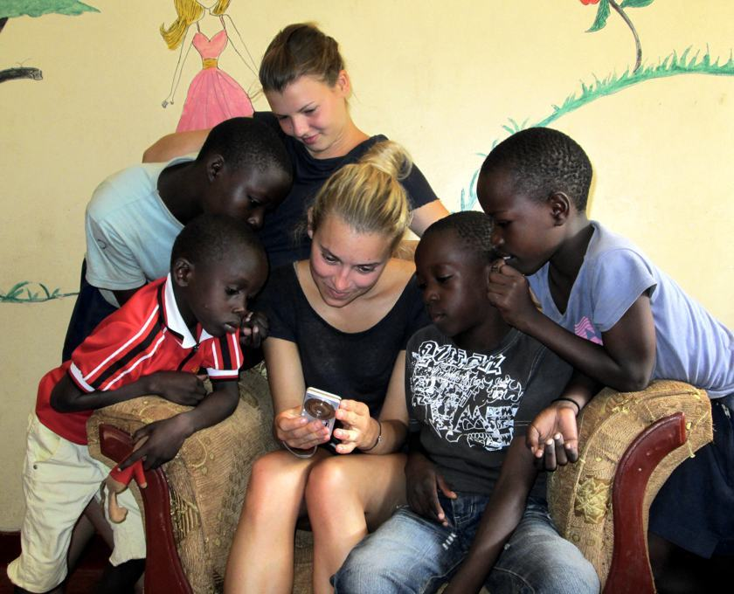
Child of Mercy Orphanage Centre is situated close to Shelly Beach and a five minute walk from the Likoni slum area south of Mombasa across the Likoni Ferry. It is 10 minutes from Timbwani Nursery and Primary School and about half an hour to the large supermarket back across the ferry in Mombasa. The house is set within a half-acre walled plot with poultry area, veg plot and space to play games with the children.
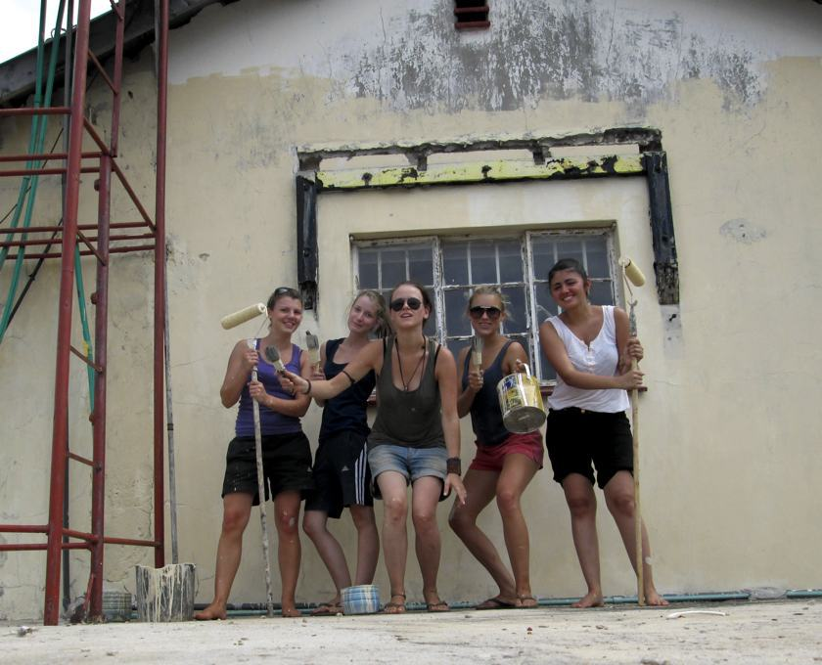
ESSENTIAL DUTIES AND RESPONSIBILITIES As a volunteer you could help us take care of the children during their free time, helping them with their homework and playing games with them.
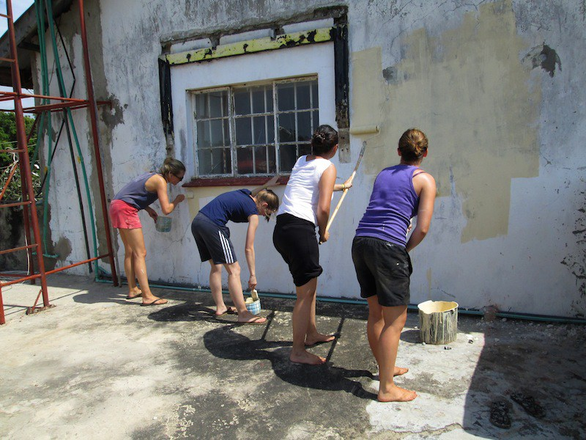
Your work may also include preparing food for the children, general cleaning and washing or even helping in the Primary and Nursery Schools.
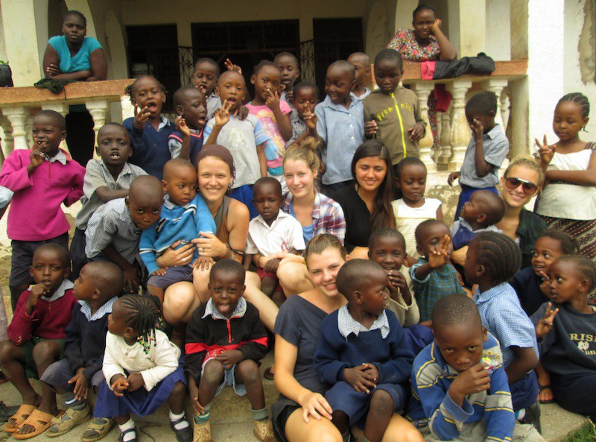
We are very happy if you are willing to organize games and activities for the children, drawing and painting or reading to them. On Sundays you could also join them going to church or take them to the beach and go swimming.
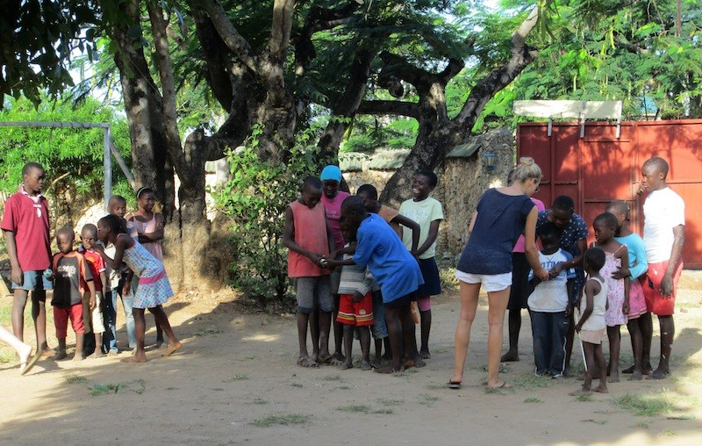
If you are interested you may also create your own activities with the children. Any ideas are welcomed and you may have specific skills that you can offer
LANGUAGE- English is the official language of the work camp
Day 1: Arrival and pick up from the Jomo Kenyatta International Airport, in Nairobi, Kenya and transfer to host family home or hostel.
Day 2: Morning: registration and start of orientation. About 4 hours lecture at the home of your host. Topics covered during orientation lecture will include East African culture, history, customs, politics, geography, and necessary health precautions, and various other topics, such as the diversity of Kenyan life. Afternoon is free for exploring rural Kenyan life and getting to know your host family.
Duration of the project: 1 to 6 months. The program is running January-June and July- December.
Orientation: Orientation meeting will take place in Nairobi before proceeding to the project.
ACCOMMODATION AND FOOD By staying in the same house with the children, volunteers are completely integrated in their lives. As a volunteer you will stay upstairs on the first floor, so you have your own area with separated rooms, shower, flush-toilet, lounge area with balcony and kitchenette with hob and fridge.
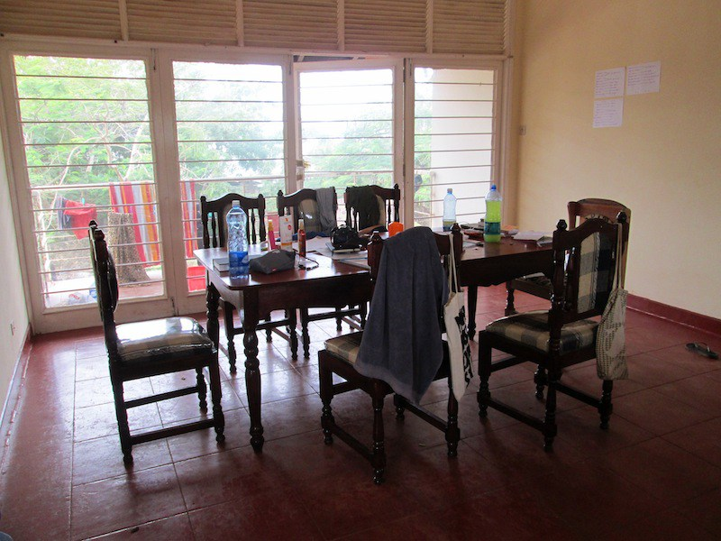
All meals are provided but you can also self-cater upstairs if you like.
Location: Mombasa County, Likoni Shelly beach Coastal Kenya.
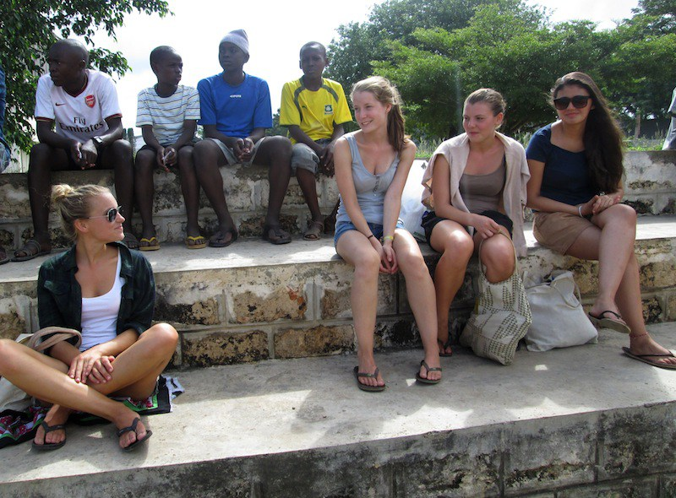
LEISURE ACTIVITY
There will be an opportunity to visit a local market, visit Vasco Da gama, Diani Beach, Fort Jesus, Old Town,Tiwi beach,Malindi, and many other things in mombasa,hippo point in Kisumu, and visit the islands in Kisumu, Impala Park. And many other historical place around the country.
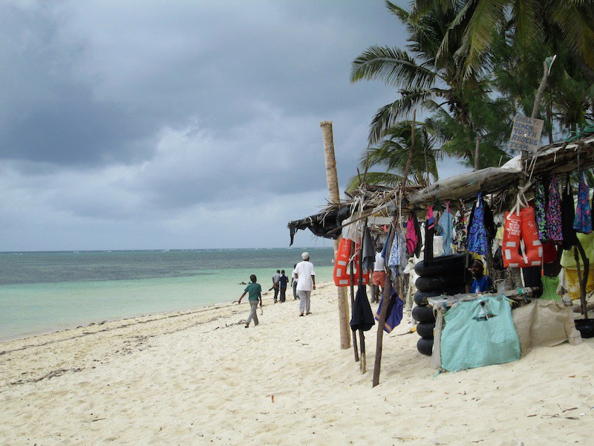
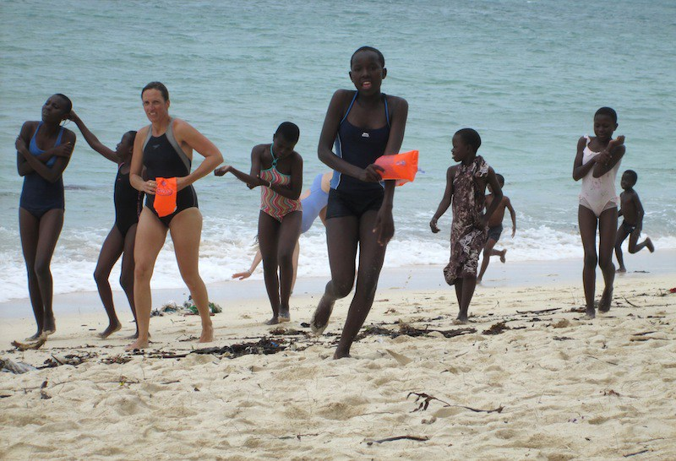
Age range: 18 and over
Participation fee: 950 Euros for 3 months
ACoH: MLTV03/2-ST’MARY’S HIGH SCHOOL
Back Ground
St Mary’s Girls high school Mumias is a girl’s boarding school found in Kenya located in Kakamega County among 47 counties in Kenya. It is located along Kakamega – Mumias highway. The school has a population of 889 students with 38 teachers and 26 support staff. The school is divided into 4 streams per class that is North, east, south, and west. It has got a maximum of 17 classes with one large building referred to as “Gorofa” divided to 10 rooms (classes, computer lab, and laboratory, etc.)
St. Mary’s Mumias Girls was started in 1973 as a harambee school under the sponsorship of catholic diocese of
Kakamega. It was started as a boarding school with a population of 23 girls who shared their facilities with St. Ann’s Primary School.

ESSENTIAL DUTIES AND RESPONSIBILITIES The volunteers will be engaged mostly in teaching lessons and also computer studies, Teach English , French,Germany,physical education, environmental education, also construction of the school new dining hall. Teach English at local school, Home stay, Develop Lesson plans, Use and share own teaching methodologies, coordinate with local teachers, help them develop conversational skills in English, Learning about different cultures at close quarters.
Day 1: Arrival and pick up from the Jomo Kenyatta International Airport, in Nairobi, Kenya and transfer to host family home or hostel.
Day 2: Morning: registration and start of orientation. About 4 hours lecture at the home of your host. Topics covered during orientation lecture will include East African culture, history, customs, politics, geography, and necessary health precautions, and various other topics, such as the diversity of Kenyan life. Afternoon is free for exploring rural Kenyan life and getting to know your host family.
Duration of the project: 1 to 6 months. The program is running January-June and July- December.
Orientation: Orientation meeting will take place in Nairobi before proceeding to the project.
Accommodation: Accommodation is provided in the hostel or host family, tap water and electricity available.
Location. Kakamega County, mumias sub- county, western Kenya.
Leisure time: Excursions at Kakamega Tropical Rain forest for beautiful sunrise and sun set, Lake Victoria for boat ride, hippo point and bird watch in Kisumu, visit kit mikai, crying stone.
Age range: 18 and over
Participation fee: 900 Euros for 3 months.

ACoH: MLTV03/3 JOSANA DAY CARE SCHOOL
Back Ground
Josana day school was started as a community school in a rental premises in the year 1999 as a simple baby care. Over the years the school population has been increasing due to relentless efforts of the teachers, management and community at large
Josana offers the 844 educational system as it is provided by the Ministry of Education science and Technology MoEST with class eight pupils sitting the Kenya corticated of primary education KCPE at the end of the primary cycle
Josana has consistently produced best pupils as is evidenced by the performance in the Kenya national exams
The school is also committed to ensuring that all students are well-rounded through co-curriculum activities which include
Currently the population data is standing at seven hundred and fifty one
JUSTIFICATION
There is need of education and better learning conditions in Dandora where Josana is located
Most of the children in this area face difficulties in accessing education because of the few strained resources and lack of support from their parents
The school is looking for ways to support and help these needy pupils using the few resources available by identifying projects that will basically respond to basic need of education for needy children and their caregivers
Its vision is to reconstitute nurture and sustain orphans needy children and care givers to have a normal life in the society this is based on the mandate that being a needy child reduces the child capability and makes them not to take part in community decision making culminating strong and energetic members in the society
The potential and latent of orphaned children can still be utilized for common good if only they are given education to participate in decision making
ESSENTIAL DUTIES AND RESPONSIBILITIES
Volunteers assist with projects that aim to encourage youth from disadvantaged communities to further their education and personal development. In addition to promoting the importance of education, individuals may be also be encouraged to undertake vocational training where they are able to gain key job skills. Volunteers may create social workshops or run specific skills-based workshops such as language classes, computing, sports, drama or music. Extra activities: helping the children With their homework, washing the kids, their clothe, helping in office work, Jiggers programme mostly field work and visiting school and children affected,cooking,and giving food to small kids.
Teaching English (1-2 hours a day) to children, Organizing games, drawing, singing, dancing, and other creative education and extracurricular activities, Taking kids on Playgrounds, Helping kids to do homework, monitor academic progress, and make sure kids complete their homework, Sanitation (helping kids in brushing teeth, shower, and personal hygiene),Child care services for orphans who cannot go to school, Help kids to dress up and reach school safely, Help with administration, running errands etc, Help in other activities or programs designed for kids.
Day 1: Arrival and pick up from the Jomo Kenyatta International Airport, in Nairobi, Kenya and transfer to host family home or hostel.
Day 2: Morning: registration and start of orientation. About 4 hours lecture at the home of your host. Topics covered during orientation lecture will include East African culture, history, customs, politics, geography, and necessary health precautions, and various other topics, such as the diversity of Kenyan life. Afternoon is free for exploring rural Kenyan life and getting to know your host family.
Duration of the project: 1 to 6 months. The program is running January-June and July- December.
Orientation: Orientation meeting will take place in Nairobi before proceeding to the project.
Accommodation: Accommodation is provided in the hostel in the orphanage, tap water and electricity are available.
Location: Nairobi County, Dandora Slum.
Leisure time: Excursions at Giraffe Center, Nairobi National Park, gong Hills, Maasai Mara National Reserve etc
Age range: 18 and over
Participation fee: 900 Euros for 3 months

ACoH: MLTV03/4AHERO MEDICAL CENTRE.
Back Ground Ahero Medical Centre is a privately owned medical clinic located in Kakmie sub location, (Situated along Ahero/Kisii highway, 200m from the junction) Onjiko location, Nyando division, Nyando Constituency in Kisumu County. The medical clinic has 26 beds, opens on weekends, and operates 24 Hours a day, no special services currently listed under this facility. The facility was operational as of October 2015.

ESSENTIAL DUTIES AND RESPONSIBILITIES Help clients get intra-natal and family planning services at , contraceptive methods (LAPMs)Volunteer will attend to outpatient and also help in the wards, improving the access to long acting methods of family planning at the facility among other reproductive health services, guiding and cancelling, HIV& AIDs sensitization. Assist doctors, Nurses and medical staffs, Assist doctors Examine and treat the patients, Treat minor injuries, Volunteers can also participate in hospital programs like record keeping, Educate patients on the importance of sanitation, nutrition, etc.
Day 1: Arrival and pick up from the Jomo Kenyatta International Airport, in Nairobi, Kenya and transfer to host family home or hostel.
Day 2: Morning: registration and start of orientation. About 4 hours lecture at the home of your host. Topics covered during orientation lecture will include East African culture, history, customs, politics, geography, and necessary health precautions, and various other topics, such as the diversity of Kenyan life. Afternoon is free for exploring rural Kenyan life and getting to know your host family.

Language: English
Duration of the project: 1 to 6 months. The program is running throughout the year.
Orientation: Orientation meeting will take place in Nairobi before proceeding to the project.
Accommodation: volunteer will be hosted in the hosting family electricity and tap water available
Location: Kisumu County, A hero sub-county, Nyando constituency
Age range: 18 and over
Participation fee: 900 Euros for 3 months.

ACoH: MLTV03/5 OLOISUKUT WILLD LIFE CONSERVANCY.
Back Ground
The oloisukut Conservancies offer visitors the ultimate safari: the lowest tourism densities; incredible day and night game viewing; and authentic cultural interactions. But above all, these Conservancies are managed according to a model that protects the delicate eco-system and benefits the landowners themselves – the Maasai people.
The oloisukut Conservancy in Kenya is home to the big cats situated on the malarienda most point of the Greater Mara Ecosystem; oloisukut borders the Olchorro Oiroua Conservancy to the south, and MMNC to the East. The important focus of the conservancy is livestock improvement through innovative cattle management programs, running alongside novel tourism projects.
The habitat comprises wooded acacia savannah with open plains on flat plateaus, riverine acacia forest and rocky, undulating hills which provide a varied habitat for browsing and grazing ungulates, as well as hideout thickets for the predators. The Mara River runs alongside the conservancy. There is a large number of giraffe and plains game and resident buffalo that live close to the Olerai boundary along the Mara River. Elephants frequent the conservancy and there is a pride of lion that is based on the edge of oloisukut. There are many hippos and crocodiles in the section of river that borders the conservancy and the riverine forests provide an area popular with leopards. Rare species such as Aardvark, Caracal, serval cat and Aardwolf are occasionally found. Colobus monkeys have been spotted in the valleys on the Kileleoni Hill and there have also been sightings of wild dog in Enonkishu. There is no doubt that oloisukut offers an incredible game viewing experience.

ESSENTIAL DUTIES AND RESPONSIBILITIES
- Oloisukut scouts patrol within the conservancy
- Security on conservancy borders and within; day and night
- Data collection
- Monitoring wildlife movement
- Control cattle grazing
- Human movement control
- Ensure upkeep of the conservancy
Treatment and rescue of orphaned wild animals with collaboration with other stakeholder’s i.e wwf, Mara elephant project, community and others
- Do joint patrol within and outside neighboring Mara conservancy in collaboration with other rangers from neighboring conservancy.

- Safari walks and game drives
- Bird watching
- Educational support i.e. outreach programme to enrich formal education
- Medical outreach services activities
- Research programmes all around fields allowed but information generated may be shared with the conservancy.
- Filming may be done on the conservancy but all rights reserved courtesy of Oloisukut conservancy
Photo shooting on our scenic landscape that include wild animals, siria/oloololo escarpment, beautiful mega rocks hanging on escarpment, very beautiful bushes and forest and our pride the Mara river that borders us with other conservancy.
We showcase the Maasai cultural activities, we have manyattas bomas, our women doing beadwork ,our system of slaughtering and meat eating in places famously known as orpul, maasai dance and so on.
Day 1: Arrival and pick up from the Jomo Kenyatta International Airport, in Nairobi, Kenya and transfer to host family home or hostel.
Day 2: Morning: registration and start of orientation. About 4 hours lecture at the home of your host. Topics covered during orientation lecture will include East African culture, history, customs, politics, geography, and necessary health precautions, and various other topics, such as the diversity of Kenyan life. Afternoon is free for exploring rural Kenyan life and getting to know your host family.

Language: English but also ready to learn Swahili and Maasai.
Duration of the project: 1 to 6 months. The program is running throughout the year.
Orientation: Orientation meeting will take place in Nairobi before proceeding to the project.

Accommodation: volunteer will be hosted in the respective bomas where they live. There will be a solar lamp and water are available

Location: Narok County Maasai Mara National game reserve.
Age range: 18 and over
Participation fee: 900 Euros for 3 months

ACoH: MLTV04/1 MTAA-MEN AND TRADITION AGAINAST AIDS
Background Information Men and traditions against AIDS in Kenya (MTAA) is a male initiative started in the year 2000. It was registered in the year 2002 as a C.B.O then in the year 2012 it was upgraded to an N.G.O status.
MTAA envisions ‘a generation free from HIV infection’ hence is involved in empowering couples and widows with knowledge and skills of mitigating their vulnerability to HIV infection and extreme poverty, through Behavior change Communication (BCC). MTAA’s approach seeks to address retrogressive socio-cultural practices that fuel the spread of HIV infection based on Kenya National Session paper No 4 of 1997.
Vision
A generation free from H.I.V infection
Mission
Empowering older couples, young couples, widows youth and adolescents with knowledge and skills pertaining to the retrogressive cultural practices that involve sexual activities that fuel the spread of HIV infection and other illnesses to mitigate their vulnerability to HIV, other illnesses and extreme poverty through behavior change and communication program.
Goal
To mitigate vulnerability of couples widows and adolescents to H.I.V infection, other illnesses and extreme poverty through Behavior Change and Communications programs.
Core Values
- Integrity
- Honesty
- Love
- Care
Coverage area
MTAA operates in Western Kenya, Kakamega county, Mumias East and West sub-counties
Target Groups
- Couples
- Widows
- Youth
- Adolescents aged 10-24years
ESSENTIAL DUTIES AND RESPONSIBILITIES

Men groups
This group comprises of the first and the second generation men.
women groups
These are mostly spouses to the first and second generation men
Widow groups
These groups comprises of widow whose spouses were mostly in the first and the second generation
Discordant couples’ group
These are couples in which one of the partners is HIV positive and the other one is HIV negative.
Youth couples groups
These groups are comprised of the third generation couples
MTAA BCC PROGRAMS
The main activity that MTAA carries out is behavior change communication program (BCC) in collaboration with the ministry of health and other organizations
Day 1: Arrival and pick up from the Jomo Kenyatta International Airport, in Nairobi, Kenya and transfer to host family home or hostel.
Day 2: Morning: registration and start of orientation. About 4 hours lecture at the home of your host. Topics covered during orientation lecture will include East African culture, history, customs, politics, geography, and necessary health precautions, and various other topics, such as the diversity of Kenyan life. Afternoon is free for exploring rural Kenyan life and getting to know your host family. Duration of the project: 1 to 6 months. The program is running January-June and July- December. Orientation: Orientation meeting will take place in Nairobi before proceeding to the project. Accommodation: Accommodation is provided in the host family, tap water and electricity available. Location: Kakamega County, Mumias Sub-county Shianda. Leisure time: Kisumu, Lake Victoria for boat ride, Kakamega forest for bird watching and sunset.
Age range: 18 and over Participation fee: 900 Euros for 3 months

ACoH: MLTV04/2 – USFW ORPHANAGE CARE CENTER
Back Ground
The Kakamega orphans care center provides a home for children deemed most needy by the USFW woman knows the children in their villages well. The care center was opened in January 2005 and now houses up to 50 children aged 1 to 17years most of whom have lost their parents to Aids, others have been abandoned with their parents, lessfotunes or recovered from street. With house parents.
USFW offers cooperative family environment where children’s receive healthy meals, loving caring, medical attention, and opportunity for accessing education.
The main objective of USFW is to rehabilitate the children and ensure their safety and welfare.

ESSENTIAL DUTIES AND RESPONSIBILITIES The volunteers will be involved in teaching English (1-2 hours a day) to children, Organizing games, drawing, singing, dancing, and other creative education and extracurricular activities, Taking kids on Playgrounds, Helping kids to do homework, monitor academic progress, and make sure kids complete their homework,anitation (helping kids in brushing teeth, shower, and personal hygiene)Child care services for orphans who cannot go to school, Help kids to dress up and reach school safely, Help with administration, running errands etc,Help in other activities or programs designed for kids.
Qualifications: No particular expertise or skills required. Participants should have a
Positive attitude, be ready to adopt and enjoy simple living conditions, be flexible and patient. However, specialized skills and expertise (such as creative arts and counseling/nursing) will be used accordingly. Also a letter from the volunteers government that show that you have never been involve in children trafficking
Day 1: Arrival and pick up from the Jomo Kenyatta International Airport, in Nairobi, Kenya and transfer to host family home or hostel.
Day 2: Morning: registration and start of orientation. About 4 hours lecture at the home of your host. Topics covered during orientation lecture will include East African culture, history, customs, politics, geography, and necessary health precautions, and various other topics, such as the diversity of Kenyan life. Afternoon is free for exploring rural Kenyan life and getting to know your host family.

Language: English
Duration of the project: 1 to 6 months. The program is running throughout the year.
Orientation: Orientation meeting will take place in Nairobi before proceeding to the project.
Accommodation: volunteer will be hosted in the orphanage hostel; electricity and tap water are available
Location: Kakamega County, western Kenya. Close to Kakamega town
Age range: 18 and over
Participation fee: 900 Euros for 3 months

ACoH: MLTV04/3 MAKONGENI YOUTH BUNGE GROUP MOMBASA
Back Ground
The Makongeni youth Bunge group is a non-political and religious registered as a self-help group under the social services department in 2011 found in Kwale County, Msambweni Sub-county Kinondo Ward. The group’s main goal is to empower and engage youth from the community to participate in community development. Currently more than 30 members are connected to the youth group varying in age from years 17 to 35 and with a variety of educational, religious and social backgrounds.
ESSENTIAL DUTIES AND RESPONSIBILITIES
Promoting unity, peace and harmony among the youth and the community at large

- Promoting better quality and quantity of farming production
- Tree Nursserrying, planting, pot filling, weeding and transfer.
- Trainings to the community, environment conservation,water&sanitation
- Full time project monitoring
- Organizing games tournaments involving participants aged fifteen to thirty years within the county
- Market cleaning day, teaching in schools.
Day 1: Arrival and pick up from the Jomo Kenyatta International Airport, in Nairobi Kenya, and transfer to host family home or hostel.
Day 2: Morning: registration and start of orientation. About 4 hours lecture at the home of your host. Topics covered during orientation lecture will include East African culture, history, customs, politics, geography, and necessary health precautions, and various other topics, such as the diversity of Kenyan life. Afternoon is free for exploring rural Kenyan life and getting to know your host family.
Duration of the project: 1 to 6 months. The program is running from January to December.
Orientation: Orientation meeting will take place in Nairobi before proceeding to the project.
Accommodation: Accommodation is provided with a host family. There is place to shower and tap water at the accommodation, and with electricity. Accommodation will be simple
Leisure time: Excursions at Mombasa with a lot of beaches, fort Jesus, Maasai Mara game reserve and visiting touristic destinations around the county.
Location: is located in Coast Province msambweni. Kwale County County.
Age range: 18 and over
Participation fee: 900 Euros for 3 months

ACoH: MLTV04/4-SEKENAN MAASAI DEVELOPMENT PROJECT (SEMADEP)
Back Ground
Is a community based organization project which is owned and managed by the Maasai community living in the sienna location in Mara division just adjacent to the great Maasai Mara Game park.

The project started in 1997 through the effort of church leaders seeking opportunities to address community needs which ranged from a lack of health facilities, poor sanitation, poverty illiteracy, human wildlife conflicts and the increasing HIV/AIDs pandemic.
The main initiative of the project is to build a strong supportive CBO that will care, support and develop programmes of benefits to the entire community.
The project aims to improve the living standards of the sekenani Area Maasai community by narrowing the poverty gaps. it is intended to expand the project to cover the whole of the siana location to meet the needs of 6000 inhabitants living within an approximate 700sq. kms radius.

ESSENTIAL DUTIES AND RESPONSIBILITIES
Teaching in Masai Community schools to impart basic education. Volunteers work in community schools and teach subjects such as English, Maths, General knowledge, Geography and Sciences. The schools in Kenya are open for the following months/terms: January to March, May to July and Sep to Nov. enquire more
Health programs in relation to natural herbs- Masai people in Kenya are highly regarded and a point of interest because of their strong culture. Masai depend on natural curative drugs in treating most diseases. They rarely visit hospitals thus embrace their medicinal herbs while at home. A medical volunteer can grab this special opportunity to work hand in hand with the Masai to further a research work on curative herbs and offer traditional healthcare providers an improvement in their health delivery to efficiently support the modern ones.
FGM- Campaign against Female Genital Mutilation and early forced marriages among girls and keep them in schools. This is a great opportunity for volunteers to participate in girl child programs. Girls are circumcised at puberty (as young as 10 years old). They are kept out of school for 3-4 months, and then married off.
-IGA IDEAS-Sensitize and empower girls and women on sustainable Income Generating Activities for self-reliance. Women are very vulnerable and due to lack of knowledge and cultural pressure (a place of a woman) they cannot explore various sources of income to be self-reliant. They entirely depend on their husbands to bring everything home.
Environmental conservation-. In this program, we promote and conserve our natural environment which a habitat of then the beautiful wild animals, birds, insects just to mention but a few by participating in environmental activities including tree planting, constructing gabions to curb soil erosion among others within Maasai Mara.
-Wildlife conservation- offer volunteer placements in an effort to promote conservation education, awareness and imparting skills to local and international volunteers. Those who join the placement include students and adults who seek a break away from their jobs in pursuit of a change.
Volunteers also have the opportunity to participate in outreach programs including;• Sporting
• Youth mentorship programs in local schools
• Repairs and renovation of schools
• Donating education materials e.g. books, pens etc.
• Home visits and nature walk
• Construction work
Day 1: Arrival and pick up from the Jomo Kenyatta International Airport, in Nairobi, Kenya and transfer to host family home or hostel.
Day 2: Morning: registration and start of orientation. About 4 hours lecture at the home of your host. Topics covered during orientation lecture will include East African culture, history, customs, politics, geography, and necessary health precautions, and various other topics, such as the diversity of Kenyan life. Afternoon is free for exploring rural Kenyan life and getting to know your host family.
Duration of the project: 1 to 6 months. The program is running from January to December.
Orientation: Orientation meeting will take place in Nairobi before proceeding to the project.
Accommodation: Accommodation is provided with a host family. There is shower and tap water at the accommodation, and with electricity.
Leisure time: Excursions at Maasai Mara game reserve and visiting touristic destinations around the county.
Location: is located in Maasai Mara National Reserve. Narok County.
Age range: 18 and over
Participation fee: 900 Euros for 3 months

ACoH: MLTV 05/1 –FORT JESUS WORLD HERITAGE MOMBASA
Back Ground
The Fort, built by the Portuguese in 1593-1596 to the designs of Giovanni Battista Cairati to protect the port of Mombasa, is one of the most outstanding and well preserved examples of 16th Portuguese military fortification and a landmark in the history of this type of construction. The Fort's layout and form reflected the Renaissance ideal that perfect proportions and geometric harmony are to be found in the human body. The property covers an area of 2.36 hectares and includes the fort's moat and immediate surroundings.

ESSENTIAL DUTIES AND RESPONSIBILITIES
Cleaning up the shipwreck in fort Jesus, devising publicity for fort Jesus, holding visitor satisfaction questioner for fort Jesus. Teach English in Primary Schools organize games and drama festivals, attend to visitor. Volunteers will facilitate educational activities with young children in the host community to promote culture, Sensitize the international and local volunteers the local community as well as the concerned authorities around issues related to world Heritage.
Day 1: Arrival and pick up from the Jomo Kenyatta International Airport, in Nairobi, Kenya and transfer to host family home or hostel.
Day 2: Morning: registration and start of orientation. About 4 hours lecture at the home of your host. Topics covered during orientation lecture will include East African culture, history, customs, politics, geography, and necessary health precautions, and various other topics, such as the diversity of Kenyan life. Afternoon is free for exploring rural Kenyan life and getting to know your host family.
Duration of the project: 1 to 6 months. The program is running from January to December.

Orientation: Orientation meeting will take place in Nairobi before proceeding to the project.

Accommodation: Accommodation is provided with a host family. There is shower and tap
Water at the accommodation, and with electricity.

Leisure time: This will provide opportunities for international volunteers to learn/ enjoy local life and exchange with local people, we have quit a number of tourists attractions and site seeing points e.g. fort Jesus, mama Ngina drive, the old town, Mwaluganje elephant sanctuary, shimoni caves, the great Mombasa temples, elephant tusks, Ngomongo village, haller park, Nguuini wildlife sanctuary, falconry bird sanctuary, Akamba curving centre, the great Indian ocean swimming beaches and marine wildlife park having good times on the beach side, enjoy swimming in the white sand beach, pirates beach,diani beach,nyali beach.
Project fee: 900 for three months

ACoH 10: MLTV05/2: SHELTER CHILDREN’S HOME
Back Ground
Shelter is a children's home located just outside of the Ngong Hills at an old Maasai Town approximately 40km from Nairobi and was set up around 12 years ago. The orphanage is home to almost 200 boys and girls from the ages of 2-18 years old.
Over 75% of the children are orphaned from HIV/AIDS with the rest being street children, abandoned, or from destitute families that cannot provide them with the proper care necessary for their upbringing, leaving the children destitute were it not for the existence of Shelter. The orphanage provides the children with a home, food, clothing and an education. Privately run, Shelter receives minimal government funding and survives on the support of a few donors and sponsors. The orphanage works to empower the children and help them recognize the reality of a future through education. The only means by which the children can overcome their devastating past is through the dreams and hope of a future.
ESSENTIAL DUTIES AND RESPONSIBILITIES
Engage the kids in group games such as kho-kho, kabbadi, relay, etc which does not require any big material or play thing to conduct it yet is quite effective. It helps the kids to learn team spirit, taking things supportively (which is the first quality every kid should learn) and learning to trust their peers (which leads to a number of positive things like learning together and learning from each other, handling tough situations by taking help from friends, sharing their emotions without fear and hesitation)

Also you can enact some small skits to show a few important things which may range from small things like how to cross the road, how to be kind and helpful to something big like the ill effects of alcohol and smoking, treating female equally.

Kids are like a beautiful piece of clay and can be molded into things which they learn from elders. So you have to be careful about how you behave, the way you talk, etc because they can mimick people well and that turns into habits often

You can make them enact little stories with moral values, and encourage them to rephrase the dialogues in their own words. This will help them overcome fear of public speaking in addition to learning a few morals
Other activities:-
- Plants trees to revive the dwindling ngong community tree project
- field trips, camps, after-work programs, and public programs
- Precaution to protect Water and encroached catchment’s areas.
- Suitable Environmental Utilization & sustainable energy alternatives.
- Teach the kids, help them with their homework.
- Wash them, feed them, and help in cooking, washing utensils.

Language: English
Duration of the project: 3 to 6-months long program, running from January-June and July- December.
Orientation: Orientation meeting will take place in Nairobi before proceeding to the project.
Accommodation: At the host family. Please note that you will share the typical living conditions of a Kenyan family. There is no electricity and shower at the accommodation, but there is solar power.
Location: Kajiado County, ngong Kenya 1 from Nairobi, The closest Hospital, Markets, Post Office, Banks (ATMs), Internet and other social facilities are located in Ngong Town. The region is cold and cool.
Leisure time:
- sightseeing (beautiful sceneries and terrains)
- Nature walks (and Ngong hills
- Cultural exchange with locals, Nairobi national park, giraffe center and Maasai Mara national reserve
Special requirements: Participants should have a positive attitude, be ready to adopt and enjoy simple living conditions, and be flexible and patient.
Age range: 18 and over
Participation fee: 900 Euros for 3 months

ACoH: MLTV06/1 – MARA HILL PRIMARY SCHOOL
Back Ground
This is a boarding school with 525 pupils aging from 2-18 years old at the heart of a small community about an hour’s drive north of Mara Plains Camp in a stunningly beautiful area. The school was built in part by the Olare Orok Conservancy Trust, and aspires to become ‘a school of excellence’. The school itself is very basic and there is much potential to develop the facilities further. Thanks to the Headmaster, there is noticeable pride in the school by both the community and the children. The school has five classrooms and a pre-school unit.

ESSENTIAL DUTIES AND RESPOSBILLITIES
Environmental conservation- In this program, we promote and conserve our natural environment which a habitat of then the beautiful wild animals, birds, insects just to mention but a few by participating in environmental activities including tree planting, constructing gabions to curb soil erosion among others within Maasai Mara.
-Wildlife conservation- offer volunteer placements in an effort to promote conservation education, awareness and imparting skills to local and international volunteers. Those who join the placement include students and adults who seek a break away from their jobs in pursuit of a change.
Volunteers also have the opportunity to participate in outreach programs including;• Sporting
• Youth mentorship programs
• Repairs and renovation
• Donating education materials e.g. books, pens etc.
• Home visits and nature walk
Day 1: Arrival and pick up from the Jomo Kenyatta International Airport, in Nairobi, Kenya and transfer to host family home or hostel.
Day 2: Morning: registration and start of orientation. About 4 hours lecture at the home of your host. Topics covered during orientation lecture will include East African culture, history, customs, politics, geography, and necessary health precautions, and various other topics, such as the diversity of Kenyan life. Afternoon is free for exploring rural Kenyan life and getting to know your host family.
Leisure Activities: Maasai Mara national Game reserve cultural exchange, excursions. The visits are done during the weekends. Volunteers can as well visit a local market, attend church, play soccer and participate in other community activities
Duration of the project: The program will run for a minimum of 1 month and a maximum of 6 months. The program is running throughout the year.
Orientation: Orientation meeting will take place in Nairobi before proceeding to the project.
Accommodation: At a host family or at school. There will be electricity, but no shower and pipe water/taps at the accommodation.
Location: Maasai National game reserve, Narok County
Age range: 18 and over
Participation fee: 900 for 3 months according intelligent answer

ACoH: MLTV 07/1 –KAKAMEGA PROVINCIAL GENERAL HOSPITAL
Back Ground
Kakamega Provincial General Hospital is situated in Kakamega town. In western Kenya in Kakamega County, which is the second most populated county after Nairobi County in Kenya? Kakamega Provincial General Hospital in Kenya receives referrals from neighboring counties in Kenya such as Vihiga County (Vihiga district hospital in Kenya), Bungoma County (Bungoma district hospital in Kenya) and various hospitals in Busia County in Kenya. The bed capacity of Kakamega Provincial General Hospital in Kenya is 448 bed and 80 cots.
Kakamega provincial hospital in Kenya is among the approved hospitals for practice of students pursuing medical courses in Kenya, and also the internship of medical students in Kenya who graduate from their respective courses
ESSENTIAL DUTIES AND RESPONSIBILITIES
Volunteer’s interns will be working and engage in different target groups within the communities explaining to the community how T.B is a social problem; it is not just for those who are ill. Volunteer will be working with local medical doctors and support the health delivery system and will be attending to TB patients HIV/AIDs, giving drugs and recording, booking patients, Assist doctors, Nurses and medical staffs, Assist doctors Examine and treat the patients, Treat minor injuries, Volunteers can also participate in hospital programs like record keeping, Educate patients on the importance of sanitation, nutrition, etc.
Attending to pregnant mother clinic/family planning, giving children injections and weighing and Laboratory services. Kakamega hospital Maternal and child health unit (MCH)- which is near the main gate of Kakamega provincial general hospital in Kenya, serves people who seek out-patient curatives services, immunization for under five years children, family planning, and HIVAIDS guiding and counseling in Kakamega. The Kakamega MCH unit is divided into rooms to provide these services.
The medical and surgical wards in Kakamega Hospital are arranged from ward one to ward ten to cater for management of medical and surgical conditions of those patients who are admitted in Kakamega provincial general hospital for further management until they recover. Those patients admitted in these Kakamega PGH wards have different diseases such as diabetes, malaria, typhoid, fractures and wound cuts and many other medical and surgical conditions.
Volunteers will have an opportunity to work directly with the rural community and HIV/Aids patients to raise awareness of counseling and testing services availability of ART and opportunistic infection while prioritizing prevention education especially among those who have benefited from ART and sex workers. The volunteer will also assist the AIDS patients through home based care and nutritional counseling. It will also assist educating/ training in model farms to increase food sustainability.
Day 1: Arrival and pick up from the Jomo Kenyatta International Airport, in Nairobi, Kenya and transfer to host family home or hostel.
Day 2: Morning: registration and start of orientation. About 4 hours lecture at the home of your host. Topics covered during orientation lecture will include East African culture, history, customs, politics, geography, and necessary health precautions, and various other topics, such as the diversity of Kenyan life. Afternoon is free for exploring rural Kenyan life and getting to know your host family.
Leisure Activities: Sunset Sun rise in Kakamega Tropical Rain Forest, cultural exchange with Luhya community, excursions.kisumu city at Lake Victoria for boat ride, hippo point and bird watching, nature walk. Duration of the project: The program will run 1 to 6 months. The program is running throughout the year. Orientation: Orientation meeting will take place in Nairobi before proceeding to the project. Accommodation: with the hosting family. There will be electricity tap water Location: Kakamega county, western Kenya in Kakamega town. Age range: 18 and over Participation fee: 900 Euros for 3 months

ACoH: MLTV07/2: JARAMOGI OGINGA ODINGA TEACHING AND REFERRAL HOSPITAL, NYANZA PROVINCE
Back Ground
Volunteers are needed in Jaramogi Oginga Odinga teaching and referral hospital, located in Kisumu City, Nyanza Province. Volunteers will be involved in most areas of the hospital, which involves working in different departments such as Pharmacy, Laboratory, Pediatric, General, HIV/AIDS, and Morgue. Orientation will be conducted for the volunteers to understand the objectives and expectations of the program. The volunteers will be supervised/guided by the doctors and clinical officers. Other duties will be counseling patients, feeding patients, therapy, giving health talks, Prevention of Mother to Child Transmission (PMTCT).
ESSENTIAL DUTIES AND RESPONSIBILITIES
Volunteer will be working and engage different target groups within the communities explaining to the community how T.B is a social problem, it is not just for those who are ill. Volunteer will be working with local medical doctors and support the health delivery system and will be attending to TB patients HIV/AIDs, giving drugs and recording, booking patients. Attending to pregnant mother clinic/family planning, giving children injections and weighing and Laboratory services. Social Bench and VCT, Reception and Recording Room, Community bench and enrollment Room, Women’s & Children's Health, Mother and Child Care, Patient Support Centre (PSC HIV), Gender based violence recovery Centre, Group therapy and Adherence Room. Also, Assist doctors, Nurses and medical staffs, Assist doctors Examine and treat the patients, Treat minor injuries, Volunteers can also participate in hospital programs like record keeping, Educate patients on the importance of sanitation, nutrition, etc.
Day 1: Arrival and pick up from the Jomo Kenyatta International Airport, in Nairobi, Kenya and transfer to host family home or hostel.
Day 2: Morning: registration and start of orientation. About 4 hours lecture at the home of your host. Topics covered during orientation lecture will include East African culture, history, customs, politics, geography, and necessary health precautions, and various other topics, such as the diversity of Kenyan life. Afternoon is free for exploring rural Kenyan life and getting to know your host family.
Leisure activities: Lake Victoria, cultural exchange, excursions. The visits are done during the weekends.
Special requirements: Doctors, nurses, paramedics, pre-med students and medical students are required for this project. However, we have an open policy and applicants with other ideas to share are also welcome to apply and will be considered. Participants should have a positive attitude, be ready to adopt and enjoy simple living conditions, and be flexible and patient.
Language: English
Duration of the project: The program will run for a minimum of 1 month and a maximum of 6 months. The program is running throughout the year.
Orientation: Orientation meeting will take place in Nairobi before proceeding to the project.
Accommodation: At a host family. Please note that you will share the typical living conditions of a Kenyan family. There will be electricity, but no shower and pipe water/taps at the accommodation. Volunteers will be using buckets for bathing. Water will be boiled for drinking purposes and those who prefer can buy bottled water.
Location: Kisumu County Kibuye Market.
Age range: 18 and over
Participation fee: 900 Euros for 3 months

ACoH: MLTV08/1: THE GANJONI PRIMARY SCHOOL
Back Ground
The Ganjoni Primary School is located in Likoni constituency in Ganjoni. The school is part of the Mombasa district in the Coast province of Kenya
The Ganjoni Primary School is a Mixed Day & Boarding school. The school is sponsored by The Local Government Authority. The School Institution Type is classified as – Ordinary. This Primary School in Kenya has an enrollment of 1075 with a student teacher ratio of 43 and this means there is 67.2 pupils per classroom in 16 classrooms. There are a total of 23 Government of Kenya Teachers at this school.
ESSENTIAL DUTIES AND RESPONSIBILITIES
Volunteer placements in an effort to promote conservation education, awareness and imparting skills to local and international volunteers. Those who join the placement include students and adults who seek a break away from their jobs in pursuit of a change.
Volunteers will be teaching in English, computer training, physical activities.
Teach English at local school, Home stay, Develop Lesson plans, Use and share own teaching methodologies, coordinate with local teachers, help them develop conversational skills in English, Learning about different cultures at close quarters

- Creative Activities
- Language Arts, Oral Reading & Writing
- Science/Agriculture and Nature study
- Hand-Writing
- Physical Education
- Swimming as a Lesson all classes from PG to std eight
- The main activity in our school is teaching and learning. Apart from that, pupils are trained on improving their talents in games and various fields

Volunteers also have the opportunity to participate in outreach programs including Sporting
• Youth mentorship programs
• Repairs and renovation
• Donating education materials e.g. books, pens etc.
• Home visits and nature walk
Day 1: Arrival and pick up from the Jomo Kenyatta International Airport, in Nairobi, Kenya and transfer to host family home or hostel.
Day 2: Morning: registration and start of orientation. About 4 hours lecture at the home of your host. Topics covered during orientation lecture will include East African culture, history, customs, politics, geography, and necessary health precautions, and various other topics, such as the diversity of Kenyan life. Afternoon is free for exploring rural Kenyan life and getting to know your host family.
Orientation: Orientation meeting will take place in Nairobi before proceeding to the project Accommodation: At a host family. Please note that you will share the typical living conditions of a Kenyan family. There will be no electricity but strong solar panels, no shower and pipe water/taps at the accommodation. Volunteers will be using buckets for bathing. Water will be boiled for drinking purposes and those who prefer can buy bottled water.
Location: Mombasa Likoni is located in the south Coast approximately 9 hours drive from Nairobi. But volunteers can fly through Moi international airport in Mombasa Transport to the project will be by public transport. The closest Market is 5 minutes walk; Post Office, Banks (ATMs), Internet and other social facilities are located in Mombasa City. Age range: 18 and over Participation fee: 900 Euros for 3 months

ACoH: MLTV09/1: MANOR HOUSE AGRICULTURAL CENTRE SUSTAINABLE AGRICULTURE FOOD SECURITY EDUCATION AND RESEARCH
Back Ground Manor House Agricultural Centre (MHAC) is a Nonprofit Charitable Organization established in 1884 to promote Bio intensive Agriculture (BIA) for improving livelihoods among Kenyan communities. BIA for improving livelihoods among Kenyan communities. BIA is an ecological smallholder farming system which increases yields 2-4 times per unit land area more than in conventional methods. Manor House promotes the farming technology (BIA) through; training, research and extension.
ESSENTIAL DUTIES AND RESPONSIBILITIES
Seed bed preparation (manual with hand garden tools) – deep soil preparation (Double- digging) Manual compost making, making of liquid manure for small holder use. Agro-forestry and nursery management/ grafting, planting: close spacing in diagonal offset in rows by hand in BIA beds, companion planting and crop rotation, practical non-chemical pest and disease management, identification, extraction and establishment of herbs for pest and disease management in crops, the village seed selection and saving of open pollinated crops (indigenous vegetables), mix farming farms, the rural indigenous chicken rearing system (free range), making a bee hive (langstroth and Kenya top bar hive)
Day 1: Arrival and pick up from the Jomo Kenyatta International Airport, in Nairobi, Kenya and transfer to host family home or hostel.
Day 2: Morning: registration and start of orientation. About 4 hours lecture at the home of your host. Topics covered during orientation lecture will include East African culture, history, customs, politics, geography, and necessary health precautions, and various other topics, such as the diversity of Kenyan life. Afternoon is free for exploring rural Kenyan life and getting to know your host family.
Duration of the project: The program will run for a minimum of 1 month and a maximum of 6 months. The program is running throughout the year.
Orientation: Orientation meeting will take place in Nairobi before proceeding to the project.
Accommodation: At a host family. Please note that you will share the typical living conditions of a Kenyan family. There will be electricity, but no shower and pipe water/taps at the accommodation. Volunteers will be using buckets for bathing. Water will be boiled for drinking purposes and those who prefer can buy bottled water.
Location: Kitale Town is located in the rift valley part of Kenya, approximately 8 hours drive from Nairobi. Transport to the project will be by public transport. Post Office, Banks (ATMs), Internet and other social facilities are located in Kitale Town. Age range: 18 and over Participation fee: 900 Euros for 3 months

ACoH: MLTV09/2 LESHUTA PRIMARY MAASAI MARA GAME RESERVE
EDUCATION, SUPPORT AND INTERCULTURAL EXCHANGE
Back Ground
Leshuta Boarding Primary School was founded in 2011by community members, and is a mixed sex school. The boys and girls who attend leshuta are between3 and 17 years old. The school currently has 300 pupils and 10 teachers. It is a government school. Located in Mara is a large reserve in Narok County, Kenya contagious with the Serengeti National Park in Mara Region, Tanzania. It is named in honor of the Maasai people ( the ancestral inhabitants of the area and their description of the area when looked at from afar, “Mara, which is Maa (Maasai language) for “spotted”, an apt description for the circles of trees, scrubs, savanna and cloud shadows that mark the area. The Maasai communities are one of the few remaining semi- nomadic ethnic group in Africa and live near the southern border of Kenya and Tanzania
ESSENTIAL DUTIES AND RESPONSIBILITIES
Teaching English language, computer skills, creative arts, participating in culture events, raise environmental awareness, planting of trees and transfer of seedlings, sports and games, theatre, computer lessons, basic education, workshops, Music and intercultural events, construction sites, making bricks, construction of classrooms and painting.
Volunteers will support the teachers and share culture and other activities in the classrooms in the morning. There will also be opportunity for sports and play with the children. In the afternoon volunteers will work with, Teaching English, Assisting teaching in daily classes, Providing general care and assistance in looking after the children, this will involve playing games, teaching English as basic life skills.
Day 1: Arrival and pick up from the Jomo Kenyatta International Airport, in Nairobi, Kenya and transfer to host family home or hostel.
Day 2: Morning: registration and start of orientation. About 4 hours lecture at the home of your host. Topics covered during orientation lecture will include East African culture, history, customs, politics, geography, and necessary health precautions, and various other topics, such as the diversity of Kenyan life. Afternoon is free for exploring rural Kenyan life and getting to know your host family.
Language: English
Duration of the project: The program will run for a minimum of 1 month and a maximum of 6 months. The program is running throughout the year.
Orientation: Orientation meeting will take place in Nairobi before proceeding to the project.
Accommodation: At a host family. Please note that you will share the typical living conditions of a Kenyan family. There will be electricity, and clean water.
Location: Leshuta is located at Naikarra, Narok County in the Rift valley, approximately 5 hours drive from Nairobi. Transport to the project will be by public transport. The closest Market is 5 minutes walk; Post Office, Banks (ATMs), Internet and other social facilities are located in Narok Town.
Age range: 18 and over
Participation fee: 900 Euros for 3 months

ACoH: MLTV 010/1: KAKAMEGA FOREST AGRICULTURAL CENTRE SUSTAINABLE AGRICULTURE, FOOD SECURITY EDUCATION AND RESEARCH
Back Ground Kakamega forest is a rain forest the largest East African forest that used to stretch from Kenya to Democratic Republic of Congo now reduced to Kenya all the way to Uganda.
The forest including reserves encloses about 238 square kilometers, a little less than half of which currently remains as indigenous forest. The forest is elevated at predominantly between 1500 m and 1600 m above sea level. In the north of the forest is the 4,468 hectares (45 km²; 17 sq mi) Kakamega National Reserve, given national forest reserve status in 1985. Just to the north is the Kisere Forest Reserve. Throughout the forest are a series of grassy glades, ranging in size from about 1 to 50, with a few larger clearings. The origins of the glades are uncertain. Some are certainly recent clearings, but others predate recent records. These may have originated from past human activity such as cattle grazing or may be the result of herbivory and movements by large mammals such as buffalo and elephants (both now extirpated from the region). The glades vary a great deal in structure, some being open grass and others having a considerable number of trees or shrubs. A number of streams and small creeks run through the reserve. The larger creeks are usually bordered by a few to tens of meters of forest on either side which divide the glades, while the smallest creeks flow through open grasslands, often forming small marshy patches.
Kakamega rainforest is the only tropical rain forest in Kenya of the Guineo-congolian type that once stretched across from West Africa to East Africa.
The forest is penetrated by network of walking trails silent with only a melody of singing birds, whispering threes, rasp of butterflies as they fly on by, the chattering of monkeys, and gurgling streams nearby.
Kakamega forest is located in Western Kenya, 418 KM from Nairobi city through, Nakuru, Kericho, Kisumu Kakamega town then Kakamega Isecheno forest station.
Kakamega rainforest has over 360 species of birds, 380 species of plants, 400 species of butterflies, 7 species of primates.
Kakamega forest plants, 80% are of highly medicinal plants that traditionally local people use them to cure Malaria, prostate cancer, common cold and many others.
Kakamega forest is an Ornithologist's dream where many different rare birds’ species are found including Great blue turaco, Blue headed bee-eater, Turners Eremomela, Yellow bellied wattle-eye, African shrike-flycatcher, Petit's cuckoo-shrike and many others.
Mammals of Kakamega forest Includes Primates, Bushback, Red and blue Duikers, Bush pigs, Porcupines and at night Flying squirrels, Hammer Headed fruit bats, Tree pangolins, poto, Mongoose along the rivers Clawless otter.
Who will explain or interpret Tropical rainforest Biodiversity including; Birds, Primates, Medicinal plants, Butterflies and cultural activities of local people staying around the forest.
ESSENTIAL DUTIES AND RESPONSIBILITIES
The volunteers will be expected to participate in:
- Tree Nursery caring/ Tree Nursery Planting, filling the gap in the forest
- Environmental Education in Schools and within the local Luhya communities.
- Food security education
- Bio diversity monitoring
- Counting and noting the different species of birds
- Feeding the colobus monkey and other species of monkeys.
- Community capacity building.
- Butterfly farm
- Work in the snake park farm.
Other activities include Agro-forestry and nursery management/ grafting, planting: close spacing in diagonal offset in rows by hand in BIA beds, companion planting and crop rotation, practical non-chemical pest and disease management, identification, extraction and establishment of herbs for pest and disease management in crops, the village seed selection and saving of open pollinated crops (indigenous vegetables), mix farming farms, the rural indigenous chicken rearing system (free range), making a bee hive (langstroth and Kenya top bar hive)
Day 1: Arrival and pick up from the Jomo Kenyatta International Airport, in Nairobi, Kenya and transfer to host family home or hostel.
Day 2: Morning: registration and start of orientation. About 4 hours lecture at the home of your host. Topics covered during orientation lecture will include East African culture, history, customs, politics, geography, and necessary health precautions, and various other topics, such as the diversity of Kenyan life. Afternoon is free for exploring rural Kenyan life and getting to know your host family.
Duration of the project: The program will run for a minimum of 6 months. The program is running throughout the year.
Orientation: Orientation meeting will take place in Nairobi before proceeding to the project.
Accommodation: At a host family. Please note that you will share the typical living conditions of a Kenyan family. There will be electricity, but no shower and pipe water/taps at the accommodation. Volunteers will be using buckets for bathing. Water will be boiled for drinking purposes and those who prefer can buy bottled water.
Location: Kakamega forest is located in Western Kenya,
Age range: 18 and over
Participation fee: 900 Euros for 3 months

ACoH: MLTV 010/2-GISELLE FOUNDATION
Back Ground Giselle Foundation is a charity registered foundation, the foundation goal is to provide life-changing interventions aimed at improving wellness of disadvantaged persons through promotion of better education, and primary health and economic empowerment primarily to children and youths and women.
We provide educational pathways, health support and shelter to the disadvantage children, initiating and supporting interventions that uplift women through social entrepreneurship and agribusiness and empower youths through education, primary health and economic empowerment initiatives in Kenya, Democratic Republic of Congo, and Rwanda with intentions to move to Philippines, Nepal and Haiti.
The foundation is also committed to other aspect of social life by ensuring that disadvantage communities get clean water close to them hurling poverty/hunger and communicable diseases, access to health services, protecting human rights by ending violence against women and girls and violence against children.
OUR VISION, MISSION AND CORE VALUES
VISION
To realize a sustained, healthy, empowered and vibrant society

MISION
To provide life-changing interventions aimed at improving wellness of disadvantaged persons through promotion of better education, health and empowerment.

CORE VALUES
- Commitment and professionalism
- Concern and passion for children
- Comprehensiveness
- Communal support and cohesion
- Corporate accountability and transparency
- Creativity/Innovation/Differentiation

PROJECTS
- Drug Prevention and Management Project.
This project is aimed at dissemination on the truth about drugs to youths with aim of prevention than treatment. Drugs and related substances is a serious issue in Africa and the entire world.
According to the world health organization the harmful use of alcohol a lone results in 3.3 million deaths each year, and at least 15.3 million persons have drug use disorders.

Giselle foundation partners with drug free world to prevent further harm caused by drug use and abuse through dissemination on the truth about drugs, and engaging youths in activities aimed at preventing the usage of harmful drugs.

- Child and Welfare Support Project

Child and welfare support projects aims to transform the lives of orphaned and disadvantaged children and change their story. With the support of individual donors, we grant educational pathways to orphans, street children and the homeless children without guardians are taken care of in our child centers in Ringa in Homa Bay County, Malindi in Kilifi County and Wundanyi in Taita Taveta.
We believe in giving children opportunity to education, good formation with high self esteem for better leaders of tomorrow.

Provision of psychosocial care and economic support is also offered to the orphans and vulnerable children and to caregivers of children outside the child centers for improved livelihoods

We are also offering teen mothers second chance to a better education and some technical skill through vocational training with their children taken care of by our child centers.

- Women Empowerment Project
We are empowering women through trainings and awareness programmes to enable them acquire a socially change agenda and also provide an environment where change-makers visions and goals are affirmed, supported, promoted, and propelled. We strongly believe that an empowered woman is an empowered community.

On economic empowerment, we aim to empower and advance women entrepreneurs across all marginalized, poverty stricken communities and slums in Kenya. We are developing our own programs, as well as collaborating with select partners on program that inspire, educate, and accelerate success for women to a successful entrepreneurship.

We are also working with women who are core to agri-business and food security. Agribusiness plays a vital role in economic development, contributing a major portion of GDP, employment, and pillar to poverty alleviation, we are supporting women in rural communities acquire farming equipments often sponsored by our partners, the equipments include giving oxen and plough machines and in some areas avail tractors to help women prepare farm at right time at half price or free, in turn the women contribute part of their profit of produce to child centers under Giselle Foundation.

We also connect them to agricultural institutions for agric-advice and trainings to improve their skill for better growth.

- Chase the Music Project
Chase the Music project from Chase the Music Foundation USA aims at using music to comfort sick and disadvantaged children, it also uses music to raise funds for support of children. Giselle Foundation is partnering with Chase the Music of USA to help raise money for the chronically ill children to support their treatment and also support other disadvantaged children.
In Kenya, the foundation is also using music to enable children acquire skills in playing instruments and improve their skills in music as alternatives to destructive concepts that will lure children to crime, children are trained on music and also musical instruments.

- Primary Health Care Project
We are providing primary healthcare services in rural communities and slums to poverty stricken population who cannot access basic health care and we do this to reduce the mortality rate. Our health project also has a positive impact on the fiscal health of a community. We are running health activities with much focus on prevention on HIV/AIDS, Drugs and substances of abuse, cancer and poor sanitation and hygiene to communities, schools and colleges.

We also take free mobile clinics to communities who are unable access health services because of distance and to those who cannot afford because of poverty or inability to pay for the services. Health care services includes; HIV, typhoid, bacterial, malaria and TB prevention services through awareness creation, education and the provision of basic medication, mosquito nets, nutritional supplements, HIV testing and referrals to partners are offered.

- Youth behavior change and support project This project aims to equip the youths with accurate and appropriate knowledge and skills for curbing the spread of HIV/AIDS and STI, and equip young people with knowledge on sexuality and reproductive health. The project also facilitates, establish and support activities among the youth that will enhance their active participation in economic rich though entrepreneurships and occupation training/therapy, advocacy on youth engagement and leadership.

The youths are also engaged in work-camps and exchange with young people across the world for expertise and cultural exchange.

Giselle Foundation is also engaging youth in sporting activities as means of reaching to other youths on health awareness programmes on HIV/AIDS, drugs and substances of abuse, reproductive health and sexuality. Sport is also used as unifying tool to sooth ethnic conflitcs in Kenya and curb crimes.

- Water, Hygiene and Sanitation Project Clean water, basic toilets and good hygiene practices are essential for the survival and development of children, without these basic needs, the lives of millions of children are at risk. For children under five, water- and sanitation-related diseases are one of the leading causes of death. Giselle Foundation works with community groups in partnership with other partners to improve water and sanitation services, as well as basic hygiene practices. Facilitation of drilling water to bring water close to communities hurling hunger/poverty and enhancing agriculture is our priority in this programme as well as sensitizing communities and training them on good hygiene practices.
ESSENTIAL DUTIES AND RESPONSIBILITIES
1. Dissemination on the truth about drugs.
2. Training of educators to disseminate the truth about drugs.
3. Youth engagements in sports and arts.
b) Good choice project.
1. How to make good choices based on the way to happiness (life skills
and value based)
c) Sustainable energy.
1. Sensitization on sustainable energy and climate change.
2. Innovation on alternative source of energy.
3. Campaign for Solar initiative in rural areas.
4. Tree planting.
d) Water, Sanitation and Hygiene (WASH) Project.
1. Sensitization on safe water consumption, clean environment and
health.
2. Awareness on menstrual hygiene.
e) Women empowerment project.
1. Training on entrepreneurial skills.
2. Supporting women groups.
f) Primary health care support.
1. Attend to less privileged community member who can not access health
care.
2. Provide guidance and counseling to HIV/AIDS victims and home
violence victims.
g) Youth behavior change and support project.
1. Life-skills training.
2. Sports and arts engagements.
3. HIV/AIDS sensitization.
Day 1: Arrival and pick up from the Jomo Kenyatta International Airport, in Nairobi, Kenya and transfer to host family home or hostel.
Day 2: Morning: registration and start of orientation. About 4 hours lecture at the home of your host. Topics covered during orientation lecture will include East African culture, history, customs, politics, geography, and necessary health precautions, and various other topics, such as the diversity of Kenyan life. Afternoon is free for exploring rural Kenyan life and getting to know your host family.
Duration of the project: The program will run for a minimum of 6 months. The program is running throughout the year.
Orientation: Orientation meeting will take place in Nairobi before proceeding to the project.
Accommodation: At a host family. Please note that you will share the typical living conditions of a Kenyan family. There will be electricity, but no shower and pipe water/taps at the accommodation. Volunteers will be using buckets for bathing. Water will be boiled for drinking purposes and those who prefer can buy bottled water.
Location: Kisumu County is located in Western Kenya
Age range: 18 and over
Participation fee: 900 Euros for 3 months

ACoH:MLTV03/2-MERCY COMMUNITY BASED ORGANIZATION
Back Ground
Mercy community based organization was founded in 2008 by women mostly widowed whom sort out to find means and ways to feed their families and also send their children to school by pulling together the locally available resources to get income from them which they did for 4yrs before formally registering in 2015 as a community organization with the ministry of Labour and social security services registration no.RN/CBO/277/2015
Objectives
- 1.To initiate table banking and Merry-go-round activities aimed at empowering members economically
2.To empower the community to embrace education of disabled children by collaborating with other partners to ensure such children are attending school
3.To promote environmental conservation by raising tree seedling and planting woodlots
4.to promote food security by adopting appropriate technology in agriculture
5.To impart indigenous skills like basketry,blacksmith carving to members and disabled to empower them economically

ESSENTIAL DUTIES AND RESPONSIBILITIES
Working and interacting with community environmental groups, teaching, playing, socializing with children at Karachuonyo primary school, karachuonyo day secondary school, campaigning for peace at chief’s barazas and other public institutions on settling matters of land sharing disputes, working and interacting with locals at a local health center, working at the community tree nursery, participating in planting of trees along the Rachuonyo river banks to help conserve water catchment zones. Organizing games with the local youth sports teams. Discussions on global warming and climate change and how to approach peace in handling daily life with the nearby Rachuonyo day High school students and teachers.
Working with other community based organization e.g. Rachuonyo farmers association to address food security in the region
- provision of seedlings and seeds for planting in numerous public and private institutions
- Protect Water and encroached catchment’s areas.
- Suitable Environmental Utilization & sustainable energy alternatives.
- Engaging community members and leaders
Day 1: Arrival and pick up from the Jomo Kenyatta International Airport, in Nairobi, Kenya and transfer to host family home or hostel.
Day 2: Morning: registration and start of orientation. About 4 hours lecture at the home of your host. Topics covered during orientation lecture will include East African culture, history, customs, politics, geography, and necessary health precautions, and various other topics, such as the diversity of Kenyan life. Afternoon is free for exploring rural Kenyan life and getting to know your host family.
Duration of the project: 1 to 6 months. The program is running January-June and July- December.
Orientation: Orientation meeting will take place in Nairobi before proceeding to the project.
Accommodation: Accommodation is provided in the family, tap water and electricity available.
Location. Rachuonyo Village in Homa Bay County,
Leisure time: Excursion Lake Victoria for boat ride, hippo point and bird watch in Kisumu, visit kit mikai, Rusinga Highland
Age range: 18 and over
Participation fee: 900 Euros for 3 months.

Being a volunteer can be one of the most rewarding and satisfying things to do with your time.
NOTE: that you can volunteer only 1 to six 6 months, you can extend as much as you want remember all programs runs all around the around the year………
mohammedagapesaid@gmail.com/ infoagapecentreofhop@gmail.com
+254702818338
Schools in Kenya are open for the following months/terms: January to March, May to July and Sep to Nov. enquire more
WELCOME ALL AND ENJOY YOUR STAY IN KENYA

